B. Collections of Information Employing Statistical Methods

The agency should be prepared to justify its decision not to use statistical methods in any case where such methods might reduce burden or improve accuracy of results. When Item 17 on the Form OMB 83-I is checked, "Yes," the following documentation should be included in the Supporting Statement to the extent that it applies to the methods proposed:

- Describe (including a numerical estimate) the potential respondent universe and any sampling or other respondent selection methods to be used. Data on the number of entities (e.g., establishments, State and local government units, households, or persons) in the universe covered by the collection and in the corresponding sample are to be provided in tabular form for the universe as a whole and for each of the strata in the proposed sample. Indicate expected response rates for the collection as a whole. If the collection had been conducted previously, include the actual response rate achieved during the last collection.

The total universe of PHAs is comprised of 3,106 individual entities scattered across 50 U.S states, the District of Columbia, U.S Virgin Islands, U.S Pacific Islands (Guam), and Puerto Rico, and grouped into ten HUD-designated regions, all of which implies the need to expressly take into account regional and state distributions when designing an approach to select a representative sample. As result, a two-tier stratified sampling schema was developed based on quantifying the distribution of PHAs across the ten regions and 54 states.

Tier 1 Stratification

To assure cross-region representativeness of the national sample the following logic was utilized: Using the sampling proportion of 9.66% (300/3,106), and region-specific ‘share of PHAs’ (Region PHA Count /3,106), region-specific Proportional Sample targets were determined.

Tier 2 Stratification

To assure cross-state representativeness of individual regional sub-samples the following logic was
utilized: Each state’s PHA share of the state’s region was computed dividing the state total by region
total. Due to very uneven shares, a handful of states ended up with less than 1 as the projected sample
(highlighted in orange), which necessitated minor adjustments to arrive at the adjusted totals.
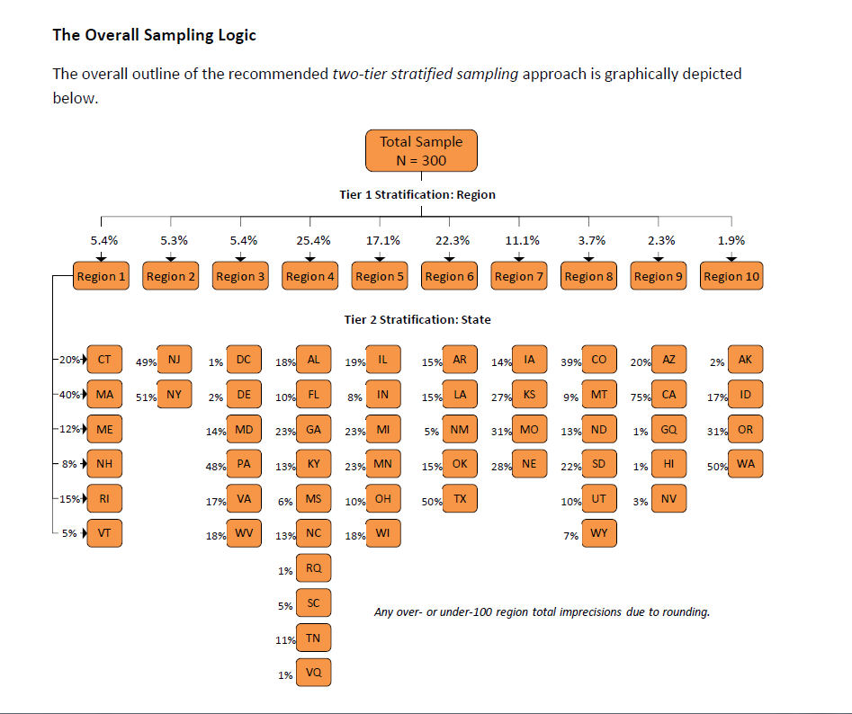

- Describe the procedures for the collection of information including:
* Statistical methodology for stratification and sample selection,
* Estimation procedure,
* Degree of accuracy needed for the purpose described in the justification,
* Unusual problems requiring specialized sampling procedures, and
* Any use of periodic (less frequent than annual) data collection cycles to reduce burden.

Due to a considerable sample size variability across the 10 regions, only directional (i.e., no statistical significance estimate) cross-regional comparisons will be possible; that said, for regions 4, 5, 6 and 7 it will be possible to estimate the magnitude of region-specific effect, albeit within the confines of considerably wider confidence intervals (i.e., +/- 10.8%, 13.2%, 11.5% and 16.5%, respectively).

- Describe methods to maximize response rates and to deal with issues of non-response. The accuracy and reliability of information collected must be shown to be adequate for intended uses. For collections based on sampling, a special justification must be provided for any collection that will not yield "reliable" data that can be generalized to the universe studied.

As indicated in Item 15 of the OMB 83-1, the purpose of collecting this information is threefold: (i) primarily and most importantly to determine compliance with regulatory requirements, and (ii) for program evaluation, planning/management. Therefore, a maximum response rate is expected because PHAs that are randomly selected to participate in the survey will be fulfilling their obligation of providing HUD with information to be used to determine compliance with statutory and regulation requirements stipulated in the Consolidated Annual Contributions Contract (ACC) between the PHAs and HUD (click on links below). PHAs that fail to respond to the survey will be contacted by PIH Field office staff and informed to do.

http://portal.hud.gov/hudportal/documents/huddoc?id=anncontributionspta.pdf

http://portal.hud.gov/hudportal/documents/huddoc?id=anncontributionsptb.pdf

- Describe any tests of procedures or methods to be undertaken. Testing is encouraged as an effective means of refining collections of information to minimize burden and improve utility. Tests must be approved if they call for answers to identical questions from 10 or more respondents. A proposed test or set of test may be submitted for approval separately or in combination with the main collection of information.

Not applicable

- Provide the name and telephone number of individuals consulted on statistical aspects of the design and the name of the agency unit, contractor(s), grantee(s), or other person(s) who will actually collect and/or analyze the information for the agency.

- HUD Staff consulted on statistical aspects of the survey design

Todd M. Richardson
Deputy Assistant Secretary (DAS)
Office of Policy Development
Policy Development and Research (PD&R)
Phone: 202-708-1537, Ext 5706

Blair Russell
Social Science Analyst
PD&R Office of Policy Development
Phone: 202-402-6907

- Name of the contractor who will conduct and analyze the survey

Lateef A. Abassi, CPA
IBS Management & Consultancy Services, LLC
1050 17th Street, NW, Suite 800
Washington, DC 20036
Tel: 202-609-8830

