Trends in International Mathematics and Science Study (TIMSS) 2019 Pretest

OMB# 1850-0803 v.238

Appendices
Communication Materials

Submitted by:

National Center for Education Statistics (NCES)
Institute of Education Sciences (IES)
U.S. Department of Education
Washington, DC

September 2018

Table of Contents
Appendix A: School Environment Recruitment Materials 3
Notification Letter from Chief State School Officer to District Superintendent 3
Notification Letter from NAEP State Coordinator to Principals 4
Pretest Logistics Information Letter from NAEP State Coordinator to School Coordinator 5
TIMSS 2019 Main Study Pocket Folder 6
TIMSS 2019 Main Study Brochure 8
TIMSS 2019 Main Study Frequently Asked Questions 10
TIMSS Pretest Sample Notification Letter: Grade 4 12
TIMSS Pretest Sample Notification Letter: Grade 8 13
TIMSS Facts for Parents about the Pretest: Grade 4 14
TIMSS Facts for Parents about the Pretest: Grade 8 15
Appendix B: Simulated Classroom Environment Recruitment Materials 16
Recruitment E-mail/Letter to Youth Organizations 16
EurekaFacts LLC Recruitment Phone Script for Community Centers and Organizations 17
Recruitment Internet/Newspaper Advertisement 19
Flyer/Information Brochure 20
E-mail/Letter Recruiting Parents or Legal Guardians of Student (under age 18) Participants 21
EurekaFacts LLC Recruitment Phone Script for Parents/Guardians of Student Participants 22
EurekaFacts LLC Recruitment Phone Script for Student Participants 25
Frequently Asked Questions (FAQs) 27
Consent Form for Parent/Guardian of Student Participants 28
Day of Research Session Reminder E-mail 30
EurekaFacts Confirmation of Research Session (Email/Letter) to Student Participant 31
EurekaFacts Confirmation of Participation (Email/Letter) to Parent/Guardian of Student Participant 32
Thank You E-mail/Letter to Parent/Guardian of Student Participants 33

Appendix A: School Environment Recruitment Materials

Notification Letter from Chief State School Officer to District Superintendent
TIMSS 2019 Pretest Notification Letter From CHIEF STATE SCHOOL OFFICER TO DISTRICT SUPERINTENDENT
Dear <District Superintendent name>,
I am pleased to notify you that <Insert Name of School or Schools> in your district have been selected to participate in the 2019 administration of the Trends in International Mathematics and Science Study (TIMSS) Pretest. TIMSS is the longest ongoing international student assessment. Since 1995, TIMSS has measured trends in academic achievement at grades 4 and 8 in countries around the world, including the United States. Results from TIMSS are used by researchers and policymakers to chart national progress against international standards and other countries around the world, informing national discussions about international competitiveness. For the first time, in 2019, TIMSS will be administered digitally. The electronic version of TIMSS, sometimes called “eTIMSS,” will be on the same scale and directly comparable to the previous paper versions of TIMSS.

In preparation for the 2019 assessment, TIMSS will administer a pretest in winter 2018-2019. The purpose of the pretest is to help ensure that the TIMSS assessment and field operations will be effective for the main study in 2019. <School District> will play an important role by participating, and I know that we can count on your full support to make this a meaningful experience for your schools and students.

The TIMSS 2019 Pretest will be administered in <Insert month>. TIMSS representatives will work with your school(s) to conduct the assessment on a date that is convenient for them. Students will take the TIMSS assessment on tablets provided by TIMSS representatives. Schools will receive $200 to thank them for their time and effort.

More information about TIMSS can be found at http://nces.ed.gov/timss. Name, our NAEP State Coordinator, will contact your staff with additional information.

I know that I can count on you to help accomplish our goal of 100 percent participation. Thank you for your time and support.

Sincerely,

Name of Chief State School Officer

CC: State Testing Director
District Testing Director
NAEP State Coordinator

NCES is authorized to conduct this study under the Education Sciences Reform Act of 2002 (ESRA 2002, 20 U.S.C. §9543). All of the information provided by school staff and students may be used only for statistical purposes and may not be disclosed, or used, in identifiable form for any other purpose except as required by law (20 U.S.C. §9573 and 6 U.S.C. §151).

Notification Letter from NAEP State Coordinator to Principals

Dear Principal,

I am pleased to notify you that <School> has been selected to participate in the 2019 administration of the Trends in International Mathematics and Science Study (TIMSS) Pretest. TIMSS is the longest ongoing international student assessment. Since 1995, TIMSS has measured trends in academic achievement at grades 4 and 8 in countries around the world, including the United States. It is administered by the National Center for Education Statistics (NCES), within the U.S. Department of Education. The purpose of the pretest is to help ensure that the TIMSS assessment and field operations will be effective for the main study in 2019.

TIMSS representatives will provide significant support to your school, bring all materials and equipment, including tablets, and administer the assessment. The TIMSS pretest assessment will take around two hours to complete. Your school may either select one grade 4 or grade 8 class to participate, or TIMSS representatives can work with you to randomly select a class to participate. Each participating school will receive a $200 check after their session to thank them for their time and willingness to participate. Participating students will receive a small gift for participating.

In <insert month>, I will send you an assessment date and detailed Pretest information. If the date presents a conflict for your school, we will work together to identify an alternate. I will also ask you to identify a school coordinator.

More information about TIMSS can be found at http://nces.ed.gov/timss. If you have questions, please contact me at telephone number or via email at email address.

Our chief state school officer, name, and your district superintendent, name, support TIMSS and look forward to your school’s participation. We know that we can count on you to help reach our goal of 100 percent participation.

Sincerely,

NAEP State Coordinator

CC: District Test Director

NCES is authorized to conduct this study under the Education Sciences Reform Act of 2002 (ESRA 2002, 20 U.S.C. §9543). All of the information provided by school staff and students may be used only for statistical purposes and may not be disclosed, or used, in identifiable form for any other purpose except as required by law (20 U.S.C. §9573 and 6 U.S.C. §151).

Pretest Logistics Information Letter from NAEP State Coordinator to School Coordinator
Dear <School Coordinator name>:

I recently notified school name of its selection to participate in the Trends in International Mathematics and Science Study (TIMSS) 2019 Pretest. I am following up with you to provide additional information about the upcoming assessment.

Please complete the following to prepare for the assessment:

- Place the TIMSS pretest date, assessment date, on your school calendar.
- Designate a school coordinator to serve as the liaison for all TIMSS activities in your school.
- Select a grade <4 or 8> class to participate in the TIMSS 2019 Pretest. If you would prefer, TIMSS representatives can work with you to randomly select a class to participate
- Give the enclosed/attached TIMSS folder to your designated school coordinator. The school coordinator should be familiar with how students participate in statewide assessments.

In a couple of weeks, a TIMSS representative responsible for administering the assessment will contact your school coordinator. During the assessment, we would appreciate the presence of a school staff person as an observer in each session. The staff member’s presence can have a positive impact on students’ motivation and performance.

If you have questions, please contact me at telephone number or via email at email address.. You may visit the TIMSS website at http://nces.ed.gov/timss for more information about TIMSS.

Again, I would like to express my appreciation for your assistance with this very important assessment of our nation’s students. Our chief state school officer, name, supports TIMSS and encourages your students’ participation.

NAEP State Coordinator

CC: Principal

NCES is authorized to conduct this study under the Education Sciences Reform Act of 2002 (ESRA 2002, 20 U.S.C. §9543). All of the information provided by school staff and students may be used only for statistical purposes and may not be disclosed, or used, in identifiable form for any other purpose except as required by law (20 U.S.C. §9573 and 6 U.S.C. §151).

Enclosed: TIMSS folder with TIMSS 2019 Brochure and TIMSS 2019 Frequently Asked Questions

TIMSS 2019 Main Study Pocket Folder
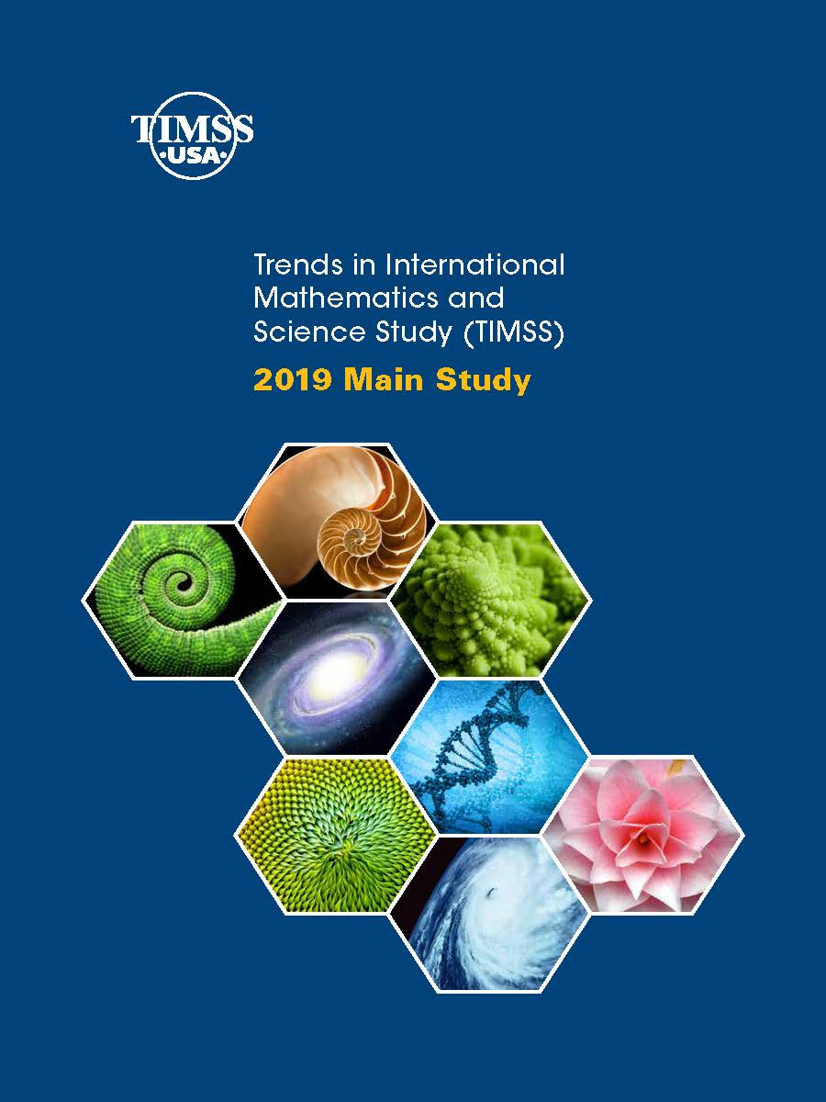
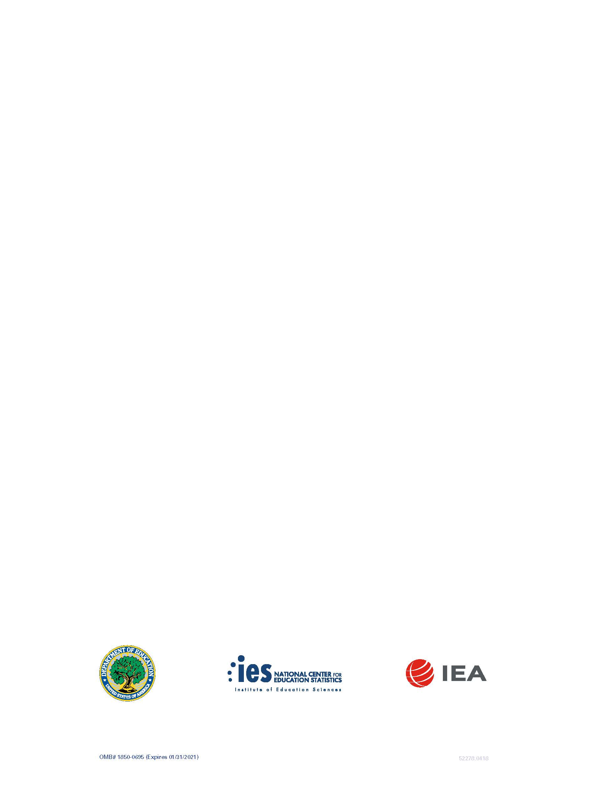

TIMSS 2019 Main Study Brochure

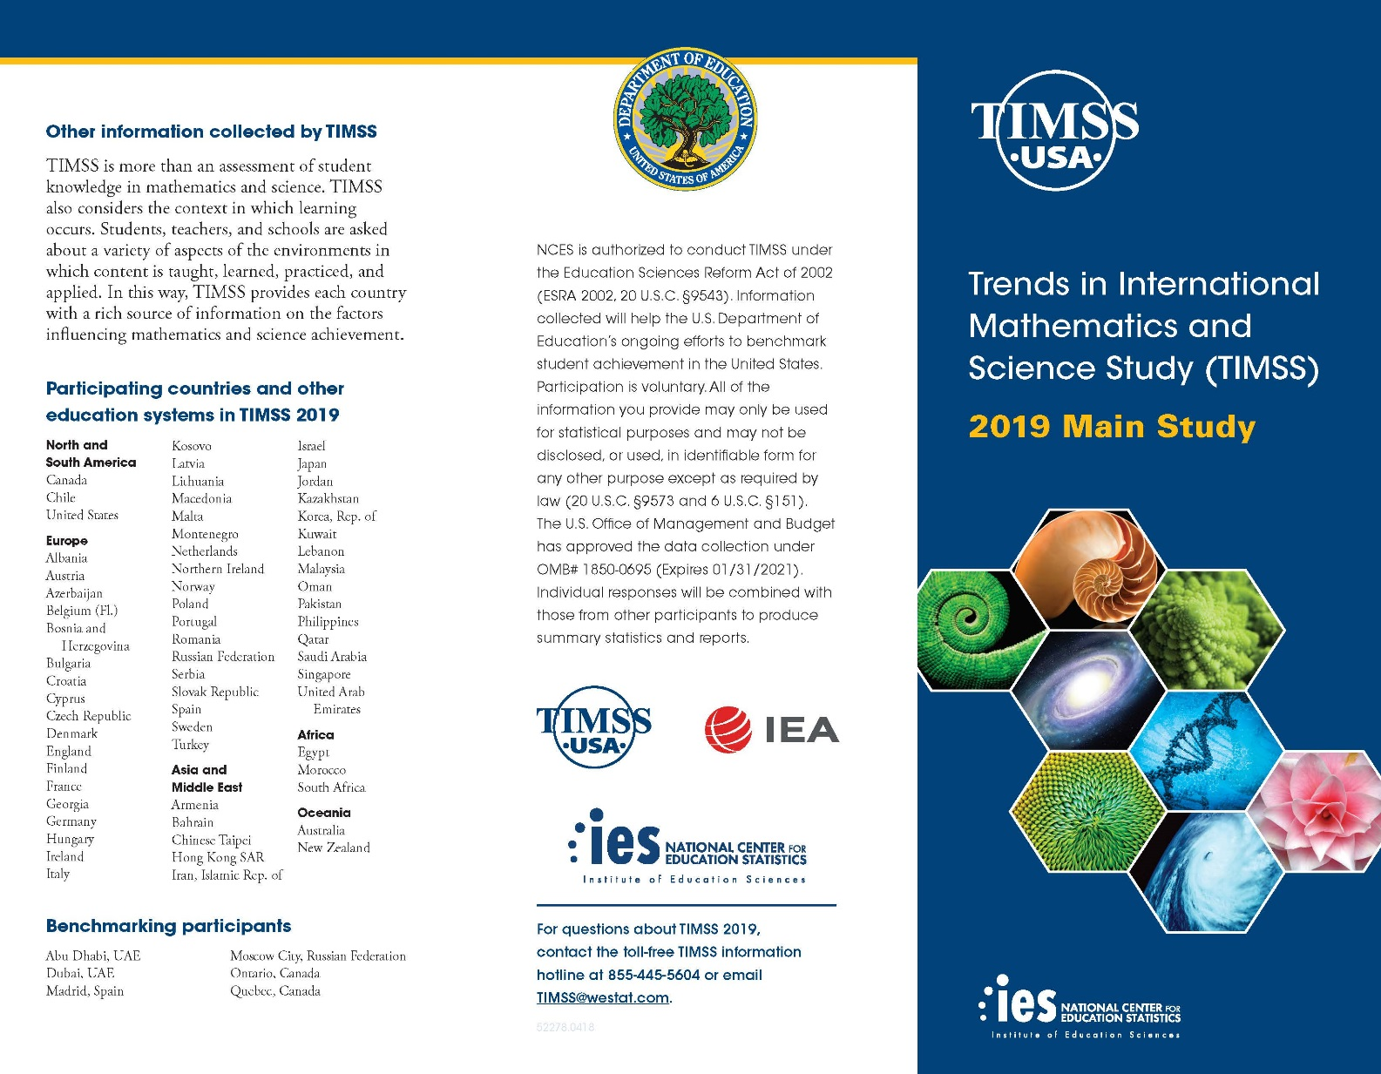
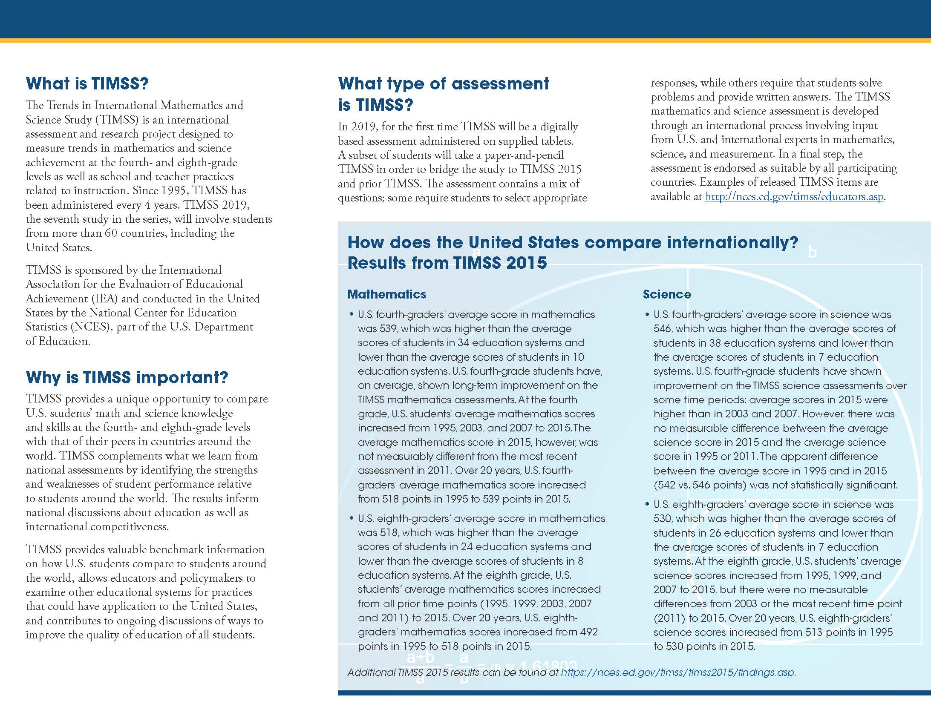

TIMSS 2019 Main Study Frequently Asked Questions
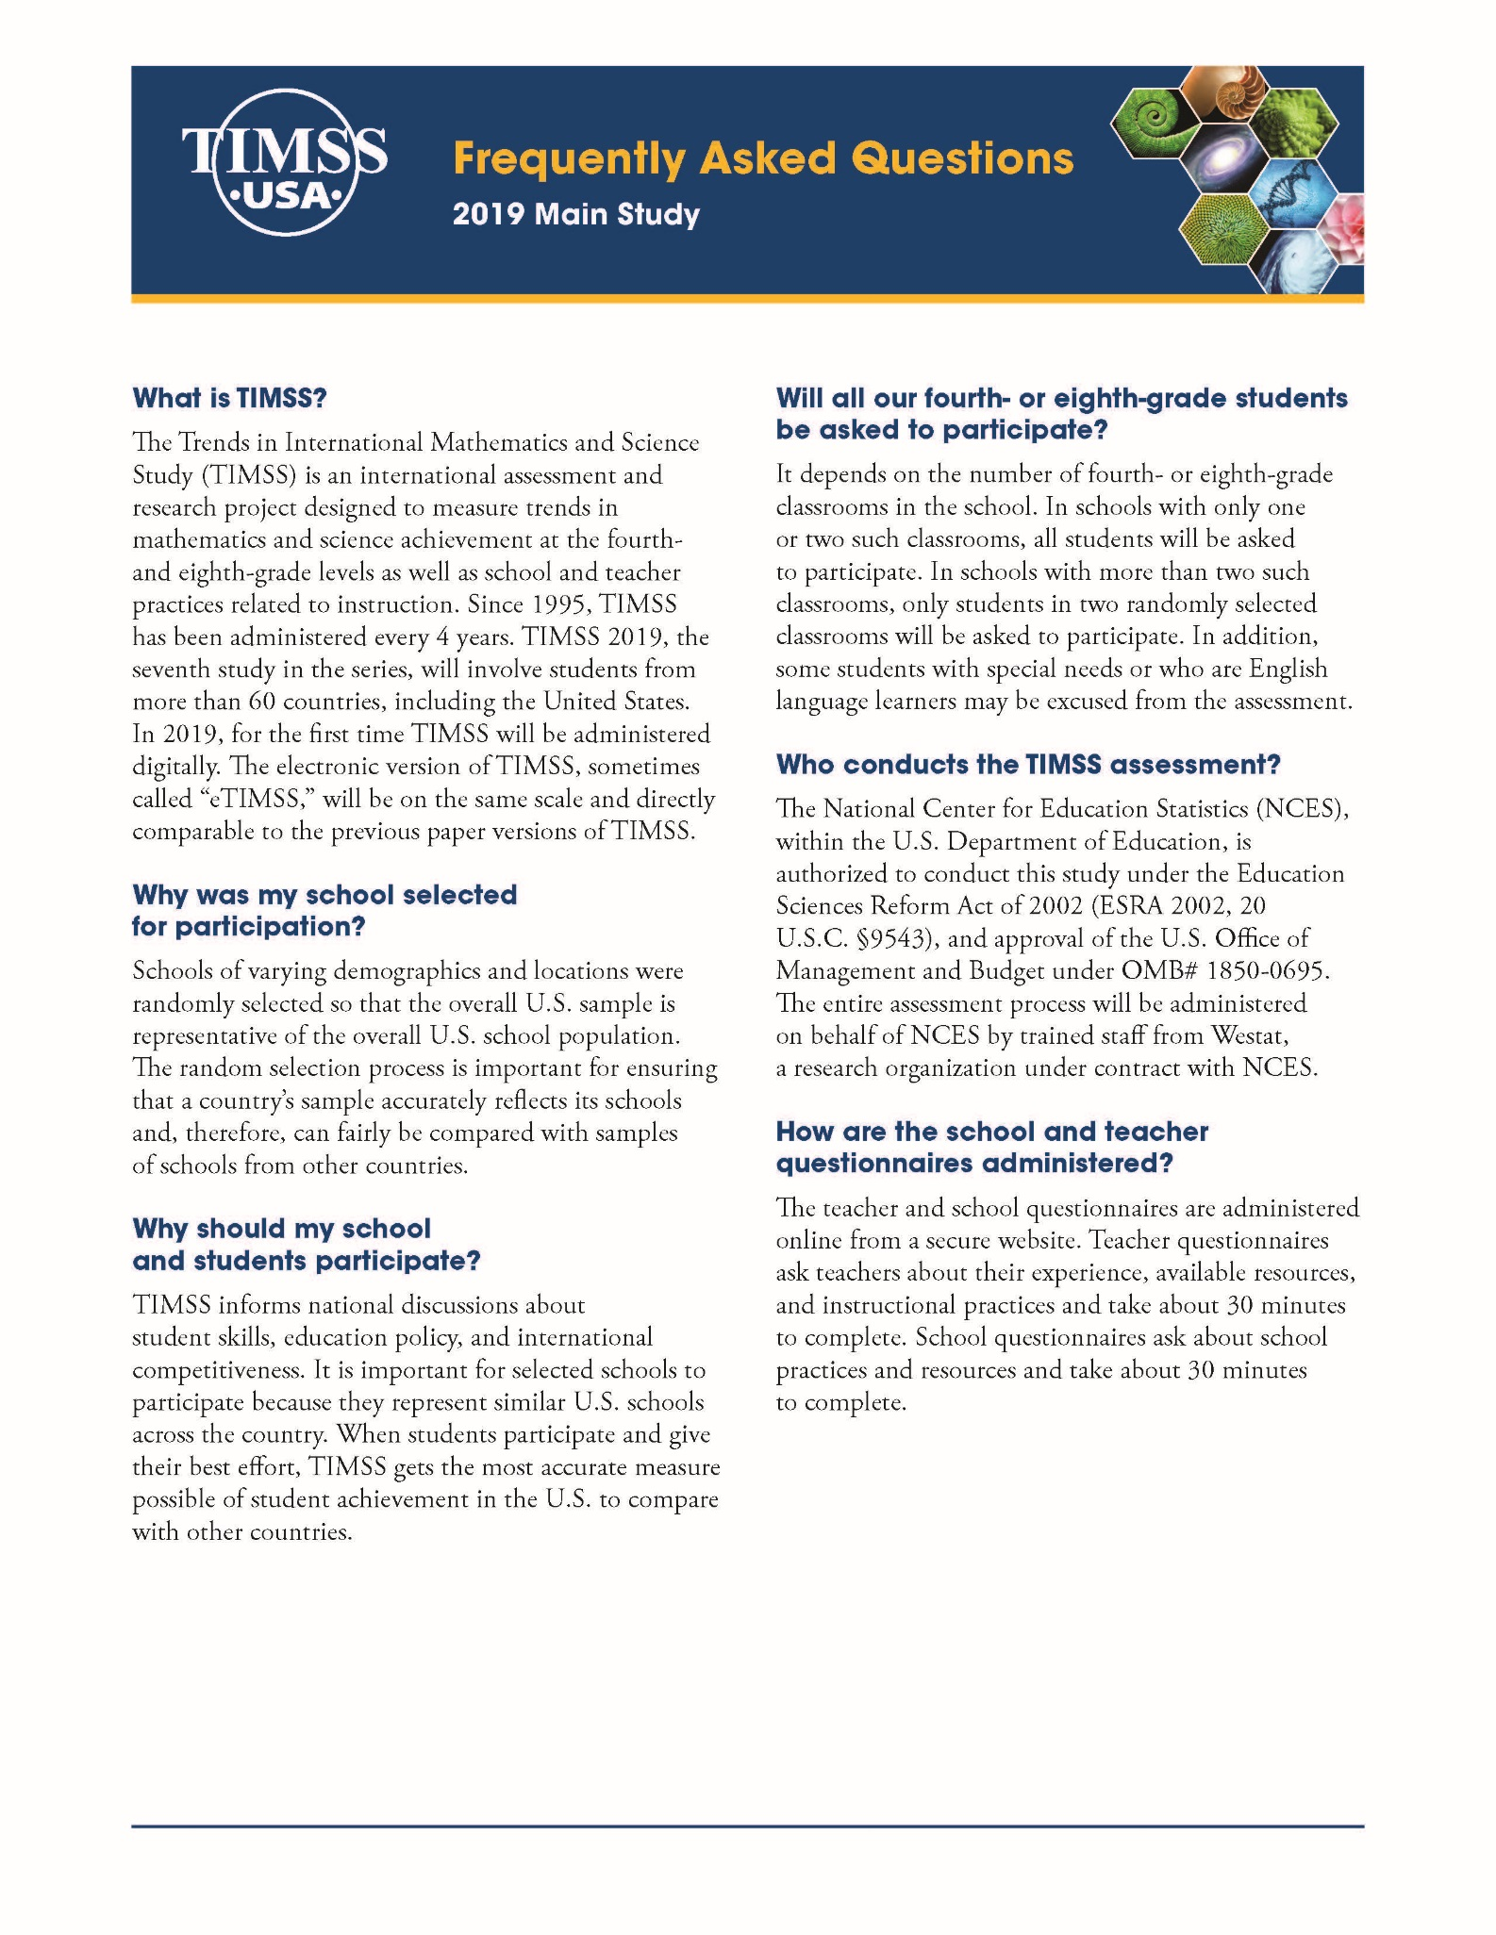
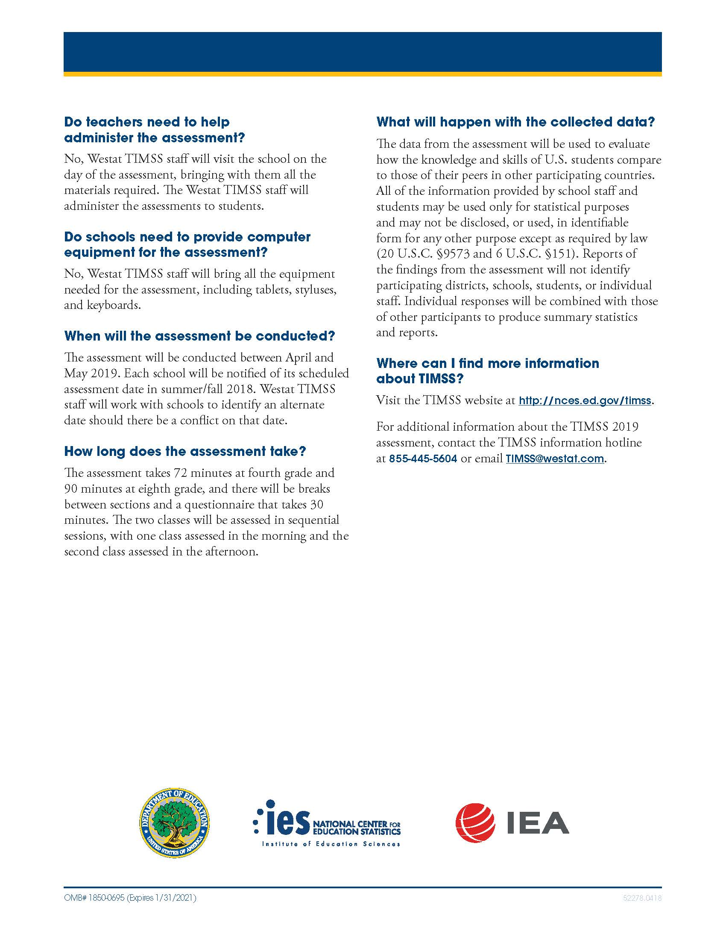

TIMSS Pretest Sample Notification Letter: Grade 4

SCHOOL LETTERHEAD

Dear Parent or Guardian,
This letter is to inform you about an important international study of student learning being conducted in our school this winter. The Trends in International Mathematics and Science Study (TIMSS) provides important information for benchmarking student performance in mathematics and science at grades 4 and 8 in the United States against countries around the world. Since 1995, TIMSS has measured worldwide trends in student knowledge of mathematics and science. The next TIMSS assessment will be in the spring of 2019.
For the first time, in 2019, TIMSS will be administered digitally. In preparation for the 2019 assessment, TIMSS will administer a pretest in winter 2018-2019. The purpose of the pretest is to help ensure that the new electronic TIMSS assessment and field operations will be effective for the main study in 2019.
Our school has accepted an invitation from the National Center for Education Statistics (NCES), part of the U.S. Department of Education, to participate in the TIMSS pretest. One of our 4th-grade classes will take part. This is your child’s class. The enclosed summary sheet provides some background information about TIMSS, explains what is involved for each student selected to participate in the study, and gives a contact phone number and email address where you can find answers to any questions you might have.
To help ensure the success of TIMSS 2019, it is important that each student selected take part in the study. I urge you to support this effort by encouraging your child to take part; however, participation in this study is entirely voluntary. Previous experience suggests that students actually enjoy taking part, and participating students will receive a small gift, which we think they will like.
All of the information collected is safeguarded, as required by law. NCES is authorized to conduct this study under the Education Sciences Reform Act of 2002 (ESRA 2002, 20 U.S.C. §9543). All of the information provided by school staff and students may be used only for statistical purposes and may not be disclosed, or used, in identifiable form for any other purpose except as required by law (20 U.S.C. §9573 and 6 U.S.C. §151). Students and schools are never identified in any reports. All reported statistics refer to the United States as a whole.
Thank you for taking the time to learn about this important study.
Sincerely,
[School official]
Enclosures: Facts for Parents about the TIMSS Pretest

TIMSS Pretest Sample Notification Letter: Grade 8

SCHOOL LETTERHEAD

Dear Parent or Guardian,
This letter is to inform you about an important international study of student learning being conducted in our school this winter. The Trends in International Mathematics and Science Study (TIMSS) provides important information for benchmarking student performance in mathematics and science at grades 4 and 8 in the United States against countries around the world. Since 1995, TIMSS has measured worldwide trends in student knowledge of mathematics and science. The next TIMSS assessment will be in the spring of 2019.
For the first time, in 2019, TIMSS will be administered digitally. In preparation for the 2019 assessment, TIMSS will administer a pretest in winter 2018-2019. The purpose of the pretest is to help ensure that the new electronic TIMSS assessment and field operations will be effective for the main study in 2019.
Our school has accepted an invitation from the National Center for Education Statistics (NCES), part of the U.S. Department of Education, to participate in the TIMSS pretest. One of our 8th-grade classes will take part. This is your child’s class. The enclosed summary sheet provides some background information about TIMSS, explains what is involved for each student selected to participate in the study, and gives a contact phone number and email address where you can find answers to any questions you might have.
To help ensure the success of TIMSS 2019, it is important that each student selected take part in the study. In addition to answering mathematics and science questions, students will be asked to complete a brief questionnaire about themselves. I urge you to support this effort by encouraging your child to take part; however, participation in this study is entirely voluntary. Previous experience suggests that students actually enjoy taking part, and participating students will receive a small gift, which we think they will like.
All of the information collected is safeguarded, as required by law. NCES is authorized to conduct this study under the Education Sciences Reform Act of 2002 (ESRA 2002, 20 U.S.C. §9543). All of the information provided by school staff and students may be used only for statistical purposes and may not be disclosed, or used, in identifiable form for any other purpose except as required by law (20 U.S.C. §9573 and 6 U.S.C. §151). Students and schools are never identified in any reports. All reported statistics refer to the United States as a whole.
Thank you for taking the time to learn about this important study.
Sincerely,
[School Official]
Enclosures:
Facts for Parents about the TIMSS Pretest

TIMSS Facts for Parents about the Pretest: Grade 4
Facts for Parents
About the TIMSS Pretest
Between December and January, your child’s school will be one of about 3 nationwide taking part in a pretest to prepare for TIMSS 2019.
What is TIMSS?
TIMSS (Trends in International Mathematics and Science Study) is an international assessment that measures student learning in mathematics and science. Every four years since 1995, TIMSS documents worldwide trends in the knowledge of 4th graders. The National Center for Education Statistics (NCES), within the U.S. Department of Education, conducts TIMSS in the United States. Along with more than 60 other nations, the U.S. will take part in the 2019 TIMSS cycle as we did in 1995, 1999, 2003, 2007, 2011, and 2015.
What is the purpose of the TIMSS Pretest?
The TIMSS Pretest is testing 4th- and 8th-grade questions in electronic formats on tablet computers in approximately three schools in the United States in preparation for the 2019 international study. This Pretest will allow test developers to help ensure that the TIMSS assessment and field operations will be effective for the main study in 2019.
What is involved?
TIMSS staff will visit the school and administer the Pretest on tablet computers that they will bring to the school. The Pretest will take approximately 1 ½ hours. The assessment itself is 72 minutes with breaks between sections. Students will also be asked some questions about their experiences taking the TIMSS assessment on tablets. Participation in the study is voluntary.
What are the benefits?
The nation as a whole benefits from TIMSS by having a greater understanding of how the knowledge and skills of U.S. 4th graders compare with those of 4th graders in other countries. Our country benefits from the Pretest by ensuring that the electronic assessment is fair and appropriate for U.S. students. Schools that participate in TIMSS will receive $200, and each student who participates will receive a small gift that we believe they will like.
Who administers TIMSS?
The entire assessment is administered by trained staff from Westat, a research organization under contract to the U.S. Department of Education’s National Center for Education Statistics.
All of the information collected is safeguarded, as required by law. NCES is authorized to conduct this study under the Education Sciences Reform Act of 2002 (ESRA 2002, 20 U.S.C. §9543). All of the information provided by school staff and students may be used only for statistical purposes and may not be disclosed, or used, in identifiable form for any other purpose except as required by law (20 U.S.C. §9573 and 6 U.S.C. §151). Students and schools are never identified in any reports. All reported statistics refer to the United States as a whole.
Where can I find out more about TIMSS?
More information about TIMSS is available at the TIMSS website at http://nces.ed.gov/timss or http://timss.bc.edu. Or if you would like to contact a TIMSS staff member directly, please feel free to call the TIMSS hotline at 1-(855)-445-5604 or email us at TIMSS@westat.com.

TIMSS Facts for Parents about the Pretest: Grade 8
Facts for Parents
About the TIMSS Pretest
Between December and January, your child’s school will be one of about 3 nationwide taking part in a pretest to prepare for TIMSS 2019.
What is TIMSS?
TIMSS (Trends in International Mathematics and Science Study) is an international assessment that measures student learning in mathematics and science. Every four years since 1995, TIMSS documents worldwide trends in the knowledge of 8th graders. The National Center for Education Statistics (NCES), within the U.S. Department of Education, conducts TIMSS in the United States. Along with more than 60 other nations, the U.S. will take part in the 2019 TIMSS cycle as we did in 1995, 1999, 2003, 2007, 2011, and 2015.
What is the purpose of the TIMSS Pretest?
The TIMSS Pretest is testing 4th- and 8th-grade questions in electronic formats on tablet computers in approximately three schools in the United States in preparation for the 2019 international study. This Pretest will allow test developers to help ensure that the TIMSS assessment and field operations will be effective for the main study in 2019.
What is involved?
TIMSS staff will visit the school and administer the Pretest on tablet computers that they will bring to the school. The Pretest will take approximately 2 hours. The assessment itself is 90 minutes with breaks between sections. Students will also be asked some questions about their experiences taking the TIMSS assessment on tablets. Participation in the study is voluntary.
What are the benefits?
The nation as a whole benefits from TIMSS by having a greater understanding of how the knowledge and skills of U.S. 8th graders compare with those of 8th graders in other countries. Our country benefits from the Pretest by ensuring that the electronic assessment is fair and appropriate for U.S. students. Schools that participate in TIMSS will receive $200, and each student who participates will receive a small gift that we believe they will like.
Who administers TIMSS?
The entire assessment is administered by trained staff from Westat, a research organization under contract to the U.S. Department of Education’s National Center for Education Statistics.
All of the information collected is safeguarded, as required by law. NCES is authorized to conduct this study under the Education Sciences Reform Act of 2002 (ESRA 2002, 20 U.S.C. §9543). All of the information provided by school staff and students may be used only for statistical purposes and may not be disclosed, or used, in identifiable form for any other purpose except as required by law (20 U.S.C. §9573 and 6 U.S.C. §151). Students and schools are never identified in any reports. All reported statistics refer to the United States as a whole.
Where can I find out more about TIMSS?
More information about TIMSS is available at the TIMSS website at http://nces.ed.gov/timss or http://timss.bc.edu. Or if you would like to contact a TIMSS staff member directly, please feel free to call the TIMSS hotline at 1-(855)-445-5604 or email us at TIMSS@westat.com.

Appendix B: Simulated Classroom Environment Recruitment Materials

Recruitment E-mail/Letter to Youth Organizations
IF SENT AS E-MAIL - Subject: Education Research Opportunity for Students in Grade <4 or 8> for TIMSS>
<DATE>
Dear <NAME>,
We are administering an important study on behalf of the U.S. Department of Education’s National Center for Education Statistics (NCES). Because your organization plays an active role in the community, we need your help.
We are looking for students in <fourth or eighth> grade to test new questions that will be used for the Trends in International Mathematics and Science Study, also known as TIMSS, a computer-based international assessment of <fourth- or eighth->grade students’ math and science skills. Student participation is vital in helping us develop the best way to deliver the test.
The voluntary research sessions will last for about 2 hours each. During group testing sessions, students will be asked to answer questions using a tablet computer as if it were an actual test. Their feedback helps us find and fix problems before other students take tests nationwide. Because we care about student privacy, we will assign each student a unique student identifier. Student names will not be linked to their answers.
Each student will receive a $35 VISA gift card at the end of the session as a thank you for participation. In addition, the student’s parent or legal guardian will receive a $35 VISA gift card as a thank you for bringing the student to and from the testing site.
Students play a key role in helping us improve our tests. In fact, their participation enhances the experience of thousands of students all over the United States who will take the tests.
We would like to ask for your assistance in letting parents/legal guardians and students know how they can help shape this international assessment to be conducted in the United States. I have included a flyer with a brief description of our study in the hopes that you can post it for everyone to see. I have also included a Frequently Asked Questions (FAQs) page with additional information about the study.
<IF OFFSITE SESSIONS ARE POSSIBLE: To make it more convenient for students, we would like to hear from you if you have space available and a group of interested students who are unable to commute to <Location>.>
We appreciate your consideration of this request and invite you to please contact us with any questions regarding this project. We look forward to speaking with you soon!
ATTACHED: Flyer and FAQs
Sincerely,
<CONTACT NAME>
<JOB TITLE>
EurekaFacts <CONTACT PHONE>

EurekaFacts LLC Recruitment Phone Script for Community Centers and Organizations
Hello. May I please speak to <NAME OF CONTACT AT COMMUNITY CENTER>?
Good morning/afternoon/evening. My name is <CONTACT NAME> and I am contacting you from EurekaFacts, a local research company, and we need your help. We are carrying out an important study for the U.S. Department of Education’s National Center for Education Statistics (NCES). Because your organization plays an active role in the community, we are asking for your help in spreading the word about this exciting research opportunity.
We are recruiting students who are in <fourth or eighth> grade to help us evaluate computer-based questions that are part of a test called the Trends in International Mathematics and Science Study, also known as TIMSS, which is delivered to students nationwide and in other countries. [If community center or organization asks what TIMSS is: This international assessment is a computer-based assessment of math and science administered periodically to students in elementary or middle schools throughout the United States and in other countries.]
Students play a key role in helping us improve our tests. In fact, their participation enhances the experience of thousands of students all over the United States who will take the tests. Student participation is vital in helping us fix any issues and develop the best way to deliver the test. The study will not retain any personally identifiable information. [Recruiter: If asked about confidentiality, please read the statement in the footnote.]Each student who participates will receive a $35 VISA gift card at the end of the session as a thank you for participating. In addition, the student’s parent or guardian will also receive a $35 VISA gift card as a thank you for bringing their child to and from the testing site.
We would like your help in distributing and posting informational flyers to let parents and students know how they can be involved in this important study. We will follow up directly with those who contact us. We will hold sessions at <LOCATION>, <ADDRESS>.
Would your <community center or organization> be interested in advertising and/or helping us to recruit students for this study?
If NO: Thank you for your time. Have a wonderful day/evening. [END CALL]
If YES: Good, thank you very much. To ensure that we have a broad mix of students to participate in the research session, I have a few brief screening questions to ask you. It should take only a few minutes.
Screener
[Recruiter: Determine recruitment needs in advance. Look in public documents and the website to find what grades the community center or organization includes, as well as the size, socio-economic status (SES), and racial/ethnic makeup of the student population. Record all responses to Screener questions. End Screener at whatever point the staff member gives a response that confirms that their group has already been sampled adequately. End Screener Script: “Based on the requirements of this study, we are not able to include your students in the study at this time. Thank you for your time. Have a good day/evening.” [Interviewer: End call]]
1. Do you have <a child or children> who are in grade <4 or 8> who might be available to participate in the study?
If NO: Thank you for your time. Have a wonderful day/evening. [END CALL]
If YES: Great.
2. Would you be able to distribute and post flyers regarding this study? [Recruiter: Interested parties would contact EurekaFacts directly. We would follow up with them by phone and ask them some screening questions to ensure that a diverse sample of students is included in this study.]

If NO: Thank you for your time. Have a good day/evening. [Recruiter: End call]
If YES: Great. Thank you for taking the time to answer the screening questions. Your <community center or organization> is generally eligible to participate in the study. EurekaFacts staff will follow up with interested parents/legal guardians by phone to make interview arrangements. [Recruiter go to Closing]

(Closing)
Thank you for agreeing to share the information about this important study. We will send you an email with the informational flyers attached.
We may need to reach you by telephone. Is the number I called the best number to use?
Do you have any questions at this time? [Recruiter: Answer any questions.]
If you have any (additional) questions, please call <PHONE NUMBER>.
Thank you again for agreeing to be part of this important research project.

Recruitment Internet/Newspaper Advertisement

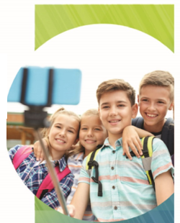

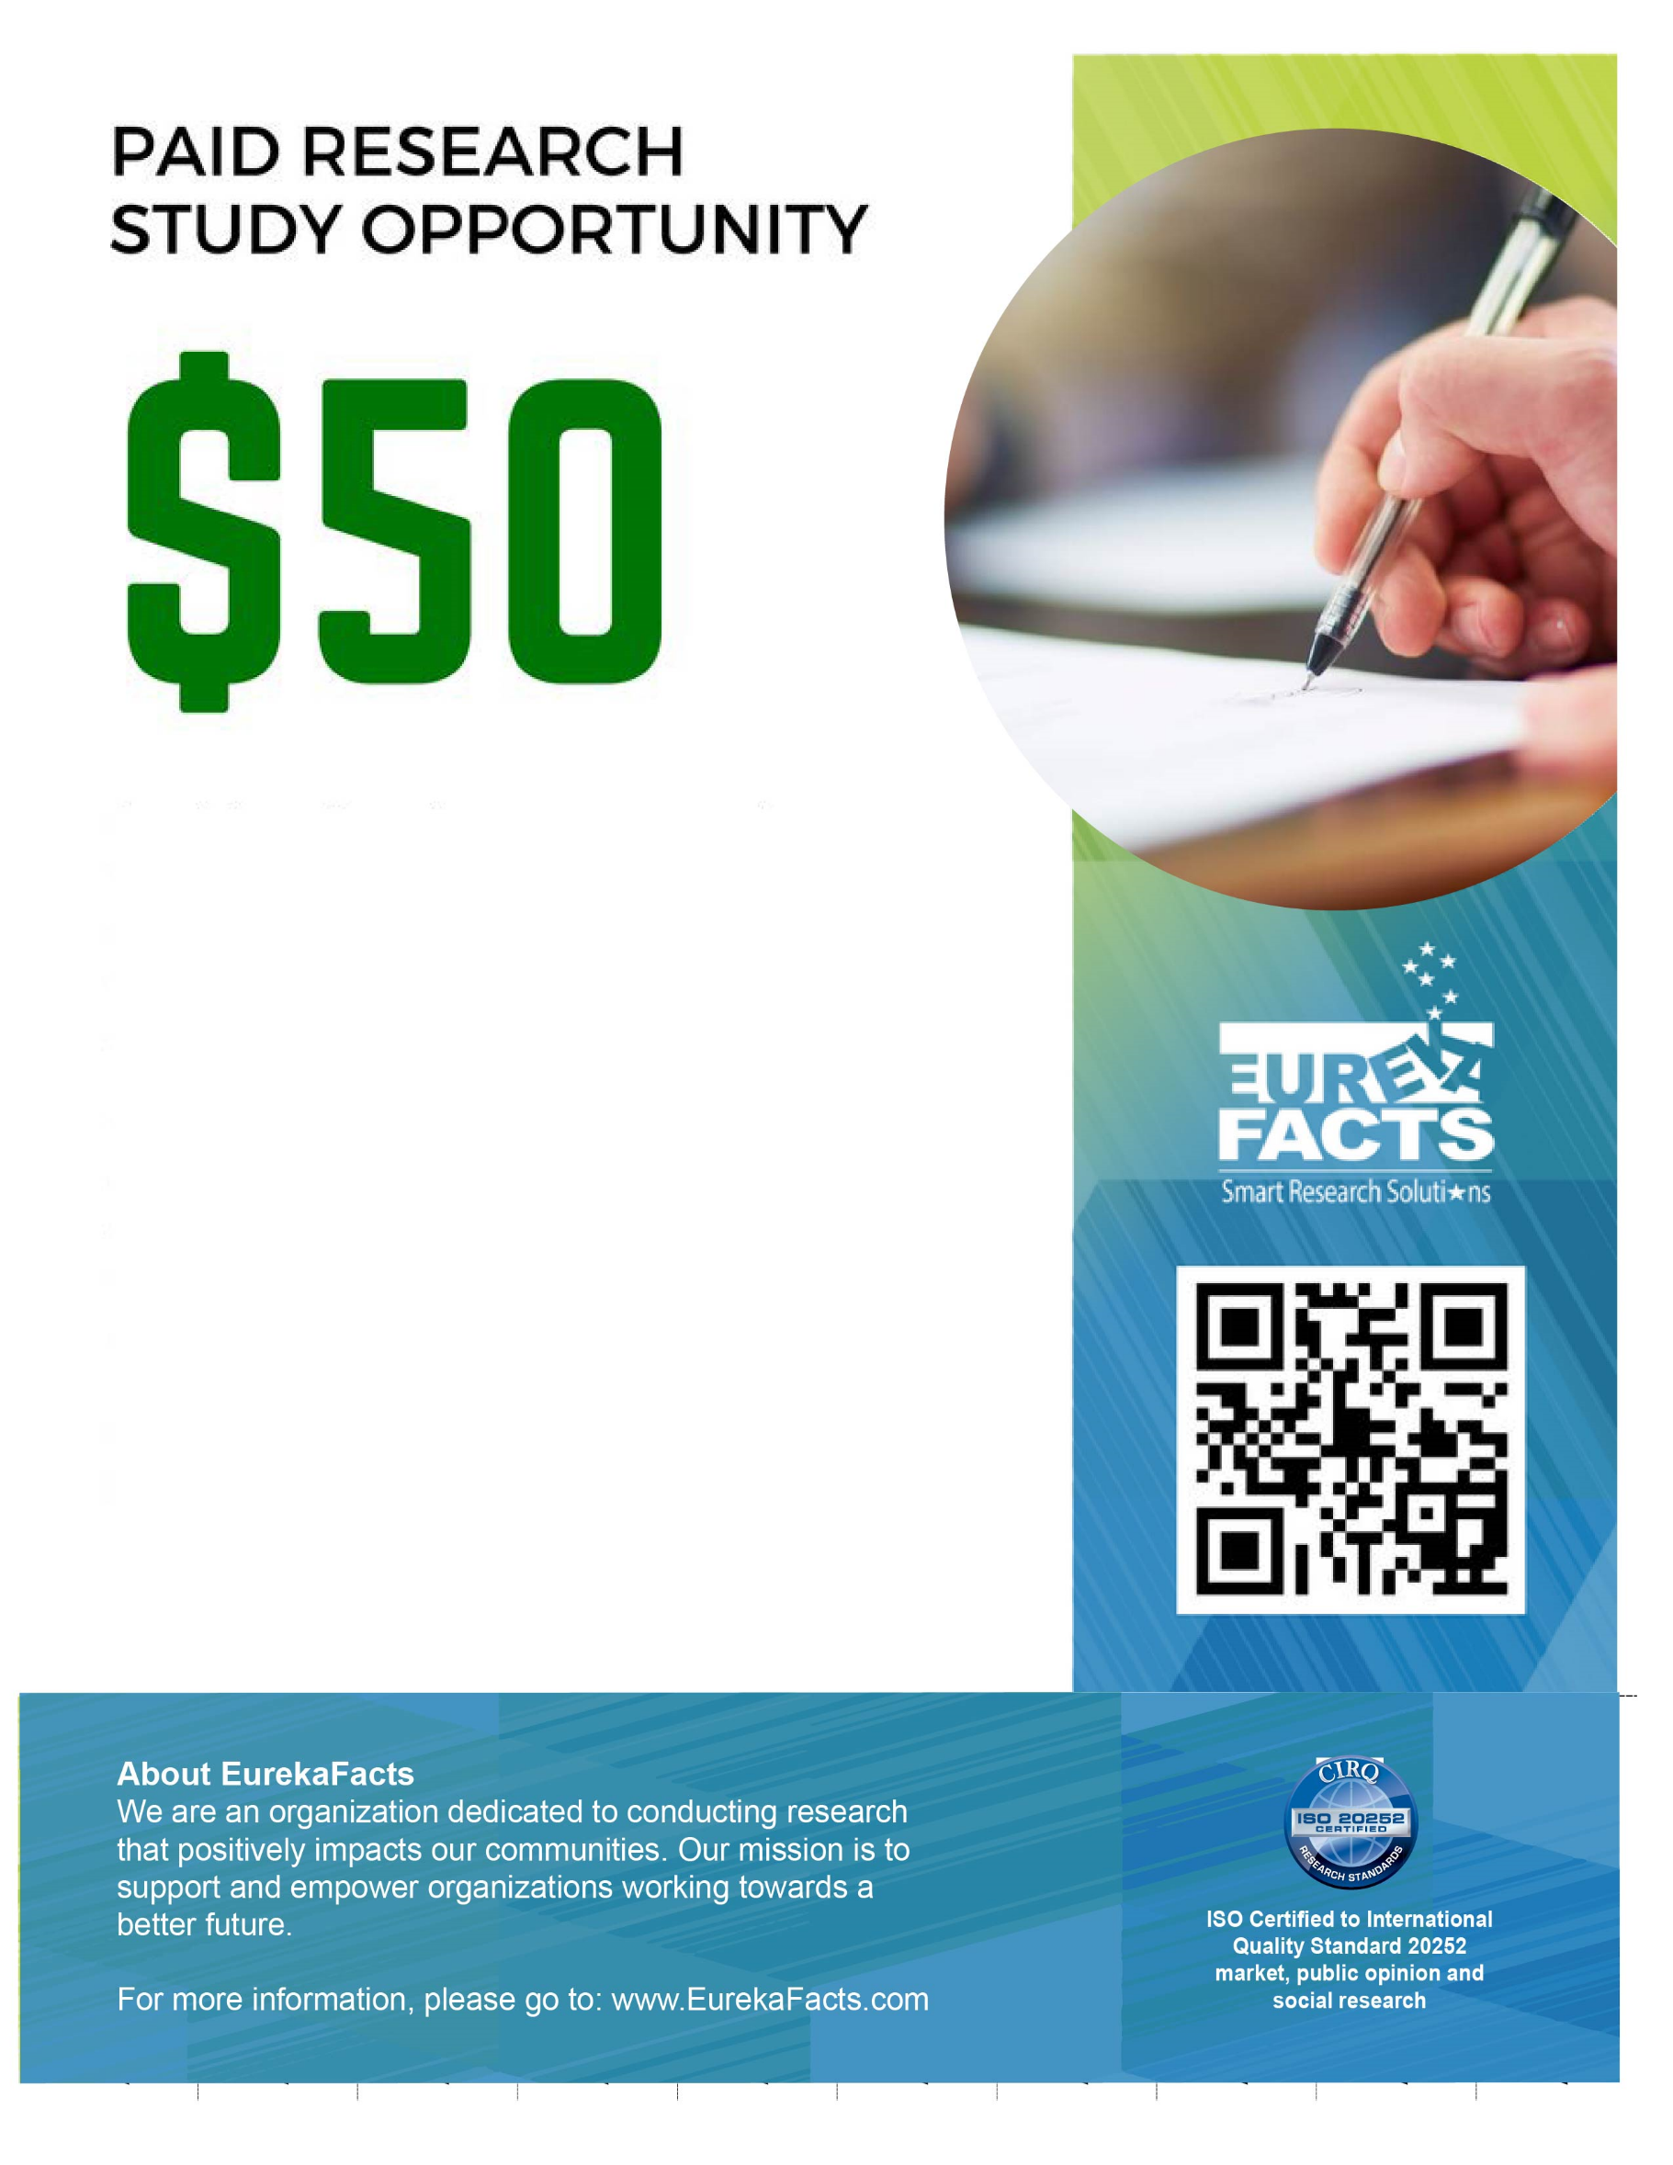
Students will test new versions of an assessment on a tablet computer for an important study for the U.S. Department of Education’s National Center for Education Statistics (NCES).

After school and weekend sessions last up to 120 minutes. Students will get a $35 VISA gift card for participating and the parent or legal guardian will also get a $35 VISA gift card as a thank you for bringing the student to and from the testing site.

Test scores will not be shared with schools.

For more information or register, please call us at (866) 985 – 7910 OR (240) 403 – 4800 ext. 216

OR email:

TestTheTest@EurekaFacts.com
4TH and 8TH
GRADE STUDENTS
PAID
EDUCATIONAL STUDY FOR

Flyer/Information Brochure

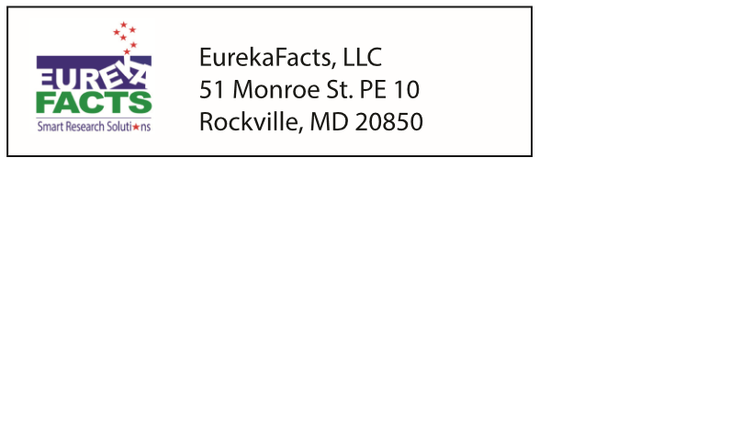
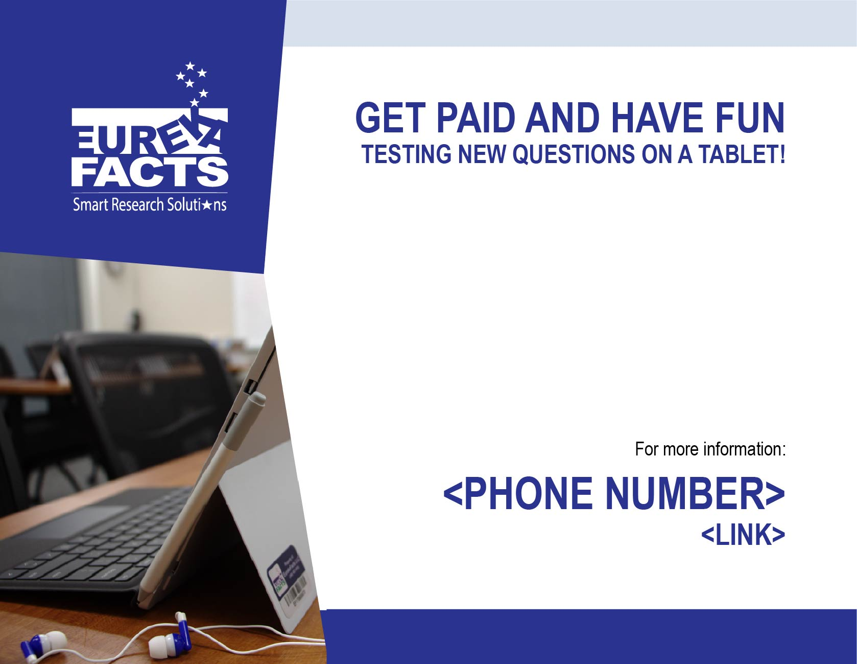
EurekaFacts invites 4th & 8th grade students to participate in an important study for the U.S. Department of Education’s National Center for Education Statistics (NCES). Sessions will take place on <DATE>. Students will get a $35 gift card and the parent or legal guardian will also get a $35 gift card as a thank you for bringing the student to and from the testing site.

E-mail/Letter Recruiting Parents or Legal Guardians of Student (under age 18) Participants

IF SENT AS E-MAIL - Subject: Paid Education Research Opportunity
Dear <NAME>:
We are reaching out to parents of <4th/8th> grade students just like you, because we need your help. Our company, EurekaFacts, is administering an important education study for the National Center for Education Statistics (NCES), which is part of the U.S. Department of Education.
NCES is looking for students who are in <fourth or eighth> grade to test new questions that will be used for the Trends in International Mathematics and Science Study (TIMSS). Students’ participation and opinions will help us find and fix issues before other students take the tests nationwide.

The research session for your child will take place at <LOCATION> and will last about 2 hours. Your child will be in a classroom setting with a group of students. They will answer questions using a tablet computer as if it were an actual test.
Your child will receive a $35 VISA gift card at the end of the session as a thank you. The parent or legal guardian who brings the student to and from the site will also receive a $35 VISA gift card as a thank you for his/her time and effort.
Because we care about your child’s privacy, we will assign him/her a unique student identifier. Your child’s name will not be linked to his/her answers.
This study is voluntary and there are two sessions available, one for 4th graders and one for 8th graders.
If your child is interested in participating in this voluntary study, please call <CONTACT PHONE> or e-mail <CONTACT E-MAIL>. We look forward to speaking with you soon!
Thank you,
<NAME>
<JOB TITLE>
EurekaFacts
<CONTACT PHONE>

EurekaFacts LLC Recruitment Phone Script for Parents/Guardians of Student Participants

(Script when calling parents/guardians from a previously compiled list)

Good morning/afternoon/evening. Is this the <NAME FROM CALL LIST> household? My name is <CALLER NAME>, and I am calling from EurekaFacts, a local research company. Our company is administering an important education study on behalf of the National Center for Education Statistics (NCES), which is part of the U.S. Department of Education, and we need your help.
We are recruiting students who are in <fourth or eighth> grade to help us test computer-based questions. If selected to participate, your child will receive a $35 VISA gift card at the end of the session as a thank you. The parent or legal guardian who brings them to and from the study site will also receive a $35 VISA gift card as a thank you for his/her time and effort.
- Are there any students in your household who are in <fourth or eighth> grade?
 | SELECT ONE
Yes | 1 | →(CONTINUE)
No | 2 | →(THANK AND TERMINATE)

We are administering a study to explore how students work through these questions. Students’ participation and opinions will help us find and fix issues before other students take the test nationwide. This test is part of a study called the Trends in International Mathematics and Science Study, also known as TIMSS. [If parent/guardians asks what TIMSS is: This international assessment is computer-based assessment of math and science administered periodically to students in elementary and middle schools throughout the United States and in other countries.]
The study session will take place at <NAME OF STUDY SITE AND LOCATION>. It can be scheduled at your convenience and will last about 2 hours. Your child will be in a classroom setting with a group of students. He/she will answer questions using a tablet computer as if it were an actual test.
NCES is authorized to conduct this study under the Education Sciences Reform Act and all of the information you provide may be used only for statistical purposes and may not be disclosed, or used, in identifiable form for any other purpose except as required by law [Recruiter: If parent/legal guardian asks about the specific laws please provide the citation from the footnote.]

- If your child qualifies, do you give your permission for us to invite your child to participate?
 | SELECT ONE
Yes | 1 | →(CONTINUE)
No | 2 | →(THANK AND TERMINATE)

- What is your child’s sex? → (READ THE QUESTION AND RESPONSE OPTIONS)
 | SELECT ONE
Male | 1
Female | 2

- Would you like me to send the consent form by e-mail or by U.S. Postal mail?
SELECT ONE
e-mail | →(CONTINUE TO 4A)
postal mail | →(CONTINUE TO 4B)
4A. What is your e-mail address?
RECORD PARENT’S/GUARDIAN’S EMAIL ADDRESS:

____________________________________________________________________________________
4B. What is your postal mail address?
RECORD PARENT’S/GUARDIAN’S MAILING ADDRESS AND PHONE NUMBER:

____________________________________________________________________________________
The next few questions are for classification purposes only.

- Does your child participate in the National School Lunch program?
 | SELECT ONE
Yes | 1
No | 2
Prefer not to answer | 3
- Do you speak a language other than English at home?
 | SELECT ONE
Yes | 1 | (CONTINUE TO 6A)
No | 2
Prefer not to answer | 3

6A. What is this language? (For example: Korean, Italian, Spanish, Vietnamese)

- Is your child Hispanic or Latino?
 | SELECT ONE
Yes | 1
No | 2
Prefer not to answer | 3
- Which of the following categories best describes your child’s ethnic or racial background? (READ LIST)
 | SELECT ALL THAT APPLY
American Indian or Alaska Native |  | 1
Asian |  | 2
Black or African American |  | 3
Native Hawaiian or Other Pacific Islander |  | 4
White |  | 5
Prefer not to answer |  | 6

- We are administering study sessions in <Month> and <Month>. If your child chooses to participate, which month would work best for you to take [HIM/HER] to the study session? <<OR, WE ARE ADMINISTERING STUDY SESSIONS ON DATE. WILL YOUR CHILD BE ABLE TO PARTICIPATE ON THAT DATE>>

[CHECK SCHEDULE FOR RESPONDENT’S AVAILABLE TIMES.]

RECORD THE PREFERRED MONTH:
____________________________________________________________________________________
- Now that you have agreed for your child to participate in the study if he/she is selected, I would like to be able to ask your child a few questions, during which you are welcome to stay on the line. Is he/she available to speak with me at this time? (If not, get a call back time and call back) What is your child’s name?

RECORD NAME:
_________________________________________________________________________________
Again, you are welcome to stay on the line, but please allow your child to speak for him/herself. Thank you.

EurekaFacts LLC Recruitment Phone Script for Student Participants

RECRUITER: Please determine how talkative and articulate the student is. It is critical that we speak with students who are comfortable expressing themselves with someone they are meeting for the first time. Please use your best judgment and recruit only students that are thoughtful and freely express themselves in a manner that is relevant to the topic being discussed.
All recruits MUST be articulate students who can answer open ended questions, and can provide support or explanation for their responses (e.g., “I like it because...,” “I don’t like it because...”)
DO NOT recruit any who have difficulty answering these questions, whose parent/guardian answers FOR them, who seem hesitant or shy speaking with you (as an adult they do not know), who answer “I don’t know,” or who CANNOT provide an explanation supporting their responses.

Hi, <STUDENT’S NAME>. My name is and I have been speaking with your parent/guardian for a few minutes.
As I explained to your parent/guardian, I work for a research company and we are administering an important study to help us test questions for an international student assessment, the Trends in International Mathematics and Science Study, also known as TIMSS. For the study session, if you agree to participate, you would be asked to visit <LOCATION> and complete computer-based questions. Your response would not be graded. The National Center for Education Statistics (or NCES) simply wants to know how you answer the questions.
You will be in a classroom setting with a group of other students your age. You will answer questions using a tablet computer as if it were an actual test. Your participation will help us find and fix problems with the test before other students take these tests nationwide. The session will take about 2 hours and you will receive a $35 VISA gift card to thank you for participating in the research session. If a parent or legal guardian brings you to and from the session site, they will also receive a $35 VISA gift card to thank them for their time and effort.
As I said before, your responses would be used to improve the national test so that it works well for all students. We would not use your name to identify you in any of our records.
- Do you think you would be interested in participating if selected?
 | SELECT ONE
Yes | 1 | →(CONTINUE)
No | 2 | →(READ THE FOLLOWING)

If No: Thank you for your time. I will need to let your parent/guardian know that you would not like to participate. Is he or she available?

TO PARENT/GUARDIAN: Your child has decided not to participate, but I would like to thank you very much for taking the time to speak with us about this opportunity.

- What grade are you in?
RECORD GRADE

(MUST BE in fourth or eighth grade OTHERWISE THANK AND TERMINATE)

- What type of school do you currently attend? (READ LIST)
 | SELECT ONE
Public school | 1 | →(CONTINUE)
Private school | 2 | →(CONTINUE)
Don’t know | 3 | →(THANK AND TERMINATE)

- You qualify to participate in a study session with a researcher in < LOCATION>. Your parent/legal guardian is available to bring you to the study on <DAY/DATE AND TIME>. The session will last about 2 hours. You will receive a $35 VISA gift card for participating. Your parent/guardian gave permission for you to attend if you are available. Will you be able to attend the session?
 | SELECT ONE
Yes | 1 | →(CONTINUE)
No | 2 | →(THANK AND TERMINATE)

- To attend the session and receive the $35 we must receive the parental consent form that we will [e-mail OR send by U.S. Postal mail] to your parent/guardian. Your parent/guardian can scan and e-mail the consent form to us, or you can bring it with you and give it to the study leader. Do you understand that you must have a completed and signed parental consent form to participate?
 | SELECT ONE
Yes | 1
No | 2

Thank you. We look forward to seeing you at the research session.

[END OF SCREENER]

Frequently Asked Questions (FAQs)

Frequently Asked Questions
(From Consent Form)
- What is this study about?
The National Center for Education Statistics (NCES), part of the U.S. Department of Education, is conducting a study with students who are in fourth and eighth grade about questions that will be used for the Trends in International Mathematics and Science Study (TIMSS). Students’ participation will help them find and fix issues before other students take the tests nationwide.
- Where will the research session take place?
The study session will take place at <NAME OF RESEARCH SESSION LOCATION>, located at <LOCATION>. There will be more than one adult present in the room.
- What will happen during the research session?
Students are tested in a group setting. At the start of a session, students will be given a brief introduction to the process and to the task(s) they will be asked to complete. Following this introduction, the student will be asked to complete a real-world test of the TIMSS system, allowing the systems to be tested in the manner that will be used in the international study to help identify system issues during the software development process.
- How long will the research session last?
The session will last about 2 hours. The session requires only one visit to the site.
- Will you keep information private and confidential?
The participating student will be assigned a unique student identifier (ID) and his/her name will not be linked to any of his/her answers.
- Will the results go to the particating student’s school?
The participating student’s answers will not be disclosed to their school and will not be linked to any personally identifiable information, such as the school’s name.
- What are the possible risks of being in the study?
There are no known risks to participating in this study.
- Whom can I contact with questions or for further information?
<CONTACT NAME> is coordinating this session at EurekaFacts on behalf of NCES. If you have any questions, please call <CONTACT PHONE> or e-mail <CONTACT E-MAIL>.
- Is participation required?
Participation in this study is completely voluntary. The participating student has the right to refuse to answer particular questions. The student may elect to withdraw from this study at any time and can end early if he/she wishes.

Consent Form for Parent/Guardian of Student Participants

PARENTAL CONSENT FORM
FOR PARTICIPATION IN RESEARCH

Thank you for your interest in participating in the study described below. This consent form explains the study. Please read it carefully and feel free to ask questions about anything you do not understand. If you do not have questions now, you may ask them later as they occur to you.
- What is this study about?
The National Center for Education Statistics (NCES), part of the U.S. Department of Education, is conducting a study with students who are in <fourth or eighth> grade about questions that will be used for the Trends in International Mathematics and Science Study (TIMSS). Students’ participation will help them find and fix issues before other students take the tests nationwide.

- Where will the study sessions take place?
The study sessions will take place at <NAME OF STUDY LOCATION>, located at <LOCATION>. There will be more than one adult present in the room.
- What will happen during the research session?
Students are tested in a group setting. At the start of a session, they are given a brief introduction to the process and to the task(s) he or she will be asked to complete. Following this introduction, your child will complete the task and discuss in a group setting with other students what he/she thought about while working through the task(s).
- How long will the research session last?
The session will last about 2 hours. The session requires only one visit to the site.
- Will you keep information private and confidential?
Your child will be assigned a unique student identifier (ID) and his/her name will not be linked to any of his/her answers.

- Will the results go to my child’s school?
Your child’s answers will not be disclosed to his/her school and will not be linked to any personally identifiable information, such as the school’s name.
- What are the possible risks of being in the study?
There are no known risks to participating in this study.
- Whom can I contact with questions or for further information?
<CONTACT NAME> is coordinating this session at EurekaFacts on behalf of NCES. If you have any questions, please call <CONTACT PHONE> or e-mail <CONTACT E-MAIL>.
- Is participation required?
Participation in this study is completely voluntary. Your child has the right to refuse to answer particular questions. Your child may elect to withdraw from this study at any time and can end early if he/she wishes.

By signing below, you agree that your child, _______________________________, may participate in this study and that we may record your child’s conversation with the researcher. Your child will receive a $35 VISA gift card at the conclusion of the session.
In addition, if transportation to the site is involved, you will receive a $35 VISA gift card to thank you for bringing your child to and from the study session site.
Your signature below will indicate that your questions have been answered satisfactorily, and that you have read and understood the information provided above.

Print Name: ___________________________________________________________________________

Signature: ____________________________________________________Date: __________________

E-mail address: _________________________________________________________________________

Day of Research Session Reminder E-mail
Dear <NAME>:
Thank you for agreeing to help us try out new computer-based questions from the Trends in International Mathematics and Science Study (TIMSS).
The session will last about 2 hours. We will begin promptly at <TIME> and it is important that you arrive 15 minutes early to check in. If you are late, we cannot guarantee that your child will be able to participate and receive the $35 VISA gift card.
This is a friendly reminder that your child has been scheduled to participate in a study at the following location and date/time:
LOCATION: Location Address
DATE: Day of Week, Month Day, Year
TIME: XX:XX AM/PM
GIFT CARD: Your child will receive a $35 gift card to thank him/her for their participation. If you bring your child to and from the research session, you will also receive a $35 VISA gift card as a thanks for your time.
PLEASE BRING THE FOLLOWING ITEMS TO THE RESEARCH SESSION:
- Parent/guardian valid picture ID – this is required for participation.
- Signed parent/guardian consent form (attached), if not we have copies available in person when you arrive.
- If your child uses eyeglasses for reading or watching TV, they should wear them during the study session.

Thank you for volunteering in this very important research for NCES. We look forward to seeing you. If you have any questions about the study, please contact <EurekaFacts CONTACT NAME> at <CONTACT INFORMATION>.
Sincerely,
<NAME>
<EurekaFacts>
<CONTACT INFORMATION>

EurekaFacts Confirmation of Research Session (Email/Letter) to Student Participant
<DATE>
IF SENT AS E-MAIL - Subject: Confirmation of Your Participation in our Study
Dear <NAME>:
Thank you for agreeing to help us try out new computer-based questions from the Trends in International Mathematics and Science Study (TIMSS). Your comments, along with the comments of other students, will help us identify and address issues prior to the operational use of the system. You will not be graded on your work.
Your participation is totally voluntary. All of your answers may be used only for statistical purposes and may not be disclosed, or used, in identifiable form for any other purpose except as required by law (20 U.S.C. §9573 and 6 U.S.C. §151).
The research session will last about 2 hours. We will begin promptly at <TIME> and it is important that you arrive 15 minutes early to check in. If you are late, we cannot guarantee that you will be be able to participate and receive the $35.
LOCATION: <ADDRESS>
DATE: <DATE>
TIME: <TIME>
GIFT CARD: You will receive $35 to thank you for your participation. If your parent or legal guardian brings you to and from the research session, he or she will receive $35 to thank them for bringing you.
PLEASE BRING THE FOLLOWING ITEMS TO THE STUDY SESSION:
- Signed <parent/guardian> consent form, if not previously provided by e-mail.
- If you use eyeglasses for reading or watching TV, you should wear them during the study session.

If for any reason you cannot fulfill your commitment, DO NOT invite anyone else to take your place. Instead, please call us at <PHONE NUMBER> so we can find a replacement for you.
Thank you for volunteering in this very important research for NCES. We look forward to seeing you. If you have any questions about the study, please contact <EurekaFacts CONTACT NAME> at <CONTACT INFORMATION>.
Sincerely,
<NAME>
<EurekaFacts>
<CONTACT INFORMATION>

EurekaFacts Confirmation of Participation (Email/Letter) to Parent/Guardian of Student Participant
<DATE>
IF SENT AS E-MAIL - Subject: Confirmation of Your Child’s Participation in Study
Dear <NAME>,
Thank you for agreeing to allow your child to participate in this important study about the Trends in International Mathematics and Science Study (TIMSS). Your <son OR daughter> is scheduled for <his OR her> session on <DAY AND DATE> at <NAME OF STUDY LOCATION>, located at <LOCATION>, near <NEARBY LANDMARK OR METRO STATION>.
Your child will be assigned a unique student identifier (ID) and his/her name will not be linked to any of his/her answers.
We will begin promptly at <TIME> and it is important that you arrive 15 minutes early to check in. If you are late, we cannot guarantee that your child will be able to participate and that you and your child will receive $35. The session will last about 2 hours.
Please read and sign the attached consent form. Your child can either bring the signed form to the session or you can scan it and e-mail it back. Without a signed form, your child cannot participate in the study and receive the $35.
PLEASE BRING THE FOLLOWING ITEMS TO THE RESEARCH SESSION:
- Your valid picture ID is required for participation.
- Signed parent/guardian consent form, if not previously provided by e-mail (attached).
- If your child uses eyeglasses for reading or watching TV, he/she should wear them during the study session.
If for any reason you cannot fulfill your child’s commitment, DO NOT invite anyone else to take your child’s place. Instead, please call us at <PHONE NUMBER> so we can find a replacement for participating in the study.
Thank you for allowing your child to volunteer in this very important research for NCES. We look forward to seeing you. If you have any questions about the study, please contact <EurekaFacts CONTACT NAME> at <CONTACT INFORMATION>.
Sincerely,
<NAME>
<EurekaFacts>
<CONTACT INFORMATION>
Attachment: Consent Form for Parent/Guardian of Student Participants <Appendix>

Thank You E-mail/Letter to Parent/Guardian of Student Participants

<DATE>
IF SENT AS E-MAIL - Subject: Thank you for your child’s participation in the TIMSS Study
Dear <Name>,
On behalf of the National Center for Education Statistics (NCES), part of the U.S. Department of Education, thank you for allowing <CHILD’S NAME> to participate in the study for the Trends in International Mathematics and Science Study (TIMSS). <CHILD’S NAME>’s input helped us identify and address issues prior to the operational use of the system. The assistance <he/she> provided, combined with input from other students, was incredibly useful and informative. We greatly appreciate you taking the time to bring <CHILD’S NAME> to and from the study location to participate.
For more information on TIMSS, please visit the NCES TIMSS website at: https://nces.ed.gov/surveys/TIMSS/.
Again, thank you for your assistance.

Sincerely,

<NAME>
EurekaFacts
<CONTACT INFORMATION >

NCES is authorized to conduct this study under the Education Sciences Reform Act of 2002 (ESRA 2002, 20 U.S.C. §9543). All of the information you provide may be used only for statistical purposes and may not be disclosed, or used, in identifiable form for any other purpose except as required by law (20 U.S.C. §9573 and 6 U.S.C. §151).
Note: Text for the flyer/brochure can be found below.
NCES is authorized to conduct this study under the Education Sciences Reform Act of 2002 (ESRA 2002, 20 U.S.C. §9543). All of the information you provide may be used only for statistical purposes and may not be disclosed, or used, in identifiable form for any other purpose except as required by law (20 U.S.C. §9573 and 6 U.S.C. §151).
NCES is authorized to conduct this study under the Education Sciences Reform Act of 2002 (ESRA 2002, 20 U.S.C. §9543). All of the information you provide may be used only for statistical purposes and may not be disclosed, or used, in identifiable form for any other purpose except as required by law (20 U.S.C. §9573 and 6 U.S.C. §151).
The Education Sciences Reform Act of 2002 (ESRA 2002, 20 U.S.C. §9543).
20 U.S.C. §9573 and 6 U.S.C. §151.
NCES is authorized to conduct this study under the Education Sciences Reform Act of 2002 (ESRA 2002, 20 U.S.C. §9543). All of the information you provide may be used only for statistical purposes and may not be disclosed, or used, in identifiable form for any other purpose except as required by law (20 U.S.C. §9573 and 6 U.S.C. §151).
NCES is authorized to conduct this study under the Education Sciences Reform Act of 2002 (ESRA 2002, 20 U.S.C. §9543). All of the information you provide may be used only for statistical purposes and may not be disclosed, or used, in identifiable form for any other purpose except as required by law (20 U.S.C. §9573 and 6 U.S.C. §151).
NCES is authorized to conduct this study under the Education Sciences Reform Act of 2002 (ESRA 2002, 20 U.S.C. §9543). All of the information you provide may be used only for statistical purposes and may not be disclosed, or used, in identifiable form for any other purpose except as required by law (20 U.S.C. §9573 and 6 U.S.C. §151).

