Attachment C: Pharmacy Site Information Form
For this form, users provide information about each of their pharmacies, such as point-of-contact, methods of survey administration, overall response rate, and other pharmacy characteristics (e.g., type of pharmacy, number of locations, average number of prescriptions dispensed per week, and number of pharmacists and pharmacy technicians). The user completing this form is directed to the prompts for the respective type of pharmacy. The following screen shots demonstrate the site information entry process.
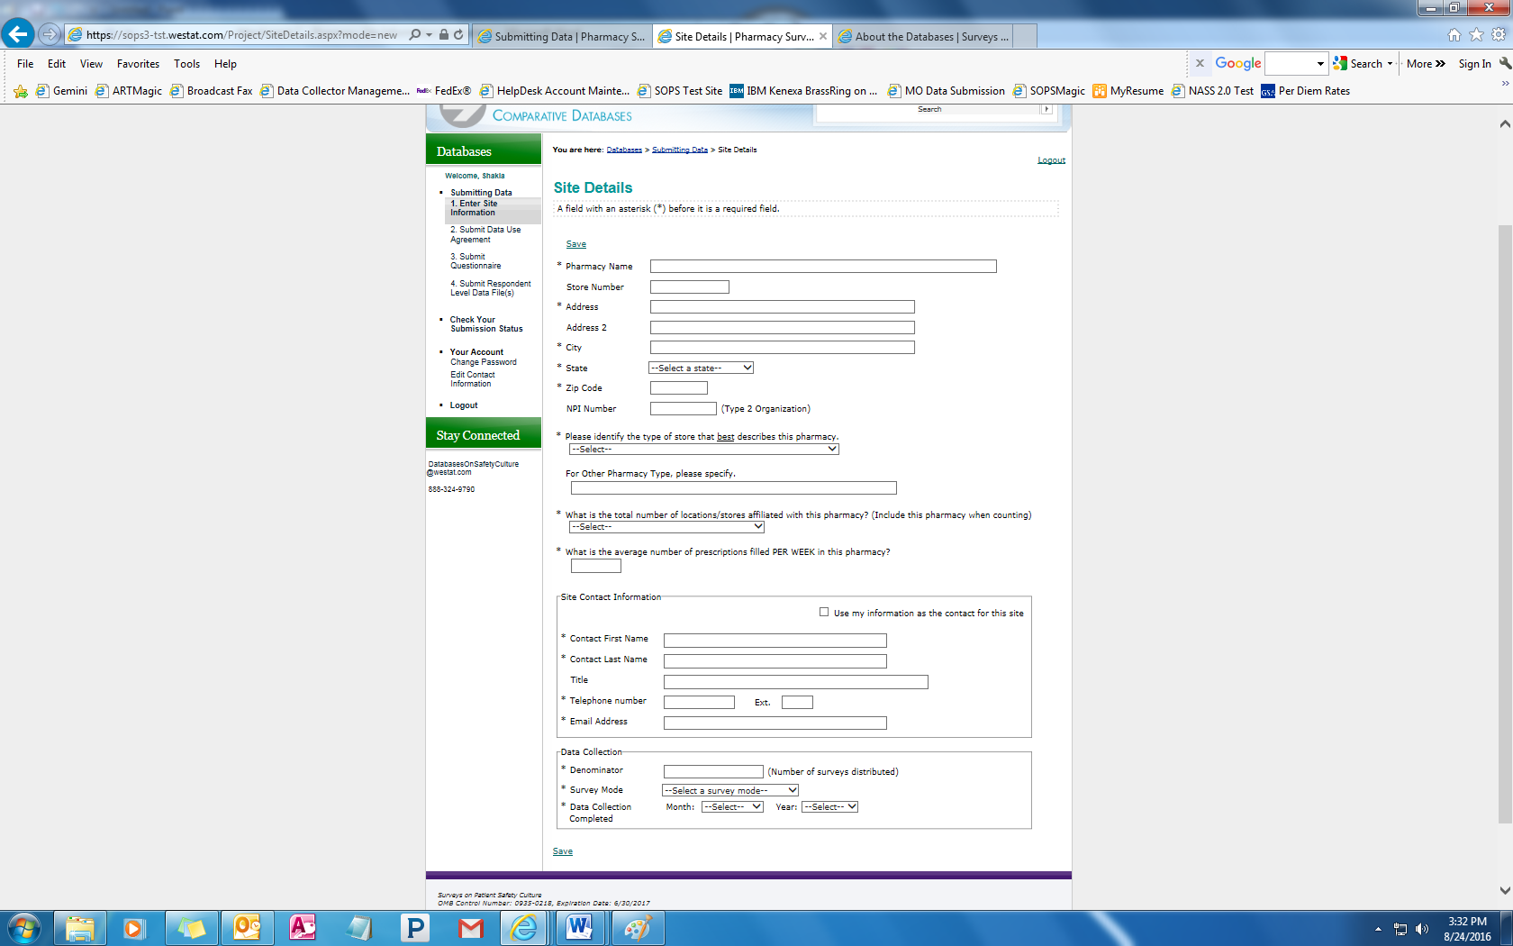
Public reporting burden for this collection of information is estimated to average 3 minutes per response, the estimated time required to complete the survey. An agency may not conduct or sponsor, and a person is not required to respond to, a collection of information unless it displays a currently valid OMB control number. Send comments regarding this burden estimate or any other aspect of this collection of information, including suggestions for reducing this burden, to: AHRQ Reports Clearance Officer Attention: PRA, Paperwork Reduction Project (0935-XXXX) AHRQ, 5600 Fishers Lane, Rockville, MD 20857.

Dropdown options for type of store:
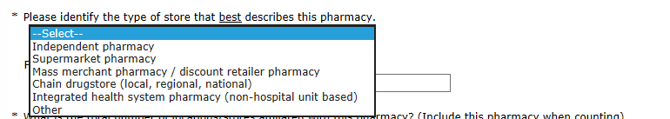
Number of locations/stores:
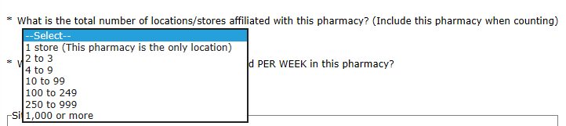
Survey mode:
