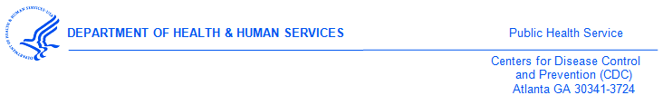
DATE

<<Medical Provider>>
<<Street1>>
<<Street2>>
<<city>><<state>><<zip>>

Dear Dr. <<Medical Provider>>,

A few weeks ago, we mailed the 2017 National Survey of Medical Providers to your practice.
If you have completed the survey, thank you!
If you have not yet completed the survey, we are asking that you do so now. Your medical practice has been randomly selected to participate, and it’s important that we have responses from those that have been selected. Your survey data will help represent almost 814,000 medical providers in the United States. Not responding can decrease the accuracy of our research.
Please complete the enclosed questionnaire and return it in the envelope provided.
The survey should take about 20 minutes to complete. Once we receive your completed survey, we will send $40 as a token of appreciation for your participation in this important research.
Participation in the survey is voluntary. If you have any questions, please contact ICF, the independent health research firm hired to conduct this study. They can be reached toll-free at 1-###-###-#### or via email at [survey name]@icfsurveysupport.com.
Survey responses will be kept private and only aggregate data will be reported.
Thank you in advance for your help in this important research study. It is only with the generous help of medical professionals like you that our research can be successful. By responding, you will help us increase the accuracy of the survey.

Sincerely,

Gail Bolan, MD
Director of Division of STD Prevention,
Centers for Disease Control & Prevention
1600 Clifton Road NE, Mailstop E-02
Atlanta, GA 30329-4027

