

General Fund Enterprise business system

Army GFEBS Supplier Self-Services (SUS)
ASA(FM&C) DASA-FIM
26 Jun 2013
v1

ASA (FM&C)
CBA Prepared by: Roger Pillar, PM Director GFEBS
Cost Data Prepared by: Pat Riley, Richard Scatamacchia, Lynda Brown, Sandra Beeker
Organization: ASA(FM&C) DASA-FIM
Phone: 703-545-8855
Email: roger.a.pillar.civ@mail.mil

Table of Contents

Army Supplier Self-Services (SUS) 1
1 Problem Statement, Objective and Scope 5
1.1 Background 5
1.2 Problem / Opportunity Statement 9
1.3 Objective/ Goal 9
1.4 Scope 10
2 Facts, Assumptions and Constraints 10
2.1 Facts 10
2.2 Assumptions 11
2.3 Constraints 12
2.4 Courses of Action 12
3 Develop Cost Estimates 13
3.1 Cost Analysis 13
3.1.1 Cost Drivers and Factors 14
3.1.2 Constant Dollar Extrapolation over Period of Analysis 14
3.1.3 Potential Budget Impact 14
4 Quantifiable and Non-Quantifiable Benefits 16
4.1 Quantifiable Benefits 16
4.1.1 Reduced cost for invoice manual processing 16
4.1.2 Reduced PPA interest paid 16
4.2 Non-Quantifiable Benefits 16
4.2.1 Productivity improvements with SUS FOC include: 16
4.2.2 SUS is integrated with the Army’s ERP to support auditability 16
4.2.3 SUS interface to GFEBS ECC is maintained by SAP 16
5 Alternative Selection Criteria 17
6 Comparison of Alternatives 18
6.1 Costs and Benefits Comparison 18
6.1.1 Comparison of All Alternatives 18
6.2 Bill payers, Offsets or Tradeoffs 18
6.3 Second and Third Order Effects 18
6.3.1 Potential Second Order Effect 18
6.3.2 Potential Third Order Effect 19
6.4 Sensitivity Analysis and Risk Assessment 19
6.4.1 Sensitivity Analysis 19
6.4.2 Risk Assessment 20
6.5 Conclusion 21
6.5.1 Results of Analysis 21
6.5.2 Value Proposition 21
7 Recommendation 22
8 Appendix A - Supporting Documentation 23

Executive Summary

The Army General Funds Enterprise System (GFEBS) piloted a SAP Procure-to-Pay (P2P) component called Supplier Self-Services (SUS) to determine the software capability within a Department of Defense (DoD) implemented Enterprise Resource Planning (ERP) system. The goal was to try to eliminate invoice interface errors by using the integrated ERP functionality and maximizing the investment the Army has made. SUS is the vendor portal component of the Army’s P2P pilot accessible through WAWF, the DoD mandated single point of entry for electronic invoicing. SUS is designed and maintained by SAP to be tightly integrated with the GFEBS (SAP backend) to pre-populate, pre-validate and provide near real-time invoice status to the vendor. The pilot is limited to nine (9) vendors due to the Paperwork Reduction Act (PRA), but demonstrated the vendor invoice entry in SUS posts error-free to GFEBS without manual intervention over 93% of the time. Additionally, survey results from vendors, contracting and resource management offices all strongly support expansion of SUS. DFAS stated additional volume is needed to fully evaluate and access to view the original invoice data is required based on Certifying Officer Legislation (COL).

The pilot team, with completion of the initial pilot, identified four (4) courses of action (COAs): COA 1 to fully implement immediately; COA 2 to fully implement, incrementally with decision points to continue; COA 3 status quo, to continue as a pilot with only 9 vendors indefinitely; and COA 4 to shut down the pilot and use only WAWF for vendors to enter invoice data. COAs 1 and 3 are not considered in the analysis of costs, benefits and risks. COA 1 is not recommended without additional data. COA 3 is not recommended since the benefit is minimal for only 9 vendors.

To evaluate the most feasible option, we completed a Cost Benefit Analysis (CBA). The findings of the CBA is that SUS implemented in increments (COA 2) will save both manual processing costs paid to Defense Finance and Accounting Services (DFAS) and interest penalties paid to the vendors over FY 13-27, but it will require investment. COA 2 estimates the current 40% DFAS manual processing rate to provide a net present value (NPV) savings of $115M with a NPV investment of $8.9M which includes the recurring $1M (BY13) hardware refreshes. COA 2 savings are expected by FY16 and Full Operational Capability (FOC) planned by end of FY19.

The recommendation is to proceed with COA 2 and fully implement SUS incrementally with checkpoints at defined increments to validate the expected benefits and required enhancements are in place for the next increment to FOC. OMB agreement that SUS can be seen as less than a substantive or material modification to the WAWF invoice data collection process or a new Office of Management and Budget (OMB) case in reference to the PRA is required for the pilot to expand beyond 9 vendors. COA 2 total estimated lifecycle cost is $319 million (current BY13 dollars), which is calculated from 4th Qtr 2013 thru FY 2027.

Problem Statement, Objective and Scope

Background
The Supplier Self Service (SUS) component of the Army’s Procure-to-Pay (P2P) pilot is a SAP commercial off-the-shelf (COTS) product accessible through Wide Area Work Flow (WAWF) that provides vendors an easy to use web-based access to submit shipment, service and invoice information linked to their awarded contracts. SUS is integrated with the SAP Enterprise Central Component (ECC) used by General Fund Enterprise Business System (GFEBS). SUS capabilities developed may also be applied to other Army and DoD SAP based Enterprise Resource Planning (ERP) systems. SUS seeks to improve ERP performance working with WAWF—vendors continue to utilize WAWF user interface (UI) as a single point of entry and for viewing historical records, but are routed seamlessly to the ERP portal for SUS upon entering of the contract number and Pay Office DoDAAC via the Department of Defense (DoD) developed integration for ERP portals called “OneStop”. The following high level architecture depicts the technical components:
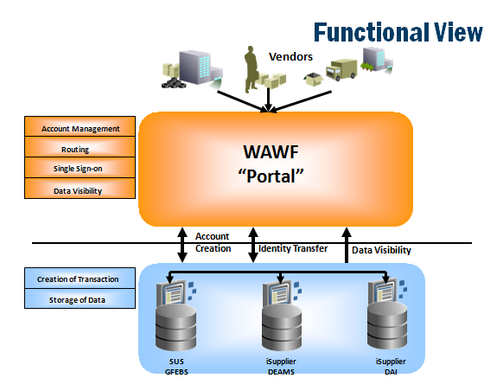

”OneStop”

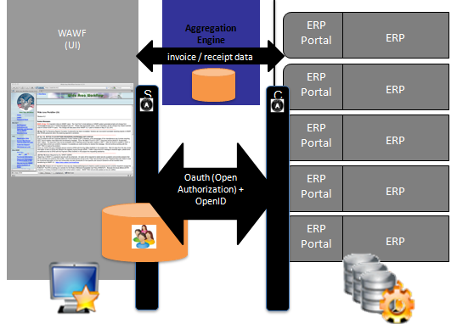
”OneStop”
Two (2) P2P Pilots were approved by the Defense Business System Management Committee (DBSMC) in 2009 to investigate end-to-end functionality of the ERPs with minimal interfaces. Defense Agency Initiative (DAI) tested Oracle capabilities and Army GFEBS tested SAP. The objective was to utilize the ERP standard functionality to validate Army business processes for installation support contracts which represented the greatest volume of transactions. The proof-of-concept sandbox solution without interfaces was demonstrated in June 2010 with an Army leadership decision to implement two of the three components in the Production environment for six month evaluation beginning first quarter 2013.

During the configuration and design of the proof-of-concept, other possible solutions were discussed to address the WAWF invoice document high failure rate to post in GFEBS. Options investigated but determined not feasible included:

- Use similar logic as Navy ERP project built for WAWF interface developed in the 2004-2005 timeframe that rejects incorrect data back to the vendor in WAWF. Determined not feasible due to differences in ERP configuration, significant cost for complete re-write of existing WAWF-to-GFEBS interfaces and ongoing maintenance.
- Populate in WAWF data from GFEBS for the vendor to use instead of data from Electronic Data Access (EDA). EDA does not contain the conformed contract and units of measure differ from GFEBS. Discussion with Defense Procurement Acquisition Policy (DPAP) representatives stated GFEBS data does not represent the contract award and would not agree. Concerns were made that the vendor might be prevented from entering an invoice and GFEBS data may be incorrect.
- Use the Oracle vendor portal (iSupplier) that DAI implemented and piloted for Business Transformation Agency (BTA). SAP and Oracle ERPs are similar, but custom interfaces to integrate would still be required, thus no advantage.
- Develop a custom vendor portal linked to WAWF and GFEBS ECC. Any non-SAP solution will require complex interface logic that must be maintained by the Army.

SUS is currently being piloted in GFEBS production with a pool of nine (9) vendors since October 2012. The pilot is limited to nine (9) vendors due to the Paper Work Reduction Act (PRA). Pilot results show the ability to process payments for invoices and supporting data entered in SUS that posts error-free to the ERP without manual intervention over 93% of the time. Pre-populated conformed contract data is provided to the vendor to initially acknowledge or confirm posted correctly in GFEBS, or request correction prior to time to invoice. Open quantity available and near real time invoice status is standard SUS functionality. The pilot survey results from vendors, contracting and resource management offices are all strongly supporting continuation of the pilot. DFAS provided mixed support of the SUS pilot, due to limited view access of the original invoice data, which they state is required to meet the Certifying Officer Legislation (COL).

SUS process overview:
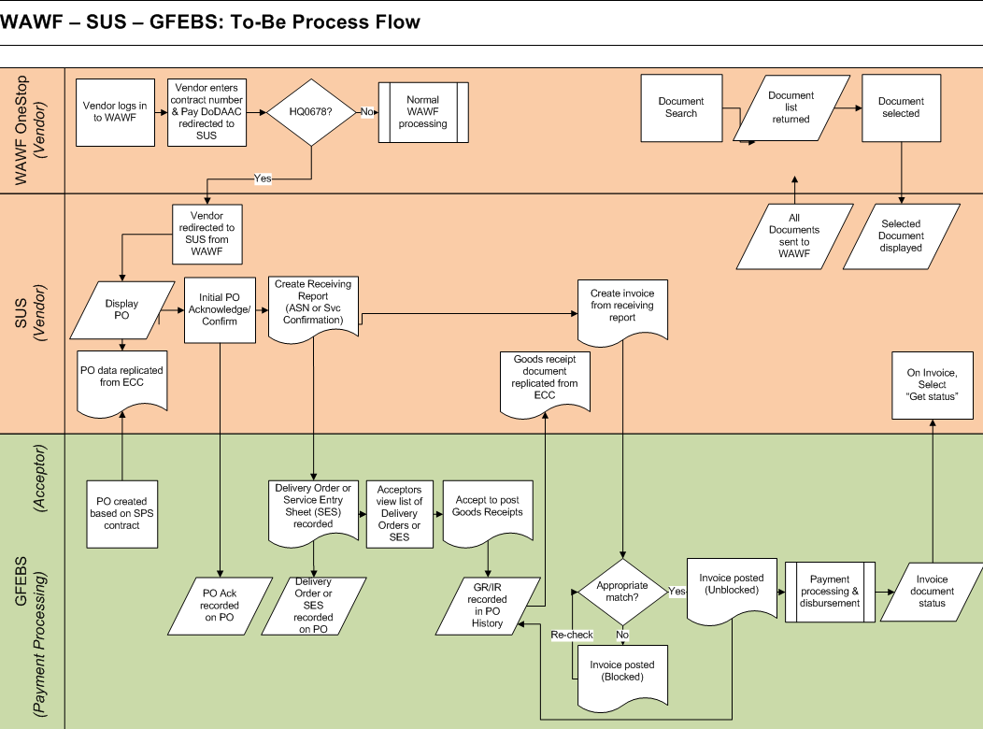

Vendors access SUS by first logging onto WAWF as they do today. Upon entering the contract number and the SUS pay office DoDAAC, they are authenticated and signed into SUS with a single sign-on. An aggregation engine pulls ERP portal summary data to WAWF.

Once in SUS the vendor can review, acknowledge, or reject, the data from GFEBS matches their awarded contract. If the data in GFEBS is incorrect, SUS highlights the error early in the process to allow the vendor to notify the Contracting Officer (KO) who will work with their Resource Manager (RM) to correct the GFEBS data. In today’s environment, the incorrect data from SPS to GFEBS is often not identified until a vendor invoice fails to post and requires costly manual intervention.

In SUS, the vendor has all contract information (PIIN, SPIIN, CLIN, SLIN, ACRN), product number (if applicable), item description, quantity ordered, unit of measure, item value, and requested delivery date or period of performance pre-populated. Additionally the GFEBS purchase order (PO) information is available to the vendor for any questions on how the contract lines match to PO lines.

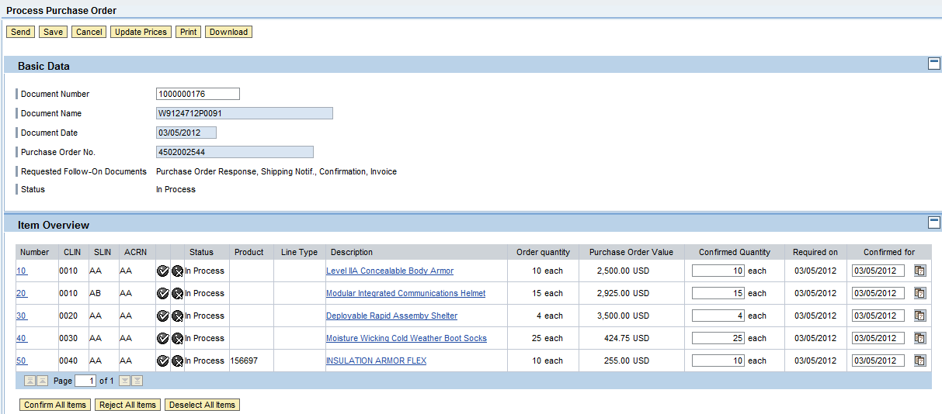

When ready to ship ordered material, or invoice for services or supplies, the vendor does not have to select from a long list of various document types as in WAWF. Supply-type purchases or quantity-based contracts allow the vendor to create a standard Advance Ship Notification (ASN) that specifies the quantity shipped or provided, and similar to the WAWF receiving report (RR). Service-type purchases or value-based contracts allow the vendor to create a standard Confirmation that specifies the service provided or amount invoiced. Easy to use buttons such as “Create ASN”, “Create Confirmation” or “Create Invoice” provide pre-populated, pre-validated data that the vendor needs to update the shipped quantity or amount per line to submit. Additionally, near real-time updates provide open values so the vendor can see the remaining open amount. The contract information and UoM cannot be changed by the vendor so the possibility of an error is significantly reduced.

All documents submitted by the vendor in SUS are linked to the GFEBS PO. Acceptance of the delivery of the supply or service is posted in GFEBS with standard SAP transaction codes. The PO quantity and price, the accepted quantity and the invoiced quantity and price are all linked together to further reduce chance of error. The vendor is provided near real-time information on the acceptance and invoice status along with disbursement clearing information specifying the Electronic Funds Transfer (EFT) trace number.

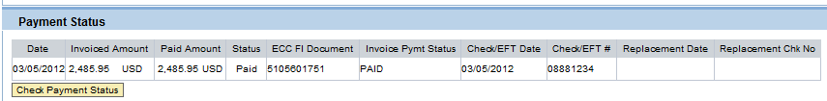

SUS requires the same pieces of invoice information (quantity, value, contract number, etc.) as does WAWF. There are no new elements of information resulting from the use of SUS. In SUS, data is pre-populated and pre-validated from GFEBS PO so in most instances the only entry required by the vendor is invoiced quantity or amount by contract line and vendor invoice number. A WAWF aggregation engine pulls required information from SUS and posts that information in WAWF for the vendor. The vendor does not have to do dual entry in both WAWF and SUS.

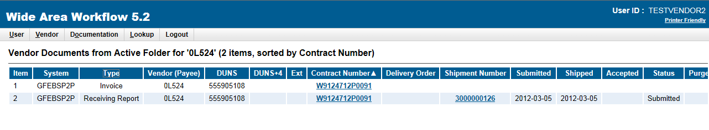
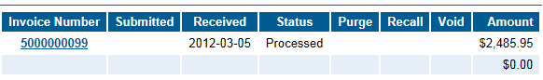

Problem / Opportunity Statement
SUS seeks to improve ERP performance while working with WAWF via OneStop. The WAWF interface to GFEBS consistently experiences approximately a 40% failure rate requiring invoices to be manually posted in GFEBS to correct errors. The failure rate is attributable to either EDA does not provide conformed contract information or GFEBS PO data does not match contract data, and data input to WAWF by vendors is not validated (vendors can change populated data or enter incorrect data). Similarly, acceptance in WAWF does not provide data validation with the awarded contract or open obligated amount. Examples of errors in posting invoices to GFEBS continue to be missing contract information, incorrect contract information, incorrect unit of measure (UoM) or no available open funds amount.

If SUS pilot results are typical, SUS will provide less than a 7% failure, significantly reducing the manual invoice processing as well as interest paid for the majority of GFEBS WAWF invoices.

Objective/ Goal

The Army would like to reduce the current manual effort required by DFAS to process vendor electronic submitted invoices, to reduce interest paid and to reduce costs associated with complex custom ERP interfaces required to communicate with WAWF.

The recommendation is to continue the SUS and incrementally increase vendors to 30, 100 and 500. A check point after each increment will verify expected benefits and required enhancements are in place before full operation capability (FOC) decision is made to continue to increase to 5k, 10k, 15k and 18k or approximately 90% of all vendors submitting invoices to GFEBS via WAWF.

SUS benefits the majority of invoices that do not require custom fields for DoD specific data such as petroleum products by tanker or barge, coal, ammunition, etc. It is estimated ~10% or 2k vendor contracts will remain invoiced in WAWF due to their unique requirements.

Scope
GFEBS is fully deployed to all Army installations using general funds with the exception of Sensitive Agencies (SA). Full SUS deployment targeted by fiscal year (FY) end 2019 would encompass approximately 90% of all current ~20,000 vendors who submit electronic invoices through WAWF to GFEBS.

Facts, Assumptions and Constraints

Facts
- Based on most recent 12 months, only ~60% of ~20,000 WAWF invoice IDOCs per month post without manual intervention to GFEBS, resulting in 40% failure rate
- SUS does not require vendor(s) to obtain SAP license(s)
- Pilot results:
  - ~93% of SUS pilot data posted to GFEBS without manual intervention, resulting in 7% failure rate
  - No interest payments
  - Invoices paid on average within 9 days
    - 8 of 9 vendor contracts were designated 8A (Small business) to allow accelerated payment
  - Ft Jackson Contracting Office stated estimated 5-7 hours per week saved addressing vendor invoice questions and concerns
    - Continued support for correct contract data obligated in GFEBS is required
  - Survey results:
    - 6 of 7 vendors who responded to the anonymous survey strongly supported continuing the SUS pilot
    - 2 of 2 installation resource managers and contracting officers strongly supported continuing the SUS pilot
    - DFAS had mixed reviews with stated concerns on the inability to view the original invoice data required for the Certifying Officer Legislation (COL)
  - Required enhancements were identified for SUS scalability and the PMO provided ROM estimates^{3,}
  - Identified required enhancements by WAWF for SUS scalability
    - Delta document pull instead of all documents
    - Gov’t view only folder updated with SUS document data

Assumptions
- Pilot 7% manual intervention rate for SUS invoice IDOCs will remain with increased number of vendors
- Current GFEBS invoice IDOCs from WAWF average of 20,000 per month will not significantly change
- Average ~2.5 LOAs per WAWF invoice IDOC
- SUS invoices estimated to average one per vendor per month
- Fully implemented SUS solution has minimum 15 year life cycle with 5 year hardware refreshes
- Incremental increase to 30, 100, 500, 5k, 10k, 15k and FOC by 2019 is achievable
  - Increase will be by new contracts or new delivery order/task order (DO/TO) that generates a new PO in GFEBS
- The new Army contract writing system will have no impact on SUS
  - If SAP Procurement for Public Sector (PPS) is selected as the system, additional cost savings could be achieved for hardware and sustainment
- SAP will continue to support and enhance SUS
- New GFEBS licenses are required for approximately 10K new “acceptors” to access GFEBS.
- Additional hardware will be required every 5 years at approximately the same cost
- Required enhancements by WAWF for SUS scalability will be completed
  - Delta document pull instead of all documents
  - Gov’t view only folder updated with SUS document data
- WAWF enhancement cost estimate based on conversation with DASA-CE estimating average DoD system enhancements no less than a $1 million per change
- Estimated 10% vendor contracts have complex clauses for invoice requirements requiring DoD specified data that is already available in WAWF will continue to be entered in WAWF and not transitioned to SUS
  - Complex contracts currently administered and/or entitled in MOCAS (Mechanization of Contract Administration Services) system will have a separate Pay Office DoDAAC and not be sent for entitlement to GFEBS, so 10% of current GFEBS invoices to remain in WAWF may be a high estimate
- Additional functional Subject Matter Experts (SME) are required to develop requirements, work with PMO, review test results of enhancements, coordinate change management and provide Tier 2 vendor support
- Online training links, recorded training sessions, and the WAWF Helpdesk will provide basic Tier 1 support to vendors
- Acceptor Tier 1 and Tier 2 support will continue to be provided by the command
- Interim Authorization to Test (IATT) certificate renewal will be continue to be approved in 4 month increments
- Authority for FOC will be approved after 500 vendor increment

Constraints
- Availability of funding for hardware and enhancements
- DPAP support of ERP vendor portals with WAWF
- OMB agreement that SUS can be seen as less than a substantive or material modification to the WAWF invoice data collection process so the pilot can expand beyond nine (9) vendors in reference to the PRA
- WAWF continued support of OneStop communication with ERP vendor portals
- WAWF implementation of two enhancements
  - Delta data pull instead of all SUS document
  - Gov’t view only folder populated with SUS data

Alternatives

Courses of Action
- COA 1 – Fully implement SUS for GFEBS immediately
- COA 2 – Fully implement SUS for GFEBS, incrementally with decision points to continue
- COA 3 – Status quo, continue SUS pilot program with only 9 vendors indefinitely
- COA 4 – Shut down the SUS pilot and only use WAWF for vendor invoicing

- COA 1 (Fully implement SUS immediately)
  - Not feasible due to:
  - Big bang approach for 18,000 – 20,000 vendors
  - Limited pilot data is not sufficient to recommend FOC
  - Known enhancements cannot be completed quickly
  - Funding
- COA 2 (Fully implement SUS, incrementally with decision points)
  - Increase participating contractors incrementally while enhancing functionality
  - Check points at 30, 100 and 500 increments before decision to fully implement

- COA 3 (Status quo - continue SUS pilot with 9 vendors)
  - Senior Leadership deemed inadequate option due to minimal data
  - No requirement for Paperwork Reduction Act (PRA)
  - Not feasible even though opportunity to continue to learn more:
  - Limited pilot data will never be sufficient to recommend FOC
  - Sustainment cost far exceeds minimal cost savings for only 9 of 20,000 vendors
- COA 4 (Shut down pilot and only use WAWF)
  - Convert existing 9 SUS pilot contracts back to WAWF
  - Army loses investment
  - Expect continued DFAS manual processing 40% of WAWF failed invoices
  - Expect continued ERP interface sustainment costs

COAs 1 and 3 are not considered in the analysis of costs, benefits and risks. COA 1 is not feasible due to limited pilot data and funding. COA 3 is not recommended since the benefit is minimal for only 9 vendors.

Develop Cost Estimates

Cost Analysis
Cost data is calculated from:
- DFAS provided processing rates for electronic versus manual invoices based on FY15 cost to process manual invoices (~$98 per line of accounting (LOA)) compared to electronic (~$13 per LOA)
- PMO provided ROM for enhancements, hardware and sustainment and current interest payments
- Analysis over a 15 year period using net present value (NPV) calculation with the mid-point of 2.35% from the OMB A94 circular rate for 10 year and 20 year analysis
- Average lines per PO (Purchase Order) is 3.5
- FY 2013 calculations are prorated for 4th quarter only using DFAS FY 2014 costs
- Prompt Payment Act (PPA) interest required for late invoice payments occurred on 15% of all document types for WAWF invoices (R4, R6, RE) during April 2013
  - Average interest payment per invoice was ~$127
  - Highest cost range from PMO ROM selected for cost analysis
- Assume DFAS manual vs. EC (electronic) invoice processing cost will remain the same as FY15 and include support services such as customer service, but accounting is billed hourly
- SUS invoices posted without manual intervention will be billed by DFAS at the electronic rate of ~$13 per LOA per discussion with DFAS
  - Manually created POs posted by Army personnel due to failed IDOCs from the Army contract writing system will not make all follow-on documents classified as manual
- Interest payments for WAWF invoice document types (R4, R6, RE) will be reduced approximately 50% with SUS invoices posting correctly matched
- Contracting office saved hours conservatively calculated based on 5 hours/week per 50 SUS vendors for cost avoidance

Cost Drivers and Factors
- Number of vendors using SUS
- Number of invoice IDOCs
- Number of LOAs per invoice
  - Number manually processed invoices
  - Number electronically processed invoices
- DFAS cost per invoice LOA
- Development costs of enhancements
- Sustainment costs
  - Number of FTEs
- Hardware costs

Constant Dollar Extrapolation over Period of Analysis
Costs savings per year in BY13$M and NPV comparison:

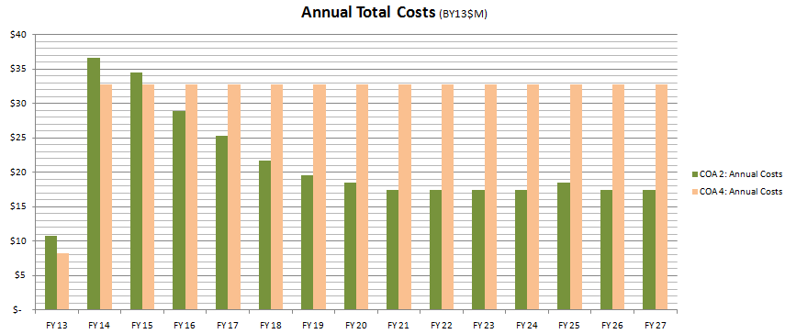

Potential Budget Impact
COA 2
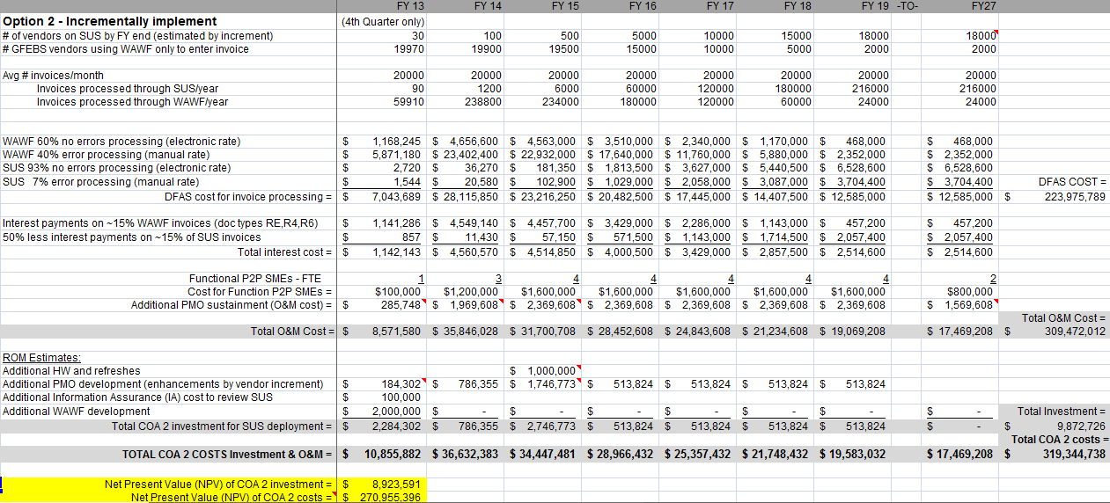

COA 4
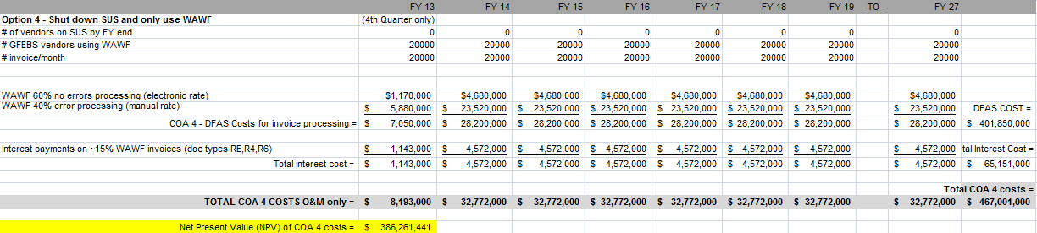

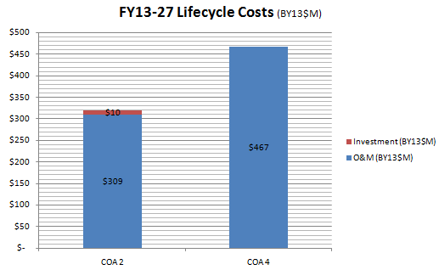

Quantifiable and Non-Quantifiable Benefits

Quantifiable Benefits

Reduced cost for invoice manual processing
- SUS will increase the percentage of electronic invoice posting from ~60% to ~93% based on pilot results
- DFAS FY14 costs for GFEBS invoice processing is:
  - $98 per LOA for manual processing
  - $13 per LOA for electronic processing

Reduced PPA interest paid
- Estimated 50% reduction in average interest paid for WAWF type invoices (doc types R4, R6 and RE)
  - SUS invoice posts in GFEBS without error
  - Acceptance (goods receipt) is posted in GFEBS referencing invoice instead of interfaced from WAWF
  - 3-way match for payment certification typically available on day 1 of invoice submission

Non-Quantifiable Benefits

Productivity improvements with SUS FOC include:
- Contracting office should receive fewer calls for issues with payments
  - Ft Jackson Contracting estimated 5-7 hours per week for the 9 pilot vendors
- DFAS customer service should receive fewer calls for issues with payments since near real-time invoice status is available in SUS
- Vendor has better usability
  - SUS web design is user friendly
  - Pre-populated conformed contract data (original award plus all modifications) is provided in SUS from GFEBS
  - SUS pre-validates data prior to invoice submission
  - Calculated open quantity per line item is provided
  - Near-real time invoice status available

SUS is integrated with the Army’s ERP to support auditability

SUS interface to GFEBS ECC is maintained by SAP

Alternative Selection Criteria

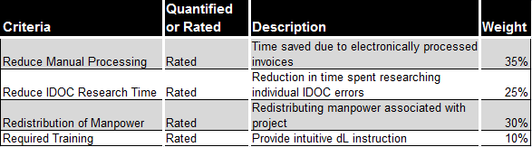

Reduce Manual Processing: Implementation of SUS will lead to a reduction in number of invoices processed manually. This was given a weight of 35% due to the large effect it will have on time spent with each invoice along with money saved due to cheaper cost to process invoices electronically as opposed to manually.

Reduce IDOC Research Time: SUS will allow submitters to correct their own IDOC errors thus alleviating time and stress for government resources. A weight of 25% was selected because IDOC research is a timely process that can often encompasses multiple people. Reducing that time will allow employees to focus on more vendor issues and increase customer service.

Redistribution of Manpower: For the purposes of this CBA reducing manpower refers to the number of people currently associated with DFAS assisting with WAWF and the future reduction of resources as SUS expands. 30% weight was selected as this important factor will allow resources to be redistributed to other projects by leadership.

Required Training: Training associated with implementation of SUS system (i.e. CBTs, DCOs, etc.). A weight of 10% was decided upon since training will be minimally invasive for new users, as system is user friendly.

Comparison of Alternatives

Costs and Benefits Comparison
Financial data calculated using net present value, where the lower cost is the preferred option (lower cost benefit index is preferred).

Comparison of All Alternatives

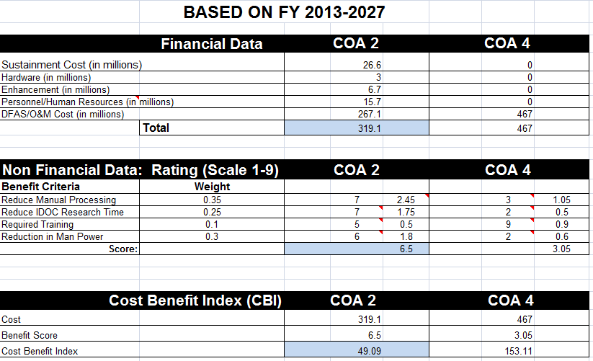

Bill payers, Offsets or Tradeoffs
- Bill payer:
  - US Army is currently paying DFAS bill.
  - FY14-FY15: TBD
  - FY16-FY27: Self funding with savings from DFAS

Second and Third Order Effects

Potential Second Order Effect
- Workforce
  - Reduce Goods Receipt processor and Invoice processor for manually processed documents
  - Increase functional FTEs for enhancements and deployment
- Network
  - Additional users on network could impact processing time
- Business processes
  - Changes in staffing, operations and support

Potential Third Order Effect
- Training
  - Training for vendors, acceptors and customer service organizations will have to be developed and planned
- Business Processes
  - Acceptors will only post goods receipt in GFEBS.

Sensitivity Analysis and Risk Assessment

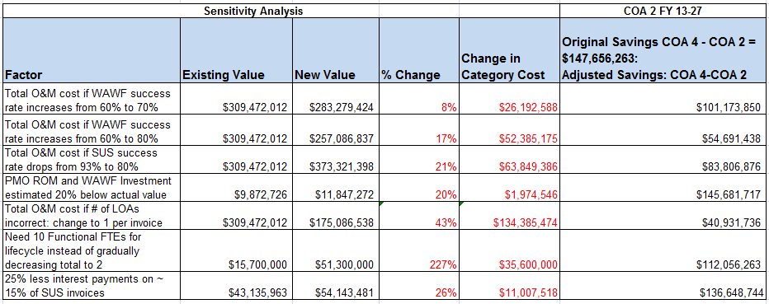

Sensitivity Analysis
- WAWF success rate increase from 60% to 70%
  - Improved WAWF invoice success rate would cause total O&M cost to decrease by 10% for COA 2, which results in a total lifecycle savings decrease to $101 million

- WAWF success rate increase from 60% to 80%
  - Additional improved WAWF invoice success rate would cause total O&M cost to decrease by 20% for COA 2, and lifecycle savings to $55 million

- SUS electronic success is only 80% instead of 93%
  - Decreasing SUS success rate to only 80% will reduce total savings to $84 million

- PMO ROM investment s estimated 20% below actual value
  - If the PMO ROM deployment investment estimate is 20% below actual value it will produce a new total savings of $146 million

- # of LOAs per invoice is incorrect – change to 1
  - If DFAS only charges a processing fee per invoice as opposed to per LOA it will cause COA 2 savings to decrease to $41 million over its lifecycle

- Need 10 functional FTEs instead of 4
  - Should 10 functional FTEs be needed to support SUS instead of 4 COA 2 total savings will drop to $112 million over its lifecycle

- 25% less interest payments instead of 50%
  - If SUS only reduces interest payments by 25% as opposed to 50% the total savings for COA 2 decreases to $137 million

Risk Assessment
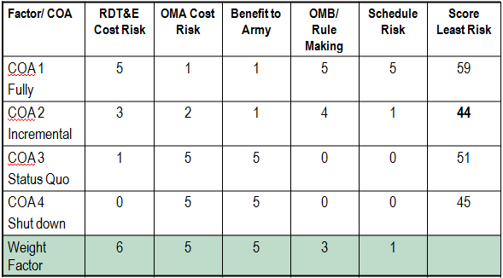

Additional noted risks:
- Enhancement ROMs may be wrong
- The cost to maintain/sustain the system (hardware, SUS, WAWF) could go up
- SUS error rate could go up
- WAWF could not accept SUS' enhancements (Gov't View Folder and Delta Pull)
- WAWF could accept SUS' enhancement, but the cost could be too expensive to implement
- PO obligation in GFEBS requirement may require additional resources to support
- Training information provided to suppliers and acceptors may not be sufficient
- Incremental increase (i.e., 5k vendors per year) may be too aggressive
- DFAS - reducing workforce could be a political challenge
- Training requirement for vendors and acceptors could spike if DCO is not sufficient
- Vendors may push back and not accept new invoice entry via SUS, i.e., change management issue
- Paperwork Reduction Act - could require GFEBS to staff, which would slow down momentum or PRA could disapprove waiver
- GFEBS/SUS attachment functionality cost too much or SAP has no solution, which would restrict the vendor from attaching any document
DPAP:
- May not support changes to DFARS to allow use of an ERP portal
- PO obligation in GFEBS requirement prior to invoice may not be supported
- Estimate to keep ~10% contract with special invoicing requirements in WAWF may not be accepted requiring significant additional enhancements

Conclusion

Results of Analysis
The scope of the CBA for Army SUS is to analyze costs savings over a 15 year period for 90% of current GFEBS invoices interfaced from WAWF. Four courses of action (COAs) / alternatives were defined: COA 1 to fully implement immediately; COA 2 to fully implement, incrementally with decision points to continue; COA 3 status quo - to continue pilot with only 9 vendors indefinitely; and COA 4 to shut down the pilot and use only WAWF for vendors to enter invoice data.

COAs 1 and 3 are not considered in the analysis of costs, benefits and risks. COA 1, a “big bang” approach, is not in accordance with OMB guidance to implement technology solutions in manageable, measurable increments. COA 3 to continue the pilot with only 9 vendors will not provide substantive data for the Army to determine if SUS benefits can be realized and the cost to support the pilot will outweigh the small cost savings for less than 1 percent of total vendors submitting invoices.

Value Proposition
The findings of the CBA are that SUS implemented in increments (COA 2) will save both manual processing costs paid to DFAS and interest penalties paid to the vendors over FY 13-27, but it requires investment for known enhancements and sustainment. COA 2 with the estimated current 40% WAWF invoice failure rate provides net present value (NPV) savings of $115M with a NPV investment of $8.9M which includes a recurring $1M (BY13) hardware refreshes. COA 2 savings are expected by FY16 with payback period within 1 year after FOC by end of FY19.

Since DFAS LOA estimates and pricing were just developed May 2013, manual billing for failed WAWF IDOCs may range between 20% and 40%. If failed WAWF invoice IDOCs can be reprocessed systematically after Army personnel either enter or correct the PO obligation, the need to post manually may be lower. Sensitivity analysis still shows NPV savings of $42M for 20% manual rate and $79M for 30% manual rate. If 20% or 30% manual rates are realized, 4-8 years are needed for payback.

Recommendation
The recommendation from the findings of the CBA is to proceed with COA 2 to implement SUS for GFEBS incrementally with decision points to continue. Decision points at defined increments will validate both the expected benefits and the required enhancements are in place for the next increment to FOC. OMB agreement that SUS can be seen as less than a substantive or material modification to the WAWF invoice data collection process or a new OMB case in reference to the PRA is required for the pilot to expand beyond 9 vendors.

Appendix A - Supporting Documentation
- DFAS eSolutions Update - March 2013 data.ppt
- ARMY Rate Brief PBR15 - 2013-05-13 Rates Final – May 2013, slide 13 shows rates
- SUS Scalability ROM DECK_May 2013_FINAL.ppt – May 2013, slide 139 shows ~3.5 PO lines per PO
- April 2013 Payment Settlement.xls
- SUS Way Forward Decision Brief – 23 May 2013 final.ppt
- SUS Scalability ROM DECK_FINAL_v2_Pricing Addendum.ppt prepared by PMO Jun 2013
- Portal-OneStop-req_WAWFv4.doc – prepared by BTA Nov 2010
- Reference: Discussion with GFEBS COR (25 Jun 2013)
- DFARS Appendix F for petroleum, coal, ammunition, etc. http://www.acq.osd.mil/dpap/dars/dfars/html/current/appendix_f.htm
- SUS_Materials_and_Supplies_print screens.ppt – Oct 2012
- OMB A94 circular rates from http://www.whitehouse.gov/omb/circulars_a094/a94_appx-c
- SUS estimates FOC v9.xls

Reference: Portal-OneStop-req_WAWFv4.doc – prepared by BTA Nov 2010
Discussions with Navy ERP estimated ~$8M investment to provide ~80% success rate.
Reference: DFAS eSolutions Update - March 2013 data.ppt
Reference: SUS Way Forward Decision Brief – 23 May 2013 final.ppt
Reference: SUS Scalability ROM DECK_FINAL_v2_Pricing Addendum.ppt prepared by PMO Jun 2013
Reference: Discussion with GFEBS COR (25 Jun 2013)
Reference: DFARS Appendix F http://www.acq.osd.mil/dpap/dars/dfars/html/current/appendix_f.htm
Reference: SUS_Materials_and_Supplies_print screens.ppt – Oct 2012
Reference: ARMY Rate Brief PBR15 - 2013-05-13 Rates Final – May 2013, slide 13 shows rates
OMB A94 circular rates from http://www.whitehouse.gov/omb/circulars_a094/a94_appx-c
Reference: SUS Scalability ROM DECK_May 2013_FINAL.ppt – May 2013, slide 139 shows statistics
Reference: April 2013 Payment Settlement.xls

