APPENDIX I.1: THANK YOU NOTE - ENGLISH

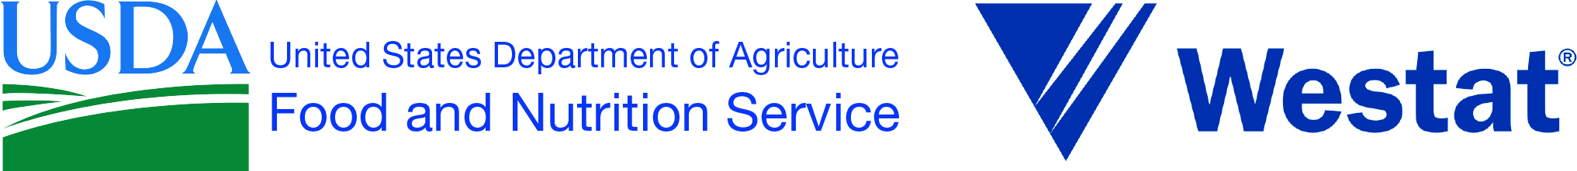 OMB Number: XXXX-XXXX
Expiration Date: XX/XX/20XX

{Date}
Dear {NAME}:
Thank you for completing the USDA “Food and Your Household Survey.” Your answers will help us understand where people shop, what they buy and eat, and how this affects a healthy diet. Enclosed is $20 for completing the survey.
If you have any questions, please feel free to call the toll-free help line at 1-xxx-xxx-xxxx.
Sincerely,

Rosemarie Downer, Ph.D. Maeve Gearing, Ph.D.
Project Officer Project Director
Food and Nutrition Service Westat
US Department of Agriculture

According to the Paperwork Reduction Act of 1995, an agency may not conduct or sponsor, and a person is not required to respond to, a collection of information unless it displays a valid OMB control number. The valid OMB control number for this information collection is XXXX-XXXX. The time required to complete this information collection is estimated to average .5 minutes per response, including the time for reviewing instructions, searching existing data resources, gathering and maintaining the data needed, and completing and reviewing the collection of information.
According to the Paperwork Reduction Act of 1995, no persons are required to respond to a collection of information unless it displays a valid OMB control number. The valid OMB control number for this collection is 0584-0564. The time required to complete this information collection is estimated to average 3 minutes per response, including the time to review instructions, searching existing data resources, gather the data needed, and complete and review the information collected.

