Get Started
Do you have a team of local activist and leaders who see broadband as an important issue for your community? | (This is a rhetorical question and does not allow for an answer.)
Question | Response
Have you formed a community broadband planning team? | 1 2 3 4 5 6 7 (1= just getting started; 7=to meet regularly with committed team)
Question | Response
Which sectors of your community are engaged in the discussion, check all that apply: | · Local, City, County and/or Tribal Officials
· Public and Government Agencies

· Not-for-profit community organizations

· Business leaders

· Neighborhood organizations

· Service Providers
· Other
Question | Response
Who are the members of your broadband planning team? | - Name, Organization, Email, Phone  - Name, Organization, Email, Phone  - Name, Organization, Email, Phone  - Name, Organization, Email, Phone  - Name, Organization, Email, Phone  - Name, Organization, Email, Phone  - Name, Organization, Email, Phone  - Name, Organization, Email, Phone  - Name, Organization, Email, Phone  - Name, Organization, Email, Phone  - Add more

Broadband Access
What wireline and fixed wireless broadband services are available in your locality? | (This is a rhetorical question introducing the section and does not allow for a response.)
Figure
Internet Service Providers offering residential services in your locality | (Information provided is based on service provider 477 data submitted to the Federal Communications Commission indicating the census blocks covered, technology type, and advertised speeds for wireline and fixed wireless residential broadband services.)
Table
Click here for a list of Internet Service Providers offering residential broadband in your locality. | (Information provided is based on service provider 477 data submitted to the Federal Communications Commission indicating the census blocks covered, technology type, and advertised speeds for wireline and fixed wireless residential broadband services.)
Figure
Internet Service Providers offering business services in your locality | (Information provided is based on service provider 477 data submitted to the Federal Communications Commission indicating the census blocks covered, technology type, and advertised speeds for wireline and fixed wireless business broadband services.)
Table
Click here for a list of Internet Service Providers offering business broadband in your locality. | (Information provided is based on service provider 477 data submitted to the Federal Communications Commission indicating the census blocks covered, technology type, and advertised speeds for wireline and fixed wireless business broadband services.)
Map
Wireless and fixed wireless broadband availability by speed and census tract | (Information provided is based on service provider 477 data submitted to the Federal Communications Commission indicating the census blocks covered, technology type, and advertised speeds for wireline and fixed wireless residential broadband services.)
Map
Wireless and fixed wireless broadband availability by technology and census tract | (Information provided is based on service provider 477 data submitted to the Federal Communications Commission indicating the census blocks covered, technology type, and advertised speeds for wireline and fixed wireless residential broadband services.)
Question | Response
The FCC 477 data only tell us so much. Local realities are critical to putting together a meaningful action plan. Do you feel that this information accurately reflects broadband access in your community? | 1 2 3 4 5 6 7 (1= not at all; 7=to a large extent)
Question | Response
In what ways does your experience or data on broadband availability differ from the representation depicted through the FCC 477 data? | narrative
Question | Response
If have other data on broadband availability, please provide your local data. | link and title
Table
Consumer considerations for home broadband access at the state and national level | (Data from the U.S. Census Digital Nation Supplement to Current Population Survey with additional Internet questions. This material is informational and does not allow for a response.)
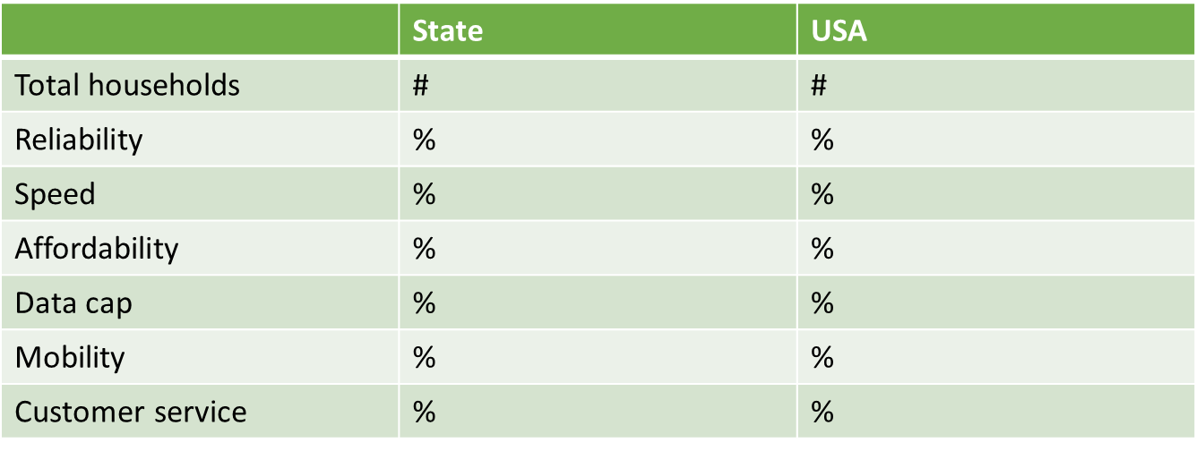
Question | Response
While the Digital Nation data represents consumer priorities for broadband access at the state and national levels, these trends may or may not be relevant to your locality. What are the greatest concerns from residents in your locality? | narrative
Question | Response
The Digital Nation survey does not include businesses. What are the key broadband access priorities or areas for concern in the local business community? | narrative
Question | Response
If you conduct your own research on broadband pricing, please record that information here. | link and title or upload worksheet
Question | Response
Please note insights or concerns about broadband pricing and value in your locality. | narrative
Question | Response
How would you describe the availability of broadband services in your locality? | 1 (poor) 2 3 4 5 6 7 (excellent)
Question | Response
What changes would you like to see in the next one to two years in the broadband services that are available to residents, businesses and community anchor institutions in your locality? | narrative
Question | Response
Links to resources that you'd like to record in your plan. | link and title
Question | Response
Links to resources that you'd like to share with other communities. | link and title

Mobile Access
What cellular coverage and technology is available in your locality? | (This is a rhetorical question introducing the section and does not allow for a response.)
Figure
Mobile coverage in your locality | (Calculated from FCC 477 data submitted to the Federal Communications Commission by cellular service providers. This material is informational and does not allow for a response.)
   | Population served % served |  | Square miles served % square miles served
  Any | # | % | # | %
  2G | # | % | # | %
  3G | # | % | # | %
  4G LTE | # | % | # | %
  4G non LTE | # | % | # | %
Figure
Mobile coverage in the USA | (Calculated from: FCC 477 data submitted to the Federal Communications Commission by cellular service providers.) This material is informational and does not allow for a response.)
   | Population served % served |  | Square miles served % square miles served
  Any | # | % | # | %
  2G | # | % | # | %
  3G | # | % | # | %
  4G LTE | # | % | # | %
  4G non LTE | # | % | # | %
Question
Comments (optional)
Figure
Mobile providers operating in your locality.  Click here for a list of Cellular Service Providers serving census blocks in your locality. | (Information provided will be based on service provider 477 data submitted to the Federal Communications Commission indicating the technology types and coverage areas for cellular services.)
Question | Response
The FCC 477 data only tell us so much. Local realities are critical to putting together a meaningful action plan. Do you feel that this information accurately reflects cellular coverage in your locality? | 1 2 3 4 5 6 7 (1= not at all; 7=to a large extent)
Question | Response
If your experience of cellular coverage differs from the reported data, please highlight the key differences. | narrative
Question | Response
If you conduct research on cellular coverage and have more accurate local figures, please provide your local data. | link and title
Question | Response
If you conducted your own research on cellular pricing, bundles, and data caps, please record that information here. | link and title or upload worksheet
Question
Please comment on the affordability and value of wireless services available to local residents and businesses in your locality. | narrative
Question | Response
How would you describe the availability of mobile broadband (data) services in your community? | 1 (poor) 2 3 4 5 6 7 (excellent)
Question | Response
How does mobile access –and any associated gaps in service - impact your community? What changes would you like to see in cellular services in your region over the next one to two years? | narrative
Question | Response
Links to resources that you'd like to record in your plan. | link and title
Question | Response
Links to resources that you'd like to share with other communities. | link and title

Provider Engagement
Are there opportunities to strengthen communications and partnerships with existing or new service providers? | (This is a rhetorical question introducing the section and does not allow for a response.)
Table
For a full list of residential service providers who reported operations in your locality, click here to download table. | (Information provided will be based on service provider 477 data submitted to the Federal Communications Commission indicating the census blocks covered, technology type, and advertised speeds for wireline and fixed wireless residential broadband services.)
Table
For a full list of business service providers who reported operations in your locality, click here to download table. | (Information provided is based on service provider 477 data submitted to the Federal Communications Commission indicating the census blocks covered, technology type, and advertised speeds for wireline and fixed wireless business broadband services.)
Question | Response
Do these tables represent a comprehensive and accurate view of the service providers in your locality? | 1 2 3 4 5 6 7 (1= not at all; 7=to a large extent)
Question | Response
Comments (optional) | narrative
Question | Response
Are there open and frequent communications between local broadband champions and service providers in your locality? | 1 2 3 4 5 6 7 (1= not at all; 7=to a large extent)
Question | Response
Please check all that apply: | · We have reviewed the list of residential providers that serve our locality.
 | · We have reviewed the list of business providers that serve our locality.
 | · We know the local or regional contacts for residential providers that serve our locality.
 | · We know the local or regional contacts for business providers that serve our locality.
 | · We have met with some of the residential providers that serve our locality at least once.
 | · We have met with some of the business providers that serve our locality at least once.
 | · We have met with most of the residential providers that serve our locality at least once.
 | · We have met with most of the business providers that serve our locality at least once.
 | · We have regular open communication with at least one residential provider that serves our locality.
 | · We have regular open communication with at least one business provider that serves our locality.
 | · Providers have confirmed or clarified their residential coverage - including technology type, advertised broadband upload and download speeds, and blocks or homes served.
 | · Providers have confirmed or clarified their business coverage - including technology type, advertised broadband upload and download speeds, and blocks or businesses served.
 | · Our outreach includes meetings with non-traditional providers in our locality such as research and education networks, nonprofit networks, and energy coops.
 | · Other (please specify)
Question | Response
Do leaders assess current and future broadband needs and communicate those needs to engaged providers? | 1 2 3 4 5 6 7 (1= not at all; 7=to a large extent)
Question | Response
Please check all that apply: | · We have a multi-year telecommunications plan that covers government/tribal agencies and functions.
 | · We have tabulated the telecommunications costs and projections across government/tribal agencies.
 | · We have a multi-year telecommunications plan that articulates broadband demand across agencies or departments.
 | · We have a multi-year telecommunications plan that aggregates broadband demand across agencies or departments.
 | · We have some awareness of the current and future needs for broadband connectivity in our business community.
 | · We have documented the current and future broadband needs of area businesses.
 | · We have some awareness of the current and future needs for broadband connectivity in our community anchor institutions.
 | · We have documented the current and future broadband needs of community anchor institutions.
 | · We have some awareness of the current and future needs for broadband connectivity among residents and people considering relocating to our community.
 | · We have documented the current and future broadband needs of residents.
 | · We have a multi-year telecommunications plan that aggregates broadband demand across sectors of the community.
 | · We request input from the public in order to understand current broadband connectivity issues or gaps and future needs.
 | · Other (please specify)
Question | Response
Do local leaders engage providers to understand deployment plans, deployment projections, and challenges? | 1 2 3 4 5 6 7 (1= not at all; 7=to a large extent)
Question | Response
Please check all that apply: | · Our leadership has conveyed what services, speeds, and coverage is needed in this locality.
 | · Residential providers have shared deployment plans and timelines.
 | · Business providers have shared deployment plans and timelines.
 | · Middle mile or backhaul providers have shared deployment plans and timelines.
 | · For providers in our locality that receive e-Rate funding, we understand service contracts and upgrade plans.
 | · For providers in our locality that receive Connect America Funding, we understand their deployment commitments and timeframes.
 | · For providers in our locality that receive Rural Utilities Service funding, we understand their deployment commitments and timeframes.
 | · If Census Blocks in our region are eligible for additional Connect America Fund support, we solicit support and interest from providers.
 | · If applicable, Research and Education Network providers are included in provider discussions, especially those that impact community anchor institutions.
 | · If local providers have identified deployment barriers, government/tribal officials are aware of barriers and work to mitigate issues.
 | · Other (please specify)
Question | Response
Do government/tribal leaders manage contracts and leaseholds to ensure that those agreements continue to meet the needs and interests of the public? | 1 2 3 4 5 6 7 (1= not at all; 7=to a large extent)
Question | Response
Please check all that apply: | · Leases and agreements with providers are a matter of public record.
 | · Our agency or department allocates staff time to support the execution of telecommunications agreements that involve public assets or public rights of way.
 | · Leases and agreements with providers include clearly defined public benefits.
 | · When reaching new agreements or renewing existing agreements, public input is requested and included in the process.
 | · Our agency monitors compliance and service delivery under the agreement and holds providers accountable for meeting obligations.
 | · Other (please specify)
Question | Response
How would you rate the efficacy of communications, agreements, and partnerships with service providers? | 1 (poor) 2 3 4 5 6 7 (excellent)
Question | Response
What changes would you like to see in the next one to two years in the way that your locality works with service providers? | narrative
Question | Response
Links to resources that you'd like to record in your plan. | link and title
Question | Response
Links to resources that you'd like to share with other communities. | link and title

Public Assets
How do local policies support the use of public assets, enhance advanced telecommunications, and serve the public good? | (This is a rhetorical question introducing the section and does not allow for a response.)
Question | Response
Do governmental or tribal agencies maintain a publicly-accessible inventory of public assets? | 1 2 3 4 5 6 7 (1= not at all; 7=to a large extent)
Question | Response
Please check all that apply: | · Our community has identified the types of public assets that could be used for advanced telecommunications.
 | · Our community maintains an asset inventory - a directory of public assets that could be used for advanced telecommunications.
 | · Our asset inventory includes information on asset type, geo-location, and ownership.
 | · Our asset inventory includes information on readiness or fitness for use and capacity.
 | · The asset inventory includes references or links to regulations that dictate the use of these assets.
 | · We employ processes to maintain the accuracy of asset data, including processes to regularly update data.
 | · The inventory is electronic and can be accessed or downloaded by prospective infrastructure builders.
 | · Our community has information on related Tribal, County, State, Federal or other assets.
 | · Our community has information on assets maintained by utility companies or private entities.
 | · Other (please specify)
Question | Response
Do governmental or tribal agencies develop and manage policies and regulations that facilitate the use of public assets? | 1 2 3 4 5 6 7 (1= not at all; 7=to a large extent)
Question | Response
Please check all that apply: | · Our community has identified the regulatory or policy jurisdictions for each asset type in the inventory.
 | · Our agency has well-defined policies and procedures that regulate the use of public assets.
 | · Our agency employs "one touch" make-ready practices to streamline permitting and deployment.
 | · Our agency provides a single-point-of-contact for providers that are exploring or implementing network deployments and upgrades.
 | · Permitting policies and procedures are available online.
 | · Permit applications can be completed and submitted online.
 | · Inspection requests can be completed and submitted online.
 | · Applicants can track permit requests, inspections, and other related processes throughout the construction process.
 | · Permitting and inspection responses are specified; agency performance is measured.
 | · Asset leasing and pricing costs are based on sound financial models that are reviewed regularly.
 | · Pole attachment leasing models and regulations are consistent with the FCC's pole attachment rules.
 | · Policies and procedures that regulate asset use are reviewed and updated regularly using processes that include stakeholder input.
 | · Policies have been updated to include considerations for siting wireless infrastructure such as antennas, towers, small cells and outdoor Distributed Antenna Systems.
 | · Other (please specify)
Question | Response
Do agency policies and regulations streamline access to public rights-of-way and support the public interest? | 1 2 3 4 5 6 7 (1= not at all; 7=to a large extent)
Question | Response
Please check all that apply: | · Our community has identified the regulatory or policy jurisdictions for rights-of-way in our locality.
 | · Our agency has identified the state, county, federal, tribal, commercial, and other regulations that apply to rights-of-way in our locality.
 | · For rights-of-way within our management scope, our agency has well-defined policies and procedures that regulate use.
 | · Our jurisdiction has implemented a dig once policy that requires public notice for all trenching or major construction.
 | · Our government actively works to coordinate construction interests to facilitate telecommunications infrastructure deployment as part of construction projects.
 | · Our policies dictate that conduit must be laid as part of major road and construction projects.
 | · We are aware of the rights-of-way regulations on county and state roads and lands in our jurisdiction. Information is accessible in our offices and websites.
 | · We are aware of the rights-of-way regulations on federal roads and lands in our jurisdiction. Information is accessible in our offices and websites.
 | · Policies and procedures that regulate rights-of-way proactively consider requirements for advanced wireless in communities.
 | · Our government is aware of the wireless spectrum loads and interference in our geography and takes proactive steps to ensure wireless service quality.
 | · Policies and procedures that regulate rights-of-way are reviewed and updated regularly using processes that include stakeholder input.
 | · Other (please specify)
Question | Response
Do governmental or tribal agencies manage contracts and leaseholds to ensure that those agreements continue to meet the needs and interests of the public? | 1 2 3 4 5 6 7 (1= not at all; 7=to a large extent)
Question | Response
Please check all that apply: | · Leases and agreements with providers are a matter of public record.
 | · Our agency or department allocates staff time to monitor the execution of telecommunications agreements that involve public assets or public rights of way.
 | · Our agency‘s compliance officer monitors agreements to ensure that vendor obligations are met.
 | · Leases and agreements with providers include clearly defined public benefits.
 | · When reaching new agreements or renewing existing agreements, public input is requested and included in the process.
 | · Other (please specify)
Question | Response
Do agency policies and regulations leverage government telecommunication infrastructure to improve broadband services to government agencies, institutions, businesses, and consumers? | 1 2 3 4 5 6 7 (1= not at all; 7=to a large extent)
Question | Response
Please check all that apply: | · Governmental or tribal agencies manage agreements that govern access to telecommunications networks and assets to ensure that those agreements continue to meet the needs and interests of the public.
 | · Government/tribal telecommunications infrastructure investment is built to a plan – with a focus on building networked assets.
 | · Government/tribal network infrastructure is accessible, such as through manholes.
 | · Governmental/tribal policies promote and support carrier neutral collocation facilities.
 | · When capacity is available, governmental/tribal networks are open and available for lease to other entities.
 | · Other (please specify.)
Question | Response
Does your community provide access to free public Wi-Fi? | 1 2 3 4 5 6 7 (1= not at all; 7=to a large extent)
Question | Response
Please check all that apply: | · Our community offers free wireless access at public libraries.
 | · Our community offers free wireless access at government buildings.
 | · Our community offers free wireless access at public parks and community centers.
 | · Our community offers free wireless access in public housing.
 | · Our community offers free wireless access in business zones.
 | · Our community offers free wireless access in residential areas.
 | · Our community conducts regular evaluations of Wi-Fi networks to ensure that networks are engineered to accommodate demands.
 | · We have an up-to-date directory of Wi-Fi coverage in our geography.
 | · Other (please specify.)
Question | Response
How would you describe the efficacy of local policies that promote the use of public assets, enhance telecommunications competition, and serve the public good? | 1 (poor) 2 3 4 5 6 7 (excellent)
Question | Response
What changes would you like to see in the next one to two years in the way that your locality manages public assets to advance broadband and community connectivity? | narrative
Question | Response
Links to resources that you'd like to record in your plan. | link and title
Question | Response
Links to resources that you'd like to share with other communities. | link and title

Adoption and Use
Who is using the Internet? Are there digital divides? | (This is a rhetorical question introducing the section and does not allow for a response.)
Figure
Internet use in your state and the nation  Before looking at the local data on broadband adoption or digging into the assessment, let’s look at the Digital Nation data collected by NTIA as part of the U.S. Census Current Population Survey. With a survey group of over 50,000 households, Digital Nation data is statistically valid at the national and state level.  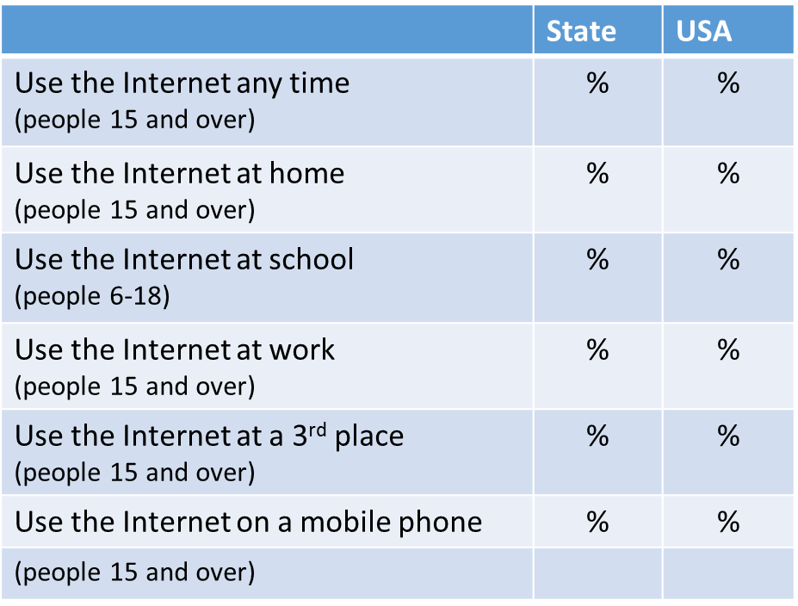 | (Data from the U.S. Census Digital Nation Supplement to Current Population Survey  with additional Internet questions. This  material is informational and does not  allow for a response.)
Figure
Computer ownership and home Internet connections in your locality  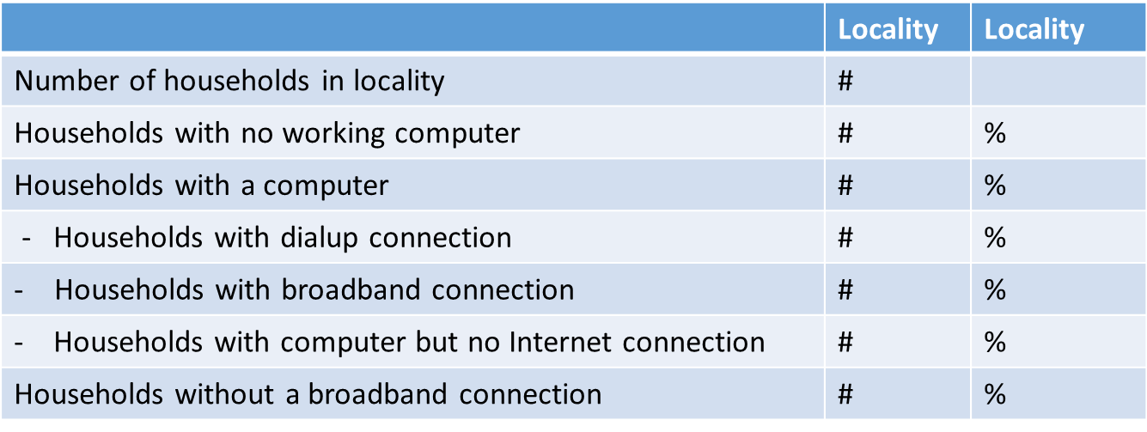 | (Data from the U.S. Census Digital Nation Supplement to Current Population Survey with additional Internet questions. This material is informational and does not allow for a response.)
Question |  | Response
Do these figures square with your experience of local adoption levels? | 1 (no) 2 3 4 5 6 7 (definitely yes) NA/don’t know

Question |  | Response
In what ways does your experience or data on broadband adoption and use in your locality differ from the representation depicted in the Digital Nation dataset? |  | narrative
Question |  | Response
If you conduct surveys on broadband adoption and use, please provide a link to your data. | link and title
Map
Home broadband subscription by census tract  The FCC calculates broadband subscription levels by census tract based on information submitted from Internet Service Providers. This map shows the percent of households in each census tract that subscribe to wireline or fixed wireless broadband. |  | (This information is calculated by the Federal Communications Commission, based on service provider 477 data. This analysis should the household broadband subscription level by quintile across all wireline and fixed wireless providers serving each census tract. This material is informational and does not allow for a response.)
Figure
Digital divides in the nation and in your state based on population  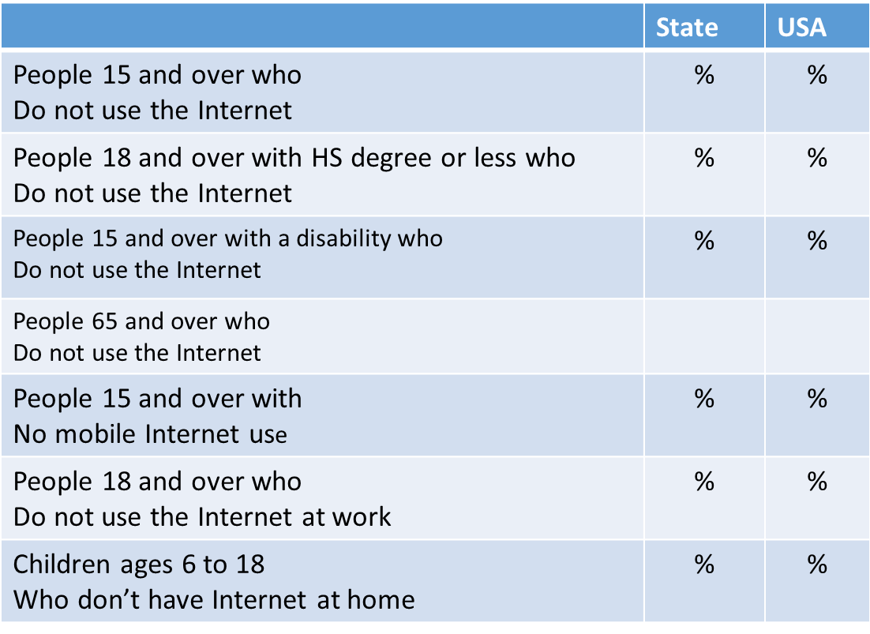 |  | (Data from the U.S. Census Digital Nation Supplement to Current Population Survey with additional Internet questions. This material is informational and does not allow for a response.)

Figure
Digital divides in the nation and in your state based on household data  Which households don’t subscribe to broadband at home? Where are the digital divides in your state?  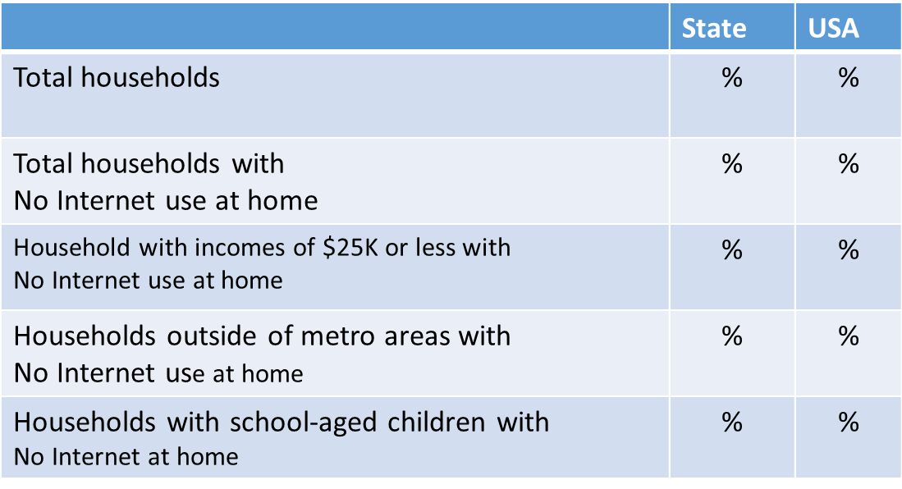 |  |  | (Data from the U.S. Census Digital Nation Supplement to Current Population Survey with additional Internet questions. This material is informational and does not allow for a response.)
Figure
Barriers to home broadband adoption 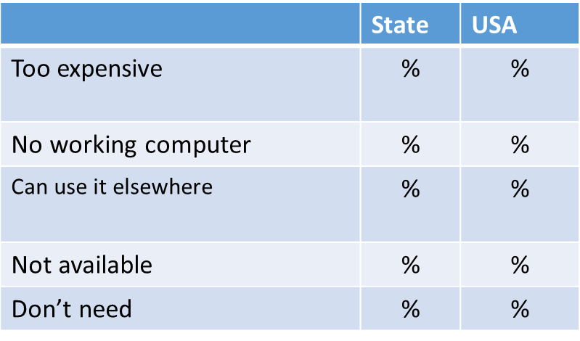 | (Data from the U.S. Census Digital Nation Supplement to Current Population Survey with additional Internet questions. This material is informational and does not allow for a response.)

Question |  |  | Response
While the Digital Nation data indicates adoption trends –and digital divides - at the state and national levels, these trends may or may not be relevant to your locality. Please indicate which trends – and gaps – are of the greatest concern to your locality? |  |  | narrative
Question | Response
How would you describe broadband adoption and use in your community? | 1 (poor) 2 3 4 5 6 7 (excellent)
Question |  | Response
What changes would you like to see in the next one to two years in broadband use across your locality? How do broadband adoption levels –and any associated divides - impact your community? |  | narrative
Question |  | Response
Links to resources that you'd like to record in your plan. |  | link and title
Question |  | Response
Links to resources that you'd like to share with other communities. |  | link and title

Digital Inclusion
What proactive measures are you taking to ensure digital equity? |  | (This is a rhetorical question introducing the section and does not allow for a response.)
Question |  | Response
Do organizations or groups in your community regularly identify, seek out, and understand the needs of underserved individuals/populations? |  | 1 2 3 4 5 6 7 (1= not at all; 7=to a large extent)
Question |  | Response
Please check all that apply: |  | · We have mapped underserved communities within our geography.
 |  | · We understand the key concerns and interests of these groups.
 |  | · Outreach efforts are conducted in the language(s) of the people we intend to support.
 |  | · Outreach programs are accessible to people with disabilities.
 |  | · Efforts to engage underserved community members include participants in program design and leadership.
 |  | · Community organizations strive to ensure that residents are aware of broadband benefits and technology support programs
 |  | · Our schools strive to ensure that low income families are aware of broadband benefits and technology support programs
 |  | · Government agencies integrate digital inclusion awareness outreach in their programs. For example, including outreach as part of programs for housing, justice, or workforce development.
 |  | · Government or tribal departments take affirmative steps to ensure that community members can access digital services.
 |  | · Corporate partners and business leaders take affirmative steps to ensure that community members can access digital services.
 |  | · Other (please specify.)
Question |  | Response
Is digital literacy training and support available to residents - either as a stand-alone service or as part of other programs, such as those for education, housing, justice, or workforce development? |  | 1 2 3 4 5 6 7 (1= not at all; 7=to a large extent)
Question |  | Response
Please check all that apply: | · Stakeholders, such as libraries or other institutions, offer one-on-one technical support.
 | · Stakeholders, such as libraries or other institutions, offer free or affordable instructor-led digital skills classes.
 | · Stakeholders, such as libraries or other institutions, offer online classes in digital basics.
 | · Digital literacy training is integrated into government services that require digital competencies such as work force development, educational support, health services, and justice.
 | · Digital literacy classes are conducted in the language of the target audience(s).
 | · Digital literacy classes are accessible to people with disabilities.
 | · Program participants contribute to the program design.
 | · Staff is provided opportunities to continually enhance and upgrade their own digital literacy skills.
 | · Other (please specify)
Question |  | Response
If you have a directory of local digital literacy programs, please provide a link. |  | link and title
Question |  | Response
Does your community promote discount or subsidy programs that lower the cost of broadband access for low-incomes individuals and households? |  | 1 2 3 4 5 6 7 (1= not at all; 7=to a large extent)
Question |  | Response
Please check all that apply: |  | · We ensure that low-income residents are aware of the Lifeline program and that they have the information needed to apply for discounted broadband service.
 |  | · We understand which carrier-provided programs are available to our residents and we ensure that eligible residents have the information that they need to apply for discounted broadband service.
 |  | · We have worked with local carriers to develop specific programs for our residents.
 |  | · Digital inclusion benefits are included in licensing agreements with service providers.
 |  | · Our public library, school or other community institution offers a Wi-Fi loan program (MiFi).
 |  | · Our community works to ensure that broadband access services including high-quality Wi-Fi networks are available for residents. This could include free Wi-Fi at the public library or wired access at public housing.
 |  | · Our community works to provide residential broadband services and offers discounted or free access for low-income residents.
 |  | · Other (please specify)
Question |  | Response
Does your community take affirmative steps to make sure that low-income individuals have access to appropriate computing devices? |  | 1 2 3 4 5 6 7 (1= not at all; 7=to a large extent)
Question |  | Response
Please check all that apply: |  | · There are physical spaces in our community that provide open access to computers and the Internet. This may include public libraries, educational institutions, government offices, or other community or business centers.
 |  | · Our public library, educational institution, or community center loans out computing devices so the people can use the devices outside of the institution or building.
 |  | · One-to-one computing programs in our schools make special provisions to ensure that all students have access to computing device that meets their educational needs.
 |  | · Eligible residents are aware of relevant service provider programs that include discounted computing devices.
 |  | · Discounted computing programs are available to area residents. This may include programs provided by banks, nonprofits, schools, or businesses.
 |  | · Our community participates in a local or national computer refurbishing program - by encouraging that computing devices be recycled and refurbished.
 |  | · Computer refurbishing programs meet industry guidelines for e-stewardship, product certification, data security, warranty, and support.
 |  | · Our community participates in a local or national computer refurbishing program by ensuring those programs deliver value and deploying refurbished products to needy individuals or nonprofits.
 |  | · Other (please specify.)
Question |  | Response
Does your community take affirmative steps to ensure that websites and technology programs are accessible to people with disabilities? |  | 1 2 3 4 5 6 7 (1= not at all; 7=to a large extent)
Question |  | Response
Please check all that apply: |  | · Government or tribal web sites have been evaluated for compliance with web accessibility standards.
 |  | · Government or tribal web sites have been modified to achieve greater compliance with web accessibility standards.
 |  | · Broadband leaders promote accessibility for other commonly used web services.
 |  | · Our community audits all facilities for accessibility and takes appropriate steps to remediate gaps.
 |  | · Public facilities are ADA-compliant.
 |  | · Mobile labs meet people where they are, bringing computing and digital coaching to homes and other gathering places.
 |  | · ADA-compliant workstations and assistive access tools are available to people who require accommodations.
 |  | · Outreach, training and inclusion programs are accessible to people with disabilities.
 |  | · Other (please specify)
Question |  | Response
Does your community have sustainable funding to promote digital inclusion? |  | 1 2 3 4 5 6 7 (1= not at all; 7=to a large extent)
Question |  | Response
Please check all that apply: |  | · Digital inclusion is a line item in government/tribal budgets.
 |  | · Local foundations and public campaigns promote digital literacy and support and sustain digital inclusion efforts.
 |  | · Businesses promote digital literacy and support and sustain digital inclusion efforts.
 |  | · Public/private partnerships are in place to promote digital literacy and support and sustain digital inclusion.
 |  | · Digital literacy and inclusion efforts are evaluated and funded using practices common for other core services.
 |  | · Other (please specify)
Question |  | Response
How would you describe the efficacy of your community’s digital inclusion programs? |  | 1 (poor) 2 3 4 5 6 7 (excellent)
Question |  | Response
What changes would you like to see over the next one to two years in the way that your locality promotes digital inclusion and equity? Does uneven digital participation impede personal or community-wide outcomes? |  | narrative
Question |  | Response
Links to resources that you would like to record in your plan. |  | link and title
Question |  | Response
Links to resources that you would like to share with other communities. |  | link and title

Digital skills
Do programs provide a ladder for residents to gain digital proficiencies - from basics to coding? | (This is a rhetorical question introducing the section and does not allow for a response.)
Question | Response
Does your community provide digital literacy training and support? | 1 2 3 4 5 6 7 (1= not at all; 7=to a large extent)
Question | Response
Please check all that apply: | · Stakeholders, such as libraries or other institutions, offer one-on-one technical support.
 | · Stakeholders, such as libraries or other institutions, offer free or affordable instructor-led digital skills classes.
 | · Stakeholders, such as libraries or other institutions, offer online classes in digital basics.
 | · Digital literacy training is integrated into government services that require digital competencies such as work force development, educational support, health services, and justice.
 | · Digital literacy classes are conducted in the language of the target audience(s).
 | · Digital literacy classes are accessible to people with disabilities.
 | · Program participants contribute to the program design.
 | · Staff is provided opportunities to continually enhance and upgrade their own digital literacy skills.
 | · Other (please specify)
Question | Response
If you have a directory of local digital literacy programs, please provide a link. | link and title
Question | Response
Does your community provide training in digital job search and work competencies such as research and information literacy, productivity software, and the professional use of social media? | 1 2 3 4 5 6 7 (1= not at all; 7=to a large extent)
Question | Response
Please check all that apply: | · Digital skills training is offered through our employment, one-stop center, or similar center.
 | · Colleges, community colleges, and universities integrate advanced digital competencies into their curricula.
 | · Schools integrate advanced digital competencies into their curricula.
 | · University extension services or the community-based organizations offer work-related digital skills training.
 | · Members of the community have opportunities to learn work-related digital skills.
 | · Members of the community have opportunities to learn productivity software such as Microsoft Office or Google docs.
 | · Community-based organizations support business start-ups by providing research and support for entrepreneurs.
 | · Community-based organizations help farmers, entrepreneurs, and makers use online tools to expand market reach and efficiency.
 | · Community-based organizations provide makers spaces or fab labs for business start-ups and entrepreneurs.
 | · Other (please specify)
Question | Response
If you have a directory of work related digital skills programs, please provide a link. | link and title
Question | Response
Does your community provide opportunities for students and adults to learn the skills and responsibilities necessary to collaborate and create content online? | 1 2 3 4 5 6 7 (1= not at all; 7=to a large extent)
Question | Response
Please check all that apply: | · School curricula include lessons on composing content and publishing through the web.
 | · Schools encourage students to learn from and contribute to online communities, including understanding the benefits and risks of online communities, and teaching the skills needed to effectively contribute.
 | · Community-based organizations integrate content creation and digital participation skills into curricula.
 | · Content creation and digital participation training or collaborative work-spaces are available to all residents.
 | · Government websites and applications facilitate constituent engagement. Online engagement informs policy, programs, and investment.
 | · Local entities support individuals, business, and nonprofits who want to create websites or mobile apps.
 | · Other (please specify)
Question | Response
Do students and adults have opportunities to learn coding skills, computer science, application development, and related skills? | 1 2 3 4 5 6 7 (1= not at all; 7=to a large extent)
Question | Response
Please check all that apply: | · Students have the opportunity to learn coding and computer science/engineering in high school.
 | · Students have the opportunity to learn coding and computer science/engineering in middle school.
 | · Students have the opportunity to learn coding and computer science/engineering in elementary school.
 | · School or after-school programs encourage and support tech innovation and skill-building.
 | · Community-based organizations offer in-person classes in computing and information technology.
 | · Community-based organizations offer online classes in technology computing and information technology.
 | · Area businesses offer in-person classes in technology computing and information technology.
 | · Area businesses offer online classes in technology computing and information technology.
 | · People in our community "meet up" to discuss technology computing and information technology. We support a tech culture.
 | · Our community leverages crowd-sourced solutions or challenges to improve lives and livelihoods, spur innovation, and address community challenges.
 | · Staff is provided opportunities to continually enhance and upgrade their own digital proficiencies.
 | · Other (please specify)

Question | Response
Does your community affirmatively address privacy, security and online safety? | 1 2 3 4 5 6 7 (1= not at all; 7=to a large extent)
Question | Response
Please check all that apply: | · Our schools integrate privacy, security and online safety into classes. Training includes the awareness of risks and benefits, best practices, and application guidelines.
 | · Students have opportunities to make informed decisions about privacy, security and online safety.
 | · Community-based organizations integrate practical information about privacy, security and online safety into classes and programs.
 | · Government agencies are aware of consumer-facing privacy and security protocols.
 | · Privacy and security are discussion topics in our community.
 | · Other (please specify)
Question | Response
Are you building an information savvy and tech-aware culture? | 1 (initial stages) 2 3 4 5 6 7 (information and tech savvy)
Question | Response
What changes would you like to see over the next one to two years in the way that your locality invests in creating/strengthening digital skills? | narrative
Question | Response
Links to resources that you'd like to record in your plan. | link and title
Question | Response
Links to resources that you'd like to share with other communities. | link and title

Devices
Do people have access to the devices they need to learn, create and participate in community and industry? | (This is a rhetorical question introducing the section and does not allow for a response.)
Figure
What we know about device ownership in your locality. | (Data from the U.S. Census American Community Survey. This material is informational and does not allow for a response.)
 | #
Number of households in locality | #
Households with no working computer | #
Households with a computer | #
Figure
Device ownership at the state and national level | (Data from the U.S. Census Digital Nation Supplement to Current Population Survey with additional Internet questions. This material is informational and does  not allow for a response.)
 | State | USA
 | No. | Devices per household
Desktop (people ages 6 and over) | # | #
Laptop (people ages 6 and over) | # | #
Tablet of e-book (people ages 6 and over) | # | #
Total (desktop, laptop, tablet, e-book) | # | #
Smart phone | # | #
Wearable (people ages 15 and over) | # | #
Smart TV or device (households) | # | #

Question | Response
Do these figure square with your experience of local device ownership levels? | 1 (no) 2 3 4 5 6 7 (definitely) NA/don’t know
Question | Response
If you conduct surveys on device ownership, please provide a link to your data. | link and title
Question | Response
Comments (optional) | narrative
Question | Response
Does your community take affirmative steps to make sure that low-income individuals have access to appropriate computing devices? | 1 2 3 4 5 6 7 (1= not at all; 7=to a large extent)
Question | Response
Please check all that apply: | · There are physical spaces in our community that provide open access to computers and the Internet. This may include public libraries, educational institutions, government offices, or other community or business centers.
 | · Our public library, educational institution, or community center loans out computing devices so the people can use the devices outside of the institution or building.
 | · One-to-one computing programs in our schools make special provisions to ensure that all students have access to computing device that meets their educational needs.
 | · Eligible residents are aware of relevant service provider programs that include discounted computing devices.
 | · Our community participates in a local or national computer refurbishing program - by encouraging that computing devices be recycled and refurbished.
 | · Computer refurbishing programs meet industry guidelines for e-stewardship, product certification, data security, warranty, and support.
 | · Our community participates in a local or national computer refurbishing program by ensuring those programs deliver value and deploying refurbished products to needy individuals or nonprofits.
 | · Other (please specify the type of device support programs available.)
Question | Response
How would you describe the level of device ownership in your community? | 1 (poor) 2 3 4 5 6 7 (excellent)
Question | Response
We have seen shifts in how devices are used by residents and business owners to pursue lifestyle and livelihood activities. Which device types and population segments are of current concern or focus in this community at this time? What changes would you like to see over the next one to two years? | narrative
Question | Response
Links to resources that you would like to record in your plan. | link and title
Question | Response
Links to resources that you would like to share with other communities. | link and title

Leadership
How are you organized to assess and improve connectivity in your locality? | (This is a rhetorical question introducing the section and does not allow for a response.)
Question | Response
Is there someone in the community who you would describe as a Broadband Champion? | 1 2 3 4 5 6 7 (1= not at all; 7=to a large extent)
Question | Response
Please check all that apply: | · My locality has a person or persons who champions broadband.
 | · The executive officer or tribal leader considers broadband a priority; it is part of their mission and work.
 | · The Chief Information or Technology director dedicates time to improve community broadband.
 | · Broadband access and technology adoption is a “standing item” on governmental agendas, e.g. this topic benefits from cross agency collaboration and consideration.
 | · Community or business leaders dedicate time to improve community broadband.
 | · Other (please specify.)
Question | Response
Does your community have a formal or informal broadband planning team? | 1 2 3 4 5 6 7 (1= not at all; 7=to a large extent)
Question | Response
Please check all that apply: | · We have an informal broadband planning team, e.g., we get together and discuss broadband.
 | · We have a formal broadband planning team that represents some portions of our community.
 | · We have a formal broadband planning team that we believe represents most sectors of our community.
 | · Our team has regularly scheduled meetings.
 | · Our team has a project plan and method for tracking deliverables.
 | · Our team has already produced a broadband plan and meets regularly to monitor progress and reassess.
 | · Other (please specify.)
Question | Response
If your broadband planning team has a web presence, please provide the link. | link and title
Question | Response
Have you asked residents, business leaders, nonprofits and other community stakeholders about their community connectivity needs and interests? | 1 2 3 4 5 6 7 (1= not at all; 7=to a large extent)
Question | Response
Please check all that apply: | · We track input from constituents.
 | · We have had a meeting or two.
 | · We have a formal process to gather input from residents.
 | · We have a formal process to gather input from business-owners, entrepreneurs, and business organizations.
 | · We have a formal process to gather input from community anchor institutions and nonprofit organizations.
 | · We solicit community input as part of our franchise renewal process and carrier negotiations.
 | · We have conducted community surveys or meetings to discuss community connectivity.
 | · We issue public reports that summarize the connectivity needs and issues expressed in community surveys or forums.
 | · Other (please specify)
Question | Response
Please provide the link or links to your community needs assessment. | link and title
Question | Response
Do you actively engage service providers to understand their current and future plans, aggregate and articulate demand, and enable deployment? | 1 2 3 4 5 6 7 (1= not at all; 7=to a large extent)

Question | Response
Please check all that apply: | · We know the service providers that operate in our locality.
 | · We cultivate strong relationships with providers.
 | · We tell providers what we need; i.e., identify current and future broadband needs of residents, businesses and institutions.
 | · We understand the deployment plans of providers operating in our locality.
 | · Our government leaders and departments manage contracts and leaseholds to ensure that agreements serve the public interest.
 | · Other (please specify.)
Question | Response
Does your community have a broadband plan? | 1 2 3 4 5 6 7 (1= not at all; 7=to a large extent)
Question | Response
Please check all that apply: | · We have a documented broadband plan.
 | · We have a documented broadband plan with measurable outcomes.
 | · We have a documented broadband plan that has been revised at least once.
 | · We have a documented broadband plan and process to review outcomes and update regularly.
 | · We conduct an annual broadband assessment and planning process.
 | · We conduct broadband assessments and planning at least every two years.
 | · Other (please specify.)
Question | Response
Please provide a link or links to your broadband plan. | link and title
Question | Response
How would you describe your community’s leadership on topics related to broadband access, adoption, and use? | 1 2 3 4 5 6 7 1= poor; 7=extraordinary
Question | Response
What changes would you like to see over the next one to two years in the way that your locality is organized to improve broadband service? How can you better engage providers, partners, and constituents to improve community connectivity? | narrative
Question | Response
Links to resources that you'd like to record in your plan. | link and title
Question | Response
Links to resources that you'd like to share with other communities. | link and title

Community Priorities
What issues draw us to take action to improve broadband? | (This is a rhetorical question introducing the section and does not require an answer.)
Question | Response
What are the specific areas of concern that motivate this effort to assess and improve our community connectivity? | narrative
Question | Response
Please check all that apply: | · Broadband service is not available in all or some parts of our locality.
 | · Mobile wireless coverage is spotty/inadequate.
 | · Broadband services are too slow, speeds don’t meet needs.
 | · Broadband service quality is poor or unreliable.
 | · We have "middle mile" problems. Traffic into our locality is throttled.
 | · Broadband service is too expensive for services offered.
 | · People who need broadband cannot afford to get the services they need.
 | · We need better broadband in order to offer better government services.
 | · We need more broadband to support the curriculum in our schools.
 | · We have a homework gap.
 | · Healthcare access and improvements.
 | · We need better broadband to attract businesses and drive economic development.
 | · People are leaving. We need better connectivity to attract and retain people.
 | · Lack of digital access or skills is creating an opportunity gap for some residents. We need to work on digital inclusion and equity.
 | · Our workforce needs more digital skills to be "work ready."
 | · Residents need better, faster broadband speeds in order to work from home or run businesses.
 | · We are innovators. We need better connectivity to support and drive innovation.
 | · We need better, faster broadband speeds to support telemedicine and distance learning.
 | · Other (please specify.)
Question | Response
Please list your highest priority community goals or objectives and indicate if and how improved broadband could support these objectives. | Narrative  Community objective/importance of connectivity  Community objective/importance of connectivity  Community objective/importance of connectivity
Question | Response
Of the following community purposes, please note the importance of each using a high (H), medium (M), low (L), or Not Applicable (NA) rating: | H, M, L, NA
· Government Services
· Citizen Engagement
· Economic Development and Innovation
· Education and Continuous Learning
· Health and Wellness
· Energy and the Environment
· Transportation
· Public Safety
· Arts and Culture
· Community Sustainability and Improvement
· Internet of Things
· Smart community (e.g., roads, energy, safety)
· Other
Figure
State and National Data on Broadband Use According to data collected by NTIA Digital Nation with the U.S. Census, people in your state ages 15 and older indicated some of the following reasons for using the Internet. | (Data from the U.S. Census Digital Nation Supplement to Current Population Survey with additional Internet questions. This material is informational and does not allow for a response.)
 | State USA
Email | % %
Financial services | % %
Health information | % %
Health records | % %
Health monitoring | % %
Household control | % %
Job search | % %
Making reservations | % %
Music podcast | % %
Shopping | % %
Social Networks | % %
Taking a class/job training | % %
Watching videos or streaming | % %
Working remotely | % %
Video calls/conferences | % %
Question | Response
While the Digital Nation data represents consumer broadband uses at the state and national levels, these trends may or may not be relevant to your locality. Do you feel that this data is representative of your locality? | 1 2 3 4 5 6 7 (1= not at all; 7=to a large extent)
Question | Response
Are there other key Internet uses that you hear from area residents, businesses, and institutions in your locality? | narrative
Question | Response
If you have an overall vision for your community, please list it here. | narrative
Question | Response
If you have a vision for your broadband planning effort, please list it here. | narrative
Question | Response
How would you rate the importance of broadband as a means or component of achieving community priorities? | 1 2 3 4 5 6 7 1= not important; 7=vital
Question | Response
Additional comments | narrative
Question | Response
Links to resources that you'd like to record in your plan. | link and title
Question | Response
Links to resources that you'd like to share with other communities. | link and title

Stakeholder Engagement
How are you engaging stakeholders that can bring interest, influence, or support to local broadband initiatives? | (This is a rhetorical question and does not allow for an answer.)
Question | Response
Have you identified project stakeholders? | 1 2 3 4 5 6 7 (1= not at all; 7=to a large extent)
Question | Response
Please check all that apply: | · We have a list of stakeholders.
 | · Stakeholder list includes representatives from a broad cross-section of our community.
 | · Stakeholder list includes intended program beneficiaries.
 | · Stakeholder list includes potential contributors, partners, or vendors.
 | · We have mapped our community stakeholders based on their interest and influence.
 | · Stakeholder list includes both advocates and nay-sayers.
 | · Other (please specify.)
Question | Response
Have you developed and implemented outreach efforts to learn from and engage stakeholder? | 1 2 3 4 5 6 7 (1= not at all; 7=to a large extent)
Question | Response
Please check all that apply: | · We have contacted many of the stakeholders on our list.
 | · We have a formal program to engage stakeholders.
 | · We engage stakeholders informally.
 | · We have an advisory group that provides insight and direction on broadband projects.
 | · Our meetings are open to the public.
 | · Planning documents and meeting notes are publically available.
 | · Stakeholder feedback is documented.
 | · Project plans are regularly adjusted to reflect input from stakeholders.
 | · Our stakeholder plan includes regular engagement with people or groups that have concerns or may be critical of our efforts.
 | · We have mapped out areas of mutual benefit with key stakeholders.
 | · Ongoing stakeholder engagement activities are tuned to each audience based on their interest and influence levels.
 | · Other (please specify.)
Question | Response
Are public private partnerships part of your broadband planning and project implementation plan? | 1 2 3 4 5 6 7 (1= not at all; 7=to a large extent)
Question | Response
Please check all that apply: | · We have identified potential broadband project partners.
 | · We have identified the possible benefit and cost (investment) for each partner.
 | · We have well-defined partnership agreements with key partners.
 | · Partnership agreements specify roles and responsibilities.
 | · Partnership agreements specify milestones, deliverables, and dependencies.
 | · Partners attend project management meetings.
 | · Partners are engaged in project planning or strategic discussions.
 | · We regularly review how existing partnerships meet project goals.
 | · Other (please specify.)
Question | Response
How would you describe the effectiveness of your stakeholder and partnership engagement programs? | 1 2 3 4 5 6 7 (1= poor; 7=extraordinary )
Question | Response
If you see greater potential to use stakeholder and partnership engagement programs to strengthen outcomes over the next one to two years, please comment on the changes you would like to see in those efforts. | narrative
Question | Response
Links to resources that you'd like to record in your plan. | link and title
Question | Response
Links to resources that you'd like to share with other communities. | link and title

Policy and Environment
Are there regional or state resources or regulations that impact local planning and investment? | (This is a rhetorical question and does not allow for an answer.)
Question | Response
Are you knowledgeable about state/tribal laws and regulations that pertain to broadband projects in your jurisdiction? | 1 2 3 4 5 6 7 (1= not at all; 7=to a large extent)
Question | Response
Please check all that apply: | · We understand the laws and regulations that restrict/guide local government broadband purchasing.
 | · My state/tribal nation has laws or regulations that restrict/guide cable franchise agreements.
 | · State laws or regulations on cable franchise agreements restrict local franchising authority on cable telecommunications providers.
 | · My state has laws or regulations that restrict/guide government investments in broadband infrastructure.
 | · My state has laws or regulations that restrict/guide government operations of broadband networks.
 | · My state has laws or regulations that put market restrictions on government broadband networks.
 | · Other (please specify.)
Question | Response
Please provide a link to applicable state or tribal laws and regulations. | link and title
Question | Response
Does your state or tribal government provide planning support or funding for local broadband projects? | 1 2 3 4 5 6 7 (1= not at all; 7=to a large extent)

Question | Response
Please check all that apply: | · We have a state broadband office.
 | · Our state conducts a statewide assessment of broadband availability.
 | · Our state maps broadband availability.
 | · We have a statewide or regional broadband plan.
 | · The state broadband office or associated partners provides planning and/technical support for local efforts.
 | · Our state Economic Development office considers broadband a key foundation for economic growth and provides support for broadband projects.
 | · Our state has a statewide e-Rate coordinator that supports school and library e-Rate applications.
 | · Our state has a grant program that support local broadband projects.
 | · Our state has a loan program that supports local broadband projects.
 | · Our state has a state Universal Service Fund that promotes telecommunications or broadband access.
 | · Other (please specify.)
Question | Response
Please provide a link to applicable state or tribal broadband and technology programs. | link and title
Question | Response
Are you aware of other regional or state programs that support broadband planning or projects? | 1 2 3 4 5 6 7 (1= not at all; 7=to a large extent)
Question | Response
Please check all that apply: | · University Extension offices support broadband planning and projects.
 | · Rural Development offices support broadband planning and projects.
 | · Our regional Council of Governments supports broadband planning and projects.
 | · Regional or local Economic Development Authorities support broadband planning and projects.
 | · Other regional entities support broadband planning and projects.
 | · Other (please specify)
Question | Response
Please provide the link or links to applicable regional programs. | link and title
Question | Response
Have you considered how previous broadband plans and projects inform current efforts? | 1 2 3 4 5 6 7 (1= not at all; 7=to a large extent)
Question | Response
Check all that apply: | · Our locality produced a broadband plan some time ago.
 | · Our locality has completed broadband projects.
 | · We have reviewed previous broadband plans and projects to identify accomplishments and lessons learned.
 | · We have reviewed previous plans and projects to identify risks and jeopardies.
 | · Other (please specify.)
Question | Response
Please provide a link or links to previous broadband plans or projects. | link and title
Question | Response
How would you describe the state, tribal or regional environment supporting local broadband efforts? | 1 2 3 4 5 6 7 1= poor; 7=extraordinary
Question | Response
What changes would you like to see over the next one to two years in the regulatory, legal or support structure around broadband? | narrative
Question | Response
Links to resources that you'd like to record in your plan. | link and title
Question | Response
Links to resources that you'd like to share with other communities. | link and title

