POSTCARD #1

Stamp
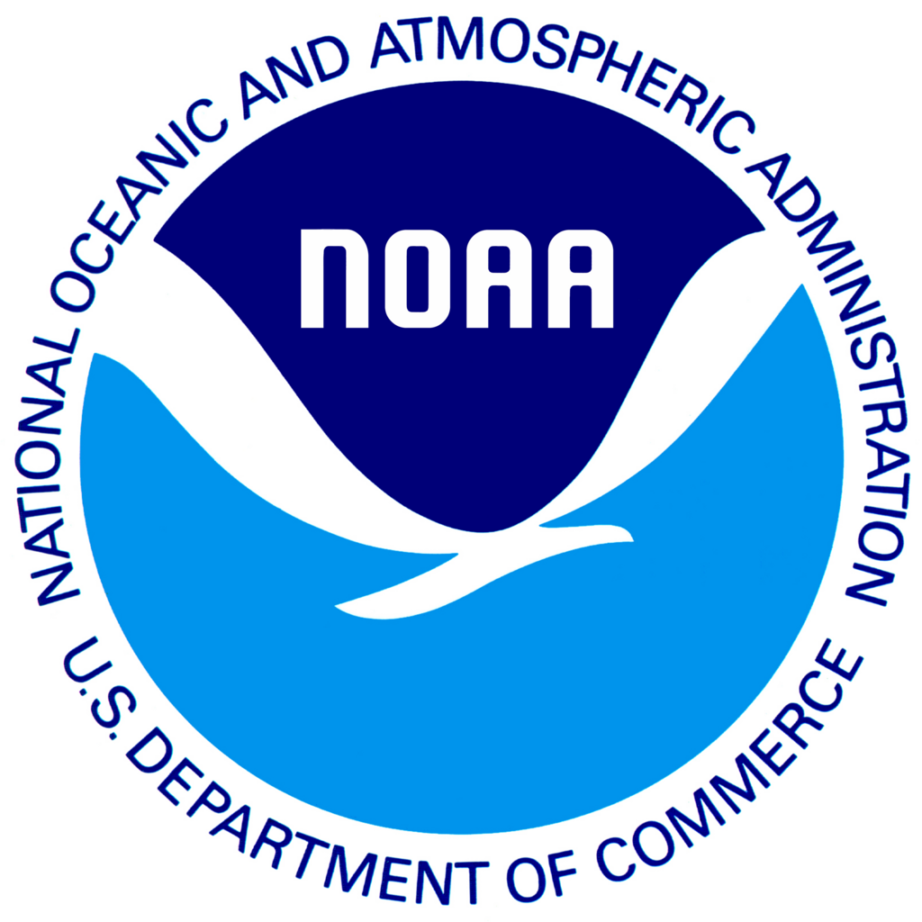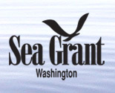
To:
From:
WA Sea Grant
c/o Hardwick Research
8720 SE 45th Street
Mercer Island, WA 98040
Hello!

We are asking your help with an important study being conducted by University of Washington Sea Grant and NOAA Fisheries to understand the importance of West Coast fisheries to individuals and communities. In the next few days you will receive a short survey in the mail.

This research can only be successful with the generous help of people like you. To say thanks, you will receive a small token of appreciation with the survey. I hope you will take 15-20 minutes of your time to help us. Most of all, I hope that you enjoy the questionnaire and the opportunity to voice your opinions about West Coast fisheries.

Any questions, feel free to contact Karma Norman (Northwest Fisheries Science Center) at 206302-2418.

POSTCARD #2

From:
National Marine Fisheries Service
2725 Montlake Blvd East
Seattle, WA 98112-2097

Stamp
To:
Hello!

Last week a questionnaire was mailed to you because you were selected to help in a study about the importance of West Coast fisheries to individuals and communities.

If you have already completed and returned the questionnaire, please accept our sincere thanks. If not, please do so right away. For your convenience, there is a web link where you can complete the survey online www.surveymonkey__.com if you prefer. You will need your participant code (under your name) so you can start the survey.

If you did not receive a paper questionnaire or please call us at 1-206-302-2418.

We are especially grateful for your help with this important study.

Hardwick Research on behalf of WA Sea Grant
POSTCARD #3

I

To:
From:
National Marine Fisheries Service
2725 Montlake Blvd East
Seattle, WA 98112-2097

Stamp
Hello Again!

We are reaching out because you have been asked to participate in very important research regarding the importance of West Coast fisheries to individuals and communities.

We want to be sure your experience and feedback are incorporated into this research study. If you have not yet filled out and returned the questionnaire, please do so right away. If you have misplaced your paper copy, we have included a web link where you can complete the survey online www.surveymonkey__.com. You will need your participant code (under your name) so you can start the survey.

Questions? Give us a call 1-206-302-2418.

We are especially grateful for your help with this important study.

Hardwick Research on behalf of ___________

