Dear

I need your help with an important initiative I am undertaking to improve our service to America's taxpayers. I want to get feedback from taxpayers like you who have recently experienced an audit of their employment tax returns.

In a few days, you will receive a survey asking your opinions about the audit with the IRS. Please direct it to the person who had the most contact with the IRS on this matter. The survey should take less than 5 minutes to complete. Your answers will be combined with others to give us an evaluation of customer satisfaction with IRS service.

The primary purpose for requesting this information is to help the IRS improve its service to taxpayers. Our authority for requesting the information is 5 USC and 26 USC 7801.

Providing information is voluntary. However, if you do not answer all or part of the survey questions, the IRS may lack information it could use to improve taxpayer service. The information you provide may be disclosed to an IRS contractor when authorized by law. The contractor is required to follow confidentiality protections required by the Privacy Act and/or Internal Revenue Code section 6103.

I am committed to improving IRS service to every taxpayer. Please help me in this effort by completing and returning the survey as soon as possible. If you do not receive a survey, please contact the Survey Helpline at
1-800-521-7177.


Sincerely,

John H. Imhoff, Jr.
Director, Specialty Programs

L1_13257-K

Dear

A few days ago, you received a letter from John H. Imhoff, Jr., Director, Specialty Programs, asking for your help with an important research project.

We are administering a nationwide survey among people who have had contact with the Internal Revenue Service (IRS). We want to know your opinions about your recent experience with the IRS audit of your employment tax return. Your responses are critical to the accuracy of this research.

We are sending surveys to all taxpayers who have gone through a recent examination of an employment tax return. All responses will be anonymous to the IRS, and your participation is voluntary. We will group your responses with others, so that no individual reply can be traced back to any one person.

The survey is quite brief and should take less than 5 minutes to complete. Please use the postage-paid reply envelope to return your completed survey. If you have any questions about this survey, please feel free to call us toll-free at 1-800-521-7177, or email us at irssurveyhelp@forsmarshgroup.com.

The IRS is committed to improving its performance and service to the American public. A first step in this process is to gather reliable information from those who have had contact with IRS services and employees. Your honest opinions will help bring about this improvement.

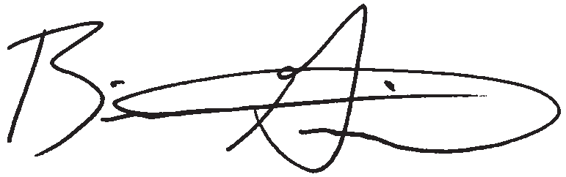
Sincerely,

Brian K. Griepentrog, Ph. D. Director of Research
Fors Marsh Group LLC

L2_13257-K
Research conducted by

P.O. Box 42048 • Arlington, VA 22204-9048



IRS SMALL BUSINESS/ SELF-EMPLOYED CUSTOMER SATISFACTION SURVEY EMPLOYMENT TAX
EXAMINATION

P.O. BOX 42048
ARLINGTON, VA 22204-9048

Do We Have Your Input Yet?

IRS SMALL BUSINESS/ SELF-EMPLOYED CUSTOMER SATISFACTION SURVEY EMPLOYMENT TAX
EXAMINATION
Recently, you received a survey asking your opinions about the service you received from the IRS in a recent contact. If you have already completed and returned the survey, please
accept our sincere thanks. If not, please take a few minutes to complete it and return it today. We want to be sure we have your opinions and suggestions.

If you did not receive the survey, or it got misplaced, please call us at 1-800-521-7177.

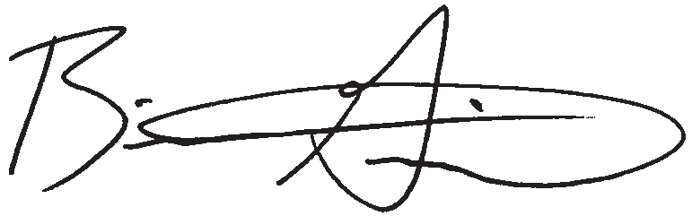
Sincerely,

Research conducted by

Brian K. Griepentrog, Ph.D. Director of Research
Fors Marsh Group

L3_13257-K

Dear

Recently you received a survey requesting your feedback about your experiences during a recent IRS audit of your employment tax return. So far, we have not received your completed survey. If you have not already completed the survey, please take a few minutes to fill in your responses. If another person was primarily responsible for dealing with the IRS on this matter, please direct the survey to that person and encourage him or her to respond.

We are administering a nationwide survey among people who had a recent IRS audit of an employment tax return. We want to know your opinions regarding the audit process and the service you received. Your responses are critical to the accuracy of this research.

We are sending surveys to all taxpayers who have gone through a recent examination of an employment tax return. All responses will be anonymous to the IRS, and your participation is voluntary. We will group your responses with others, so that no individual reply can be traced back to any one person.

The survey is quite brief and should take less than 5 minutes to complete. Please use the postage-paid reply envelope to return your completed survey. If you have any questions about this survey, please feel free to call us toll-free at 1-800-521-7177, or email us at irssurveyhelp@forsmarshgroup.com.

The IRS is committed to improving its performance and service to the American public. A first step in this process is to gather reliable information from those who have had contact with IRS services and employees. Your honest opinions will help bring about this improvement.

Thank you in advance for your cooperation.

Sincerely,

Brian K. Griepentrog, Ph. D. Director of Research
Fors Marsh Group LLC

L4_13257-K
Research conducted by

P.O. Box 42048 • Arlington, VA 22204-9048

IRS SMALL BUSINESS/SELF-EMPLOYED CUSTOMER SATISFACTION SURVEY
EMPLOYMENT TAX EXAMINATION
OMB# 1545-1432

The IRS is trying to improve its service to the public. You can help in this important mission by answering the questions below. This voluntary survey should take less than 5 minutes to complete. Your responses will be kept completely anonymous to the IRS. If you have any questions about this survey, you may call the Survey Helpline at 1-800-521-7177.

The questions that follow ask your opinion regarding how the IRS handled your recent examination. For each question, regardless of whether you agree or disagree with the final outcome, please indicate your answer by filling in the circle that best represents your opinion.
Q1

A.

B.

C.

D.

Please continue on back
 | How would you rate the...  Explanation of why you were being examined? | Very  Dissatisfied  1 | Somewhat  Dissatisfied  2 | Neither Satisfied Nor Dissatisfied  3 | Somewhat  Satisfied  4 | Very  Satisfied  5 | Don't Know/ Not  Applicable  NA
 | Explanation of the exam process? | 1 | 2 | 3 | 4 | 5 | NA
 | Ease of understanding the notice regarding your initial appointment? | 1 | 2 | 3 | 4 | 5 | NA
 | Time given you to provide requested information to the IRS? | 1 | 2 | 3 | 4 | 5 | NA
E. F.  G.  H. | Time the IRS took to respond to you? | 1 | 2 | 3 | 4 | 5 | NA
E. F.  G.  H. | Flexibility of auditor in scheduling meetings? | 1 | 2 | 3 | 4 | 5 | NA
E. F.  G.  H. | Reasonableness of information you were asked to provide? | 1 | 2 | 3 | 4 | 5 | NA
E. F.  G.  H. | Explanation of why records were required after initial appointment? | 1 | 2 | 3 | 4 | 5 | NA
I. J. K.  L. | Business knowledge of your auditor? | 1 | 2 | 3 | 4 | 5 | NA
I. J. K.  L. | Tax knowledge of your auditor? | 1 | 2 | 3 | 4 | 5 | NA
I. J. K.  L. | Courtesy of your auditor? | 1 | 2 | 3 | 4 | 5 | NA
I. J. K.  L. | Consideration given to the information you submitted? | 1 | 2 | 3 | 4 | 5 | NA
M. N. O. P.  Q. | Length of the exam process from start to finish? | 1 | 2 | 3 | 4 | 5 | NA
M. N. O. P.  Q. | Amount of time you had to spend on the examination? | 1 | 2 | 3 | 4 | 5 | NA
M. N. O. P.  Q. | Understanding that you have payment options? | 1 | 2 | 3 | 4 | 5 | NA
M. N. O. P.  Q. | Explanation of why adjustments were made? | 1 | 2 | 3 | 4 | 5 | NA
M. N. O. P.  Q. | Fairness of treatment by the IRS? | 1 | 2 | 3 | 4 | 5 | NA

IRS SMALL BUSINESS/SELF-EMPLOYED CUSTOMER SATISFACTION SURVEY
EMPLOYMENT TAX EXAMINATION
OMB# 1545-1432

Regardless of whether you agree or disagree

Don't

Are you…?
Q2 with the final outcome, how would you rate your overall satisfaction with the way your examination was handled? | Very  Dissatisfied  1 | Somewhat  Dissatisfied  2 | Neither Satisfied Nor Dissatisfied  3 | Somewhat  Satisfied  4 | Very  Satisfied  5 | Know/ Not Applicable  NA

Q3
1 The taxpayer
2 A tax professional who represented the taxpayer
3 Someone else who represented the taxpayer

If you have been unable to resolve any specific problems with your tax matter through the normal IRS channels, or now face a significant hardship due to the application of the tax law, we encourage you to contact the Taxpayer Advocate Service at 1-877-777-4778.

Q4 Use this space for comments or suggestions for improvement.

Internal Revenue Service, Special Services Section, SE:W:CAR:MP:T:M:S, 1111 Constitution Ave. NW, Room 6129, Washington, DC 20224.

Thank you for completing the survey.
Please return the questionnaire to P.O. Box 42048, Arlington, VA 22204-9048 USA.

Paperwork Reduction Act Notice. The Paperwork Reduction Act requires that the IRS display an OMB control number on all public information requests. The OMB Control Number for this study is 1545-1432. Also, if you have any comments regarding the time estimates associated with this study or suggestions on making this process simpler, please write to the: Internal Revenue Service, Tax Products Coordinating Committee, SE:W:CAR:MP:T:T:SP, 1111 Constitution Ave. NW, Washington, DC 20224.

