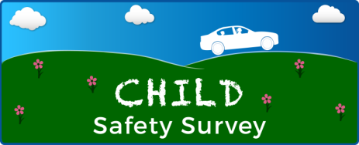
Please help the National Highway Traffic Safety Administration (NHTSA) at the U.S. Department of Transportation (DOT) improve child safety in your community.

Your participation in the Child Safety Survey will help us make travel safer for children and build better child safety programs.

About a week ago we sent you a letter asking for your help with this important survey. If you have already responded – thank you! If not, there’s still time.

To begin the survey, please visit the study website at www.childsafetysurvey.com and enter your PIN. Your PIN is located under your address on the other side of this card.

You will receive $5 as a thank you for completing the survey.

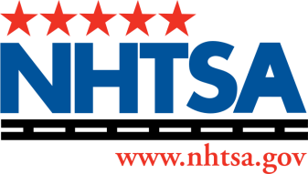
Questions? Please email XXXXXXXXXXXXXXXXXXX or call 1-800-XXXXXX
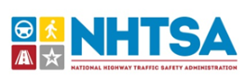
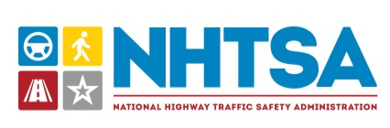
Thank you for helping to improve child safety!
Si quiere participar en este estudio sobre la seguridad infantil, o si quiere
obtener más información, por favor llame al 800 NUMBER.

Address – TBD
OFFICIAL BUSINESS
Resident
<Primary Address>
<City>, <State> <ZIP>
<PIN>

The Child Safety Survey is sponsored by the
U.S. Department of Transportation

