[Month, Day, Year]
[Name and Credentials]
[Title]
[Name of Organization/Facility]
[Street Address]
[City, State, Zip Code]

Dear [Complete Name]:
Researchers at RAND, a non-profit research organization, are collaborating with AHRQ to study practice’s use of patient experience surveys, specifically how practice leaders use the data from these surveys, if at all, during PCMH transformation, and the effects of changes made during PCMH transformation on patient experiences. You will find additional information in the enclosed materials, which describes the various components of the study. At this point, we are reaching out to you to set up and conduct an interview.
We are asking 150 practices across the country to participate. You were identified as one provider from your practice involved in your practice’s NCQA PCMH Recognition process. We would like to complete a telephone interview and ask you to fill out a PCMH assessment tool to understand your practice’s “PCMH-ness”. The interview will take about 40 minutes and you will receive a $75 honorarium to thank you for your time to do the interview. The assessment form takes about 10 minutes to complete and you will receive an additional $75 honorarium upon its completion.
Your participation in any aspect of the study is voluntary and your answers are strictly confidential. RAND will use the information you provide for research purposes only. We will not disclose your identity or information that would identify you to anyone not working on the survey without your permission, except as required by law.
If you would like to schedule an interview, please contact {RAND SRG STAFF} at RAND at {PHONE} or e-mail {RAND STAFF EMAIL} She will be contacting you in about 2-3 days to answer any questions you may have.
Thank you in advance for your participation.

Sincerely,
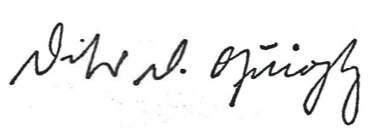
Denise D. Quigley, PhD
RAND Health
Principal Investigator, PCMH Items QI Demonstration Study, CAHPS IV Project

