Supporting Statement to Request Reinstatement of Information Collection

Antidrug and Alcohol Misuse Prevention Programs

for Personnel Engaged in Specified Aviation Activities—2120-0535

1. Explain the circumstances that make the collection of information necessary.

The FAA mandates specified aviation entities to conduct drug and alcohol testing under its regulations, Antidrug and Alcohol Misuse Prevention Programs for Personnel Engaged in Specified Aviation Activities (14 CFR Part 121, appendices I and J), 49 USC 31306 (Alcohol and controlled substances testing), and the Omnibus Transportation Employee Testing Act of 1991 (the Act).

This collection of information supports the DOT and FAA strategic goals for safety.

2. Indicate how, by whom, and for what purpose the information is to be used, and the actual use made of the information received from the current collection.

The FAA uses this information for: determining program compliance or non-compliance of regulated aviation employers, oversight planning, determining who must provide annual MIS testing information, and communicating with entities subject to the program regulations. In addition, the information is used to ensure that appropriate action is taken in regard to crew members and other safety-sensitive employees who have tested positive for drugs or alcohol, or have refused to submit to testing.

3. Describe whether the collection of information involves the use of automated or other technological collection techniques and any consideration of using information technology to reduce the burden.

In 2004, the Drug Abatement Division issued a regulation that requires part 121 and 135 certificate holders and those entities holding 145 certificates that opt to obtain antidrug and alcohol misuse prevention programs to certify their compliance by obtaining an A449 paragraph in FAA’s Operations Specifications System (OPSS). Companies that possess the capability of transmitting information securely can make and amend these entries electronically. Others may call or mail/email information to be input by the FAA. Therefore, in reference to the Government Paperwork Reduction Act requirements, and as explained in the following paragraph, most submissions may be made electronically.

Line 13.b.1. of the Paperwork Reduction Act Submission form, i.e., “Percentage of these responses collected electronically” refers to responses required in the form of reports to the FAA, i.e., items 2, 10, 11, 12 and 13 on the attached table -- of these responses 60% are submitted to the FAA electronically. The remaining Paperwork Burden responses consist of recordkeeping and may be accomplished in any form (electronic or otherwise) that the respondents choose. We estimate that a similar percentage of these responses, i.e., 60%, are maintained electronically as well.

4. Describe efforts to identify duplication. Show specifically why any similar information already available cannot be used or modified for use.

No similar information exists.

5. If the collection of information impacts small businesses or other small entities, describe methods used to minimize burden.

The Drug Abatement Division reduced the paperwork burden on small businesses by simplifying the data requirements for certifying.

- Describe the consequences to Federal program or policy activities if the collection was conducted
less frequently.

The data required for program certification or registration is provided upon startup by each regulated company and then amended only when significant program changes occur or after three years; whichever comes first. If we were unable to update company information, we would not be able to stay current with the status of companies we regulate. Furthermore, if we did not receive reports of positive drug or alcohol tests or test refusals by airmen, we would not be able to take critical action regarding the status of their certificates, resulting in a serious detriment to public safety.

7. Explain any special circumstances that require the collection to be conducted in a manner inconsistent with the guidelines in 5 CFR 1320.5(d)(2)(i)-(viii).

The information required is not in conflict with these guidelines.

8. Describe efforts to consult with persons outside the agency to obtain their views on the availability of data, frequency of collection, the clarity of instructions and recordkeeping, disclosure or reporting format, and the data elements to be recorded, disclosed, or reported.

Every regulation pertaining to the program has been preceded by a Notice of Proposed Rulemaking that sought public comments. All such comments were considered before final rules were published. Furthermore, the FAA published a Federal Register Notice on August 23, 2016 (81FR58549), requesting public comments about our intention to seek Office of Management and Budget (OMB) approval of our current information collection. No comments were received.

9. Explain any decision to provide any payment or gift to respondents, other than remuneration of contractors or grantees.

No payments or gifts are provided.

10. Describe any assurance of confidentiality provided to respondents and the basis for the assurance in statute, regulation, or agency policy.

The antidrug and alcohol misuse prevention testing programs are replete with confidentiality protections for safety-sensitive workers who are tested, at every stage of testing, from random selection for testing through collection and processing of urine or breath samples, to handling, communication, and storage of the results. These protections are specified throughout the pertinent regulations, which are 49 CFR Part 40 and 14 CFR Part 121, Appendices I and J. Enforcement of these protections is a major responsibility both of the FAA Drug Abatement Program and the Department of Transportation Office of Drug and Alcohol Policy and Compliance.

As explained above, the statutory authority for these assurances of confidentiality is contained in The FAA’s authority to issue rules regarding aviation safety (Title 49 USC). Subtitle VII, Section 106 describes the authority of the FAA Administrator. Subtitle VII, Section 45102, charges the FAA with prescribing regulations to establish programs for drug and alcohol testing of employees performing safety-sensitive functions for air carriers.

11. Provide additional justification for any questions of a sensitive nature.

There are no questions of a sensitive nature.

- Provide estimates of the hour burden of the collection of information.

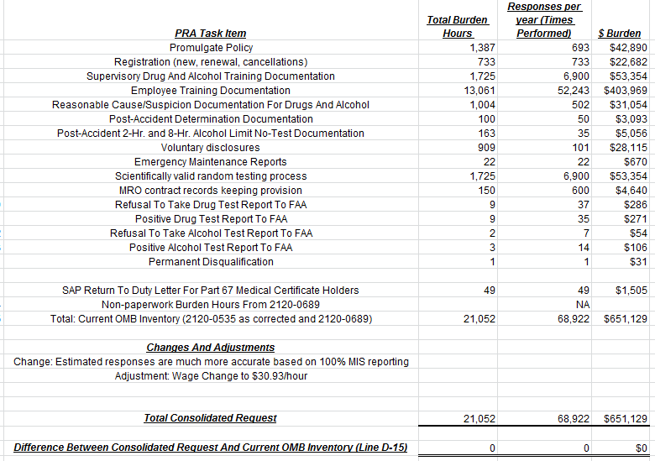

13. Provide an estimate of the total annual cost burden to respondents of recordkeepers resulting from the collection of information.

There are no costs other than what is listed in the attached table.

14. Provide estimates of annualized costs to the Federal Government.

--- OpSpec certification or registration tracking process
--- Annual report tracking and analysis
--- Processing reports on drug and alcohol test refusals

Total staff hours = 3,397.67 staff hours for a total cost of $145,641
This represents 3,387 hours at an average hourly rate of $43.00, totaling $145,641 (previously reported in 2120-0535 which incorporated the previous 2120-0685 submittal), an average hourly rate of $3.00 higher than in 2013, totaling $10,161 more than in 2013.

Total contractor costs: $21,000

Total cost to the Federal Government: $156 ,709.49

15. Explain the reasons for changes in burden.

Since 2015, all covered companies have been required to complete a Management Information System (MIS) report to the DOT. Because of this previously existing requirement, the estimation for the numbers above are based on actual data instead of an estimate. The actual numbers are lower than previously reported values.

16. For collections of information whose results will be published, outline plans for tabulation and publication.

These results will not be published.

17. If seeking approval to not display the expiration date for OMB approval of the information collection, explain the reasons that display would be inappropriate.

No such approval is being requested.

18. Explain each exception to the certification statement.
There are no exceptions.

