Family Options Study: Long Term Tracking

Supporting Statement for
Paperwork Reduction Act Submission
Part B

May 25, 2017

Family Options Study 36-Month Follow-Up Data Collection – Draft

Table of Contents
Part B: Collection of Information Employing Statistical Methods 1
B.1 Identification of Appropriate Respondents 1
B.1.1 Sample Recruitment and Random Assignment 1
B.1.2 Universe of Households and Survey Samples 3
B.2 Administration of the Survey 4
B.2.1 Statistical Methodology for Stratification and Sample Selection 4
B.2.2 Estimation Procedures 4
B.2.3 Degree of Accuracy Required 4
B.2.4 Unusual Problems Requiring Specialized Sampling Procedures 5
B.2.5 Any Use of Periodic Data Collection Cycles to Reduce Burden 5
B.3 Maximizing the Response Rate and Minimizing Non-Response Risk 5
B.4 Test of Procedures 7
B.5 Individuals Consulted on Statistical Aspects of the Design 8
References 9

Part B: Collection of Information Employing Statistical Methods

B.1 Identification of Appropriate Respondents

B.1.1 Sample Recruitment and Random Assignment
The Family Options Study was conducted as a randomized experiment. From September 2010 through January 2012, the research team enrolled 2,282 homeless families into the study in 12 sites. Each family was randomly assigned to one of four interventions:

- Permanent Housing Subsidy (SUB)
- Project-Based Transitional Housing (PBTH)
- Community-Based Rapid Re-housing (CBRR)
- Usual Care (UC)

In an effort to maximize the likelihood that families randomly assigned to the study interventions could actually receive the assigned intervention, the research team established conditions that had to be met for random assignment to proceed:

- Families had to meet the general eligibility requirements—reside in shelter at least 7 days prior to enrollment and have at least one child age 15 or under with them—for participation in the study and had to consent to enroll in the study.
- Intervention slots had to be available at the time of random assignment or anticipated within 30 days.
- Families had to meet more particular intervention-specific program eligibility criteria for at least two interventions for which slots are available. These more particular requirements included such things as having no criminal background, being clean and sober, having some form of income, not owing back rent to a housing authority, etc.

Enrollment in the study and conducting random assignment was a multi-step process, as shown in Exhibit B-1. The right side of the exhibit summarizes the conditions under which some families would be ineligible or decline to participate.

Exhibit B-1. Random Assignment Process
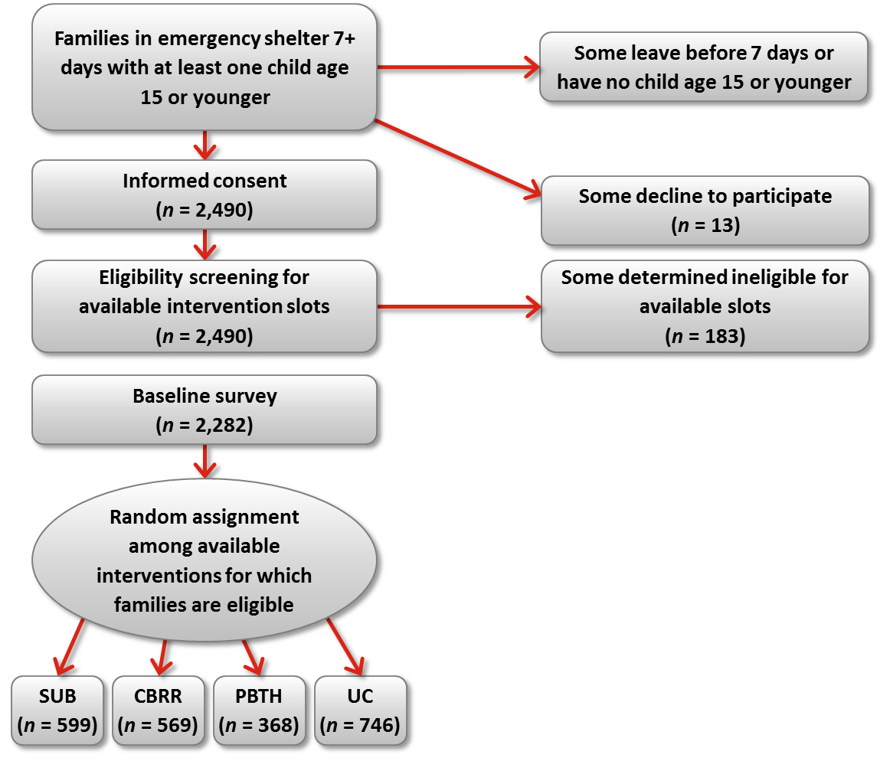
Notes: 2,307 families completed the baseline survey and were randomly assigned. The research team subsequently determined that 25 of these families should not have been enrolled in the study, as they did not have at least one child age 15 or younger at enrollment. These 25 families were removed from the impact analysis sample.

The study was not designed to capture the experiences of families who sought assistance directly from transitional housing programs without first entering emergency shelters. The design relied on emergency shelters as the point of intake for families in the study.

The design excluded families who left shelter in less than 7 days because the more intensive interventions considered in this study were not considered appropriate for families with such transitory needs. The research team expected shelters to continue to provide all services and referrals they ordinarily provided to help families leave shelter up until the point of random assignment. As shown at the top of the exhibit, the population of interest for this study was all families who had been in an emergency shelter for at least 7 days and who had at least one child 15 or younger at baseline. This restriction was included because child outcomes are important to the study, and the study would not have a large enough sample to consider outcomes for youth who become young adults in the course of the follow-up period. Following enrollment and baseline data collection, families were randomly assigned, as close to the 7-day mark as was feasible, to one of the four interventions.

The study design also recognized that not all families were eligible for all interventions. Consistent with this consideration, families were screened as to their eligibility for each specific service provider in their site, prior to random assignment. Families were randomly assigned among only interventions for which they appeared eligible, based on their responses to a set of intake screening questions. As long as one provider within each intervention at a given site would accept a family with a particular profile, that family was considered eligible for that intervention.

As described below, this design assured that comparisons of interventions involved well-matched groups in each intervention. To achieve this, a family was included in the pairwise impact comparisons only for pairs of interventions to which it could have been assigned (i.e., interventions that were available at the time of that family’s randomization and for which the family was eligible). The design thus assured that any observed differences in outcomes are caused by the differential treatment families receive following random assignment, and not by any pre-existing differences among the families.

Although assignment to interventions was conducted at random, within interventions families were not assigned at random to specific service providers that provided the intervention. Allocation among providers was made instead on the basis of family characteristics, as is customary practice in the housing assistance system. Thus, for example, if one or more of the transitional housing programs in a site specialized in families with a particular profile (only families with domestic violence issues, or only families where the mother has been clean and sober for some period), then among families randomly assigned to PBTH, only those that fit that program were assigned to that service provider. This preserves and studies programs as they operated. For more information on the short-term impacts from the 20-month follow-up study, please refer to Gubits, et al. (2015). Information on the three-year impacts of housing and services interventions were published in October 2016 (Gubits et al., 2016).

B.1.2 Universe of Households and Survey Samples
This supporting statement seeks clearance for a data collection effort to collect two types of data:

- Participant contact information updates
- A tracking interview

72-Month Tracking Interview and Participant Contact Information Form
The universe for the 72-month tracking interview and the participant contact information updates is the adult respondent from all families who were enrolled in the study (2,271 families, 2,282 enrolled less 11 families known to be deceased at the time of the 37-month follow-up survey). To be eligible for the study, the families—defined as at least one adult and one child—had to have experienced homelessness, received assistance at an emergency shelter, and remained in the shelter for at least seven days prior to enrollment. There are no sample selection requirements as all enrolled families are eligible to participate in the 72-month tracking interview and the participant contact updates.

B.2 Administration of the Survey
The full sample of 2,271 families will be released for tracking and locating activities and the 72-month tracking interviews. Interviewers will attempt to locate respondents and complete tracking interviews during a six-month period from April 2017-October 2017. Local Abt SRBI field interviewers will conduct the tracking and interviewing activities. Interviewers will first call respondent contact phone numbers. If they reach the participant, they will complete the interview. If they do not reach the respondent, interviewers will continue to attempt to contact families by phone, using secondary contacts, as well as attempting to reach out to participants via email and mail. After all of those efforts have been exhausted local interviewers will begin in-person efforts for any non-completed cases. Wherever possible, once an interviewer locates the participant—an immediate attempt will be made to complete the 15-minute tracking interview.

B.2.1 Statistical Methodology for Stratification and Sample Selection
The study sample for the long term tracking data collection is all 2,271 families enrolled in the study (families known to have been deceased at the time of the 37-month survey are excluded). Therefore, no sampling or stratification is required for the long term tracking interviews and participant contact updates.

B.2.2 Estimation Procedures
The objective of the long-term tracking project is to attempt to locate the study sample, update contact information, and collect a small number of items collected previously during earlier data collection. No impact analysis is planned. The data collected will be used to assess the feasibility of renewing contact with the study sample and for conducting future follow-up data collection. The data items to be collected in the tracking interview will be appended to the longitudinal database established for the Family Options Study to augment the research platform.

B.2.3 Degree of Accuracy Required
The objective of the long-term tracking project is to attempt to locate the study sample, update contact information, and collect a small number of items collected previously during earlier data collection. No impact analysis is planned. The data collected will be used to assess the feasibility of renewing contact with the study sample and for conducting future follow-up data collection. The data items to be collected in the tracking interview will be appended to the longitudinal database established for the Family Options Study to augment the research platform.

B.2.4 Unusual Problems Requiring Specialized Sampling Procedures
In this study, the research team may encounter interview respondents whose first language is Spanish. As done in prior data collection efforts, the research team will translate the 72-month tracking survey instrument and participant contact update form into Spanish, for respondents who prefer to complete the data collection in Spanish. The consent forms also will be translated into Spanish. All prior interviews were conducted in either English or Spanish, with no need for other languages, thus the research team does not anticipate other language needs for the 72-month tracking data collection.

B.2.5 Any Use of Periodic Data Collection Cycles to Reduce Burden
The research team will use two types of administrative data to provide additional contact information for tracking and locating the study sample. These data do not impose any respondent burden. The research team will obtain data from HUDs Homeless Management Information System (HMIS)/ PIH Information Center (PIC)and Tenant Rental Assistance Characteristics (TRACS) data systems to obtain historical data on the receipt of housing assistance. PIC and TRACS data will be collected twice over the three-year contract period. PIC and TRACs will provide address information for families who receive housing assistance that is reported in these systems.

B.3 Maximizing the Response Rate and Minimizing Non-Response Risk
The research team conducted intensive tracking with study families from enrollment throughout the initial three-year follow-up period (data collection ended in December 2014). The tracking approach was designed to maintain contact with the study sample every three months during that time, which was essential to achieving the highest possible response rates for the 20- and 37-month follow-up surveys. The success of this approach was reflected in the high response rates achieved. In both follow-up efforts, the research team exceeded the target 75 percent response rate for the head of household survey with overall completion rates of 81 percent and 78 percent respectively.

The last contact with the study families occurred during the 37-month follow-up survey data collection. The earliest families to complete that interview did so in March 2014, and the last family completed it in late December 2014. At the time that the 72-month tracking data collection is scheduled to start (April 2017), about 27 to 36 months will have elapsed since the last contact with study families (and an even longer period for families who were not interviewed at 37 months). This is a substantial gap in communication for any longitudinal study of families, but even more so for those who have experienced homelessness and thus may have unstable housing. The 72-month tracking data collection is intended to help assess the feasibility of a future long-term follow-up study. The research team will implement an aggressive tracking protocol, building upon the activities that have proven successful with this population over time, to help the Department assess the likelihood of re-engaging a large enough portion of the study sample to support a future long-term follow-up effort.

In order to estimate the target response rate for this tracking effort, the research team reviewed the completion rate for the prior tracking interviews as well as the time elapsed since the last contact with study families. Exhibit B3 shows the response rates to the tracking interviews under the prior contracts.

Exhibit B3: Completion Rates to Prior Tracking Interviews
 | Sample (N) | Cases Completed (N) | Completion Rate (%)
6-month tracking | 2,282 | 1,671 | 73.2
12-month tracking | 2,282 | 1,632 | 71.5
27-month tracking | 2,282 | 1,149 | 50.4 (62*)
*Not all participants were released for the last tracking interview because the research team released the last few enrollment cohorts prior to the 36-month anniversary. Excluding those cases that were not released for the 27-month interview, the response rate was 62 percent.
In contrast to the proposed 72-month tracking interview, earlier tracking efforts were done when interviewers were in frequent contact with study participants. Of particular relevance for projecting response rate for the 72-month interview, is the 11 percentage point drop in completion rate between the 6-month and 27-month interviews. The drop occurred during a period of time where the research team maintained frequent communication with the study participants, and participants were engaged in the ongoing research efforts.

The study participants have been fairly mobile over time. The research team analyzed the location of the most recently observed location for study participants that completed the 20 and/or 37-month follow-up survey. That analysis showed that 12 percent were living in a state other than the one they lived in at the time of enrollment. This number is likely higher as it does not include those who were not interviewed at 37-months. Further, by the end of the first follow-up period, participants were living in 42 different states (see McInnis and Rodriguez, 2016).

Given the known mobility of the study population, the research team’s experiences in the prior tracking interview efforts, and the uncertainty about feasibility of locating the families after so much time has elapsed the target response rate for the tracking interviews is 50 percent. The research team will strive to exceed this target if possible within the level of resources available for the project.

In order to complete as many tracking interviews as possible, the research team will use a longer field period than used for previous tracking surveys (6 months rather than 12 weeks). The research team will capture detailed information on the final dispositions of all cases, regardless of whether or not a tracking interview was completed. The detailed disposition data will help ensure that the research team and the Department can effectively assess the feasibility of a long term follow-up study.

The research team’s survey management staff will monitor production across sites and intervention groups and report to the Department on a biweekly basis. If changes to the field procedures are needed to reach or exceed our target response rates, the research team will work collaboratively to implement them immediately.

The research team will utilize the same strategies to minimize non-response levels and the risk of non-response bias that proved successful during the 20- and 37-month data collection period. These strategies include the use of:

- Local site interviewers. The research team will rely on the local site interviewers to lead the local data collection activities for the 36-month follow-up survey. These local interviewers are established in the study communities and are well known to the families participating in the study. The research team will also recruit additional interviewers who are skilled at working with this population, to support the data collection.
- Automated field management system. The research team will use a field data collection management system that permits interactive sample management and electronic searches of historical tracking and locating data. This will allow the research team to monitor response rates closely and to work the sample groups for each of the study interventions evenly.

Prior to the start of data collection, the data collection team will review the study sample to identify cases that do not have tracking updates from any point of tracking. These cases will be classified as “high priority cases” and will be assigned to field interviewers to work first. In addition to any information obtained through the tracking process (e.g. updates from participants or information from secondary contacts), the research team will also contact rely on administrative data for updated information. High priority cases will be reviewed by the Field Manager regularly to make sure all leads are followed. Field interviewers will receive a comprehensive history of respondent’s information history collected through the baseline, all interwave tracking components and the 20- and 37-month follow-up efforts (all address, home/cell phone numbers and emails), secondary contacts and any relevant notes collected during the tracking efforts.

As noted in Part A.9, the research team will again use incentives to thank participants for their time responding to the 36-month data collection effort. Adult respondents will receive $25 for completing the 72-month tracking interview. After the 72-month survey, the research team will send adult respondents one request for updated contact information, those who respond will also receive $5 as a token of appreciation for their time spent responding to the request.

B.4 Test of Procedures
The instruments used in the 72-month tracking interview data collection effort are almost identical to the ones previously approved under OMB Approval Number 2528-0259, expiring on 03/31/2017. The interview length used to calculate the burden estimates in Section A12 are based on the actual experience with the prior tracking interviews and 37-month follow-up interview administration efforts. Given the high response rates to prior efforts, we do not anticipate any challenges for respondents to answer them. Therefore, since we are not proposing any new questions or questions previously untested with this study population, we do not believe a pretest will be necessary for this data collection.

B.5 Individuals Consulted on Statistical Aspects of the Design
The individuals shown in Exhibit B-9 previously assisted HUD in the statistical design of the evaluation.

Exhibit B-9. Individuals Consulted on the Study Design
Name | Telephone Number | Role in Study
Dr. Stephen Bell  Abt Associates Inc. | 301-634-1721 | Co-Principal Investigator
Dr. Marybeth Shinn  Vanderbilt University | 615-322-8735 | Co-Principal Investigator
Dr. Jill Khadduri  Abt Associates Inc. | 301-634-1745 | Project Quality Advisor
Mr. Jacob Klerman  Abt Associates Inc. | 617-520-2613 | Project Quality Advisor
Dr. Martha Burt  Consultant to Abt Associates Inc. | 202-261-5551 | Project Advisor
Dr. Dennis Culhane  University of Pennsylvania | 215-746-3245 | Project Advisor
Dr. Ellen Bassuk,  Center for Social Innovation and National Center on Family Homelessness | 617-467-6014 | Project Advisor
Mr. Rick Jarmon  Abt SRBI | 617-386-2601

Inquiries regarding the statistical aspects of the study's planned analysis should be directed to:

Ms. Michelle Wood Project Director Telephone: 301-634-1777
Dr. Daniel Gubits Project Quality Advisor Telephone: 301-634-1854
Dr. Marybeth Shinn Project Advisor Telephone: 615-322-8735

References
Duffer, Allen P. et al., "Effects of Incentive Payments on Response Rates and Field Costs in a Pretest of a National CAPI Survey" (Research Triangle Institute, May 1994).
Gubits, Daniel et al., Interim Report, Family Options Study, Washington, DC: U.S. Department of Housing and Urban Development, March 2013. http://www.huduser.org/portal/publications/homeless/hud_503_FOS_interim_report.html
Gubits, Daniel et al., Family Options Study, 3-Year Impacts of Housing and Services Interventions for Homeless Families. Washington, DC: U.S. Department of Housing and Urban Development, October 2016. https://www.huduser.gov/portal/sites/default/files/pdf/Family-Options-Study-Full-Report.pdf
"National Adult Literacy Survey Addendum to Clearance Package, Volume II: Analyses of the NALS Field Test" (Educational Testing Service, September 1991), pp. 2-3.

The final enrollment count for the study was 2,307 families. However, upon reviewing baseline data collected, the research team determined that 25 families had been enrolled in error and did not satisfy the family eligibility requirement of having at least one child age 15 or younger. These 25 families, scattered at random among the four random assignment arms in the study design, have been removed from the research sample without skewing the statistical equivalence of the arms, leaving 2,282 families.
The term slot refers to opportunities for placement in a study intervention. For SUB intervention, a slot refers to a housing choice voucher or a unit in a public housing or project-based assisted development. For the PBTH intervention, a slot refers to a family’s housing unit or space at a transitional housing facility. For the CBRR intervention, a slot refers to rental assistance provided to the family to subsidize the rent of a housing unit in the community. When we refer to an intervention slot as available, we mean that there was an open space for a family to be placed in that study intervention.
Initially, random assignment was contingent upon family eligibility for available slots in at least three of the four interventions, in order to maximize the number of experimental comparisons that each family could be included in. In August 2011, this condition was relaxed to two of the four interventions in order to take full advantage of service slots that had been reserved for families in the study. Sometimes it took longer to utilize all of the slots for one intervention type than others. In those instances, as one intervention type—CBRR for example—was fully utilized, but another intervention type had slots remaining—SUB for example—we relaxed the requirement in order to take advantage of the slots reserved for the study.

