Appendix B: Interview Protocol

[NOTE TO INTERVIEWER] After each task ask the following question.
How easy or difficult was it to complete this task?
- Very easy
- Somewhat easy
- Neither easy nor difficult
- Somewhat difficult
- Very difficult
Task | Task Name | Text Read to Respondents
1. | Login 1 | First, I’d like you to use this user name and password to log in.
2. | Lunch | Next, you will see a screen instructing you to enter an expense below. On [DATE] you go out to eat lunch with your child and order one meal for yourself and one meal for your child. Enter the expense into the diary.  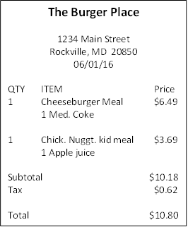
3. | Groceries | On the way home you stop at the grocery store and purchase some food. Enter this expense in the diary.  
4. | Shopping trip 1 | On [DATE] you go shopping at a local discount store and purchase a chair, a video game for your child, and a book to read. You also stop to purchase gas and get your car washed on the way home. Enter the expenses in the diary.  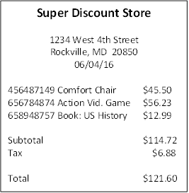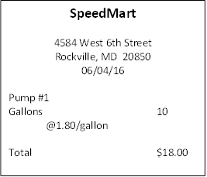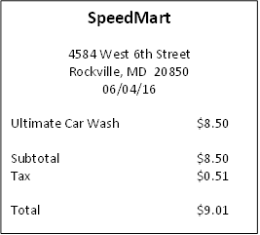
5. | Return book | You decide to return the book that you bought. Please go back and delete that item.
6. | Medicine | On [DATE] you stop at the pharmacy to purchase some medicine to treat your sore throat. You also pick up some personal care products. Enter these expenses in the diary.  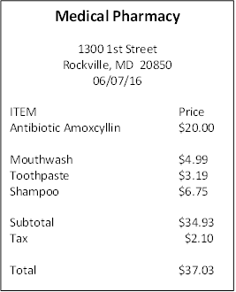
 |  | Now I would like to show you another version of the diary. [DEMONSTRATE BY ENTERING ONE EXPENSE.]
7. | Login 2 | Now, I’d like you to use this user name and password to log in to another version of the diary.
8. | Dinner | Next, you will see a screen instructing you to select the day that some expenses occurred. On [DATE] you and your spouse go out to eat dinner at a restaurant. Enter the expense into the diary.  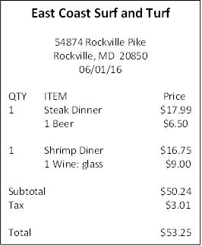
9. | Movie | You also go out to a movie that night after dinner. Enter this expense in the diary.  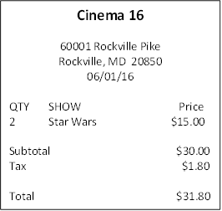
10. | Shopping trip 2 | On [DATE] you take the bus downtown to shop for some jewelry, cosmetics, and clothes. Enter the expenses in the diary.  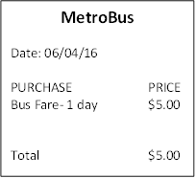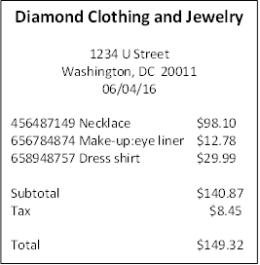
11. | Return shirt | You decide to return shirt that you bought. Please go back and delete that item.
12. | Own expense | Enter the first three purchases on the receipt that you brought with you to the interview.

Debriefing Questions

[ASK Q1 TO Q4 AFTER EACH VERSION OF THE DIARY]

Q1. What do you think about this version of the diary?

Q2. Was the computer diary easy or difficult to use?
- Extremely difficult
- Very difficult
- Somewhat difficult
- Neither easy nor difficult
- Somewhat easy
- Very easy
- Extremely easy
Q3. How confident did you feel in filling out the entries in the diary?
- Not at all confident
- A little confident
- Somewhat confident
- Very confident
- Extremely confident
Q4. How much training do you think the average person would need to get started using the diary?
- None
- A little
- A moderate amount
- A lot
[ASK Q5 AFTER BOTH VERSIONS OF THE DIARY HAVE BEEN COMPLETED]

Q5. Which version of the diary do you prefer – the first one or the second one? Why? (remind respondent what each one looked like if needed)

Q6. What was the most difficult when entering these expenses?

Q7. What was the easiest part of entering expenses?

Q8. Do you have any thoughts for how to make this easier? If yes, what are your thoughts?

INTERVIEWERS: If there is any time left, check with observers to see if they have any additional questions for this participant. If not, thank the participant and dismiss (give them their incentive and have them sign the receipt).

