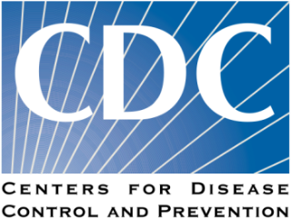
Centers for Disease Control and Prevention
Knowledge, Beliefs, Attitudes and Practices of Providers (K-BAP)
HIV Provider Survey

Several days ago, we mailed you an invitation letter to participate in the K-BAP [City Name] Primary Care Provider HIV Survey. The letter included a link and a password to access the survey online. If you have already completed the survey, please accept our thanks. If you have not had an opportunity to complete it, we are asking for less than 30 minutes of your time, the time it will take you to answer the questions in your survey. The invitation mailing included $20 as a token of our appreciation for completing the survey.
We realize that your schedule is extremely busy and that there are many demands for your time. Participating in this survey is voluntary, but we hope you can help us. Your responses matter. At the end of the survey, you will be given the opportunity to complete a free Continuing Education (CE) eligible course on HIV prevention and treatment.
If you have any questions about the survey or need assistance accessing the online survey, please call 877-828-5101 or email the Study Director at cdc.survey@altarum.org.

Sincerely,

Madeline Sutton, MD, MPH, FACOG
Lead, Minority Health & Health Equity Activity
Division of HIV/AIDS Prevention
Centers for Disease Control and Prevention

