HIGH RISK COUNTIES USED FOR RECRUITMENT IN STUDY*

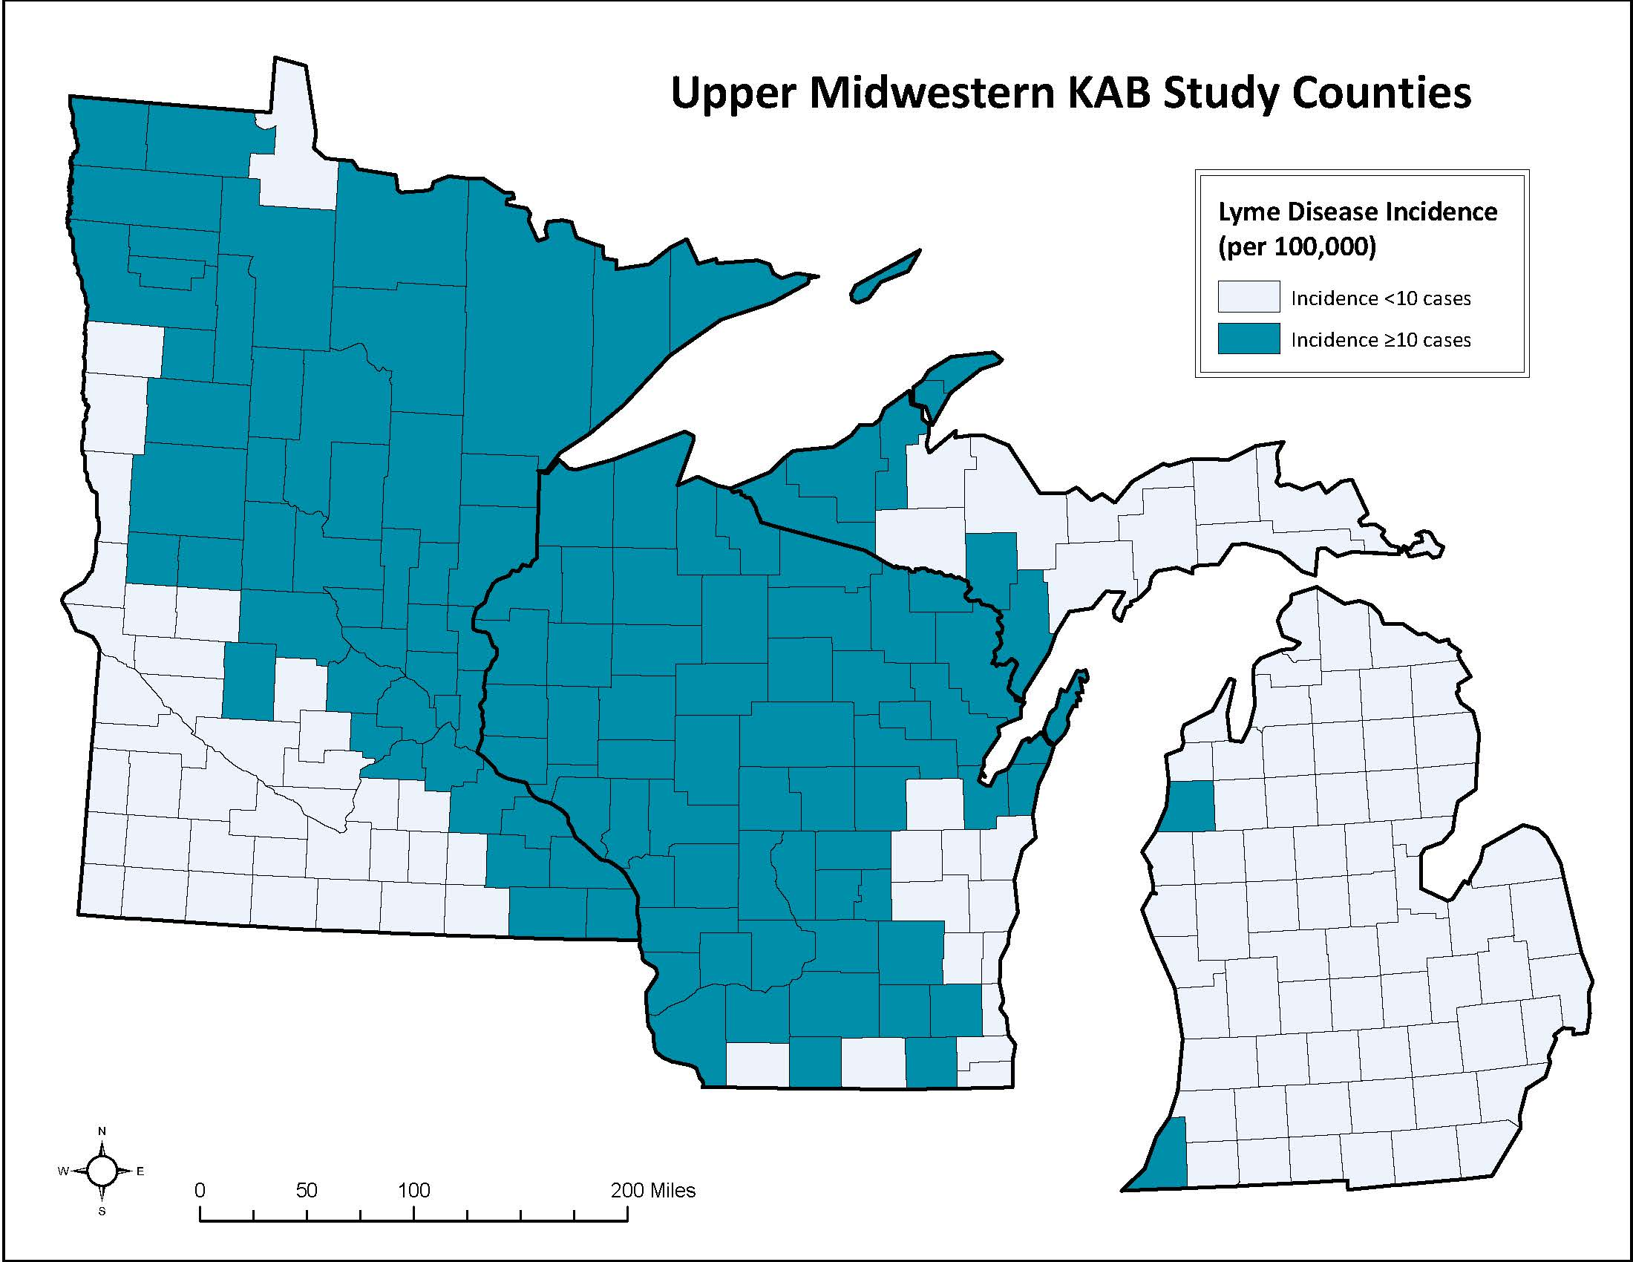
*”High risk” counties used for recruitment in this study have been defined as counties with a five-year average (2013-2017) Lyme disease incidence ≥ 10 cases per 100,000 persons. The list of counties targeted in each of the three states are included below:

Michigan (n=8)
Berrien
Dickinson
Gogebic
Houghton
Keweenaw
Manistee
Menominee
Ontonagon

Minnesota (n=49)
Aitkin
Anoka
Becker
Beltrami
Benton
Carlton
Carver
Cass
Chisago
Clearwater
Cook
Crow Wing
Dakota
Douglas
Fillmore
Goodhue
Grant
Hennepin
Houston
Hubbard
Isanti
Itasca
Kanabec
Kandiyohi
Kittson
Koochiching
Lake
Mahnomen
Marshall
Mille Lacs
Morrison
Olmsted
Otter Tail
Pennington
Pine
Polk
Ramsey
Red Lake
Roseau
Scott
Sherburne
St. Louis
Stearns
Todd
Wabasha
Wadena
Washington
Winona
Wright

Wisconsin (n=59)
Adams
Ashland
Barron
Bayfield
Brown
Buffalo
Burnett
Chippewa
Clark
Columbia
Crawford
Dane
Dodge
Door
Douglas
Dunn
Eau Claire
Florence
Forest
Grant
Green Lake
Green
Iowa
Iron
Jackson
Jefferson
Juneau
Kewaunee
La Crosse
Langlade
Lincoln
Marathon
Marinette
Marquette
Menominee
Monroe
Oconto
Oneida
Pepin
Pierce
Polk
Portage
Price
Richland
Rusk
Sauk
Sawyer
Shawano
St. Croix
Taylor
Trempealeau
Vernon
Vilas
Walworth
Washburn
Waukesha
Waupaca
Waushara
Wood

