Evaluation of Enhancing HIV Prevention Communication and
Mobilization Efforts through Strategic Partnerships

Attachment 3b:
Metrics Data Dictionary


AAA Metrics Dictionary
2015

Compiled by: Sara Bresee, MPH, CHES and Ichhya Pant, MPH
Date last updated: 24 September, 2015
Contact information for all questions: Hannah Badal MPH, CHES and Ichhya Pant, MPH

Contents
AAA Metrics and General Guidelines 7
Act Against AIDS Initiative 7
Purpose 7
Domains 7
How to use this document 10
1. Materials 11
Description 11
2. Events 24
Description 24
3. Media Impressions 32
Description 32
4. Internet Ads 39
Description 39
Type of Internet Ad 39
5. Home Page Views 50
Description 50
6. Gettested.cdc.gov Data 53
Description 53
7. Media Monitoring 56
Description 56
8. Facebook Page-Level 59
Description 59
9. Facebook Post-Level 63
Description 63
10. Continuing Medical Education (CME) 67
Description 67
11. Twitter – Page Level 69
Description 69
12. Twitter – Post Level 71
Description 71
13. Instagram 73
Description 73
14. Videos 74
Description 74
15. Business Responds to AIDS (BRTA) Initiative Metrics 76
Description 76

List of Acronyms

AAA Act Against AIDS
BRTA Business Response to AIDS
AAALI Act Against AIDS Leadership Initiative
CBSA Core Based Statistical Area
CDC Centers for Disease Control and Prevention
CME Continuing Medical Education
CTR Click Through Rates
DHAP Division of HIV and AIDS Prevention
HTW HIV Treatment Works
KOL Key Opinion Leaders
LGBT Lesbian, Gay, Bisexual and Transgender
MAI Minority AIDS Initiative
NPIN National Prevention Information Network
OCAT One Conversation At a Time
PIC Prevention Is Care
PSA Public Service Announcement
TCTT Take Charge. Take the Test
TMUS Testing Makes Us Stronger
Together Let’s Stop HIV Together
STSH Start Talking. Stop HIV
URL Uniform Resource Locator

Relevant Resources
TITLE | DESCRIPTION
Media Dictionaries | Media dictionaries provide a list of campaign materials available for free download on the individual campaign websites and the AAA website. Examples include posters, banner ads, and an HIV testing locater widget. Each campaign has a detailed and short version of this document available as a campaign specific metrics guidance resource. Please contact your designated contact within the PCB Research and Evaluation team to request this resource.
PCB Database User Manual | Guidance document on the PCB Database which functions as an online web portal for AAA campaign staff, contractors, and evaluators to enter and query metrics data for each AAA campaign. Metrics data (e.g. events, materials or other data) can be entered directly by partner organizations, RTI, and CDC staff. Once entered, data can quickly be pulled into reports for analysis. The database has been designed to simplify data management and be user-friendly for all users. This User Manual provides step-by-step instructions for using the AAA Metrics Database.
PCB Database Training Materials | Training Materials available for the PCB database. Please contact your designated contact within the PCB Research and Evaluation team to request this resource.
CDC-INFO | CDC-INFO is the CDC’s national contact center, providing information to the public, healthcare providers, and public health professionals. CDC-INFO also manages the distribution of printed materials through the CDC-INFO On Demand ordering system. On Demand is a webpage where you can order or download CDC materials free of charge.  Website URL: http://www.cdc.gov/cdc-info/
Twitter Activity Dashboard by Twitter | The Tweet activity dashboard is a tool you can use to learn more about your Tweets and how they resonate with your audience. For instance:  - See how people engage with your Tweets in real time  - Compare your Tweet activity, and see how it trends over time  - Click on any Tweet to get a detailed view of the number of Retweets, replies, favorites, follows or clicks it receives  - Download your Tweet metrics  https://support.twitter.com/articles/20171990#
About Page Insights by Facebook | Since Pages are public spaces, your engagement with Pages is also public. We provide Page Insights to Page managers about people's activity on their Page.  https://www.facebook.com/help/336893449723054/
Act Against AIDS Website | http://www.cdc.gov/actagainstaids/index.html
NPIN Website | https://npin.cdc.gov/
Act Against AIDS Twitter Handle | www.twitter.com/talkhiv
Act Against AIDS Facebook Page | https://www.facebook.com/ActAgainstAIDS
Act Against AIDS Instagram Page | www.instagram.com/ActAgainstAIDS
List of AAA Standard Metrics | Standard metrics are collected across all campaigns which is then aggregated up to the overall AAA initiative level. The aggregated data sheds light on the overall status of instances such as total number of materials distributed or total number of HIV tests administered by the Act Against AIDS initiative. Please contact your designated contact within the PCB Research and Evaluation team to request this resource.

AAA Metrics and General Guidelines

Act Against AIDS Initiative
Act Against AIDS (AAA) is a national initiative launched by the Centers for Disease Control and Prevention (CDC) and the White House to combat complacency about HIV and AIDS in the United States. Launched in 2009, Act Against AIDS focuses on raising awareness among all Americans and reducing the risk of infection among the hardest-hit populations – gay and bisexual men, African Americans, Latinos, and other communities at increased risk.

AAA consists of several concurrent HIV prevention campaigns and projects that use mass media (TV, radio, newspapers, magazines, and the Internet) to deliver important HIV prevention messages. All campaigns and projects support the comprehensive HIV prevention efforts of CDC and the National HIV/AIDS Strategy (NHAS).

Purpose
The purpose of the data dictionary is to provide a uniform description to all metrics that fall under the AAA initiative and also provide relevant examples. The AAA initiative has a total of 12 domains. The purpose of these domains and metrics is to monitor and evaluate the progress of the initiative during the implementation period. Data quality assurance is pivotal in order to ensure a rigorous evaluation of effectiveness and reach. The metrics outlined in the data dictionary are utilized by the DHAP Prevention Communication Branch’s Research and Evaluation Team to assist the Mass Media Team, Health Care and Public Health Team, and National Partnership Teams in campaign implementation and assessment of the various campaigns and projects conducted by the branch. These metrics are also used to produce reports that highlight how the Act Against AIDS initiative is reaching its goals, objectives, and target audiences.

Domains
Domains are categories of implementation activities that illustrate campaign effectiveness and reach. Table 1 lists out the 15 non-mutually exclusive domains where similar metrics are captured across various domains.
Table 1. List of domains for the AAA Initiative
No. | Domain Names | Description
 | Materials | This domain captures materials that have been developed and distributed for the AAA initiative. Materials include posters, brochures, and provider kits. They can either be hardcopy or digital materials, such as PDF documents. They can also include materials promotional and novelty items (like pens, condoms or wristbands).
 | Events | This domain captures information on events where there is campaign activity. Events can either be in person or they can be virtual (i.e., via the webinar on the computer or telephone).
 | Media Impressions | This domain captures information on media impressions. Media impressions are the number of estimated times an advertisement or article is seen; however, it is not the unique number of people. One person could contribute to multiple impressions. For example, a billboard on the interstate may have one million impressions, but many of those could come from people who drive that interstate multiple times a week. Impression calculations may change depending upon the medium (e.g., internet, out-of-home). It is, therefore, important to ensure that impressions are standardized as much as possible. Please note: Banner advertisements are a type of paid media impression, but we do not record them here, as they have unique metrics (e.g., click-throughs). Therefore, banner advertisements are recorded in the Internet Advertisements domain.
 | Internet Ads | The Internet Ads domain captures any form of internet advertisement, including banner advertisements and “widgets”. Any advertising done via the internet should be recorded under Internet Ads (as opposed to the media impressions tab). The Internet Ads domain is more tailored to the information that would need to be collected, such as click-throughs.
 | Homepage views | In the Home Page Views domain, we record traffic to AAA sites. This domain has different metrics available for collection, including page views, unique visitors, and number of visits. For AAA, primarily homepage views are tracked. Different analytic services (e.g., site catalyst, Google analytics) track data differently. Thus a limitation of the home page views metrics is that it helps to judge relative traffic from month to month, but it would be difficult to compare two different websites if they had different analytic services.
 | Gettested.cdc.gov Data | This domain was formerly known as hivtest.org and hitvtest.cdc.gov. Data captured in this domain are ZIP code searches for HIV testing locations on Gettested.cdc.gov website or widgets.
 | Media Monitoring | The Media Monitoring domain collects a large array of media monitoring data including:  - Mentions on social media sites like Facebook and Twitter.  - Tracking the usage of Twitter-specific metrics like hashtags (#), handles (@), and keywords.  - Tracking of keywords and phrases usage on Facebook or blogs.  Mentions of AAA or a campaign in mainstream media are captured under Media Impressions and not under Media Monitoring. Media Monitoring captures mentions of AAA on social media.
 | Facebook – Page Level | All Facebook metrics are reported by their internal analytics system called “Facebook Insights”. A benefit of Facebook Insights is that it is standard across all Facebook pages, making it possible to make comparisons between two different campaigns that have Facebook pages.  Page-level records the reach and engagement on Facebook such as net new likes, people talking about this, engaged users etc.
 | Facebook – Post Level | All Facebook metrics are reported by their internal analytics system called “Facebook Insights”. A benefit of Facebook Insights is that it is standard across all Facebook pages, making it possible to make comparisons between two different campaigns that have Facebook pages.  Post-level records engagement and reach of a particular post.  In general though this should not present a large issue as most activity for a Facebook post subsides shortly after posting. For instance, a company (doing a non-peer reviewed study) found that 95% of all likes that a post will receive come in the first 22 hours. [source] Facebook will call metrics for posts “lifetime” metrics even though “lifetime” here is only 28 days. Facebook will only record metrics for a post for 28 days after a post is posted. Any activity that happens after 28 days is not recorded. Thus the Facebook Insights report for the number of likes for a post may not match what we visually see on the Facebook website. Post-Level data should never be pulled until 28 days after it posted.
 | Continuing Medical Education | The Continuing Medical Education (CME) domain captures all metrics related to continuing medical education for health care providers. Continuing medical education refers to classes health care professionals take to keep their medical license valid. They require a certain number per year.
 | Twitter - Page Level | The Twitter Page Level Domain captures data that comes from Twitter for the AAA account handle @TalkHIV. Twitter metrics come from its proprietary analytics dashboard and social media analytics platforms like Sysomos Map and Simply Measured. While these two are the platforms in utilization at the moment to derive web analytics data, please note that the systems could be upgraded or changed in the future. These data are collected to show how people are interacting with tweets and can potentially show which tweets are more successful.  Page-level records tweets posted, number of profile visits, mentions by other profiles, number of new followers, and tweets linking to the account.
 | Twitter - Post Level | The Twitter Post Level Domain captures data that comes from Twitter for the AAA account handle @TalkHIV. Twitter metrics come from social media analytics like Sysomos Map and Simply Measured. While these two are the platforms in utilization at the moment to derive web analytics data, please note that the systems could be upgraded or changed in the future. These data are collected to show how people are interacting with tweets and can potentially show which tweets are more successful.  Post-level records the text of tweets posted, engagements and engagement rate, number of retweets, replies and favorites for the individual tweets made by the @TalkHIV account.
 | Instagram | The Instagram domain captures data that comes from the Instagram account @ActAgainstAIDS. Instagram metrics come from social media analytics platforms like Simply Measured. While Simply Measured is the system currently in use, please note that the systems could be upgraded or changed in the future. Data in this domain is captured to exemplify how individuals are interacting with photos and graphics posted on the account.
 | Videos | The Videos domain captures data related to video views. These are videos that have been posted on an internet platform, like Youtube, where the number of times a video is viewed can be tracked based on clicks or intentional views.
 | Business Responds to AIDS (BRTA) Initiative Metrics | BRTA was launched in 1992 as a long-term, primary prevention program for HIV education. This program encourages business executives, managers, and labor leaders to undertake comprehensive workplace HIV education. The table below documents BRTA specific metrics related to recruitment and outreach and training and technical assistance efforts that do not fall under the domains currently listed within the Act Against AIDS (AAA) data dictionary.

How to use this document
This document contains the specific domains, metrics, definitions, and examples for each metric in the form of a table. Throughout the document, you will see notes in orange boxes that are lessons learned added in based on experiences with other contractors.

PLEASE TAKE NOTE
- Rows within tables that are greyed out to indicate that the metric has been archived and is no longer being actively used.
- Certain metrics will get highlighted through this document for your convenience using the following symbols –
SYMBOL | SIGNIFICANCE | DESCRIPTION
* | Repeating Metrics | This symbol denotes metrics that repeat across the various domains such as date, city, zip code, CBSA etc.
! | Required Metrics | This symbol denotes metrics that are required by the campaigns.

Materials

Description
The Materials domain captures materials that have been developed and distributed for the AAA initiative. Materials include posters, brochures, and provider kits. They can either be hardcopy or digital materials, such as PDF documents. They can also include materials promotional and novelty items (like pens, condoms or wristbands).
Table 2. List of Metrics for the Materials Domain
Metric ID | Title | Description | Example
Begin_date | Begin Date  ! * | The begin date lists the starting point of materials distribution over a number of days. | Brochures may be distributed over a five-day conference. Rather than entering a line for each day, the appropriate begin and end date of the distribution is recorded.
Materials_end_date | End Date  ! * | The end date lists the ending point of materials over a number of days. | Brochures may be distributed over a five-day conference. Rather than entering a line for each day, the appropriate begin and end date of the distribution is recorded.
Materials_idnum | Publication ID Number | The CDC-INFO system has publication ID numbers assigned to campaign materials that are shipped out upon placing formal requests. These are recorded to have a precise record of what materials were distributed through this platform. | Above is a screen shot from CDC-Info of a Prevention Is Care brochure. In red is the Publication ID.
Material_name | Name of Material | Material names are standard names created by the campaign team that describe the materials. | If a brochure is called “HIV and You”, it should always be entered as it is spelled and not “HIV & You”.
Material_url | Material URL | For materials that are hosted online, please record the URL for the actual file and not the web page where the material is housed. Having this information helps the AAA staff identify the material file type and title by following the URL, if needed. | Below is an example of a URL for a poster from HIV Treatment Works: http://www.cdc.gov/actagainstaids/pdf/campaigns/hivtw/hivtw_poster_aaron.pdf
Material_language | Language | This would be the language that different materials are produced in. Materials for most campaigns are in Spanish or English. The database will include a standard dropdown which includes the following options:  - (other)  - (unknown)  - English  - Spanish  - English/Spanish |   Above is a material entirely in Spanish from the One Conversation at a Time (OCAT) campaign.
Material_type | Materials Type  ! | There are 15 types of materials developed and distributed by the various AAA campaigns, which are as follows:
 |  | - Annotated Guide  (Provider campaigns only) A guide from an MMWR that has more detailed annotations on the side. | 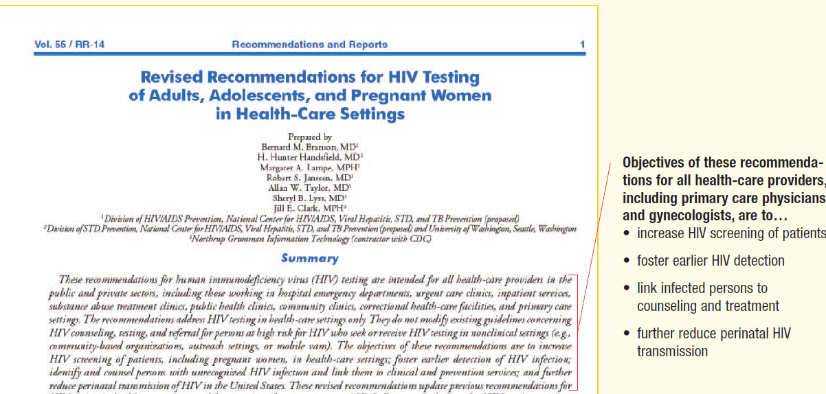  Above is a screenshot from an Annotated Guide from the HIV Screen Standard Care (HSSC) campaign.
 |  | - Backgrounder and Briefing Documents  A document that provides background information on the campaign. It lists strategies and year-to-date highlights. | 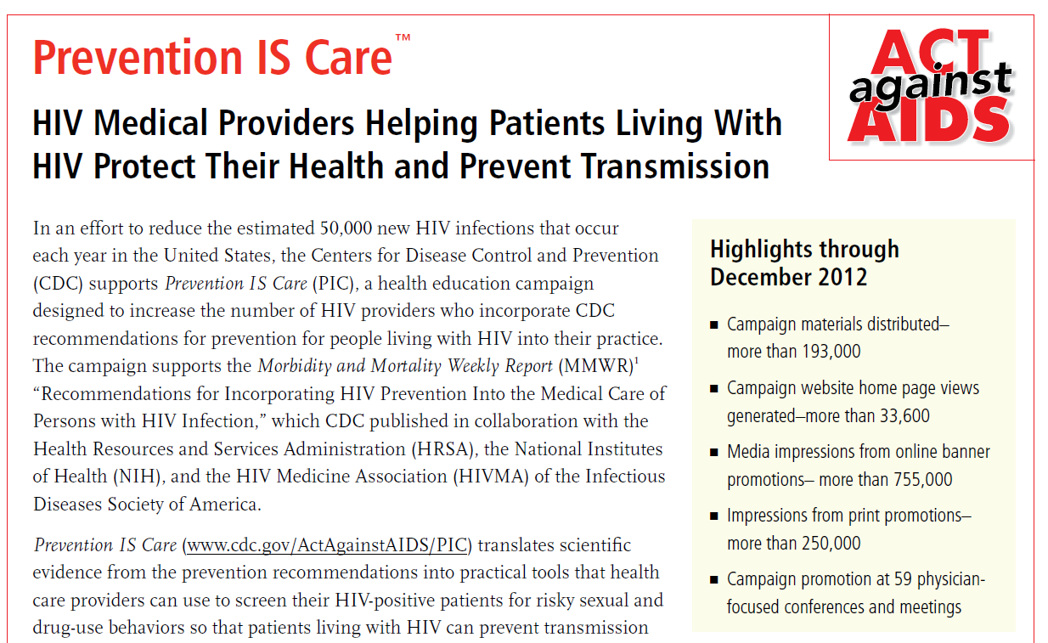  Above is a briefing document describing Prevention is Care (PIC)
 |  | - Brochure/Pamphlets/  Booklets  An informative paper document that is folded or has multiple pages. |   Above is an example of a brochure from PIC.
 |  | - Curriculum  (Provider campaigns only).  A course typically used as a continuing medical education (CME) credit for physicians. |   Above is a screenshot of a curriculum from PIC
 |  | - Dear Colleague Letter  A letter from a colleague (i.e., provided from the CDC) that explains important campaign content and describes campaign resources. | 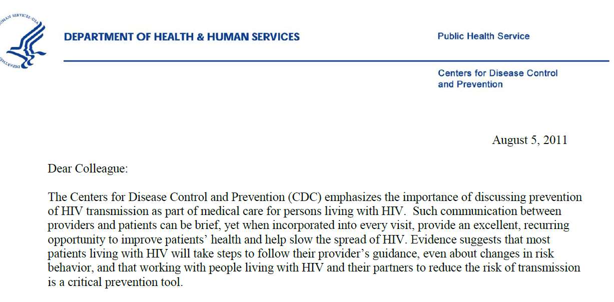  Above is a screenshot of a dear colleague letter from Prevention IS care
- DVDs and CDs
DVDs and CDs are disks that contain electronic versions of materials.
 |  | - Information/Fact Sheets  These are typically one-page handouts and are provide statistics and other facts about a specific population. | 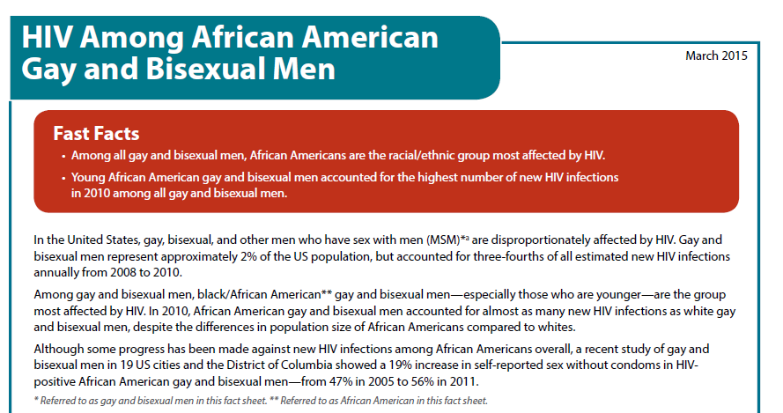  Above is a screenshot of a factsheet for African American Gay and bisexual men
 |  | - Kits  (Provider campaigns only).  Kits are a range of resources, tools, and information bundled together for HIV medical providers to facilitate patient education efforts. |   Above is the cover of the PIC kit folder.
 |  | - Materials Order Card  Also called Business Reply Cards (BRCs). These are cards that end users can fill out to request more materials. Typically MOCs are only used for the provider campaigns. | 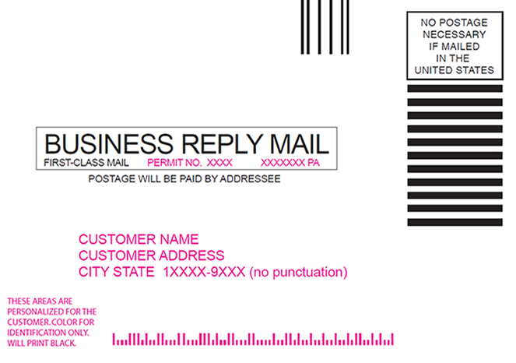  Above is an example of a Business Reply card template.
 |  | - Novelty  Novelty items are materials branded with the campaign logo that do not serve a specific purpose. These items can include pens, wristbands, condoms, bags, t-shirts, and other like items. | 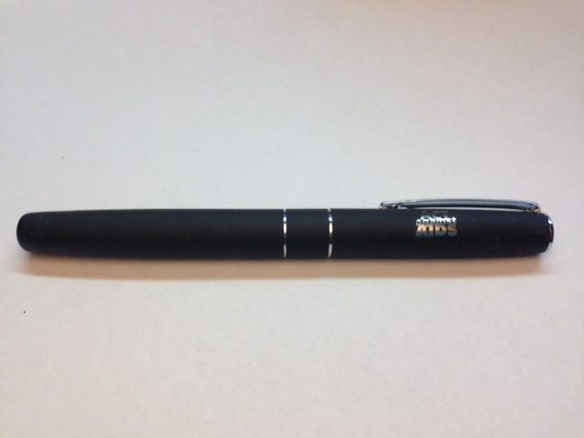  Above is a picture of a pen with the Act Against AIDS logo on it.
 |  | - Palm and Postcards  This category is for tracking smaller palm cards and postcards that are given out, typically at events. They are 4x6 inches in size. |   Above is a palmcard from the HIV Treatment Work (HTW) campaign.
 |  | - Physician Tool  (Provider campaigns only).  This is used for tracking different physician tools that are created for physician use such as decision support wheels or algorithms. | 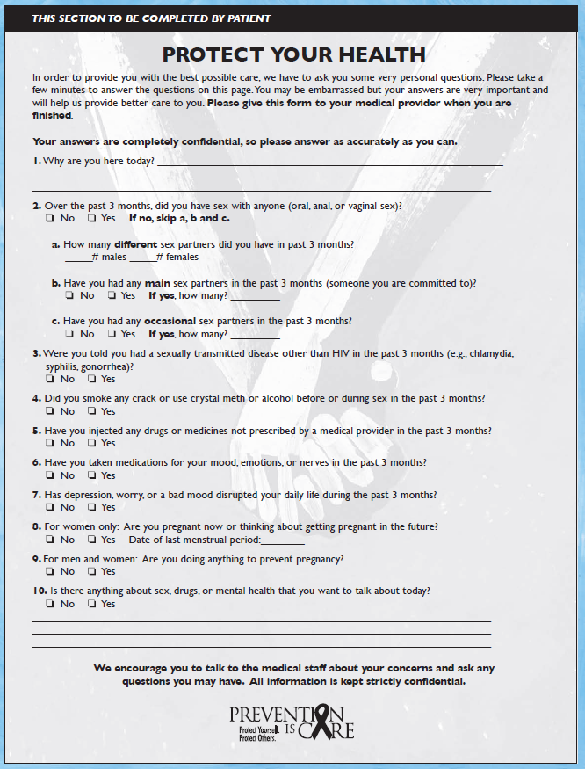  Above is a physician tool from PIC.
 |  | - Posters  Typically they are designed to be posted on a wall. A common use of these are in the provider campaigns where posters are given to physicians to post in their waiting rooms. |   Above is a poster from HIV Treatment Works.
 |  | - Resource Sheet  This is sheet that includes all of the resources for a campaign. Resources in this case refer to CDC websites or medical association websites that can provide guidance to providers. |   Above is an example of a resource sheet for providers.
material_tmus_kit_size | If Items Within a Kit, Kit Size | This metric is currently only used for the TMUS campaign. For TMUS, three distinct sizes of kits are sent out and can be entered into the database utilizing the drop-down list option  - Small  - Medium  - Large
Campaign_name_ _creative_iteration | Creative Iteration  * | Creative iterations are different versions of materials (this includes internet ads) that have the same exact content with minor variations such as a different photo. They can be more than just substantive materials and can also be used for media ad buys and banner ads.  Please note that the database allows for selecting campaign specific creative iterations. |   Above are examples from the Testing Makes us stronger of the same creative iteration.
Material_distribution_channel | Distribution Channel  ! | The distribution channel refers to the final distribution point before the material is received by its intended audience. | If a material produced by the CDC was given to the target audience at a conference, then “Conference” will be the distribution channel.
- AAALI Partner
This is only being used by the AAALI campaign. It records materials that were distributed by AAALI partners. Currently, we always use this code for materials that AAALI partners put on their reports.
- Bulk Order
This refers to when large shipments are sent out together.
 |  | - Participant Network  Refers to when a member of an official campaign network distributes a material. | For example, the Together network or HIV Treatment Works network.
- CDC
This is used to record any materials that are sent out directly from CDC by the campaign managers. If a CDC staff member gives out provider campaign materials at a conference booth, it is recorded as “Conference” instead.
- CDC-INFO
This is used to record any materials that are sent out directly from CDC-INFO which is a national warehouse that holds and distributes campaign materials requested via the CDC-INFO website.
 |  | - CDC Contractor  This is used to record materials that are sent out on behalf of CDC by its contractors. | When a contractor sends out materials to a community based organization this is recorded as “CDC contractor”.
- Conference
Conference” is used to record materials given out at conferences. Here we are talking about large conferences and not small hour meetings that might be called a conference.
- Event- Other
This is used for event types that are not covered in our preexisting list.
- Gay Pride Event
This is used to record materials that were given out at gay pride events.
- Internet
This is used to record digital materials that were downloaded or viewed on the internet.

Hsscmai_external_partner | External Partner Distribution | This is when a specific partner to the HSSC MAI campaign distributes a material.  A drop-down list is available with the following options:  - (other)  - (unknown)  - Annals of Emergency Medicine  - KOL  - NAHA  - National Black Nurses Association  - National Hispanic Medical Association  - National Medical Association
Material_receiving_org_name | Receiving Organization Name | The name of the receiving organization is documented here, if known. If the information is available outside of CDC-INFO orders, it can be listed under this metric as well.
Material_receiving_org_type | Receiving Organization Type | For materials distributed, select the type of organization that they would fall under. If the organization type is unknown, please select an option from the below to the best of your knowledge.  The following list is a menu of dropdown items available as options in the CDC-INFO system. They include:  - (other)  - (unknown)  - AAALI Partners  - Church/Faith-based Organization  - Clinic  - College  - Community-based Organization  - Educator  - Elementary School  - General Population  - Government Agency  - Health Maintenance Organization (HMO)  - High School  - Hospital  - Library  - Local Health Department  - Middle School  - Physician  - Professional Organization  - State Health Department  - Social Organization
Materials_during_event | Were materials distributed during a recorded event?  ! | This is used to record whether or not the materials were distributed at a recorded event. A “recorded event” is an event that was captured under the Events domain. This metric helps clarify the frequency of materials handed out at events. The available options are:  - Yes  - No  - Unsure
Materials_ifevent_name | If yes, name of activity | If materials are given out at a recorded event, the name of the event is recorded under this metric.
Materials_quantity | Quantity Distributed  (Required field) | The number of materials that were distributed are recorded here.
Zip | Zip Code  * | The ZIP code, if known, of where the materials were distributed is recorded here. If the materials are shipped out the shipping ZIP code is captured. Alternatively, if materials are given out at an event, the ZIP code of where the event was held is captured.
City | City  * | The name of the city where the materials were distributed.
State | State  * | The state where the materials were distributed. Expressed as a two letter abbreviation using official US Postal Service abbreviations.
Cbsa | Core-Based Statistical Area (CBSA)  * | A Core-Based Statistical Area (CBSA) is a U.S. geographic area defined by the Office of Management and Budget (OMB) that centers on an urban center of at least 10,000 people and adjacent areas that are socioeconomically tied to the urban center by commuting. The CBSA of where the materials were distributed. The options available for this metric will be have a dropdown menu in the database.
Data_source | Source of Data | This metric is captured to help track where data comes from. Often, data is received from multiple sources and it can be difficult to later see where a piece of data came from (CDC, a contractor, a certain report, etc.).  In the database, the following options will be available for selection as a drop-down list:  - (other)  - (unknown)  - Danya  - Omniture  - Health Department  - FHI  - BWA  - Porter Novelli
Material_source | Source of Material | This metric shows who is distributing the material and has the following options available for selection as a drop-down list:  - (other)  - AAALI Partner  - CBO  - CDC and CDC- Info  - Co-branded  - Danya  - Health Department  - Internet  - Ominture  - Self-developed  - Unknown
Material_year | Material Year | This refers to the year that the material was created.
Materials_comments | Comments  * | This is an open-text field to allow for any comments to be entered to might be helpful later to explain the context or nature of the data entered.  It is important to carefully look at all of the metrics to make sure that whatever comment you would like to make is not already provided below in a different cell. | For example, if data are missing, it is helpful to put into the comments section that you are awaiting data and it will be updated later. However, a common mistake has been for people to put zip codes or into the comment section. Since zip codes are a separate metric, they do not belong here.

Events

Description
This domain captures information on events where there is campaign activity. Events can either be in person or they can be virtual (i.e., via the webinar on the computer or telephone). These metrics have been listed in Table 3 below:
Table 3. List of Metrics for the Events Domain
Metric ID | Title | Description | Example
Begin_date | Begin Date  !* | The begin date lists the starting point of events over a number of days.
End_date | End Date  !* | The end date lists the ending point of events over a number of days.
Event_type | Event Type  !* | Data is collected on the type of events held to track the number of events being held for professional audiences (like conferences) and for consumers (like health fairs). The types of events are as follows:
- Community Engagement Meeting
A community engagement meeting is a meeting where someone goes into the community they are trying to reach. They tend to meet with key opinion leaders in the field.
- Conference
A conference here does not refer to a small meeting, but rather a larger conference such as the annual American Medical Association conference.

When recording attendance, you would record the attendance for the entire conference.

For meetings, use the “Meeting” option described below.
Conference – Booth
“Conference – Booth” is a subset of “Conference”. This option is used for booths that are hosted at a conference. Here, when recording attendance, you would record the number of people who visited the booth.

The attendance is recorded at a booth separately from the attendance at the conference as a whole to have a better sense of how many people were engaged and to avoid double-counting booth and conference attendees.
 |  | Conference – Workshop  “Conference – Workshop” is a subset of “Conference”. This option is used for workshops that are held at a conference. When recording attendance, you would record the number of people who were in the workshop. | If you hold a workshop that is not part of a conference you would use the “Workshop” dropdown option. This option is only used when there is a risk of double-counting the number of people who attended a conference in general and those who attended a workshop at a conference
- Convention
Currently, this dropdown option is only used by AAALI but can be used by other campaigns as well.

Unlike a conference, conventions are usually not research-focused. Rather, it is a large gathering of people interested in a similar topic, or united by demographics or organizational membership. For example, the NAACP holds an annual convention in July for members of the organization.

Unlike meetings, where a select number of people are invited, conventions are typically open to any member of an organization.
- Health Fair
Health Fairs are typically community events focused around health education and disease prevention. Health screenings, including for HIV, are often a component of health fairs.
- KOL Workshop
A workshop that is working with KOL or Key Opinion Leaders. Typically, they brief the KOLs on the campaign or a new topic of the campaign.
- Launch Event
These launch events refer specifically to campaign launch events. That is, when new campaigns are started, this metric records the events that occurred during the launch period.
- Meeting
Meetings are typically smaller in scale and are either in-person, on the phone, or on the computer via Skype or other similar mechanism.
- Outreach
Outreach events are events that directly link to the community. Typically, they are led by community coordinators.
- Panel
Panel discussions are when multiple people are involved. Typically, panels have longer question and answer sessions.
- Pride Event
Pride events are typically LGBT-focused events. This could include gay pride parades or social events
- Testing Event
Testing events are typically focused around HIV testing.
Unlike health fairs, there are no other testing or screening activities being performed.
- Training
A training is an in-person event where a concept or skill is taught. Often, there is an instructor leading the group and there is less input from others in the audience.
- Town Hall
Town Halls are usually informal meetings held to discuss a topic of interest.
- Webinar
A webinar is a type of training delivered over the computer rather than in-person. Webinars are typically live and delivered in real-time
- Workshop
Workshops are a type of training typically more interactive and focus on the application of skills learned.
Event_attendance | Attendance  ! | Record the number of attendees at the event.
Event_leads | Number of Leads | Number of key opinion leaders that answer questions at the event booth.
Event_people_engaged | Number of People Engaged | This field is used to record the precise number of people who were engaged at a larger event. | The number of people that were spoken to at a health fair or number of people who came to the booth.
Event_description | Name and Description of Event  ! | This field is used for recording the name of the event. A short description can be added here as well.
Event_audience | Description of Audience | This field uses a dropdown of predefined audience types to attempt to broadly define the audience engaged. The options are:  - (mixed)  - (other)  - (unknown)  - AFAM - General  - AFAM - Men  - AFAM - MSM  - AFAM - Women  - AFAM - Youth  - General - General Public  - General - Men  - General – MSM  - General - Women  - General - Youth  - Health Provider - Nurse  - Health Provider - Other  - Health Provider - Physicians  - Hispanic - General  - Hispanic - Men  - Hispanic - MSM  - Hispanic - Women  - Hispanic – Youth
Event_hivtest_yesno | Were HIV Tests Offered at This Event?  ! | This field records whether or not HIV tests were administered at the event in relation to the campaign attending the event. If so, the following two fields apply.  - Yes  - No | For example, if another booth at the same event administered HIV testing and CDC facilitated or organized testing, then select “yes”. Similarly, if CDC is driving event attendees to the testing booth, also select “yes” and attempt to get HIV testing data from the organization(s) administering testing.
Event_hivtest_numberof_tests | If Yes, Number of HIV Tests Administered | If HIV tests were administered, record the number of tests given. This may not equal the number of people tested in cases where a person tests multiple times.
event_hivtest_numberof_prelimpositives | If yes, Number of Preliminary HIV Positive Results | This records the number of preliminary HIV test results from the event testing.  As these are rapid tests and require a western blot test to confirm diagnosis, we can only report the number of preliminary positives, rather than confirmed positives.
Zip | ZIP Code  * | The ZIP code, if known, of where event happened. If the event did not happen in a certain zip code (e.g., a webinar) this field can be left blank.  If the exact ZIP code is not known, the surrounding ZIP code is recorded instead. Typically, the purpose of the ZIP is to look up the city, state, and Core-Based Statistical Area.
City | City  * | The name of the city where the event took place.
State | State  * | The state where the event took place. It is expressed as a two letter abbreviation using official US Postal Service abbreviations.
Cbsa | Core-Based Statistical Area (CBSA)  * | A Core-Based Statistical Area (CBSA) is a U.S. geographic area defined by the Office of Management and Budget (OMB) that centers on an urban center of at least 10,000 people and adjacent areas that are socioeconomically tied to the urban center by commuting. The CBSA of the materials distribution location. The options available for this metric will be have a dropdown menu in the database.
event_media_yesno | Did the media produce a story or article about the event, or mention the event in a story or article?  ! | This metric is currently only being used by AAALI only.  This tracks whether or not an event was covered by the media and either wrote a story about it or mentioned the event in a story. The options available for this metric will be have a dropdown menu in the database in the form of a drop-down list with the following options:  - Yes  - No  - Unsure
event_partnership_yesno | Did other AAALI partners have a role or help in this activity?  ! | This metric is currently only being used by AAALI only.  It tracks whether other AAALI partners helped the organizing partner of the event with the event or had some role in the event. The options available for this metric will be d in the database in the form of a drop-down list with the following options:  - Yes  - No  - Unsure
Event_partners_List | [If yes…] List the AAALI partners. | This metric is currently only being used by AAALI only.  If other partners did have a role, they are listed here.
Event-chapterrole_yesno | Did chapters and/or other affiliates of your organization have a role or help in this activity?  ! | This metric is currently being used by AAALI only.  This metric tracks whether or not chapters or affiliates of the AAALI organization had a role with helping with the activity. The options available for this metric will be have a dropdown menu in the database in the form of a drop-down list with the following options:  - Yes  - No  - Unsure
Event_sponsors_yesno | Did this activity have sponsors? Don't include your own organization.  ! | This metric is currently only being used by AAALI only.  This metric tracks whether or not there were sponsors of the activity, excluding their own organization. The options available for this metric will be have a dropdown menu in the database with the following options:  - Yes  - No  - Unsure
Event_externalpartners_yesno | Did other external partners have a role or help in this activity?  ! | This metric is currently only being used by AAALI only.  This metric tracks whether or not there were external partners who had a role in the activity. The options available for this metric will be auto-populated in the database in the form of a drop-down list with the following options:  - Yes  - No  - Unsure
Event_distributematerials_yesno | Did you distribute materials at this event?  ! | This metric is currently only being used by AAALI only.  This metric tracks whether or not materials were distributed during the activity. The options available for this metric will be have a dropdown menu in the database with the following options:  - Yes  - No  - Unsure
Event_host | Hosting Organization | If the event was hosted by another organization, the name of that organization is included here.
Event_purpose | Purpose of Event | The purpose of the event is recorded here. For example, the purpose may have been to reach a certain demographic with materials or to screen for HIV.
Events_stakeholders_partners | Other Partners/ Stakeholders Engaged | If other partners or stakeholders are engaged during the event, those organizations are entered here.
Event_comments | Comments  * | This is an open-text field to allow for any comments to be entered to might be helpful later to explain the context or nature of the data entered.  It is important to carefully look at all of the metrics to make sure that whatever comment you would like to make is not already provided below in a different cell. | For example, if data are missing, it is helpful to put into the comments section that you are awaiting data and it will be updated later. However, a common mistake has been for people to put zip codes or into the comment section. Since zip codes are a separate metric, they do not belong here.

Media Impressions

Description
This domain captures information on media impressions. Media impressions are the number of estimated times an advertisement or article is seen; however, it is not the unique number of people. One person could contribute to multiple impressions. For example, a billboard on the interstate may have one million impressions, but many of those could come from people who drive that interstate multiple times a week. Impression calculations may change depending upon the medium (e.g., internet, out-of-home). It is, therefore, important to ensure that impressions are standardized as much as possible. Please note: Banner advertisements are a type of paid media impression, but we do not record them here, as they have unique metrics (e.g., click-throughs). Therefore, banner advertisements are recorded in the Internet Advertisements domain.
Table 4. List of Metrics for the Media Impressions Domain
Metric ID | Title | Description | Example
Begin date | Begin Date  !* | The begin date lists the starting point of media impressions over a number of days.
End_date | End Date  !* | The end date lists the ending point of media impressions over a number of days.
Media_outlet | Media Outlet  ! | This is a dropdown menu where the type of media outlet is recorded. The options are as follows:  - Internet  This is for recording items that are online. If an article appears in both print and online edition two separate entries are made. One for “Internet” and the other as “Print”. | For example, an article that is on the nytimes.com.
 |  | - TV  TV can either be advertising or lay/professional media (described below). It includes anything broadcast by a TV station that is received by an end user by antenna, cable, and satellite or FIOS/Google Fiber-like service. It does not include recorded videos that are viewed on the internet, DVD players are otherwise not live and are not broadcasted by a television station. Online television stations are not included here. | For example, a PSA airing on the Bravo television network.
 |  | - Out-of-Home  Out-of-home is usually advertising and it appears outside of the home. It is typically in a print format but it can appear electronically. It reaches consumers while they are “on the go”, whether driving or riding public transit. | The best example of out-of-home advertising are billboards that appear alongside roadways. However posters on buses, subways or other mass transit options are also considered out-of-home advertising. Posters in the workplace, waiting rooms and airports also fall under out-of-home advertising. An example of an electronic billboard is a sign in Times Square.
 |  | - Print  Print can either be advertising or lay/professional media (described below in media type). It includes categories, such as newspapers, magazines, and professional journals. Note that posters, even though they are print material, are not included here; instead, they are grouped with out-of-home. | For example, OCAT had a full page advertisement in People en Español.
 |  | - Radio  Radio can either be advertising or lay/professional media (described below). It includes anything on the radio. To count the message must be broadcasted by a radio station over FM, AM, or satellite airways. Streaming audio from the internet or prerecorded audio played on a person’s computer, CD player, or like device does not count. Internet-only radio stations are also not included here. | For example, a PSA plays on a local radio station in Houston.
Media_type | Media Type  ! | Media type is broadly categorized into two categories:
 |  | - Advertising or PSA  In general this includes anything that is advertising. This can be either earned (free) or unearned (paid) media. We later breakout earned vs. donated media for both impressions and dollars paid/donated. | As an example AAA may have a 30-second TV commercial about HIV testing. It is possible that AAA will have to pay for this ad space, but at other times may get donated ad space.
 |  | - Lay or Professional Media  This refers to media impressions that came from a journalist creating a story either on the TV, on the radio, or in print. These are typically unpaid mentions of AAA or a specific campaign.  The following flow chart should help with deciding what media type an item should be placed under. | For example, New York Times publishes an article highlighting PIC.
Media_outlet_name | Name of Media Outlet or Provider | The name of the media outlet is recorded here. | For example: Washington Post
Media_description | Provide a short description of the media activity | When possible, we ask for a short description of the media activity. | For example, providing further data related to out-of-home media like saying it was a billboard or a bus ad.
Campaign_name_creative_iteration | Creative Iteration  * | Creative iterations are different versions of materials (this includes internet ads) that have the same exact content with minor variations such as a different photo. They can be more than just substantive materials and can also be used for media ad buys and banner ads.  Please note that the database allows for selecting campaign specific creative iterations. | Above are examples from the Testing Makes us stronger of the same creative iteration.
Language | Language  * | The language of the advertisement is recorded. Even for campaigns that only have English or Spanish ads, we still like to record the language so that later, on the AAA level, we can run reports to better understand ad impressions by language.  The database will include a standard drop-down menu which includes the following options:  - (other)  - (unknown)  - English  - Spanish  - English/Spanish
Media_reach | Was this a national, regional or local media impression? | When possible, we try to capture the reach of an ad. | For example, was it a local billboard or was a national ad on network television?
 |  | - Local  If an ad is shown only in a specific city, metro area or a CBSA then it would be called local. | For example, a billboard in zip code in the Metro Atlanta Area.
 |  | - Regional  Regional is when an ad is shown in one of the regions according to the US census. For any doubts concerning Region please see the US Census Regions map: http://www2.census.gov/geo/pdfs/maps-data/maps/reference/us_regdiv.pdf | For example, it could be a print ad targeting all Southern states.
 |  | - National  National reach is typically achieved through either national television stations (e.g. NBC, TNT, CNN), satellite radio or nationally-syndicated radio shows. | For example: a national print ad in people magazine.
Zip | ZIP Code  * | The ZIP code, if known, of where media activity happened. If the event did not happen in a certain zip code (e.g., a radio ad), this field can be left blank.  Typically, the only time a ZIP code is available is for stationary out-of-home media (i.e., excluding transit ads). | Billboards, for example, can be pinpointed to one ZIP code. If additional zip codes apply, please enter into the comments field.
City | City  * | If the media activity can be pinpointed to one city it is added here. Like for ZIP codes, this is typically left blank except for out-of-home media.
State | State  * | The state where the media activity occurred. Most media activities can usually be isolated to the state level, even when it is not possible to pinpoint to a city or ZIP level.
Cbsa | Core-Based Statistical Area (CBSA)  * | A Core-Based Statistical Area (CBSA) is a U.S. geographic area defined by the Office of Management and Budget (OMB) that centers on an urban center of at least 10,000 people and adjacent areas that are socioeconomically tied to the urban center by commuting.The CBSA of where the media activity occurred. The options available for this metric will be have a dropdown menu in the database. A CBSA is a multi-digit number code which is equivalent to a geographical location. | For example Metro Atlanta’s CBSA is Atlanta Sandy Springs-Roswell, GA.
Media_paid_impressions | Number of Paid Impressions | Impressions can be broken down into both paid and donated impressions. Paid impressions counts the number of impressions that were paid for.
Media_donated_impressions | Number of Donated/Bonus Impressions | This refers to the number of impressions that were not paid for. It is possible to have both paid and donated impression for the same media activity. A single radio, TV or print activity can also have both paid and unpaid impressions. | For example, a billboard can be paid to remain posted for 30 days and in those 30 days it receives 1,000,000 impressions. Those 1,000,000 impressions would be classified as paid impressions since they were explicitly paid for. If it remained posted another ten days for no cost additional impressions they are unpaid (in this case called “bonus” impressions). So the billboard had both paid and unpaid impressions.  Another example would be a scenario where a digital banner ad is offered as earned media after paying for a print media buy. Or lastly, a full page ad in a Pride Guide is offered in exchange for donated space for a PSA on Bravo TV network.  Distinguishing between and accurately reporting paid vs. unpaid (donated or earned) impressions is very important. It helps us understand additional value that the CDC is getting for per dollars spent.
Media_paid_dollars | Dollars Paid | Record the dollar amount paid for advertisements as a media activity. | For example: a print ad in People magazine that costs $10,000.
Media_donated_dollars | Dollars Donated/Value of Bonus Impressions | For advertisements record how much value was received, either through donated media or through bonus impressions. “Dollars donated” would include the monetary value of either discounted or free media. The “value of bonus impressions” would include the monetary value of extra impressions gained from media running longer than the contracted value (e.g. billboards). Note: do not assign a value to “Lay or Professional Media”, only to “Advertising or PSA”. Lay and professional media is never paid for and therefore should not be assigned a monetary value.  Like with paid and donated impressions, it is possible for the same advertisement to have both a paid and unpaid value. For example, if a radio ad spot normally costs $1,000, but was discounted to $750, we would record dollars paid as $750 and dollars donated as $250
Media_tracking_service | Media Tracking Service | The database will have a drop-down menu with the following options available for selection:  - (other)  - (unknown)  - Simply Measured  - Sysomos Map  - Radian6  - Omniture Site Catalyst  - Linguastat
Topic_description | Provide a short description of the topic addressed | This metric is pertinent for lay or professional media. Put in the topic that was addressed in the article or blog here. | For example: if there is an article promoting the launch of the HIV Treatment Works campaign.
Data_source | Source of data | This metric is captured to help us track where data comes from. Often, data is received from multiple sources and it can be difficult to later see where a piece of data came from (CDC, a contractor, a certain report, etc.).  In the database, the following options will be available for selection as a drop-down list:  i. (other)  ii. (unknown)  iii. Danya  iv. Omniture  v. Health Department  vi. FHI  vii. BWA  viii. Porter Novelli
Media_comments | Comments  * | This is an open-text field to allow for any comments to be entered to might be helpful later to explain the context or nature of the data entered.  It is important to carefully look at all of the metrics to make sure that whatever comment you would like to make is not already provided below in a different cell. | For example, if data are missing, it is helpful to put into the comments section that you are awaiting data and it will be updated later. However, a common mistake has been for people to put zip codes or into the comment section. Since zip codes are a separate metric, they do not belong here.

Internet Ads

Description
The Internet Ads domain captures any form of internet advertisement, including banner advertisements and “widgets”. Any advertising done via the internet should be recorded under Internet Ads (as opposed to the media impressions tab). The Internet Ads domain is more tailored to the information that would need to be collected, such as click-throughs.

Below are examples of internet ads:

Example Widget  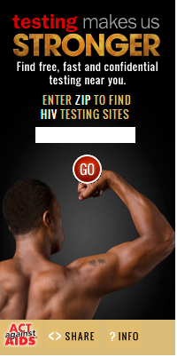 | Example banner ads  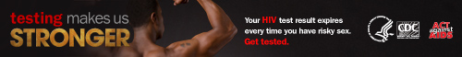  

Type of Internet Ad
Below is an algorithm to help decide if something should be a widget or banner ad.
Table 5. List of Metrics for the Internet Ads Domain
Metric ID | Title | Description | Example
Begin_date | Begin Date  !* | The begin date lists the date upon which internet ads start being posted and become available to the target audience.
End_date | End Date  !* | The end date lists the date upon which internet ads stop being posted and available to the target audience.
Internet_ad_website | Website  ! | The website on which the ad ran. It is expressed as a URL. | For example: “nytimes.com” and not “NY Times” or “New York Times”.
Internet_ad_wavenum | Wave Number | If applicable, the wave number of the ad run. Currently, this has only been used by the Know Where You Stand campaign.
Internet_ad_campaigname | Campaign | The campaign name is the strategy associated with the internet ad such as example, Google Display Network (GDN), Mobile App Ad, Keywords etc.
Internet_ad_adname | Ad Name | The name of the ad. This ad name should be standardized for the campaign. That is, the same name for an ad should be used for the entire campaign. | For example, it was decided that “Two women” should always be called that and not “The two women” or “Two women ad”. The Ad name should be the same as the ad name created by the campaign team.
Internet_ad_logo | Logo or no logo | This describes whether or not the CDC logo was on the internet ad.
Internet_ad_image_url_source | Ad URL | If the ad is served from one server, the URL of the ad should be recorded. This URL is unique to an ad and helps determine later which ad was being reported. | https://gettested.cdc.gov/takecharge/posters/11x17_Poster_Family.pdf
Internet_ad_language | Language  * | The database will include a standard dropdown which includes the following options:  i. (other)  ii. (unknown)  iii. English  iv. Spanish  v. English/Spanish
Internet_ad_type | Type of Internet Ad  !* | Here we breakdown the type of internet ad. The categories are as follows:
- Banner Ad
A banner ad is typically non-interactive. It may or may not be animated. Most internet ads for AAA are classified as banner ads.
 |  | - Mobile App Ad  This is when the advertisement appears on a mobile app. |   For example: when advertisements for Start Talking were posted on GRINDR.
- Poster
A poster is any printed paper material designed to be attached to the wall. It is also available for download in digital formats on the campaign website.
 |  | - Interstitial Ad  Interstitial ads are essentially pop-up ads. They appear over content and require a user to close the ad, or the ad closes after a set amount of time. | 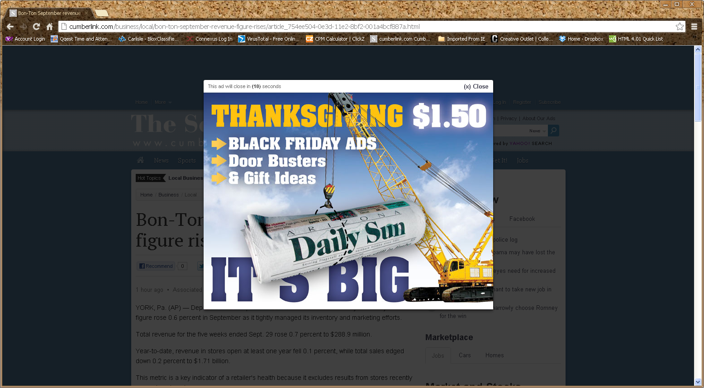  Above is an example of a non-AAA interstitial ads. The user must close the ad in order to view the site content.
 |  | - Search Ad  Search ads are ads that appear after a user searches for a certain time. These are common on search engines. As an example a user may search for “HIV Testing” on Google.com. Above the normal search results may be paid search results with links for a user to follow. | 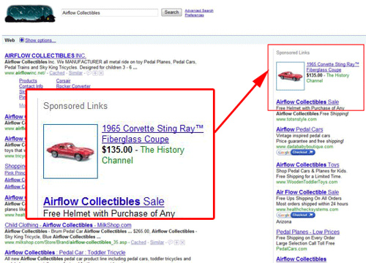  Above is a non-AAA example of a search ad. Notice that the user searches for Airflow collectibles and a link to a collectible from The History Channel appears to the right under Sponsored Links.
 |  | - Video Stream  YouTube videos where the ad appears at the bottom of the video while the video is playing. The user has the ability to close the ad. | 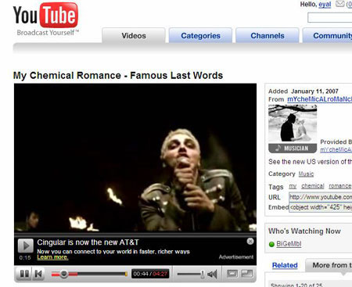  Above is an example of a video stream ad for AT&T.
 |  | - TrueViewVideo  TrueView in-stream ads run on videos served on YouTube or within the Google Display Network videos, games and apps. These ads may also run on YouTube videos that are embedded on other sites. They can also appear on Android and iOS YouTube apps, as well as m.youtube.com (on iPad and Android).  Viewers can choose to skip the video ad after 5 seconds. If they choose not to skip the video ad, the YouTube video view count will be incremented when the viewer engages with the video ad or watches 30 seconds of the video ad (or the duration if it's shorter than 30 seconds), or engages with your video, whichever comes first. Video interactions include clicks on the call-to-action overlays (CTAs), cards, and companion banners. If video view counts are a major concern, it is recommended to make videos at least 12 seconds long. | Above is an example of a TrueView video. It appears before the intended video and may be skipped by the user after a specified amount of time.
- Internet Radio
This is an internet ad that is on an internet radio station. It is interactive and therefore is considered an internet ad and not a radio ad.
 |  | - Widget  Widgets are typically interactive and they are “websites within websites”. When someone searches for a ZIP code within a widget the search results are sometimes presented inside the ad rather than go to a separate website. Widgets will typically have a “iframe” in its HTML embed code as shown in the text box.  Example of ZIP code search results rendering within the widget. | <iframe src="http://www.cdcnpin.org/TMUSWidget/TMUSWidget.aspx" id="TMUSWidget" title ="TMUS Widget" width="200" height="400" marginheight="0px" marginwidth="0px" frameborder="0" scrolling="no" style="padding: 0px; vertical-align: text-top; margin: inherit"><p>You can search for HIV testing sites near you by visiting <a href="http://HIVtest.CDC.gov/default.aspx" title="Find an HIV testing site near you.">National HIV and STD Testing Resources</a> website. </p></iframe>  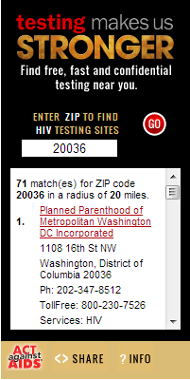
Internet_ad_plannedornot | Space Allocation  ! | Here we track whether or not an internet ad was planned or unplanned. A drop-down menu will auto-populate in the data with the following options: as described below.
 |  | - (other)
 |  | - (unknown)
- Planned
Planned internet ads are ones that CDC actively worked on to have placed. This is irrespective of whether they paid for them or not, only if they engaged a webmaster to have the ads placed.
- Unplanned
Unplanned internet ads are ads that ran without CDC’s working to place them. Almost always this will be from webmasters who copy the code for the internet ads from CDC’s website and paste it into their website.
CampaignName_Creative_iteration | Creative Iteration  * | Creative iterations are different versions of materials (this includes internet ads) that have the same exact content with minor variations such as a different photo. They can be more than just substantive materials and can also be used for media ad buys and banner ads.  Please note that the database allows for selecting campaign specific creative iterations. | Above are two examples of creative iterations from the Testing Makes Us Stronger campaign.
Internet_ad_placement | Placement | Here describe where the ad was placed, if known (e.g., “header” or “sidebar”). Due to the immense variability between websites and where ads can be placed, we don’t have standard nomenclature for this field. | For example, the ad on this site has been placed on the sidebar.
Internet_ad_size | Ad side (WxH) | Record, in number of pixels, the size of the ad. The width of the ad should be listed first, followed by an “x” and then height. | For example, an ad 600 pixels wide by 400 pixels long should be written as "600x400".
Internet_ad_animated | Animated | An animated internet ad is when the internet ad moves as opposed to static ad.  The database will consist of a drop-down list with the following options available for selection:  - (other)  - (unknown)  - Animated  - Not animated | Above is an example of three frames of the same animated internet ad. The first frame pictures the couple laying down and the words “Love Him” enter from the left. The words fade as the image zooms in on the woman and the words “Love yourself more” enters from the right. Finally “Take Charge. Take the Test” enters from the right on a black background. The animated ad then starts over in continues on this loop.
Internet_ad_orphaned | Orphaned Data  ! | Sometimes impression data are available for an ad but not clicks or vice versa. An implication of this is when we calculate click through rates (CTR) we need to exclude these data since they may impact the CTR.
- Yes
Used when either the clicks or impressions data are missing.
- No
Used when both the clicks or impressions data are reported.
Internet_ad_paid_impressions | Paid Impressions | Record here the number of paid impressions for an ad during the reporting period.
Internet_ad_paid_clicks | Paid Clicks | Record here the number of paid clicks for an ad during the reporting period.
Internet_ad_costs | Costs | Record here the cost of the ad during the reporting period.
Internet_ad_donated_impressions | Donated Impressions | Record here the number of donated impressions for an ad during the reporting period.
Internet_ad_donated_clicks | Donated Clicks | Record here the number of donated clicks for an ad during the reporting period.
Internet_ad_donated_value | Monetary Value of Donated Clicks | Record here the value of the donated internet ads. If value is unknown, please provide best estimate.
Internet_ad_zipcode_click | ZIP Code Clicks | This field is used to track how many people entered a ZIP code into an ad, click “search” and were taking directly to the search results for their ZIP code.
Internet_ad_nonzipcode_click | Non-ZIP Code Clicks | In contrast to zip code clicks, this field is used to track how many people did not enter a ZIP code into an ad and instead clicked inside the ad to be taken to the Gettested.cdc.gov or campaign website and not their search results. | Above is an example of a Testing Makes Us Stronger (TMUS) widget. If this user does not type their zip code and instead clicks anywhere else within the image, the user will be sent to the TMUS website.
Internet_ad_datasource | Source of data  * | Record here the source of data (the metrics reporting platform, not the person) for the internet ads. This may help us later understand where a certain entry came from in case we need to double check data.  The database will have a dropdown menu with the following options available for selection:  - (other)  - (unknown)  - AIR  - BWA  - Danya  - Facebook  - FHI  - Google  - McCulloh  - Porter Novelli  - Virginia Department of Health
Internet_ad_provider | Internet Ad Provider | This refers to which organization will be providing the ad.  The database will have a dropdown menu with the following options available for selection:  - Ad Network  - Google Display Network  - MediaMoguldom | For example: if there were a buy with Google one would choose Google Display Network.
Internet_ad_comments | Comments  * | This is an open-text field to allow for any comments to be entered to might be helpful later to explain the context or nature of the data entered.  It is important to carefully look at all of the metrics to make sure that whatever comment you would like to make is not already provided below in a different cell. | For example, if data are missing, it is helpful to put into the comments section that you are awaiting data and it will be updated later. However, a common mistake has been for people to put zip codes or into the comment section. Since zip codes are a separate metric, they do not belong here.

Home Page Views

Description
In the Home Page Views domain, we record traffic to AAA sites. This domain has different metrics available for collection, including page views, unique visitors, and number of visits. For AAA, primarily homepage views are tracked. Different analytic services (e.g., site catalyst, Google analytics) track data differently. Thus a limitation of the home page views metrics is that it helps to judge relative traffic from month to month, but it would be difficult to compare two different websites if they had different analytic services.
Table 6. List of Metrics for the Home Page Views Domain
Metric ID | Title | Description | Example
Begin_date | Begin Date  !* | The begin date lists the date in which Home Page Views begins to record over a number of days.
End_date
  End Date
  !*
  The end date lists the date in which Home Page Views being recorded over a number of days are no longer recorded.
Homepageviews_datasource | Source of Data  * | For home page views, since different analytic services can report different numbers, it is important to know what the analytic service used was.  The database will have a dropdown menu available for selection:  - (other)  - (unknown)  - Danya  - Google Analytics  - Omniture  - Urchin  - Web Funnel
Homepageviews_visits | Number of Visits | Prior to entering data in this field, please re-confirm that the appropriate analytic service specific measure is being selected. This is the number of visits to the site. A difficulty with this metric is that a “visit” can be defined differently on different analytic services. | One common thread is that a “visit” can include a variety of activities in one a session.  In the example provided below a person visited two pages and then did a zip code search for a testing facility. All together this counts as one visit.
Homepageviews_uniquevisitors | Number of Unique Visitors | This is the number of unique visitors in a time frame. “In a time frame” is important here. The unique visitors’ metric is not an additive metric. The number of unique visitors must be recalculated for each time frame, removing duplicate visits by the same person in a defined time frame. | The example below helps to convey this. In the example, there were 100 unique visitors for July and 50 unique visitors for August. If we wanted to know how many unique visitors there were from July 1st to August 31st , we would not add up the two and say there were 150 unique visitors because there were 30 visitors who had visited in both July and August. Thus, there are actually 120 unique visitors from July 1st to August 31st.  n=30
Homepageviews_pageviews | Number of Page Views | Pageviews is the total number of times a homepage is viewed. This exact definition will differ depending on the analytics platform in use. | For example, in Google analytics, a pageview is defined as a view of a page on your site that is being tracked by the Analytics tracking code. If a user clicks reload after reaching the page, this is counted as an additional pageview. If a user navigates to a different page and then returns to the original page, a second pageview is recorded as well.
Homepageviews_referringsites | Number of Referring Sites | This is the number of unique third-party websites that referred traffic to a specific AAA campaign website in a time frame. Like the number of unique visitors it does not have an additive property.
Homepageviews_zipcodesearches | Number of ZIP Code Searches | The total number of zip code searches conducted on the home page.
Homepageviews_language | Language  * | This is used for campaign websites that have more than one language. Using this field allows us to separate data for the different language versions of the same site.  The database will include a standard drop-down menu which includes the following options:  i. (other)  ii. (unknown)  iii. English  iv. Spanish  v. English/Spanish
Internet_ad_comments | Comments  * | This is an open-text field to allow for any comments to be entered to might be helpful later to explain the context or nature of the data entered.  It is important to carefully look at all of the metrics to make sure that whatever comment you would like to make is not already provided below in a different cell. | For example, if data are missing, it is helpful to put into the comments section that you are awaiting data and it will be updated later. However, a common mistake has been for people to put zip codes or into the comment section. Since zip codes are a separate metric, they do not belong here.

Gettested.cdc.gov Data

Description
This domain was formerly known as hivtest.org and hitvtest.cdc.gov. Data captured in this domain are ZIP code searches for HIV testing locations on Gettested.cdc.gov website or widgets. Table 7 list the metrics available for the domain.
Table 7. List of Metrics for the Gettested.cdc.gov Domain
Metric ID | Title | Description | Example
Begin_date | Begin Date  !* | The begin date lists the starting point of zip code searches for HIV testing locations over a number of days.
End_date | End Date  !* | The end date lists the ending point of zip code searches for HIV testing locations over a number of days.
Zip | ZIP Code  ! | The ZIP code that was typed into the search bar.
City | City  * | The name of the city of the ZIP code that was searched.
State | State  * | The state that the ZIP code search was for. Expressed as a two letter abbreviation using official US Postal Service abbreviations.
Cbsa | Core-Based Statistical Area (CBSA)  * | A Core-Based Statistical Area (CBSA) is a U.S. geographic area defined by the Office of Management and Budget (OMB) that centers on an urban center of at least 10,000 people and adjacent areas that are socioeconomically tied to the urban center by commuting. The CBSA of where the materials were distributed. The options available for this metric will be have a dropdown menu in the database.
Hivtestorg_searchfreq | Number of ZIP Code Searches  (Required field)  ! | The number of ZIP code searches. The Gettested.cdc.gov report aggregates the number of searches for a zip code in the reporting period.  Widget searches however are typically not aggregated and each individual search is listed. Thus, the number of searches in this case is one.
Hivetestorg_searchtype | Search Type  (Required field)  ! | We are currently tracking three different types of searches in this domain:
 |  | - Gettested.cdc.gov  Most search data falls under this category. These are searches that can occur either via widgets or campaign websites. When a search is executed the user is sent to the Gettested.cdc.gov website to view the search results. | Above is the gettested.cdc.gov site that appears when a zip code search is executed.
 |  | - Widget  Widget searches occur within widgets embedded into websites. Sometimes, widget search results are returned within the widget itself rather than on Gettested.cdc.gov. Other times a new window pops up with the search results. | 
- Text Message
These refer to searches that occur via text message. When a user texts their zip code to KNOWIT, the user is sent a list of results/testing locations via text message.
Hivtestorg_widgetsite | [If Widget] Site | The URL of the website where the widget is housed.
Hivtestorg_comments | Comments  * |  | For example, if data are missing, it is helpful to put into the comments section that you are awaiting data and it will be updated later. However, a common mistake has been for people to put zip codes or into the comment section. Since zip codes are a separate metric, they do not belong here.
  This is an open-text field to allow for any comments to be entered to might be helpful later to explain the context or nature of the data entered.
  It is important to carefully look at all of the metrics to make sure that whatever comment you would like to make is not already provided below in a different cell.

Media Monitoring

Description
The Media Monitoring domain collects a large array of media monitoring data including:
- Mentions on social media sites like Facebook and Twitter
- Tracking the usage of Twitter-specific metrics like hashtags (#), handles (@) and keywords.
- Tracking of keywords and phrases usage on Facebook or blogs.

Mentions of AAA or a campaign in mainstream media are captured under Media Impressions and not under Media Monitoring. Media Monitoring is capturing mentions of AAA on social media. Table 8 lists the metric available for the Media Monitoring domain.
Table 8. List of Metrics for the Media Monitoring Domain
Metric ID | Title | Description | Example
Begin_date | Begin Date  !* | The begin date lists the starting date of social media activities that may occur over a number of days.
Mediamonitoring_end_date | End Date  !* | The end date lists the ending point of social media activities over a number of days.
Mediamonitoring_trackedsite | Media Type  ! | The types of media being monitored and reported on will get have a dropdown menu in the database with the following options available for selection:
 |  | - (other)
- Blogs
The mention of AAA or use of some monitored key word or phrase on a blog.
- Facebook Mention
The mention of AAA or use of some monitored keyword or phrase on Facebook.
- Twitter
The tracking of Twitter-specific metrics like hashtags (#), handles (@), and keywords.
- YouTube
This refers to the tracking of hashtags that appear on YouTube.
- Flickr
This refers to tracking keywords or hashtags that appear on Flickr.
- Instagram
This refers to the tracking of campaign specific hashtags on Instagram.
Mediamonitoring_trackingtype | Tracked Metric | The type of metric typed. For example, a Twitter hashtag or a keyword.  - Hashtag (#)  A hashtag (#) which is typically used on Twitter but also being used by other sites now like Facebook. Hashtags can have no spaces. For example, #stophiv instead of #stop HIV. In the latter case the hashtag would have only been #stop.  Hashtags typically need to be unique to be worthwhile collecting. | For example, #stophiv could be used by many users outside of the campaign, whereas #StopHIVtogether is more unique.
 |  | - Handle (@)  A Twitter handle consists of usernames and is denoted by an @ symbol. | For example, “@cdcgov” is CDC’s username.
 |  | - Keyword or Phrase  A keyword or phrase being tracked. | For example:“Let’s Stop HIV Together”
Mediamonitoring_keyword | Tracked keyword, phrase, or hashtag | This is the specific campaign phrase or keyword being tracked by the media monitoring platform. A campaign phrase or hashtag were created specifically for the campaign. | For example, #stopHIVtogether is the hashtag for the together campaign
Mediamonitoring_frequency | Number of Instances  ! | For the tracked site and metric we record the number of instances observed here. For example, if “#letsstophivtogether” was used 100 times in a month we would record 100 here.
Mediamonitoring_trackingservice | Media Monitoring Service | When known we record the name of the media monitoring service here. This helps us to know where the data is coming from so we can track down problems later. The current media monitoring services will be have a dropdown menu in the with the following options available for selection:  - (other)  - (unknown)  - Simply Measured  - Sysomos Map  - Radian6  - Omniture Site Catalyst  - Linguastat
 | Number of Facebook mentions | Captures the mention of AAA or a campaign on Facebook.
Mediamonitoring_comments | Comments  * |  | For example, if data are missing, it is helpful to put into the comments section that you are awaiting data and it will be updated later. However, a common mistake has been for people to put zip codes or into the comment section. Since zip codes are a separate metric, they do not belong here.
  This is an open-text field to allow for any comments to be entered to might be helpful later to explain the context or nature of the data entered.
  It is important to carefully look at all of the metrics to make sure that whatever comment you would like to make is not already provided below in a different cell.

Facebook Page-Level

Description
All Facebook metrics are reported by their internal analytics system called “Facebook Insights”. A benefit of Facebook Insights is that it is standard across all Facebook pages, making it possible to make comparisons between two different campaigns that have Facebook pages.

Page-level records the reach and engagement on Facebook such as net new likes, people talking about this, engaged users etc.
Table 9. List of Metrics for the Facebook Page-Level Domain
Metric ID | Title | Description | Example
Begin_date | Begin Date  !* | The begin date of the reporting period for the Facebook page or post. | For page-level data this reports activity for the page within the month. For example, a page-level report for August gives impressions for the page from August 1 to August 31.
Facebookpage_end_date | End Date  !* | The end date of the reporting period for the Facebook page or post. | For page-level data this reports activity for the page within the month. For example, a page-level report for August gives impressions for the page from August 1 to August 31.
Facebookpage_reachtotal | Net new likes | The use of the term “like” in Facebook is confusing at times. One can “like” a post but one can also “like” a page. In this case it is the latter. “Liking” a page is analogous to subscribing to the page.  Net new likes is the net number of subscribers to the page from the first day of the reporting period to the last day of the reporting period. This number can be a positive or negative number. It does not tell you how many subscribers you have, only the change.
Facebookpage_reachorganic | Reach - Total | Reach at the page-level reflects the unique number of people who saw the page in a defined time period. It is not an additive property.  Facebook says: “Total reach counts the number of unique people who saw your content, regardless of how many times they saw it.”
Facebookpage_reachorganic | Reach - Organic | Reach at the page-level reflects the unique number of people who saw the page in a defined time period. It is not an additive property.  The number of unique users that saw page content from their News Feed, the Ticker or visited the page. These users are being served content directly from the brand or opting to view the content from the page.
Facebookpage_reachpaid | Reach - Paid | Reach at the page-level reflects the unique number of people who saw the page in a defined time period. It is not an additive property.  It represents the unique users that viewed page content from a Facebook ad or Sponsored Story.
Facebookpage_reachviral | Reach – Viral | Reach at the page-level reflects the unique number of people who saw the page in a defined time period. It is not an additive property.  It represents the unique users that viewed content from a story published by a friend. Unlike organic, these people were not subscribed to the page and didn’t see the post on our page.
Facebookpage_ptat | People Talking About This | “People Talking About This” at the page-level is similar to “Talking About This” at the post-level. It reflects the number of stories created at the page-level. Actions that affect this metrics are:  - Liking a page  - Posting to a page’s Wall  - Mentioning a page in a post  - Photo-tagging a page  PTAT doesn’t include people using your Page’s name in one of their personal posts without @-mentioning or tagging it (“Check out Testing Makes Us Stronger” vs “Check out Testing Makes Us Stronger!”) [source] | 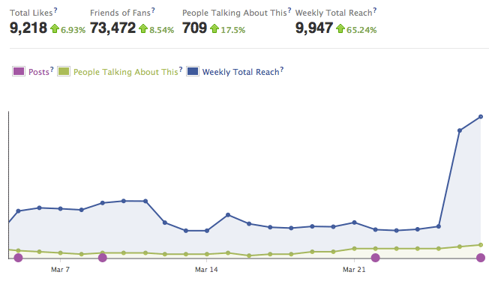  Above is an example of what People Talking About this looks like within Facebook Insights.
Facebookpage_engagedusers | Engaged Users | Engaged users are the number of unique people who have clicked anywhere in a post. It is comprised of:  - Stories generated: A story is generated when a fan likes, comments on, shares a post with his or her friends, answers a question or responds to an event. This is an important number because it reflects the ability of content to cause a second action. The fans read what we wrote and were compelled to share, like or otherwise amplify our content, creating a story or action in their own news stream that subtly tells their friends they “endorse” the page, or at least found what you wrote to be engaging enough to make them take an action. [source]  - Other clicks: The measurement of additional actions our viewers took, within a post, such as clicking on the number of likes to see who else liked our post, people’s names, or the timestamp. Facebook says this is a strong indicator of the attention viewers are paying to your content. They’re digging deep, looking for more information, interacting with the content longer. [source]  - Photo Views: Indicated if users clicked on a photo to make it larger. This means they were motivated to interact with, spend time with, and look over the visual content. [source]  - Video Plays: Number of times the play button of a video was pressed.
Facebookpage_comments | Comments  * |  | For example, if data are missing, it is helpful to put into the comments section that you are awaiting data and it will be updated later. However, a common mistake has been for people to put zip codes or into the comment section. Since zip codes are a separate metric, they do not belong here.
  This is an open-text field to allow for any comments to be entered to might be helpful later to explain the context or nature of the data entered.
  It is important to carefully look at all of the metrics to make sure that whatever comment you would like to make is not already provided below in a different cell.

Facebook Post-Level

Description
All Facebook metrics are reported by their internal analytics system called “Facebook Insights”. A benefit of Facebook Insights is that it is standard across all Facebook pages, making it possible to make comparisons between two different campaigns that have Facebook pages.

Post-level records engagement and reach of a particular post.

In general though this should not present a large issue as most activity for a Facebook post subsides shortly after posting. For instance, a company (doing a non-peer reviewed study) found that 95% of all likes that a post will receive come in the first 22 hours. [source] Facebook will call metrics for posts “lifetime” metrics even though “lifetime” here is only 28 days. Facebook will only record metrics for a post for 28 days after a post is posted. Any activity that happens after 28 days is not recorded. Thus, the Facebook Insights report for the number of likes for a post may not match what we visually see on the Facebook website. While Facebook post-level insights provide greater details, only three of these metrics listed on Table 10 below are of interest to the AAA initiative.

Post-Level data should never be pulled until 28 days after it posted.

Table 10. List of Metrics for the Facebook Post-Level Domain
Metric ID | Title | Description | Example
Begin date | Begin Date  !* | The begin date of the reporting period for the Facebook page or post.  For post-level data, an August report would give all data for a post that was first posted in August, even if metrics carry over to the next month. | For example, if a post was made on August 31st at 11:59PM all of the posts metrics would be contained in the August report even if most of the activity happened in September.
Facebookpost_description | Post Description | A description of what was contained within the post. For status updates this should be a copy of the message posted. | 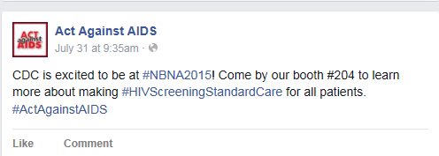  For this post, it would be the exact words written for the HSSC Campaign.
Facebookpost_posttype | Type of Post | Any post made on Facebook can be categorized into a total of six categories (iii-viii) provided by Facebook in the Insights report.  The database will have a dropdown with the following options for selection:  - (other)  - (unknown)
 |  | - Link  A link to a website or other location on Facebook. | 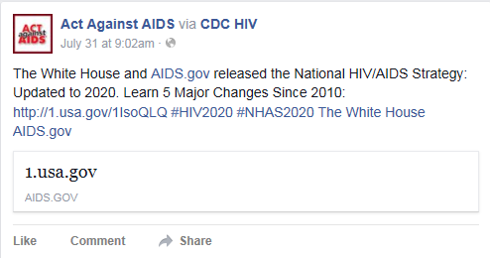  In this post, a link is provided that leads to another relevant site.
 |  | - Photo  A photo or a photo gallery. | 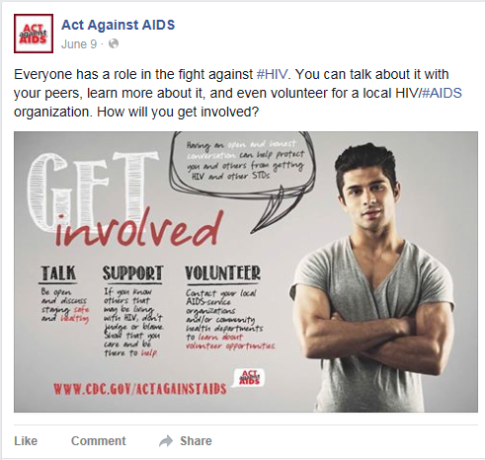
- Question
Essentially a poll. A special type of post where the page administrator can ask a question and then create predefined response options. Users can then click a response option and see how others have answered.
 |  | - Share  A share is created when the page administrator clicks the “share” button on another post and shares it from another page onto their own page. | This post has been shared from the Greater Than AIDS Facebook page as indicate at the top of the post where it says “ Act Against AIDS shared Greater Than AIDS’s photo”.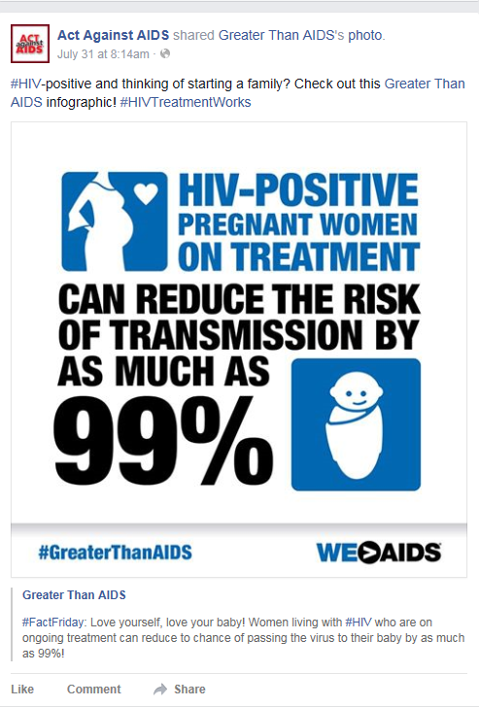
 |  | - Status  This is the most prevalent type of post. It is a “status update” where the page administrator types a text string to share with end users. | 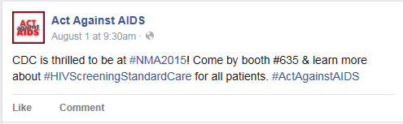
 |  | - Video  A video posted directly onto Facebook. Note that links to other videos (e.g. on YouTube) would count as a “Link”. | In this post, a video is posted directly to Facebook.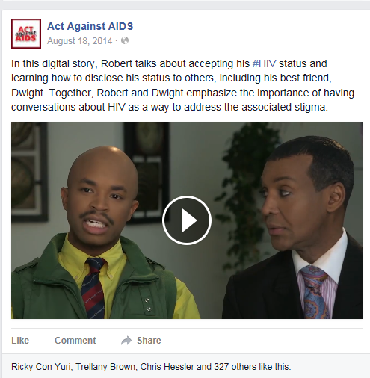

Continuing Medical Education (CME)

Description
The Continuing Medical Education (CME) domain captures all metrics related to continuing medical education for providers. Continuing medical education refers to classes physicians take to keep their medical license valid. They require a certain number per year. Table 11 lists the metrics available for the Continuing Medical Education (CME) domain.
Table 11. List of Metrics for the Continuing Medical Education (CME) Domain
Metric ID | Title | Description | Example
Begin_date | Reporting Begin Date  !* | The begin date lists the date in which continuing medical education activities begin over a number of days.
Cme_end_date | Reporting End Date  !* | The end date lists the date in which continuing medical education activities ends over a number of days.
Cme_name | Name of CME | The title of the Continuing Medical Education offering. | 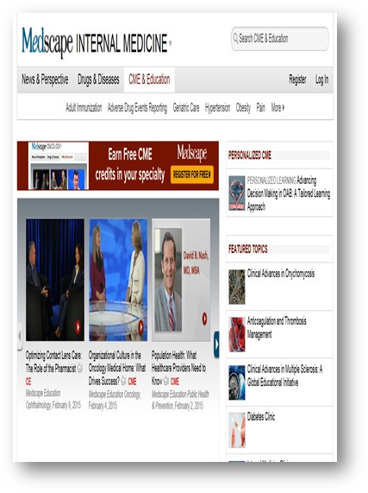For example the above page shows a site designed for physicians to earn CME credits. The name of one of the courses is “Population Health: What Healthcare Providers Need to Know”
Cme_ impressions | CME Impressions | Refers to the potential number of impressions a CME could have.
Cme_totalpageviews | CME Total Pageviews | This is for online CMEs. This refers to the number of times a CME page was viewed.
Cme_completed | CME Completed | Refers to the number of individuals who completed the CME.
Cme_dollarspaid | Dollars Paid | This refers to how much the CME courses cost to make.
Cme_comments | Comments  * | This is an open-text field to allow for any comments to be entered to might be helpful later to explain the context or nature of the data entered.  It is important to carefully look at all of the metrics to make sure that whatever comment you would like to make is not already provided below in a different cell. | For example, if data are missing, it is helpful to put into the comments section that you are awaiting data and it will be updated later. However, a common mistake has been for people to put zip codes or into the comment section. Since zip codes are a separate metric, they do not belong here.

Twitter – Page Level

Description
The Twitter Domain captures data that comes from Twitter for the AAA account handle @TalkHIV. Twitter metrics come from its proprietary analytics dashboard and social media analytics like Sysomos Map and Simply Measured. While these two are the platforms in utilization at the moment to derive web analytics data, please note that the systems could be upgraded or changed in the future. These data are collected to show how people are interacting with tweets and can potentially show which tweets are more successful.

Page-level records tweets posted, number of profile visits, mentions by other profiles, number of new followers, and tweets linking to the account. Table 12 lists the metrics available for the domain.
Table 12. List of Metrics for the Tweets Domain
Metric ID |  | Title | Description | Example
Twitter_tweets | Tweets |  | The total number of tweets posted by the account during the reporting period.
Twitter_profilevisits |  | Profile Visits | The total number of times the account was visited during the reporting period.
Twitter_mentions |  | Mentions | The total number of mentions to the @TalkHIV account during the reporting period.
Twitter_newfollowers |  | New followers | The total number of new followers for the Twitter account during the reporting period.
Twitter_tweetslinktoyou |  | Tweets Linking to You | The total number of click on tweets or twitter cards that contain URLs linking to the account during the reporting period.
Twitter_comments |  | Comments  * | This is an open-text field to allow for any comments to be entered to might be helpful later to explain the context or nature of the data entered.  It is important to carefully look at all of the metrics to make sure that whatever comment you would like to make is not already provided below in a different cell. | For example, if data are missing, it is helpful to put into the comments section that you are awaiting data and it will be updated later. However, a common mistake has been for people to put zip codes or into the comment section. Since zip codes are a separate metric, they do not belong here.

Twitter – Post Level

Description
The Twitter Post Level Domain captures data that comes from Twitter for the AAA account handle @TalkHIV. Twitter metrics come from its proprietary analytics dashboard and social media analytics like Sysomos Map and Simply Measured. While these two are the platforms in utilization at the moment to derive web analytics data, please note that the systems could be upgraded or changed in the future. These data are collected to show how people are interacting with tweets and can potentially show which tweets are more successful.

Post-level records the text of tweets posted, engagements and engagement rate, number of retweets, replies and favorites for the individual tweets made by the @TalkHIV account. Table 13 lists the metrics available for the domain.
Table 13. List of Metrics for the Tweets Domain
Metric ID |  | Title | Description | Example
Twitter_tweettext | Tweet text |  | The content of individual tweets posted during the reporting period. | For example, HIV Treatment Works. Share CDC’s new campaign with your patients http://go.usa.gov/pcfT #HIVTreatmentWorks  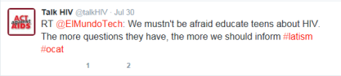
Twitter_time |  | Date  * | List the date when the tweet was posted. | 6/14/2015
Twitter_engagements |  | Engagements | Total number of times a user interacted with a Tweet. Clicks anywhere on the Tweet, including retweets, replies, follows, favorites, links, cards, hashtags, embedded media, username, profile photo, or Tweet expansion.
Twitter_engagementrate |  | Engagement rate | Number of engagements divided by impressions
Twitter_retweets |  | Retweets | The total number of times the content was retweeted. | For example, this tweet shows that it has been retweeted 13 times.
Twitter_replies |  | Replies | Times a user replied to the Tweet
Twitter_favorites |  | Favorites | Times a user favorited the Tweet
Twitter_postcomments |  | Comments  * | This is an open-text field to allow for any comments to be entered to might be helpful later to explain the context or nature of the data entered.  It is important to carefully look at all of the metrics to make sure that whatever comment you would like to make is not already provided below in a different cell. | For example, if data are missing, it is helpful to put into the comments section that you are awaiting data and it will be updated later. However, a common mistake has been for people to put zip codes or into the comment section. Since zip codes are a separate metric, they do not belong here.

Instagram

Description
The Instagram domain captures data that comes from the Instagram account @ActAgainstAIDS. Instagram metrics come from social media analytics platforms like Simply Measured. While Simply Measured is the system currently in use, please note that the systems could be upgraded or changed in the future. Data in this domain is captured to exemplify how individuals are interacting with photos and graphics posted on the account.
Table 14. List of Metrics for the Tweets Domain
Metric ID |  | Title | Description | Example
Instagram_followers | Followers |  | The total number of followers for the account.
Instagram_newfollowers |  | New followers | The total number of followers for the reporting period.
Instagram_posts |  | Posts | The total number of posts during the reporting period.
Instagram_fanresponses |  | Fan responses | The total number of comments on posts during the reporting period.
Instagram_likess |  | Fan likes | The total number likes on the account for the reporting period.
Instagram_comments |  | Comments  * | This is an open-text field to allow for any comments to be entered to might be helpful later to explain the context or nature of the data entered.  It is important to carefully look at all of the metrics to make sure that whatever comment you would like to make is not already provided below in a different cell.

Videos

Description
The video domain is capturing data related to video views. These are videos that have been posted on an internet video sharing platform like YouTube, where the amount of times a video is viewed can be tracked based on clicks or intentional views. Table 15 lists the metrics available for the Videos domain.
Table 15. List of Metrics for the Videos Domain
Metric ID | Title | Description | Example
Begin_date | Reporting Begin Date  !* | The begin date lists the date the video was released and displayed.
Video_end_date | Reporting End Date  !* | The end date lists the date the video was displayed.
Videos_videoviews | Number of video views in the reporting period | This refers to the number of times the video was viewed in a certain period. A view could change depending on the platform. | Most videos are housed on YouTube and they define a view as having actively loaded a video. Autoplayed videos do not count.
Videos_platform | Video Platform | This refers to the platform where the video is hosted. The database will have the following dropdown menu available for selection:  - (other)  - (unknown)  - Break  - CDC.gov  - Daily Motion  - Metacafe  - Revver  - Viddler  - Vidilife  - Vimeo  - Yahoo! Video  - YouTube | For example: YouTube or Dailymotion.
Videos_url | Link to Video | The URL where the referenced video is available for viewing.
Videos_comments | Comments  * | This is an open-text field to allow for any comments to be entered to might be helpful later to explain the context or nature of the data entered.  It is important to carefully look at all of the metrics to make sure that whatever comment you would like to make is not already provided below in a different cell. | For example, if data are missing, it is helpful to put into the comments section that you are awaiting data and it will be updated later. However, a common mistake has been for people to put zip codes or into the comment section. Since zip codes are a separate metric, they do not belong here.

Business Responds to AIDS (BRTA) Initiative Metrics

Description
BRTA was launched in 1992 as a long-term, primary prevention program for HIV education. This program encourages business executives, managers, and labor leaders to undertake comprehensive workplace HIV education. The table below documents BRTA specific metrics related to recruitment and outreach and training and technical assistance efforts that do not fall under the domains currently listed within the Act Against AIDS (AAA) data dictionary.
Table 15. List of Metrics for the BRTA Initiative
Title | Description
Number of businesses invited to BRTA recruitment/engagement events | This is the number of businesses invited to attend BRTA recruitment/engagement events (including webinars)
Number of businesses that attend BRTA recruitment/engagement events | Number of businesses that attend the BRTA recruitment/engagement events (including webinars)
Number of businesses that join BRTA as a partner | This is the number of businesses who commit to adopt at least one of the five BRTA principles
Number of BRTA partners that attend BRTA webinars for technical assistance/training | Number of businesses that attend the BRTA recruitment and information webinars.
Number of BRTA partners requesting/receiving technical assistance/training | Number of businesses that request/receive technical assistance/training
Comments  * | This is an open-text field to allow for any comments to be entered to might be helpful later to explain the context or nature of the data entered.  It is important to carefully look at all of the metrics to make sure that whatever comment you would like to make is not already provided below in a different cell.

Note: This code will eventually be renamed “Event – Conference” to bring it in line with “Event – Other”.
Note: Eventually all categories for event type will be carried over here with “Event –“preceding them. For example, “Event – Meeting”.
Note: This code will eventually be renamed “Event – Gay Pride Event” to bring it in line with “Event – Other”.
Definition is from https://www.whitehouse.gov/sites/default/files/omb/bulletins/2013/b13-01.pdf
Definition is from https://www.whitehouse.gov/sites/default/files/omb/bulletins/2013/b13-01.pdf

