Introduction to Laboratory Informatics: Life of a Specimen and Life of a Result CDC eLearning Courses
Learner Feedback Survey Invitation and Reminders

Invitation Email
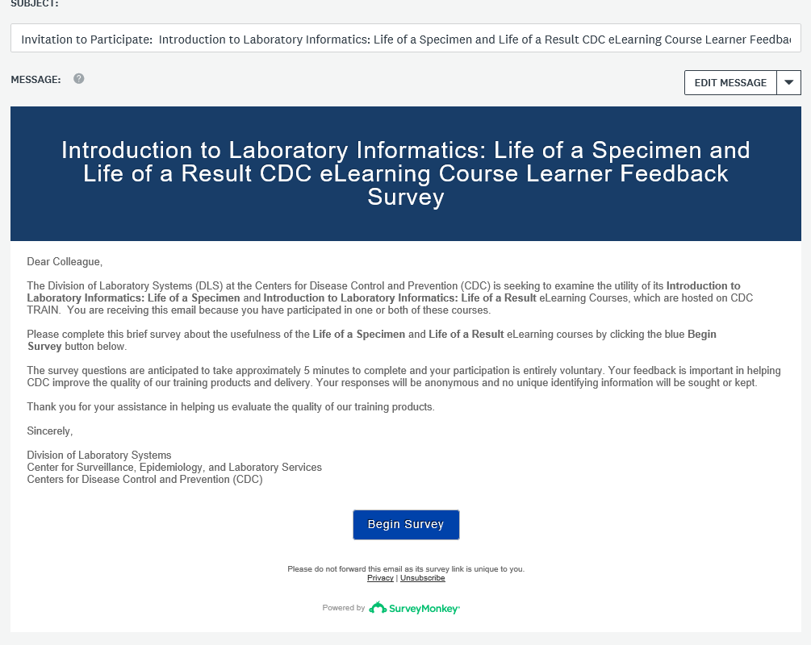

Reminder Email

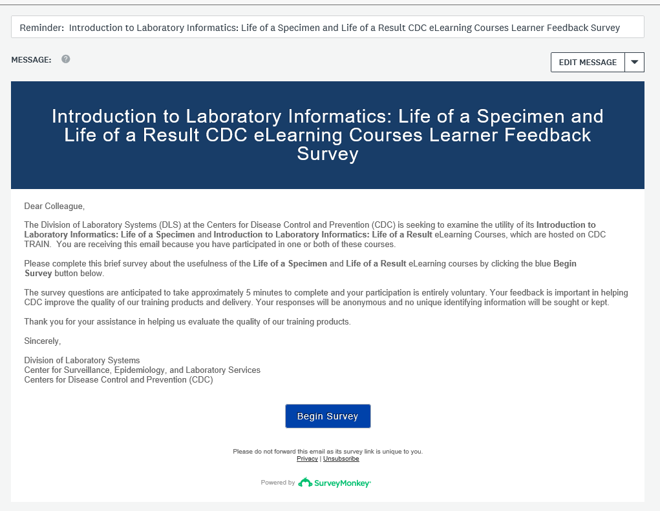

Final Reminder Email

