Screen shot of Invitation and Reminder Email Invitations to 2018 Good Laboratory Practices for Molecular Genetic Testing eLearning Learner Feedback Survey

Invitation Email

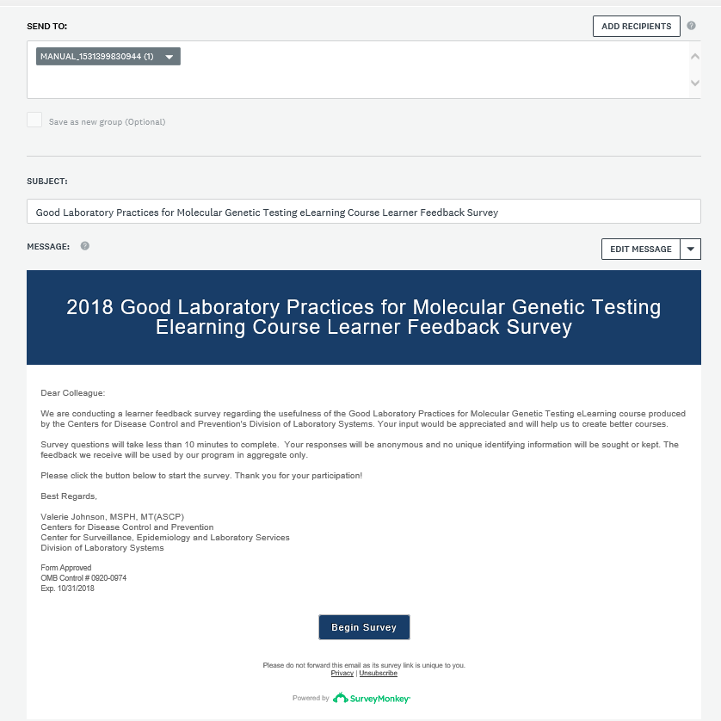

Screen Shot of Reminder Email

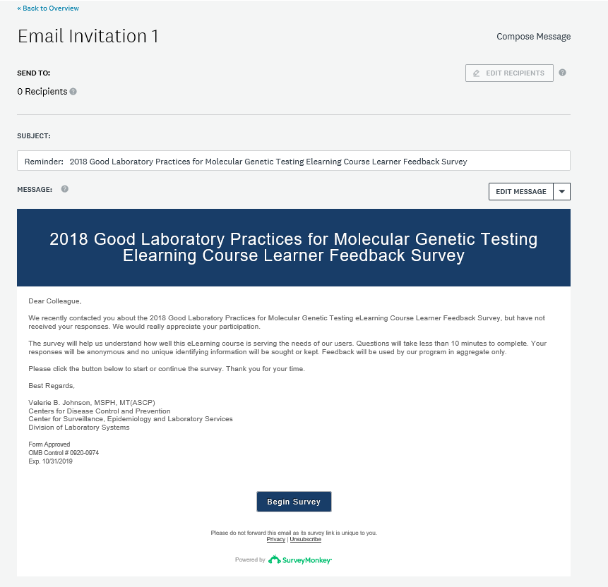

Screen shot of Final Reminder with Closing Date

