Screen shots Packaging and Shipping Division 6.2 Materials eLearning Course Learner Feedback Survey -- Invitation, Reminder, Final Reminder

Invitation
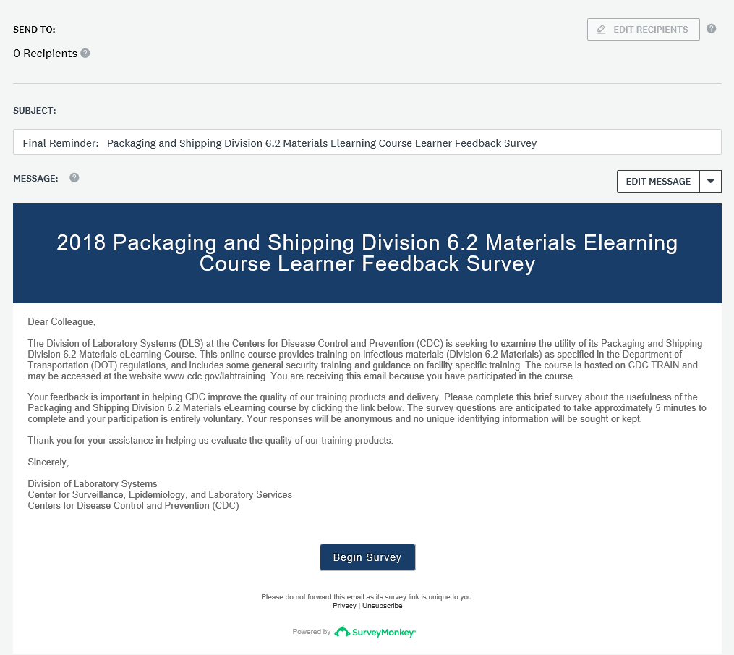

Reminder
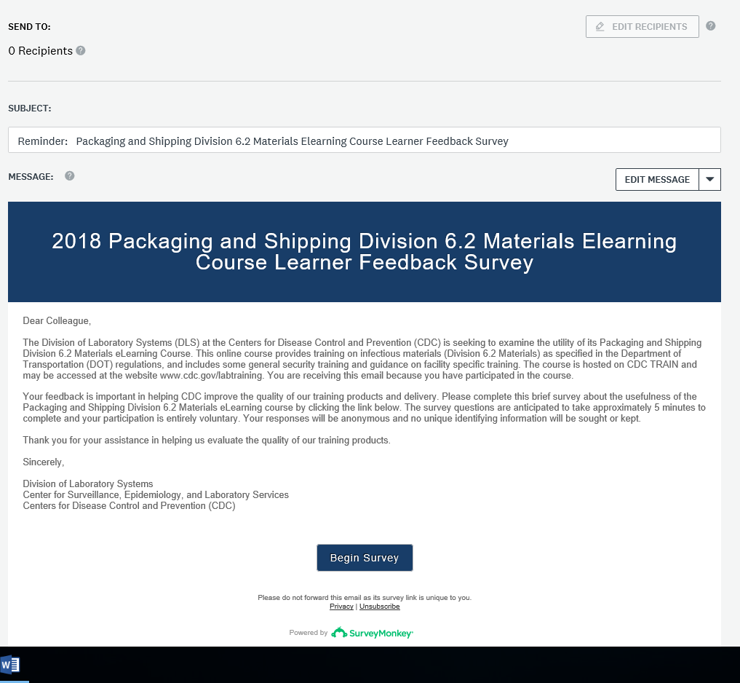

Final Reminder
