APPENDIX B1
EMAIL NOTIFICATION TO REGIONAL OFFICES
 |  | OMB Number: 0584-XXXX  Expiration Date: XX/XX/XXXX  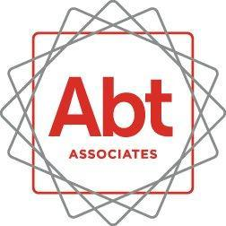

X/X/2016

To: [ALL FNS REGIONAL DIRECTORS]
Subject: Community Eligibility Provision (CEP) Characteristics Study.
Good afternoon!
FNS has contracted with 2M Research Services and its partner Abt Associates to conduct the Community Eligibility Provision (CEP) Characteristics Study. The CEP Characteristics Study is being conducted to examine operational issues, perceived incentives of and barriers to adopting CEP, and estimates of any impacts of adopting CEP on participation in school meals and per meal revenues in the National School Lunch Program (NSLP) and the School Breakfast Program (SBP).
Please notify your States about the study and encourage their assistance with any study requests from 2M Research Services and Abt Associates.
Thank you in advance for your assistance.
[FNS/USDA]

