FAST-Track 3090-0297
Req-32

OGP’s Website Feedback Survey

Screen 1
This screen is a pop-up that appears when the user has not been asked to take the survey in the last 30 days AND fulfills one of the following criteria:
- Demonstrates intent to exit the website
- Visits 3 or more pages
- Spends at least 60 seconds on the website

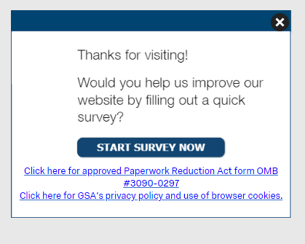

The first link (“Click here to see the full Paperwork Reduction Act statement…”) will open the below pdf in a new tab.
The second link (“Click here to read more about…”) goes to GSA’s Website Privacy and Security Notice webpage.
Screenshot of GSA’s PRA Statement pdf link
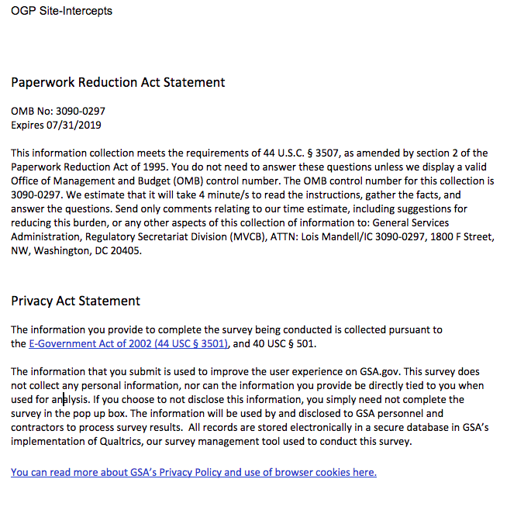

Screen 2 - Displayed if survey was triggered
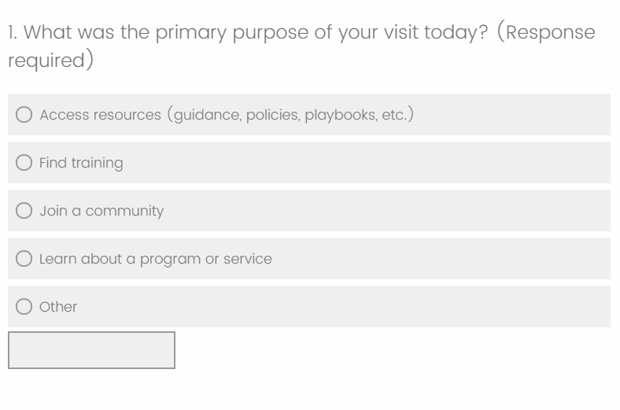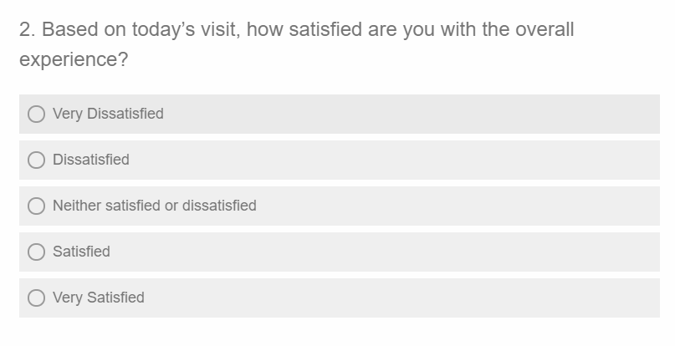

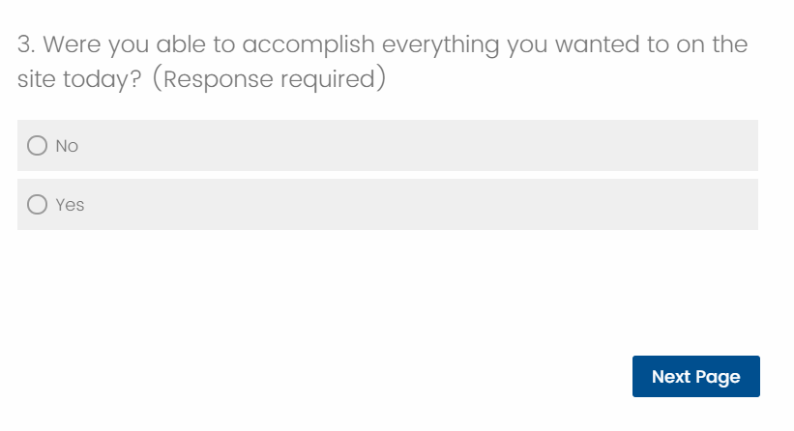

Screen 3
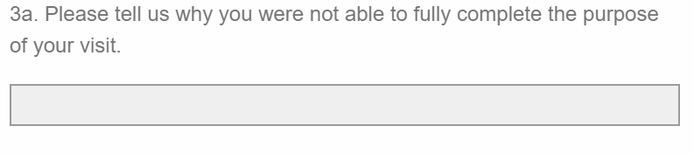

This question will only be displayed if the respondent answered “No” to the previous question
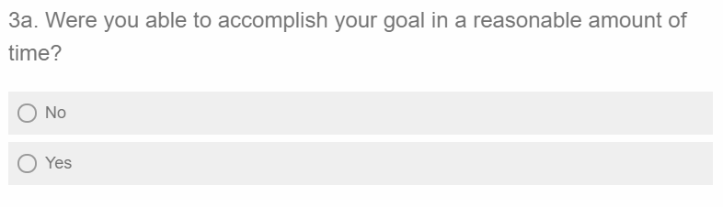

This question will only be displayed if the respondent answered “Yes” to the previous question

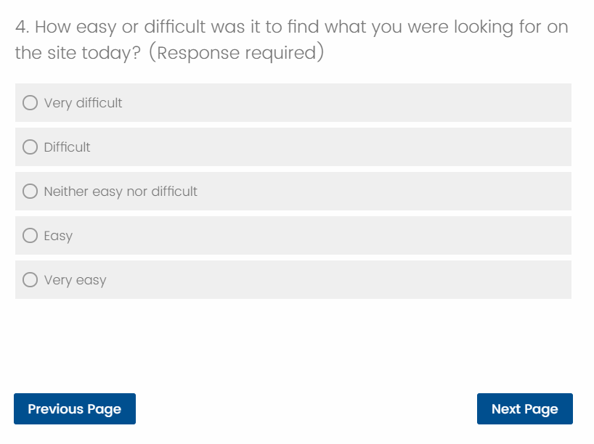

Screen 4
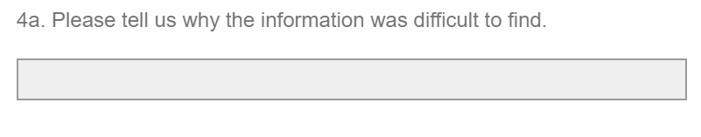
This question will only be displayed if the respondent answered “Difficult” or “Very Difficult” on the previous question

[WEBSITE] will be replaced with the actual website name for each survey.

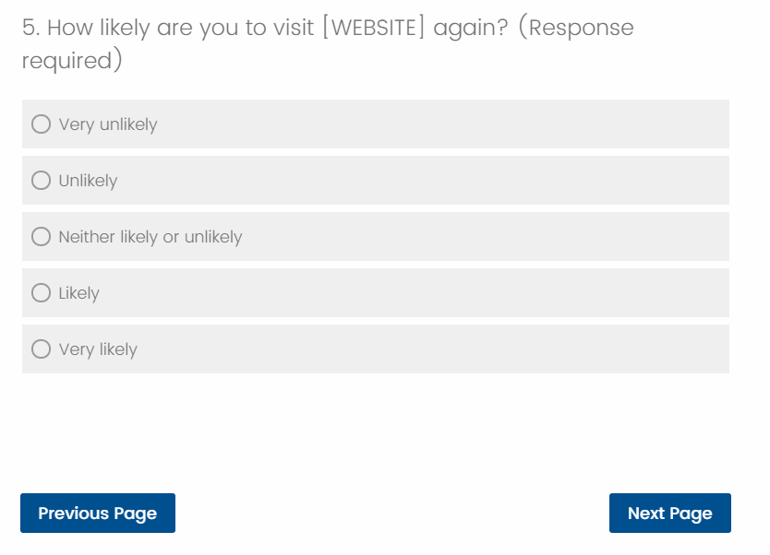

Screen 5
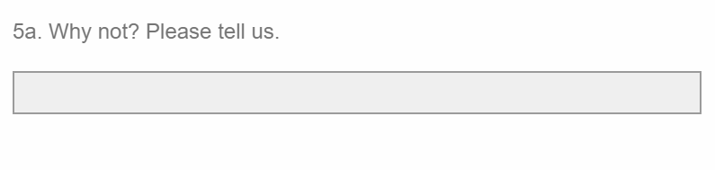
This question will only be displayed if the respondent answered “Unlikely” or “Very unlikely ”on the previous question

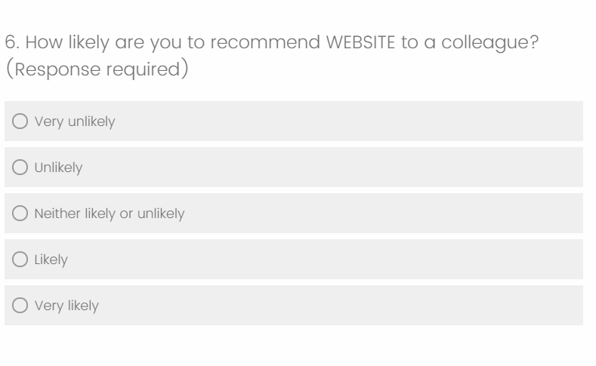

[WEBSITE] will be replaced with the actual website name for each survey.

[WEBSITE] will be replaced with the actual website name for each survey.

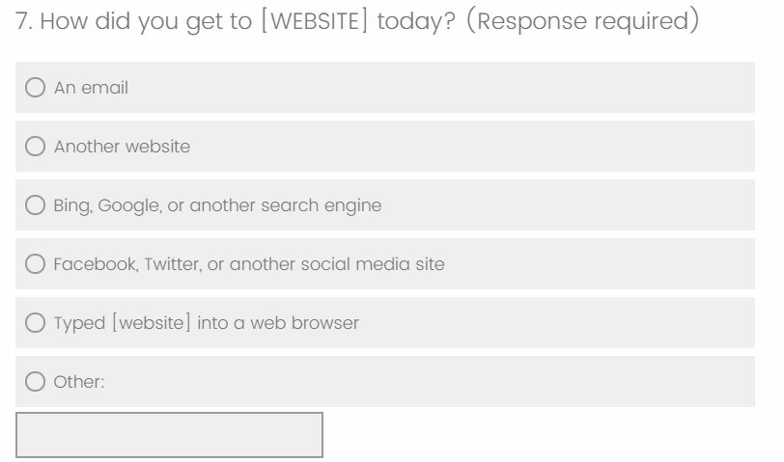

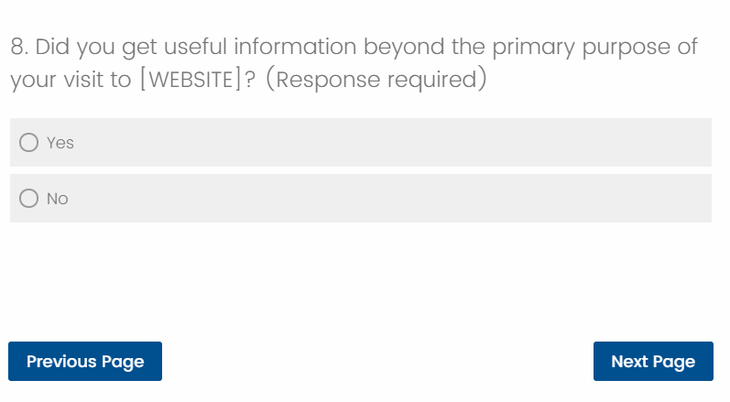

[WEBSITE] will be replaced with the actual website name for each survey.

Screen 6
This question will only be displayed if the respondent answered “Yes” to the previous question
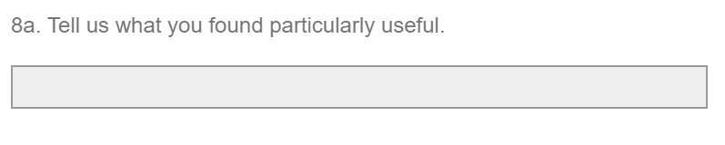

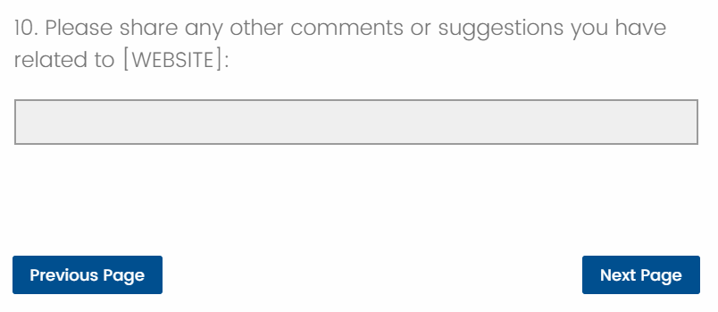

[WEBSITE] will be replaced with the actual website name for each survey.

Screen 7
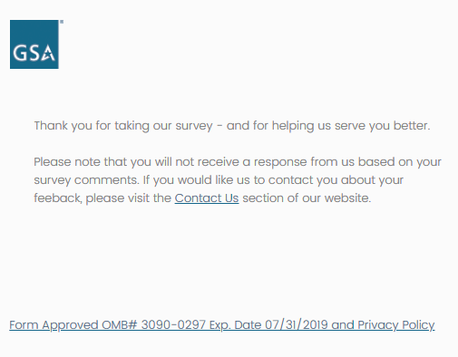
“Contact Us” link will link to individual website contact page / email address

