FAST Track 3090-0297
Req-33

GSA Advantage Website Feedback Survey

Screen 1
This screen is a pop-up that appears when the user has not submitted a survey within the last 30 days and meets the following criteria:
- Demonstrates intent to exit the website
- Visits 3 or more pages
- Spends at least 60 seconds on the website

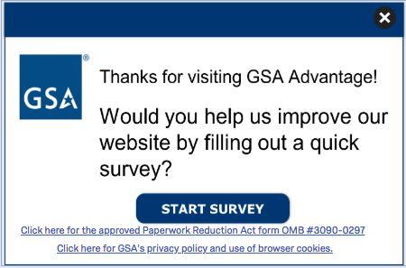

The first link (“Click here to see the full Paperwork Reduction Act statement…”) will open the below pdf in a new tab.
The second link (“Click here to read more about…”) goes to GSA’s Website Privacy and Security Notice webpage.
Screenshot of GSA’s PRA Statement pdf link
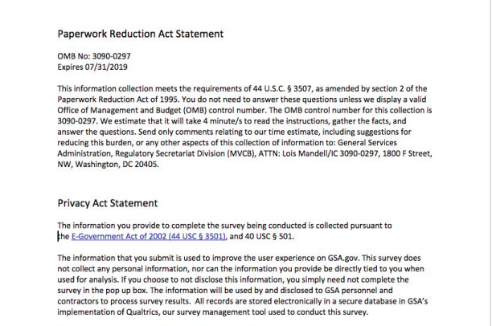

Screen 2 - Displayed if survey was triggered
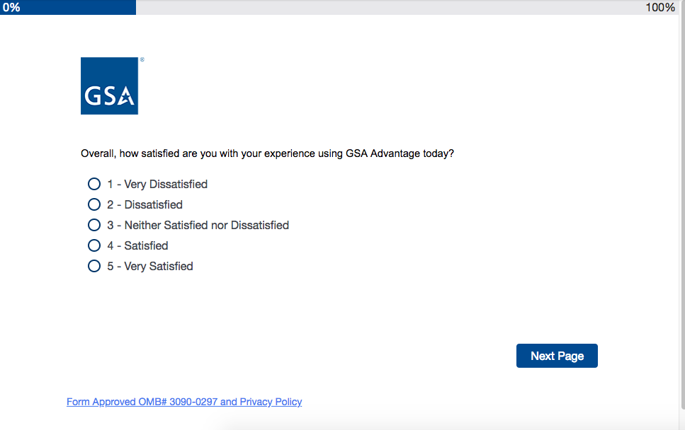
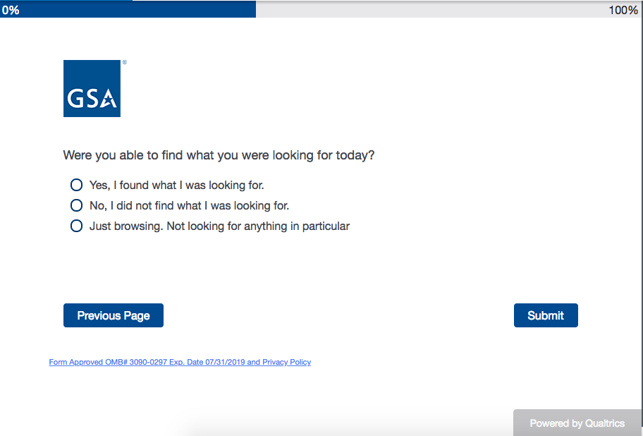

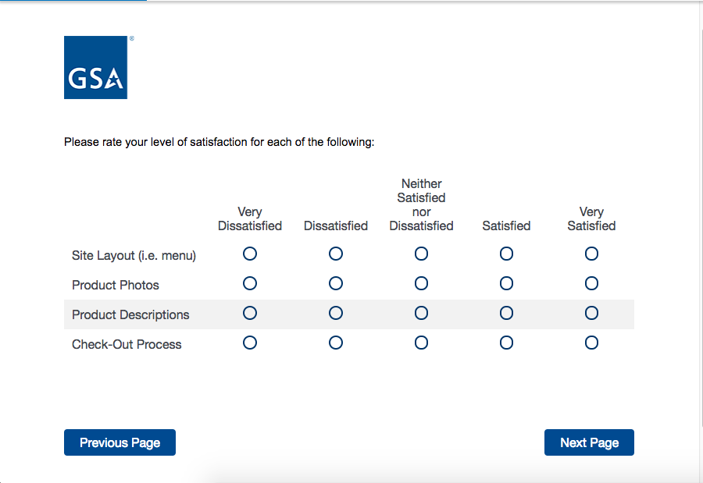

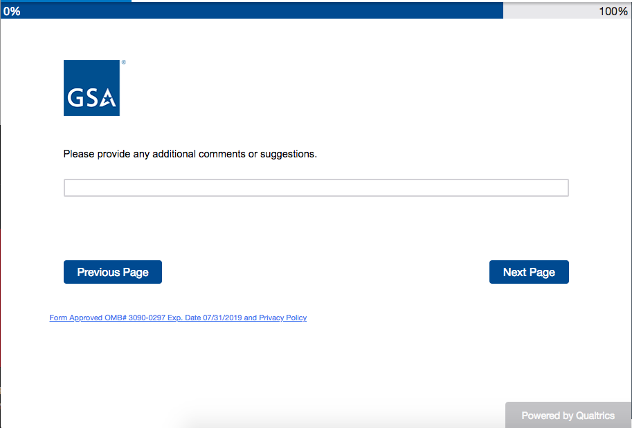
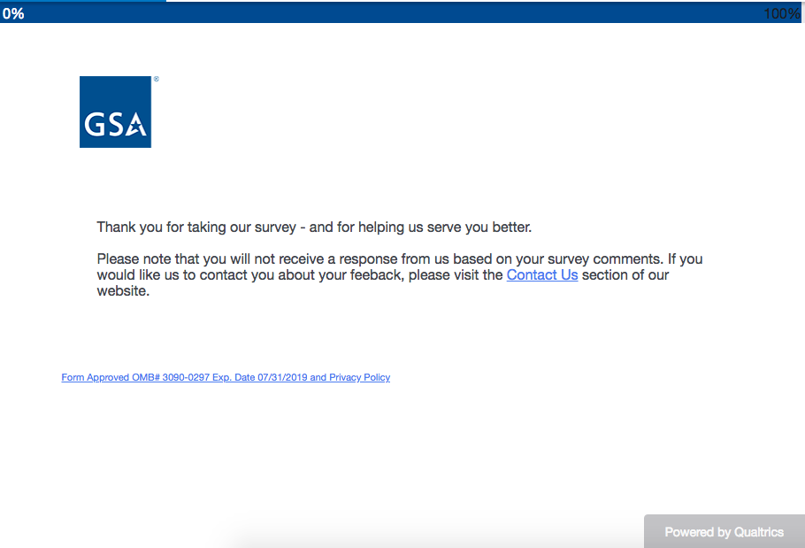

The “Contact Us” hyperlink leads to the following page:
