FAST-Track 3090-0297
Req. 21
NMCD Campaign Training Survey

Screen 1:

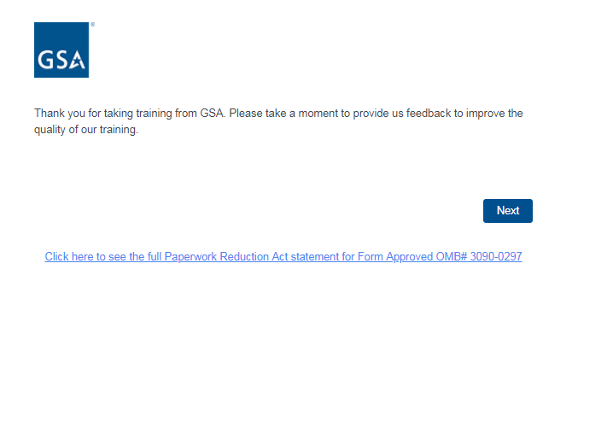

Screen 2:

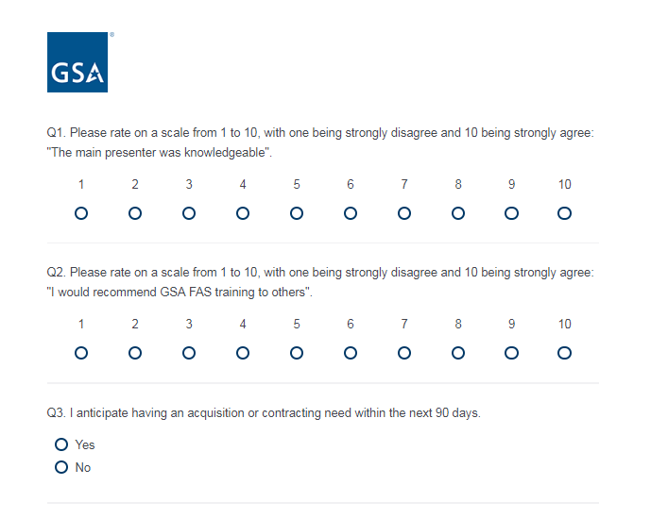

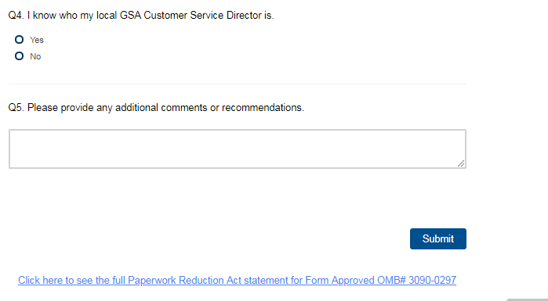

Screen 3:

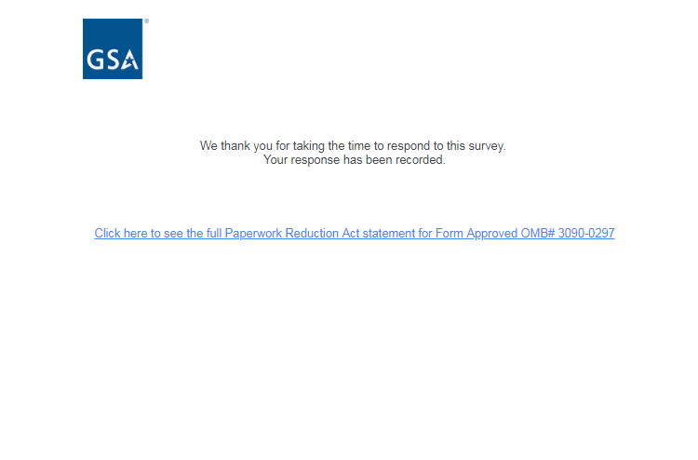

Link to PRA statement directs to PDF of the below statement:
