FAST Track 3090-0297
Req-10
Fleet Marshaling Transactional Survey

Screen 1
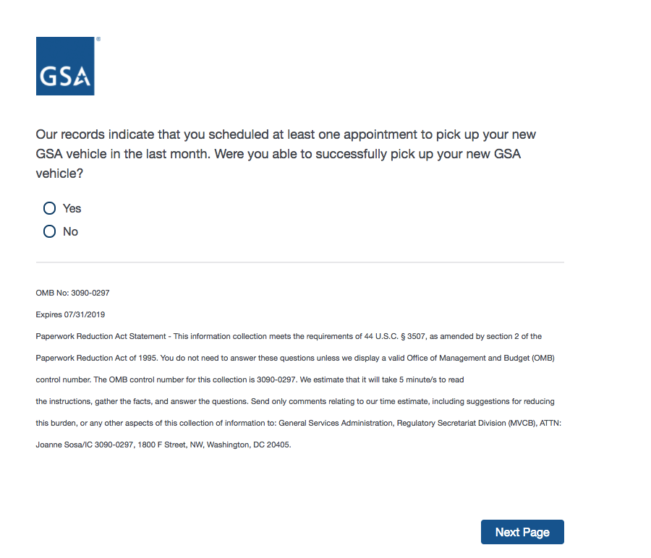

If Yes, then Display Screen 2.

If No, then skip to Screen 6

Screen 2

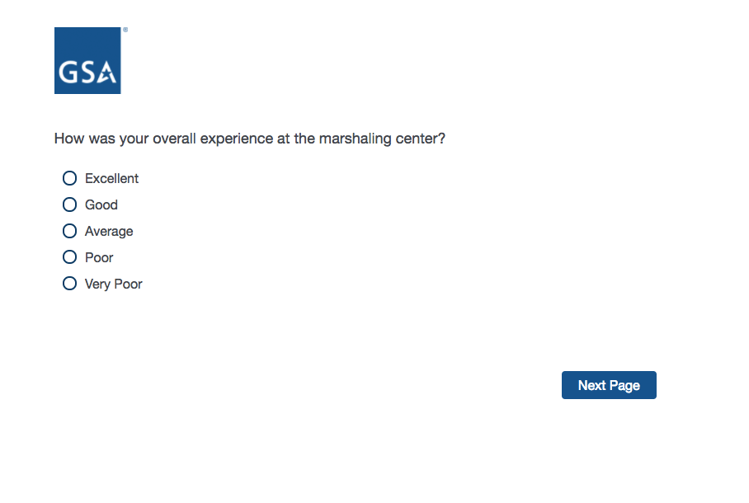
If Average, Poor, or Very Poor, then display Screen 3

If Excellent or Good, skip to Screen 4.

Screen 3

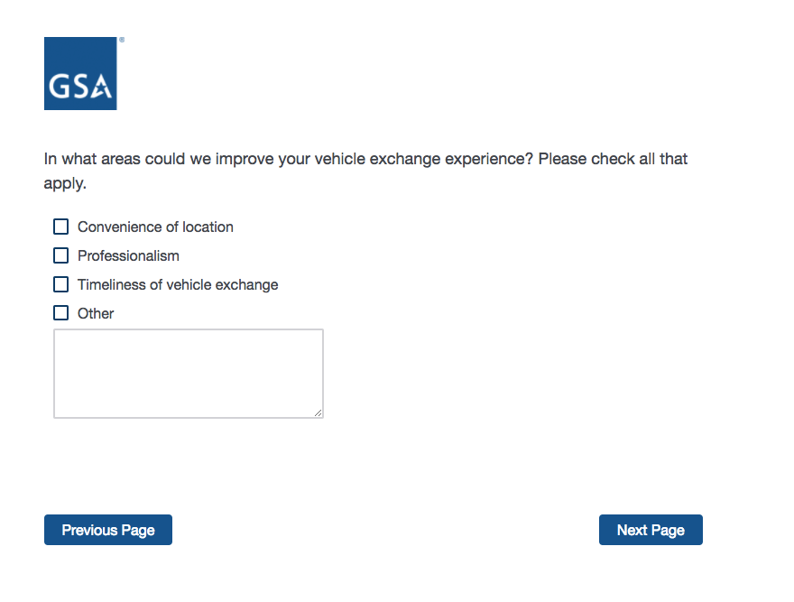

Screen 4

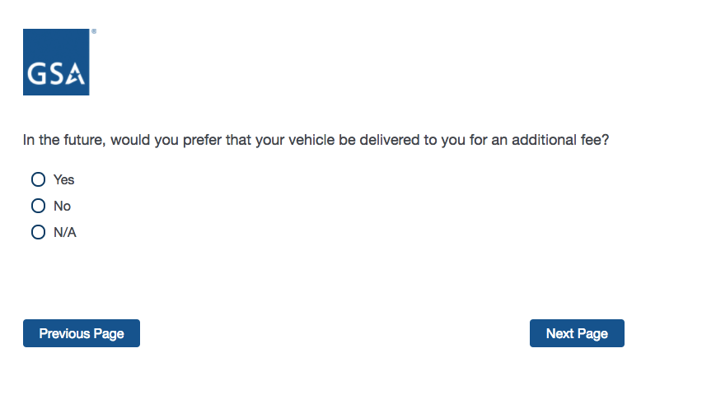

Screen 5

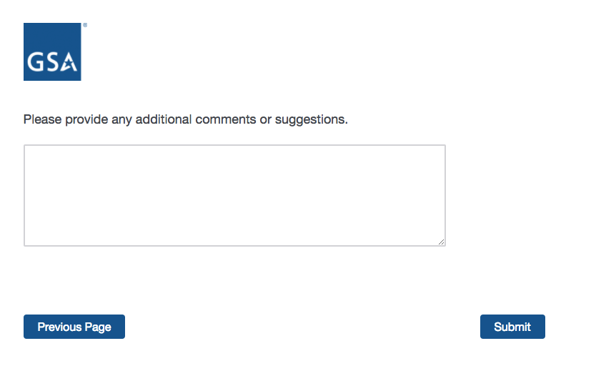

End of Survey:

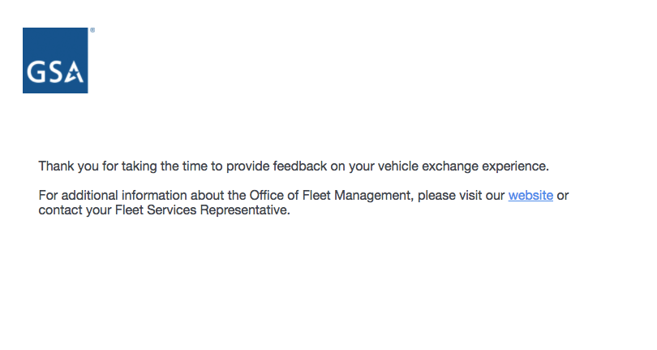

Screen 6

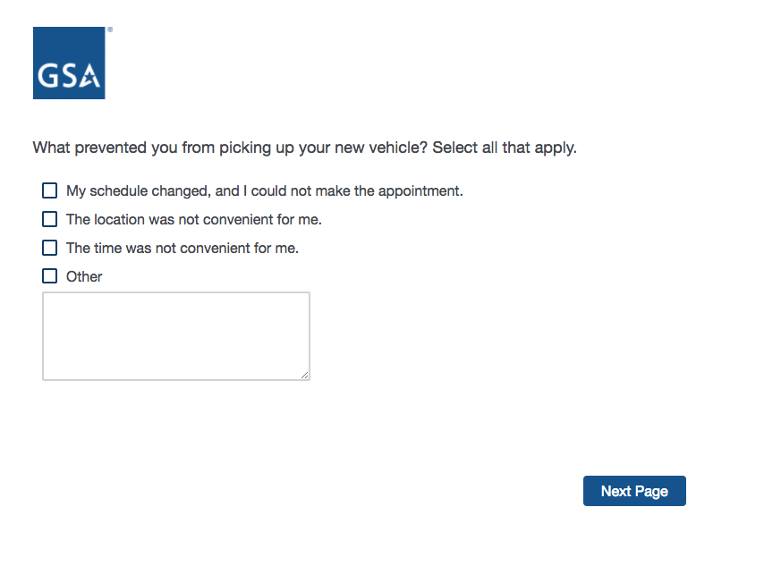

Screen 7

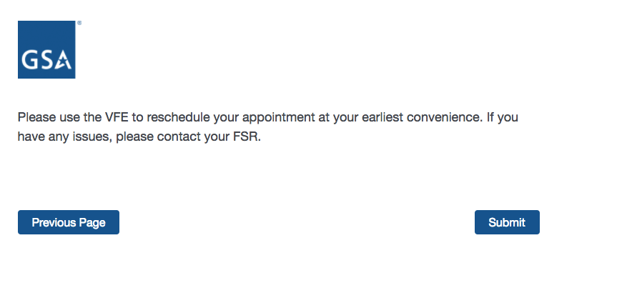

End of Survey:

