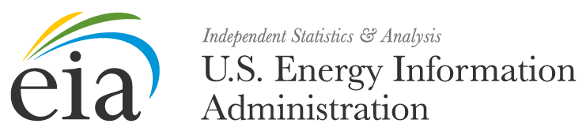

Date

Dear EIA-860 Respondent,

This is a reminder that the annual EIA-860 report for 2017 is due in less than a week, on the final day of February 2017. These data are collected pursuant to the Federal Energy Administration (FEA) Act of 1974, Public Law 93-275, and response to this survey is mandatory under the FEA Act.

The data collected on the EIA-860 provides information on the status of existing electric generating plants and associated equipment in the United States, and those scheduled for initial commercial operation within 10 years. These data are essential to EIA to perform analyses and projections that are relied upon by the U. S. Congress to prepare for legislative actions, by the U.S. Department of Energy to set policy, and by the electric power industry to analyze supply, economic, and reliability conditions. The data will appear in a number of EIA publications, such as the Annual Energy Outlook, the Electric Power Annual, and the Annual Energy Review. The data will also be used in other EIA products, such as the State Energy Data System and for EIA forecast models.

We want to help make this process as easy for you as possible. Thank you for your time and effort in diligently completing this form. We appreciate your timely report of the 2016 annual data by the last day of February 2017.

If you have not completed your submission for this reporting period, we advise you to please do so prior to the due date as your response is mandatory and required pursuant to 15 U.S.C., Sections 764(b), 772(b) and 790a of the Federal Energy Administration Act of 1974.. Failure to respond may result in fines and other penalties. Your company’s mandatory participation will continue into the future unless otherwise notified. EIA estimates that the average reporting burden for this survey is 9.26 hours.

The following information reported on Form EIA-860 will be protected and not disclosed to the public to the extent that it satisfies the criteria for exemption under Freedom of Information Act (FOIA), 5 U.S.C. §552, the DOE Regulations, 10 C.F.R. §1004.11, implementing the FOIA and the Trade Secrets Act, 18 U.S.C. §1905:

• All information associated with the “Survey Contact” and the “Supervisor of Contact
Person for Survey” on Schedule 1

• Information reported for the data element “Tested Heat Rate” on Schedule 3, Part B, Generator Information – Existing Generators

• All data reported on Parts A and B of Schedule 5, Generator Cost Information

All other information reported on Form EIA-860 will be treated as non-sensitive and may be publicly released in identifiable form.

Please log into the U.S. Energy Information Administration Single Sign-On (SSO) System at https://signon.eia.gov/ssoserver/login to access your form and submit your data. If you have any questions on filling out this form or have not registered with the e-file SSO system, send an email requesting assistance to: EIA-860@eia.gov. If you have not yet completed your submission for this reporting period, we advise you to please do so prior to the due date as your response is mandatory and required by law.

EIA has a legal mandate to carry out a central, comprehensive, and unified energy data and information program. All persons owning or operating facilities or business premises who are engaged in any phase of energy supply shall make available to the Administrator such information and periodic reports. By law the EIA Administrator has the authority to conduct mandatory information collections and obtain the information by issuing subpoenas, conducting physical inspections or by other means identified in 15 U.S.C. 779.

Sincerely,

Jonathan DeVilbiss
EIA-860 Survey Manager
EIA-860@eia.gov
U.S. Energy Information Administration

