Online Quarterly Pricing Data Entry Screen (CMS-367a)
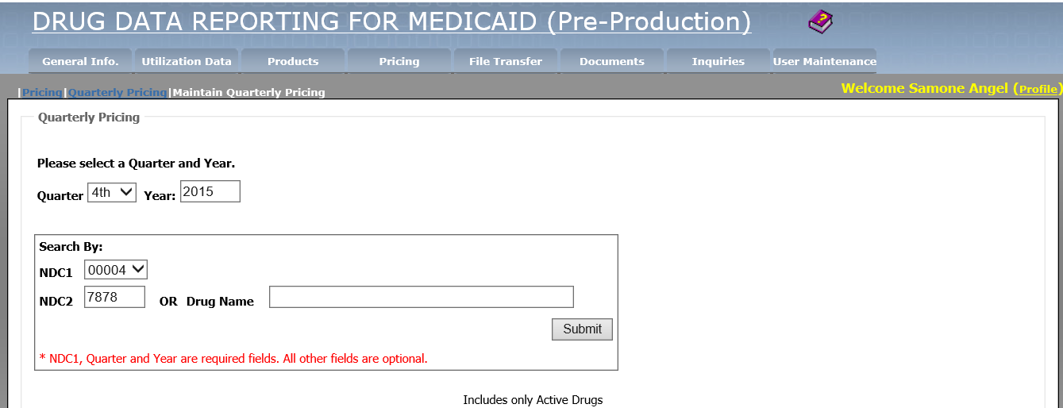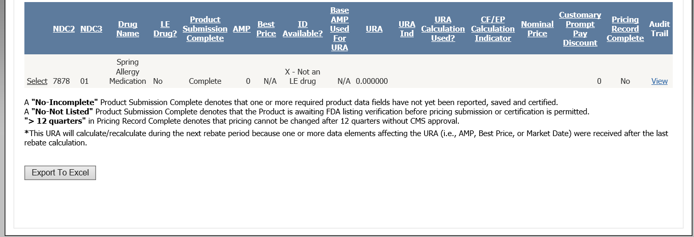

File Transfer Quarterly Pricing Layout (CMS-367a)
Field | Size | Position | Remarks
Record ID | 1 | 1 - 1 | Constant of “Q”
Labeler Code | 5 | 2 - 6 | NDC #1
Product Code | 4 | 7 - 10 | NDC #2
Package Size | 2 | 11 – 12 | NDC #3
Period Covered | 5 | 13 – 17 | QYYYY (Qtr/Yr)
Average Mfr Price | 12 | 18 – 29 | 99999.999999
Best Price | 12 | 30 – 41 | 99999.999999
Nominal Price | 9 | 42 – 50 | 999999999
Customary Prompt Pay Disc. | 9 | 51 – 59 | 999999999
Initial Drug Available for LE | 1 | 60-60 | Y, N, X or Z
Initial Drug | 9 | 61-69 | 9 digits alpha-numeric

Online Monthly Pricing Data Entry Screen (CMS-367b)
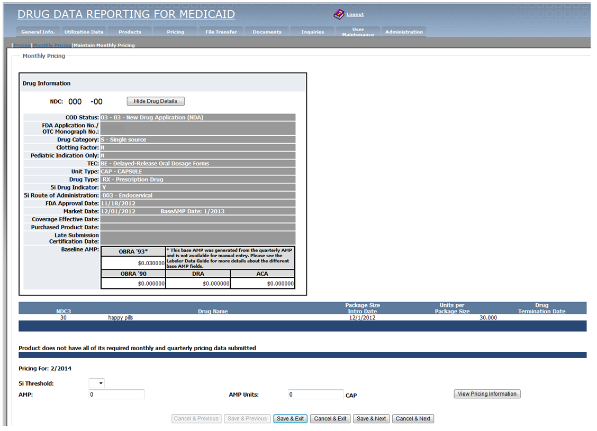

File Transfer Monthly Pricing Layout (CMS-367b)
Field | Size | Position | Remarks
Record ID | 1 | 1 – 1 | Constant of “M”
Labeler Code | 5 | 2 – 6 | NDC #1
Product Code | 4 | 7 – 10 | NDC #2
Package Size | 2 | 11 – 12 | NDC #3
Month | 2 | 13 – 14 | MM
Year | 4 | 15 – 18 | YYYY
Average Mfr Price | 12 | 19 – 30 | 99999.999999
AMP Units | 14 | 31 – 44 | 99999999999.99
5i Threshold | 1 | 45 - 45 | Y, N, X, or Z

Online Product Data Entry Screen (CMS-367c)
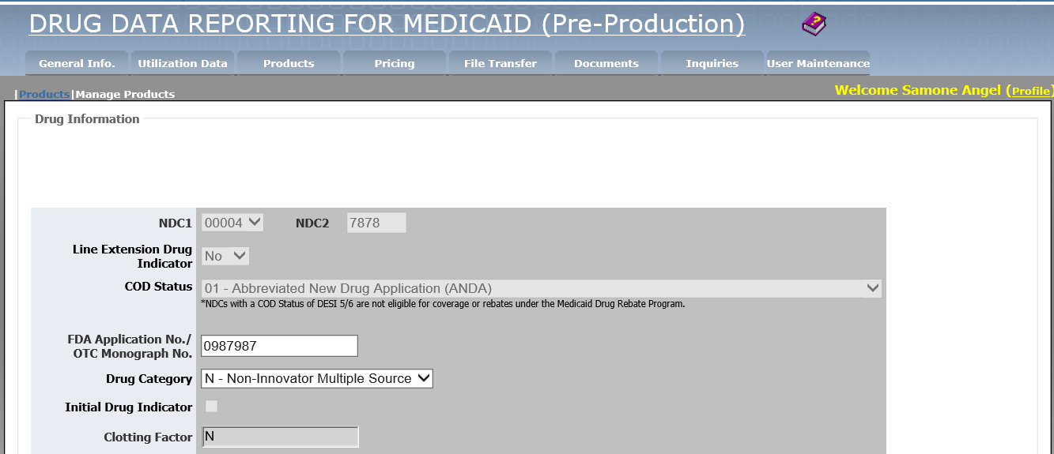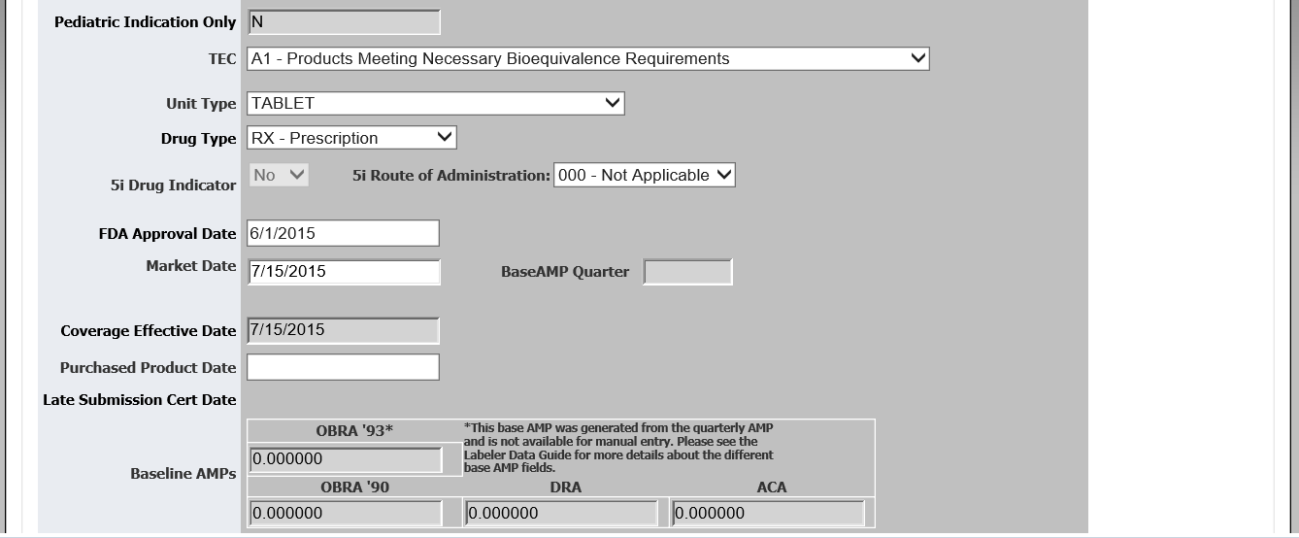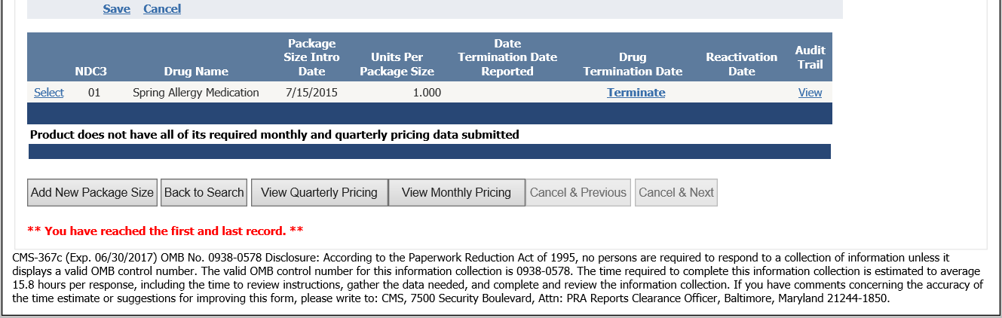

File Transfer Product Layout (CMS-367c)
Field | Size | Position | Remarks
Record ID | 1 | 1 – 1 | Constant of “P”
Labeler Code | 5 | 2 – 6 | NDC #1
Product Code | 4 | 7 – 10 | NDC #2
Package Size Code | 2 | 11 - 12 | NDC #3
Drug Category | 1 | 13 - 13 | See Data Element Definitions
Unit Type | 3 | 14 - 16 | See Data Element Definitions
FDA Approval Date | 8 | 17 - 24 | MMDDYYYY
FDA Thera. Eq. Code | 2 | 25 - 26 | See Data Element Definitions
Market Date | 8 | 27 - 34 | MMDDYYYY
Termination Date | 8 | 35 - 42 | MMDDYYYY
Drug Type Indicator | 1 | 43 – 43 | See Data Element Definitions
OBRA’90 Baseline AMP | 12 | 44 – 55 | 99999.999999
Units Per Pkg Size | 11 | 56 – 66 | 9999999.999
FDA Product Name | 63 | 67 – 129 | FDA Product Name
DRA Baseline AMP | 12 | 130 – 141 | 99999.999999
Package Size Intro Date | 8 | 142 – 149 | MMDDYYYY
Purchased Product Date | 8 | 150 – 157 | MMDDYYYY
5i Drug Indicator | 1 | 158 – 158 | See Data Element Definitions
5i Route of Administration | 3 | 159 – 161 | See Data Element Definitions
ACA Baseline AMP | 12 | 162 - 173 | 99999.999999
COD Status | 2 | 174 – 175 | See Data Element Definitions
FDA Appl. No./OTC Mono. No. | 7 | 176 – 182 | See Data Element Definitions
Line Extension Drug Indicator | 1 | 183 – 183 | See Data Element Definitions

