Appendix K:
Experimental task

Form Approved
OMB No. 0920-xxxx
Exp. Date xx/xx/20xx
Experimental Study
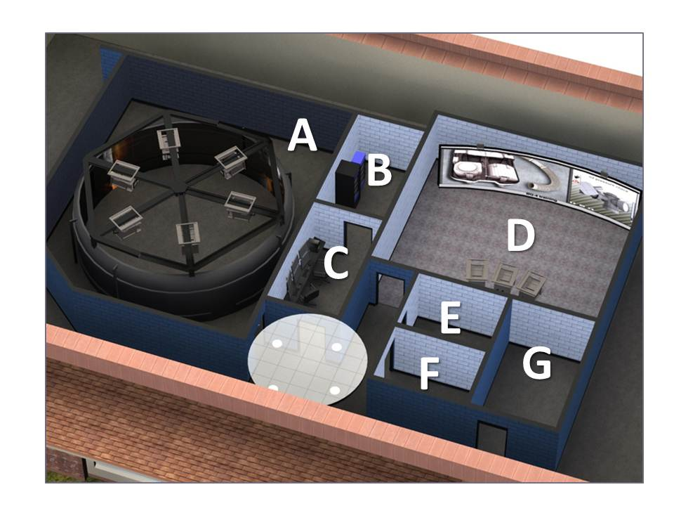
All participants will experience the same experimental procedure. All data collection will occur within the Virtual Immersion and Simulation Laboratory (VISLab) located at the NIOSH facility in Bruceton, PA. Figure 1 is a top down view of this facility. The lab houses two state-of-the-art virtual environment spaces. One consists of a 360° screen that is 10 feet tall and 33 feet in diameter (Room A in Figure 1). Participants will stand inside the cylindrical screen area as panoramic images are presented. The other lab houses a 26 feet wide by 10 feet tall screen with a 50° curve (Room D). The projection system in this room can produce stereoscopic images and the area can also be used for other types of data collection sessions. Controls for the systems and a prototyping system are in room C. The computer clusters that run the projection and prototyping systems are in room B. Rooms E, F, and G are personnel offices.
Figure 1. VISLab
All participants will be asked to read and verbally consent to taking part in the study before any data is collected. After completing the informed consent, the experimental study will begin. The experimental study will take place in Room A. Participants will be given the following instructions about the study: Imagine that you are traveling around the mine site where you work. You step out of your vehicle to begin a new task. I’d like you to perform a hazard assessment of each of the sites you will see during the study. Your goal therefore is to identify all of the hazards you can. When you identify a hazard, I’d like you to press a button on the air mouse you are holding. When you are finished with a site, please double click on the air mouse. Doing this will remove the site from the screen. You will have a short break between sites.
While the participant is performing this task, eye movements will also be monitored. In order to monitor eye movements, participants will be asked to wear SMI Eye-tracking Glasses (see Research Instruments for additional information).

Public reporting burden of this collection of information is estimated to average 1 hour per response, including the time for reviewing instructions, searching existing data sources, gathering and maintaining the data needed, and completing the collection of information agency may not conduct or sponsor, and a person is not required to respond to a collection of information unless it displays a currently valid OMB control number. Send comments regarding this burden estimate or any other aspect of this collection of information, including suggestions for reducing this burden to CDC/ATSDR Information Collection Review Office, 1600 Clifton Road NE, MS D-74, Atlanta, Georgia 30333; ATTN: PRA (0920-xxxx).
The Eye-tracking Glasses are lightweight and record to a hand held computing devise that is approximately the size of a smart phone. After the participant indicates the Eye-tracking Glasses fit comfortably, the recording device will be secured in a carrying case worn comfortably around the participant’s waist.
Before beginning the experimental study, participants will be given time to become comfortable wearing the eye-tracking glasses and hand held computing device and also to practice using the air mouse. Once participants indicate they are comfortable, the experimental study will begin. First, participants will perform a calibration of the eye tracking system. To calibrate, the participant will be asked to fixate markers on the screen in from on them. After the eye-tracking system is calibrated, participants will be presented with two practice scenes. They will be asked to perform a work place inspection on each of the scenes and to indicate any hazards within the scenes. They will also be given the opportunity to ask questions for clarification purposes. Participants will then be presented with 34 experimental scenes.
After viewing all of the static scenes for hazard recognition, participants will be given a break. After the break, participants will move to Room D within the VISLab. They will be shown the panoramic scenes a second time. During the second viewing, all hazards within a panoramic scene will be highlighted and participant responses to the hazards will be indicated. Meaning, participants will be told which hazards were accurately identified, what non-hazards were identified, and what hazards were not identified. Errors will be probed with open ended questions to gain insight as to why certain hazards were not identified. Finally, participants will also be asked to rate the risk level of the hazards within scenes and the Accident Probability and Accident Severity.
At the completion of the study, participants will be asked to fill in a demographic survey and two risk tolerance questionnaires. Demographic and risk tolerance questionnaires will be administered after all other data is collected to minimize any bias that may occur as a result of the measure. Because of the limited control OMSHR researchers have over who the mine workers are that take part in the study – beyond recommendations to the mining company with regards to mine worker age and years of experience as a miner – the demographic survey will be used to describe the sample of SSG mine workers taking part in the study. A variety of questions will be included on the demographic survey related to mining experience, positions held throughout the mining career, number of mines the mine worker has been employed, etc.

