BIOPHILIA: A BIO-CULTURAL FRAMEWORK
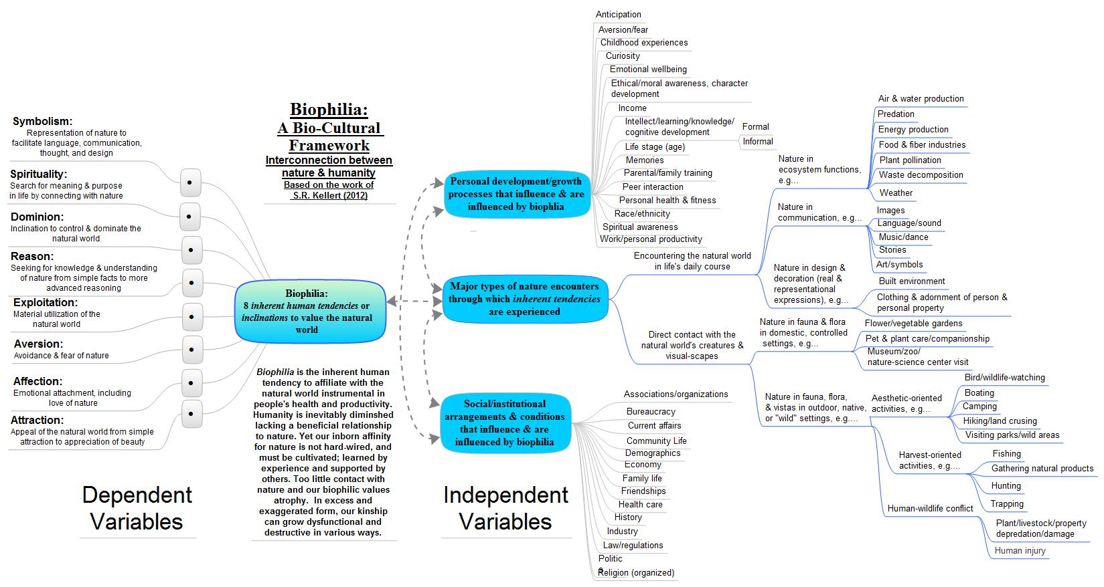

Kellert, S. R. 2012. Birthright: people and nature in the modern world. New Haven and London: Yale University Press, 242pp.

