APPENDIX 2

DATA COLLECTION INSTRUMENTS
Email Intake Form
(customer service and demographics questions)

Email Intake Form- (upper half of page) http://www.cancer.gov/global/contact/email-us

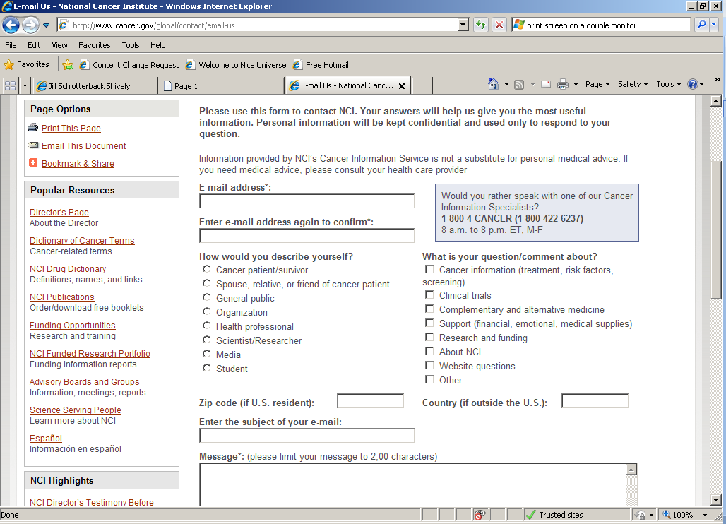

Email Intake Form- (lower half of page)

