2018 Columbia/Snake River
Navigational Survey
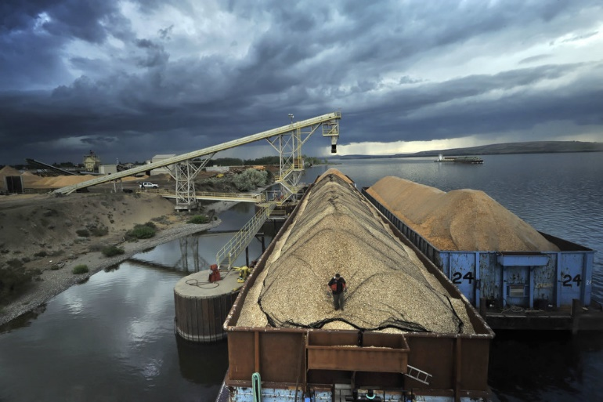
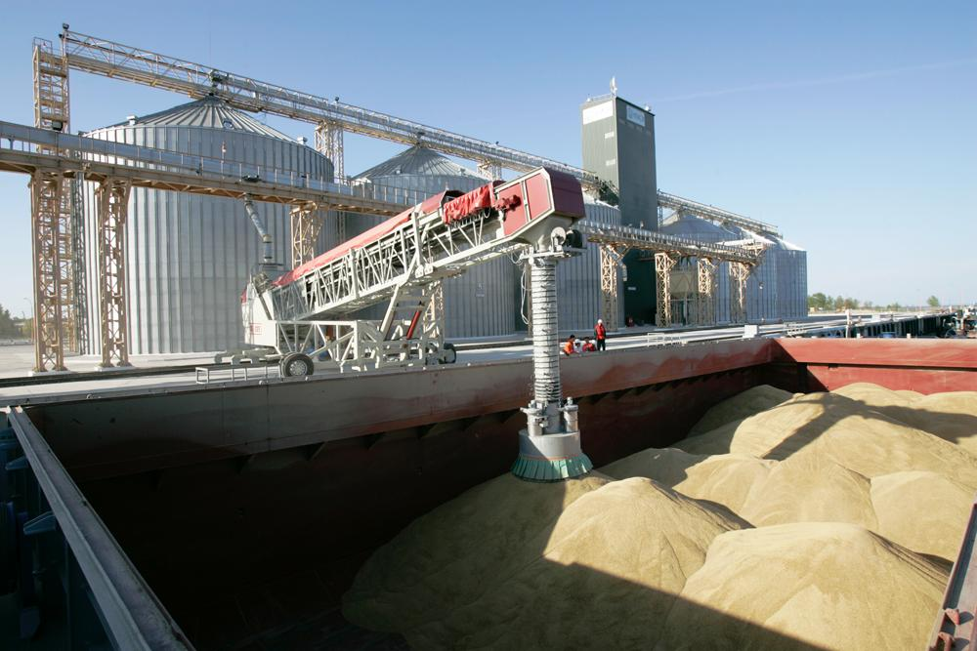
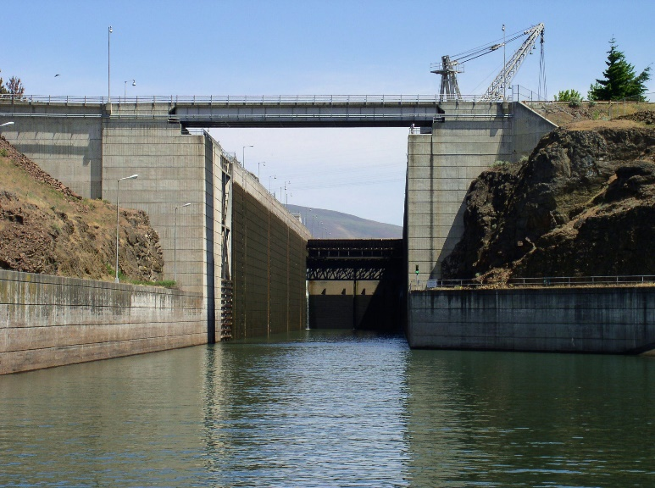
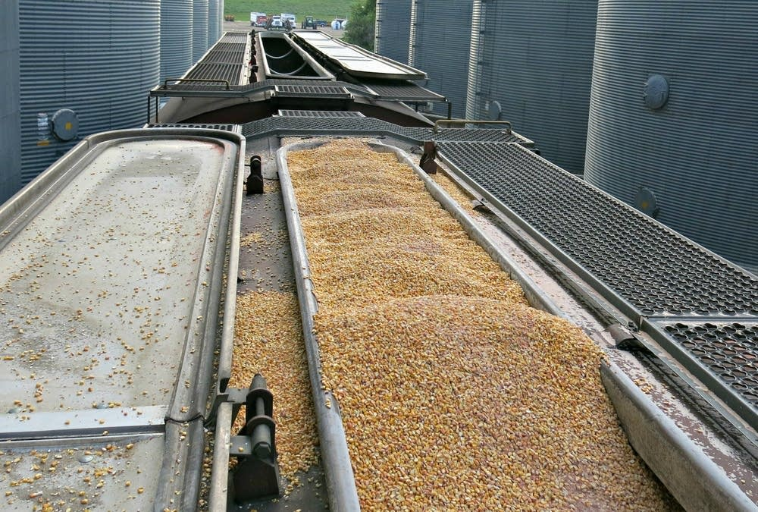

Sponsored by:

United States Army Corps of Engineers

The information obtained from this survey is part of the court mandated Columbia River System Operations EIS. Your voluntary response to this survey will aid the USACE in fulfilling this mandate and evaluating different operating needs. Collected information can be used by local, state and federal transportation agencies to evaluate and support public provision of transportation infrastructure improvements. Depending upon the number of facilities served, the survey response time could take up to 30 minutes.

The public reporting burden for this collection of information, 0710-0018, is estimated to average 30 minutes per response, including the time for reviewing instructions, searching existing data sources, gathering and maintaining the data needed, and completing and reviewing the collection of information. Send comments regarding the burden estimate or burden reduction suggestions to the Department of Defense, Washington Headquarters Services, at whs.mc-alex.esd.mbx.dd-dod-information-collections@mail.mil. Respondents should be aware that notwithstanding any other provision of law, no person shall be subject to any penalty for failing to comply with a collection of information if it does not display a currently valid OMB control number.

Shipment Information
«NAME»
Choice: Consider your last shipment from this location: «ADDRESS1»
(Please complete one questionnaire for each «CITY», «STATE» «ZIP»
facility you manage)

Q1. What is the primary commodity you ship from this facility? _____________ commodity

Q1b. What other commodities do you ship from this location? ______________________

Q2. At this location, do you have loading capabilities for…

Yes No
▼ ▼
- Trucks ₁ ₂
- Rail Cars ₁ ₂
c. Barges ₁ ₂

Q2b. If YES to Rail loading capability, what is your rail car loading capacity?

______ # of cars

Q2c. If NO to Rail loading capability, how close is the nearest rail loading facility to this location?

_______ miles

Q2d. If NO to Barge loading capability, how close is the nearest barge loading facility to this location?

_______ miles

Your last Freight Shipment

Q3. What commodity was shipped in your last shipment? _____________ commodity

Q4. Where was this commodity shipped to: _____________________________ city ___________ state

Q4b. What type of destination is this?

₁ River terminal ₂ Another Elevator ₃ Railroad terminal ₄ Processing Plant
₅ Other (please specify): _______________________________________(eg: export terminal, farm, feedlot,etc.)

Q5. How large was this shipment (payload weight)?

_____________________________ payload weight, in

₁ Tons ₂ Cwt. ₃ Gallons ₄ Bushels ₅ Other (specify): _________________

Q6. What type of transportation was used for this shipment, approximately what distance did each travel (in miles), and what was the approximate transportation rate?

Mode Distance Transportation Per Unit type for commodity
(check if used) traveled rate Tons Cwt Gallons Bushels Shipment Other (Specify)
▼ ▼ ▼ ▼ ▼ ▼ ▼ ▼ ▼
Truck __________ miles __________ rate ₁ ₂ ₃ ₄ ₅ ₆ _________
Rail __________ miles __________ rate ₁ ₂ ₃ ₄ ₅ ₆ _________
Barge __________ miles __________ rate ₁ ₂ ₃ ₄ ₅ ₆ _________

What were the total transport costs? ___________ ₁ ₂ ₃ ₄ ₅ ₆ _________
What was the total shipment distance in miles? ___________

Q7. Did that shipment arrive on-time? ₁ Yes ₂ No

Q7a.What do you estimate was the shipment time (include scheduling
time, wait for equipment and transit time)

_________ days + _________ hours.

Q8. What price did you receive for your commodity at the destination terminal?

__________ dollars per

₁ Tons ₂ Cwt. ₃ Gallons ₄ Bushels ₅ Shipment ₆ Other (specify): _________________

Shipping Alternatives

We want to know what options you could take if the mode and destination you used for your last shipment had not been available and would never be available. For example, if the rail system were shut down, shippers who used rail could use truck instead of rail, or could use barge with truck access to a barge loading facility, or could have sent the shipment to a different destination. We need to know what these alternatives are for you. Nearly everyone has some kind of shipping alternatives. Please provide us with information on these alternatives for you.

Q9. If the mode options and destination you used for your last shipment had not been available and would never be available, then you would …

₁ Continue your operations but in a different, perhaps more costly way
₂ Do something else: ________________________

First (best) Shipping Alternative

Q10. Where would this commodity be shipped to? ____________________ city _______ state

Q11. What type of destination is this?

₁ River terminal ₂ Another Elevator ₃ Railroad terminal ₄ Processing Plant
₅ Other (please specify): ________________________

Q12. What transportation would be used for this shipment, approximately what distance would each travel (in miles) and what would be the transportation rate?

Mode Distance Transportation Per Unit type for commodity
(check if used) traveled rate Tons Cwt Gallons Bushels Shipment Other (Specify)
▼ ▼ ▼ ▼ ▼ ▼ ▼ ▼ ▼
Truck __________ miles __________ rate ₁ ₂ ₃ ₄ ₅ ₆ _________
Rail __________ miles __________ rate ₁ ₂ ₃ ₄ ₅ ₆ _________
Barge __________ miles __________ rate ₁ ₂ ₃ ₄ ₅ ₆ _________

What would be the total transport costs? ________ ₁ ₂ ₃ ₄ ₅ ₆ _________

What would be the approximate total shipment distance in miles? ___________

Q13. What do you estimate would be the shipment time (include scheduling time, wait for equipment and transit time)

_________ days + _________ hours.

Q14. How reliable is the service? That is, for shipments like this one, what percent of the time would you expect them to arrive on time?

__________ percent on-time arrivals

Q15. How large would your shipment be (payload weight)?

_____________________________ payload weight, in

₁ Tons ₂ Cwt. ₃ Gallons ₄ Bushels ₅ Other (specify): ____________________

Q16. What price would you receive for your commodity at the destination terminal?

__________ dollars per

₁ Tons ₂ Cwt. ₃ Gallons ₄ Bushels ₅ Shipment ₆ Other (specify): ____________________

Other Shipping Alternatives

Please complete the table below for your other shipping alternatives. If you have no other alternatives, skip to Q23

 | Second Best Alternative | Third Best Alternative
Q17. Where would it be shipped to? | ______________ city _______ state | ______________ city _______ state
Q18. What type of destination is this? | ₁ River terminal ₂ Another Elevator  ₃ Rail terminal ₄ Processing Plant  ₅ Other (specify): _______________ | ₁ River terminal ₂ Another Elevator  ₃ Rail terminal ₄ Processing Plant  ₅ Other (specify): _______________
Q19. What type of transportation modes would be used for this shipment? | Mode Distance Transportation  (Check if used) traveled rate  ▼ ▼ ▼  Truck _____miles ____rate  Rail _____miles ____rate  Barge _____miles ____rate  ₁ Tons ₂ Cwt. ₃ Gallons  ₄ Bushels ₅ Shipment ₆ Other  (specify): | Mode Distance Transportation  (Check if used) traveled rate  ▼ ▼ ▼  Truck _____miles ____rate  Rail _____miles ____rate  Barge _____miles ____rate  ₁ Tons ₂ Cwt. ₃ Gallons  ₄ Bushels ₅ Shipment ₆ Other  (specify):
Q20. What do you estimate would be the shipment time? | _____ days + _____ hours | _____ days + _____ hours
Q21. How large would the shipment be? | __________ payload weight  ₁ Tons ₂ Cwt. ₃ Gallons  ₄ Bushels ₅ Other  (specify): | __________ payload weight  ₁ Tons ₂ Cwt. ₃ Gallons  ₄ Bushels ₅ Other  (specify):
Q22. What estimated price would you receive for your commodity at the destination terminal | __________ dollars  ₁ Tons ₂ Cwt. ₃ Gallons  ₄ Bushels ₅ Shipment ₆ Other  (specify): | __________ dollars  ₁ Tons ₂ Cwt. ₃ Gallons  ₄ Bushels ₅ Shipment ₆ Other  (specify):

Transportation Rates

In each of the next three questions relating to rate and service changes, please regard the changes as permanent changes.

Q23. For your last shipment, if the transportation rate increased «Percent_change1»%, would you continue with the original mode and destination or switch to your best alternative choice?

₁ Continue to use Original mode
₂ Switch to Best Alternative Choice Skip to Q24

Q23b. If you would continue to use your Original mode, what percentage increase in the transportation rate would be necessary to cause you to switch to the Alternative transportation mode?

______ % increase

Transit Time

Q24. For your last shipment, if the transit time (including scheduling and wait for equipment) for the original option increased «Percent_change2»%, would you continue with the original mode and destination or switch to the alternative at this location?

₁ Continue to use Original mode
₂ Switch to Best Alternative Choice Skip to Q25

Q24b. If you would continue to use your Original mode, what percentage increase in the transit time would be necessary to cause you to switch to the Alternative transportation mode?

______ % increase

Volume

Q25. If the average transportation rate you pay increased by «Percent_change4»%, would your annual volume shipped decrease (assume the rate increase applies to BOTH you and to your competitors)?

₁ Yes
₂ No Skip to Q26

Q25b. If yes, by how much would the volume decrease (assuming the rate increase applies to both you and to your competitors)?

__________ volume decrease

Shipper Characteristics

Q26. How long has this facility been at its current location?

_____ years

Q27. How large is your facility?

__________________ Total Amount of Annual Units Shipped

please check the type of unit for this facility
₁ Tons ₂ Cwt. ₃ Gallons ₄ Bushels ₅ Other (specify): __________________

__________________ Total Amount of Storage Capacity

₁ Tons ₂ Cwt. ₃ Gallons ₄ Bushels ₅ Other (specify): __________________

Q28. What proportion of the primary commodity shipped from this location is shipped
within each time period on a typical year?

__________%Sept.- Nov. __________%Dec.- Feb. __________%Mar.-May ___________%Jun.-Aug.

Q29. Does your firm (or parent firm) own export or import facilities?

₁ Yes
₂ No

Q30. How many facilities such as this one does your firm own and/or operate?

_______________ number of terminals or elevators.

Q31. How many employees (including yourself) work at this facility? _______ people

Q32. Finally, if we have any questions and wish to follow up, may we contact you?

₁ Yes
₂ No Skip to Q33

Q32b. Name: __________________________ Telephone: __________________________

Email: __________________________

Q33. Would you like a summary of the survey results?

₁ Yes
₂ No Skip to Q34

Q33b. Yes, please email the website for the report. Email: __________________________
Yes, please send a hard copy to:
Name: __________________________

Address: _________________________

City, State Zip: _____________________

Q34. Thank you for your help with this study. We would welcome any additional comments you would like to provide about shipping.

Please return your completed questionnaire to:

TBD
«ID» - 1

