AESDirect

User Guide
Updated 11/3/15
The complete guide to file Electronic Export Information to the Automated Export System

About the Automated Export System (AES) and the Data

The AES is the primary instrument used for collecting export trade data, which are used by the Census Bureau for statistical purposes. The AES record provides the means for collecting data on U.S. exports. Public Law 107-228 of the Foreign Trade Relations Act of 2003 authorizes this collection. Title 13, U.S.C., Chapter 9, Sections 301-307, mandates the collection of these data. The data collected in the AES is confidential under Section 301(g), which prohibits public disclosure of export data collected by the Census Bureau unless the Secretary of Commerce determines that such exemption would be contrary to the national interest. The regulatory provisions detailing the mandatory reporting of these data are contained in the Foreign Trade Regulations (FTR), Title 15, Code of Federal Regulations (CFR), Part 30.

The official export statistics collected from these tools provide the basic component for the compilation of the U.S. position on merchandise trade. These data are an essential component of the monthly totals provided in the U.S. International Trade in Goods and Services (FT900) press release, a principal economic indicator and a primary component of the Gross Domestic Product.

In addition to developing the FT900, other federal agencies have used the data for export control purposes to detect and prevent the export of certain items by unauthorized parties or to unauthorized destinations or end users.

Burden Estimate

Public reporting burden for this collection of information is estimated to average approximately 3 minutes (.05 hour) per transaction for the Automated Export System, including the time for reviewing instructions, searching existing data sources, gathering and maintaining the data needed, and completing and reviewing the collection of information. Send comments regarding this burden estimate or any other aspect of this collection of information, including suggestions for reducing this burden to: ECON Survey Comments 0607-0152, U.S. Census Bureau, 4600 Silver Hill Road, Room EMD-6K064, Washington, DC 20233. You may e-mail comments to ECON.Survey.Comments@census.gov. Be sure to use ECON Survey Comments 0607-0152 as the subject. This collection has been approved by the Office of Management and Budget (OMB). The eight-digit OMB approval number is 0607-0152. Without this approval we could not conduct this survey.

Table of Contents
General Information on Shipments 4
Parties Involved in an Export Transaction 6
Getting Started with AESDirect 6
Create Export Filing 7
Step 1: Shipment…………………………………………………………………………………….………………………8
Step 2: Parties………………………………………………………………………………………………………………10
Step 3: Commodities………………………………………………………………………………………….…………17
Step 4: Transportation……………………………………………………………………………….…………………20
Template Manager 26
Party Profile Manager 31
AES Responses 34
AES Proof of Filing Citations 34

General Information on Shipments

Before learning to file Electronic Export Information (EEI) using AESDirect, here is some general information regarding EEI. We will refer to EEI as “Shipments” from this point forward.
Sections in each shipment

Transportation details
Shipment details
Parties related to the shipment
Goods being exported
Transportation
Shipment

Parties

Commodities

Transportation
Contains transportation details for the shipment, including carrier information.
(Required for all shipments.)
Commodities
Contains commodity information. (Required for all shipments.)
Parties
Contains information about the USPPI (the person or entity in the United States that receives the primary benefit, monetary or otherwise, from the export transaction), the Ultimate Consignee (the person or entity overseas who receives the product), and the Freight Forwarder and Intermediate Consignee (if applicable). (Required for all shipments.)
Shipment
Contains general shipment information. (Required for all shipments.)
Special Shipments

Routed export transactions - Transactions where the Foreign Principal Party in Interest (FPPI) authorizes a U.S. agent to facilitate export of items from the United States on its behalf and also prepare and file the shipment.
Shipments to Puerto Rico – The following is required:

- List a Port of Unlading
- Addresses should be listed with:
  - City – List municipality in Puerto Rico
  - State – Indicate Puerto Rico (PR)
  - Country – Indicate United States (U.S.)
  - Postal Code – Indicate a valid postal code in Puerto Rico

Shipments From Puerto Rico – The following is required:

- List a Port of Unlading
- Addresses should be listed with:
  - City – Indicate city of destination
  - Country – Indicate country of destination

Transshipments through Mexico, Canada or another foreign country, the mode of transportation is the mode of the carrier transporting the goods out of the United States.
Sold en Route – If the Ultimate Consignee is unknown at the time of export because your cargo will be sold while at sea, click the Sold en Route box. If selected, you must update all consignee information within four calendar days of export. Information should be stated as:
  - Ultimate Consignee Company Name: Sold en Route
  - Address 1: SEA
  - City: City of First Port of Call
  - Country: Country of First Port of Call
Mail - If the carrier is the United States Postal Service (USPS), select “Mail” as the mode of transportation. Leave the Carrier SCAC/IATA and Conveyance Name/Carrier Name fields blank.

Parties Involved in an Export Transaction
- Foreign Principal Party in Interest (FPPI)
The party abroad who purchases the goods for export or to whom final delivery or end-use of the goods will be made. This may be the ultimate consignee.
- Ultimate Consignee
The ultimate consignee is the person, party or designee that is located abroad and actually receives the export shipment. This may be the end-user or FPPI.
- U.S. Principal Party in Interest (USPPI)
The USPPI is the person or entity in the United States that receives the primary benefit, monetary or otherwise, from the export transaction.

Definitions of Parties in the AES
- Freight Forwarder – Authorized Agent
The person in the United States who is authorized by the principal party in interest to facilitate the movement of the cargo from the United States to the foreign destination and/or prepare and file the required documentation.
- Intermediate Consignee
The intermediate consignee is the person or entity in the foreign country that acts as an agent for the principal party in interest with the purpose of effecting delivery of items to the ultimate consignee.

Getting Started with AESDirect

AESDirect Interface

Colors and Symbols
- (1) RED asterisk indicates a mandatory field (Required)
- (2) RED asterisks indicates a conditional field (May be required)
- No asterisk indicates an optional field (Not required)

Help (i)
Available to the right of most sections to determine what is needed for each field and when fields are required.

Log in to Account
Step | Action
1 | Go to https://ace.cbp.dhs.gov.
2 | Enter Username and Password
3 | Click Continue.
Create Export Filing

Step | Action
1 | Log in to ACE account.
2 | Navigate to Main Menu.
4 | 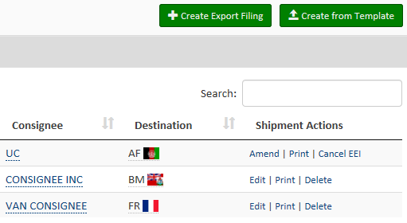  Click Create Export Filing.

The following sections provide instructions for completing each of the required sections, as well as definitions of all of the data fields for each section.
Step 1: Shipment
Step | Action
1 | Select Step 1: Shipment
2 | Complete all of the shipment details as required.

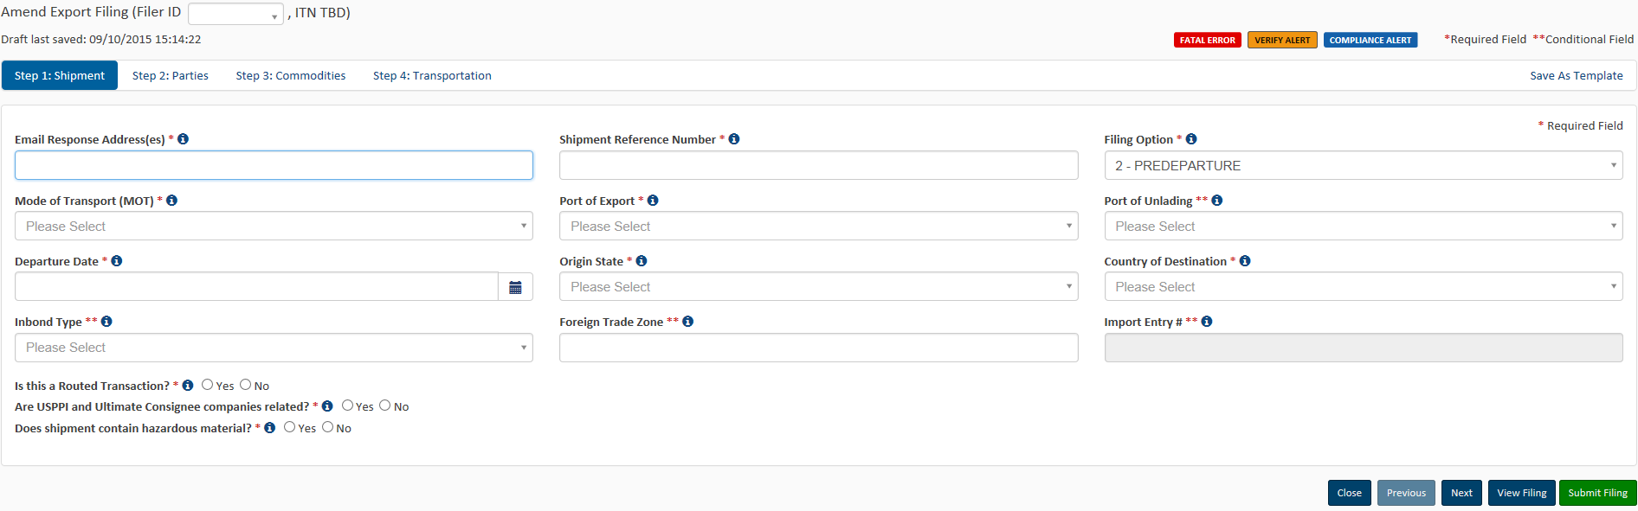

Explanation of Data Fields for this section

E-mail Response Address – This is where the AES Response will be sent. More than one e-mail address can be added if separated by commas.
Required: at least one e-mail

Shipment Reference Number – This is a unique identification number (1 - 17 alphanumeric characters) used to identify each shipment. The reuse of a Shipment Reference Number is prohibited. We recommend that you establish a unique format to create Shipment Reference Numbers and maintain a log of those already used.
Required: unique number used to identify each shipment; cannot be re-used

Are USPPI and Ultimate Consignee related?
When USPPI and/or Ultimate Consignee owns directly or indirectly 10 percent or more of either party.

Required: state the filing option of this EEI
Filing Option – Select the filing option you wish to use for this EEI:
2 – Predeparture, 3P- AEI – Partial, 3F – AEI – Complete, 4 –Postdeparture
filing. This field will default to Option 2. Postdeparture and Advanced Export Information (AEI) filing is only available with approved USSPPI IDs and for EEI that meet the requirements for postdeparture (AEI) filing.

Mode of Transport (MOT) - Report the method by which the goods are exported from the U.S.
For shipments crossing through Canada or Mexico to another destination, report the mode of transportation for the movement of the goods out of the United States.
Required: how the goods will be transported out of the U.S.

Required: port where the goods are loaded on the exporting carrier
Port of Export – Seaport or airport where the goods are loaded on the exporting carrier that is taking the goods out of the United States, or the port where the exports (by overland transportation) cross the U.S. border into a foreign country.

Conditional: required for all vessel shipments and air shipments between the U.S. and Puerto Rico.
Port of Unlading – First port where the goods will be removed from the exporting carrier.

Departure Date - Report the date of export out of the U.S.
Required: date leaving the U.S.

Required: state where the goods begin their journey to the port of export
Origin State - Indicate where the goods begin their journey to the port of export. If a shipment is coming from more than one warehouse located in different states, provide the state with the commodity of greatest value. If this is unknown, provide the state where the commodities are consolidated for export.

Required: country where the goods will be consumed
Country of Destination - Country where the goods will be consumed, further processed, stored or manufactured as known at the time of export. For shipments with the ultimate destination of Puerto Rico, select ‘Puerto Rico’ from the drop-down.

Required: Inbond shipments may not require an AES filing per FTR 30.2(d)(1)
Inbond Code – The code indicating whether the shipment is being transported under bond, and if so, the type of withdrawal.

Foreign Trade Zone (FTZ) - Provide the alphanumeric code assigned by the Foreign Trade Zone Board from where goods are withdrawn for export. Foreign Trade Zones are specially licensed commercial and industrial areas or areas near ports of entry where foreign and domestic goods may be brought in without being subject to payment of Customs duties.
Conditional: only required if goods are removed from the FTZ and not entered for consumption

Conditional: only required if Inbond Code is reported
Import Entry # – If an Inbond Code is specified, report import entry number

Required: indicate yes if routed or no if standard
Is this a Routed Transaction?
A shipment is considered “Routed” when the foreign principal party in interest (FPPI) authorizes a U.S. Freight Forwarder or U.S. agent to facilitate the export of items, prepare and file the EEI on its behalf.

Does shipment contain hazardous material?
Specify if there is any hazardous merchandise (as defined by the Department of Transportation).
Required: indicate yes or no
Are USPPI and Ultimate Consignee related?
When USPPI and/or Ultimate Consignee owns directly or indirectly 10 percent or more of either party.
Required: indicate yes or no

Step 2: Parties

Step | Action
1 | Select Step 2: Parties
2 | Complete all of the information for the involved parties in this transaction.  NOTE: You will need at least one USPPI and one Ultimate Consignee for each transaction.

USPPI (mandatory)
If you are the exporter, you will need to enter your information into the USPPI section.

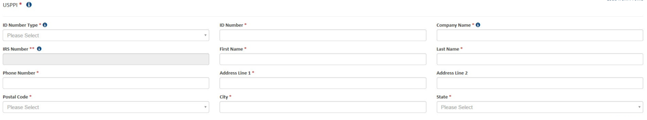
Required
First and Last Name - Provide the first and last name of the contact person. Names must have at least two letters and can not have special characters such as accents or punctuation.
Company Name - Provide the company’s name.
ID Number – Employer Identification Number (EIN) or Foreign Entity ID (ex: passport number).
Note: Foreign party must be in the US when goods are obtained for export.
Required
Required: names must have at least two letter; special characters are not allowed
IRS Number - If you select ‘DUNS’ as the ID Number Type, then the EIN would also be required.
Conditional: required if ID Number Type is DUNS
ID Number Type – Select either Employer Identification Number (EIN), DUNS or Foreign Entity ID (ex: passport number).
Required
Explanation of Data Fields for this section
Required: address where the merchandise actually begins its journey to the port of export
Address Line 1 - Indicate address (no P.O. box number) of the location from which the merchandise actually began its journey to the port of export.
Example: Goods loaded in a truck at a warehouse in Georgia for transport to Florida to then be loaded on a vessel for export to a foreign country must show the address of the warehouse in Georgia.
For shipments of multiple cargo origins, report the address from where the commodity with the greatest value begins its export journey. If such information is not known, report the address in state where the merchandise is consolidated.

Required: telephone number
Phone Number - Provide the contact telephone number.

State - Enter the state for the corresponding address.

Required
City - Enter the city for the corresponding address.
Required
Postal Code - Enter the postal code for the corresponding address.
Required
Address Line 2 – Enter the second line of the address.
.
Optional
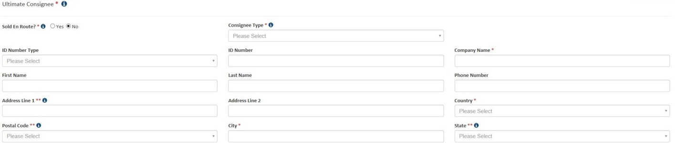
Ultimate Consignee (mandatory)
The Ultimate Consignee section is always required. Please complete each data field as required.

Explanation of Data Fields for this section

Required: indicate yes or no
Sold en Route - If you do not know the ultimate consignee because your cargo will be sold while in transit, select ‘Yes’.
Input data as follows:
- Ultimate Consignee Name: SOLD EN ROUTE
- Address 1: SEA
- City: City of First Port of Call
- Country: Country of First Port of Call (ISO Code)
Consignee information must be updated within 4 (four) days of exportation or as soon as the information is known.

Phone Number – The contact person’s telephone number.
Optional

Optional
First and Last Name - The contact person’s name.
Required: company name or sold en route indicator
Company Name - Enter the company’s name. If you select ‘Sold en Route’, all consignee information must be updated within 4 calendar days from the departure date.
Optional
ID Number: Employer Identification Number (EIN), DUNS, or Foreign Entity ID (ex: passport number).
Optional
ID Number Type – Select either Employer Identification Number (EIN), DUNS, or Foreign Entity ID (ex: passport number).
Required: select consignee type from the drop-down menu
Consignee Type - Select Consignee Type based on the
business function from consignee that applies most often.
You can select from:
- Direct Consumer - a non-government institution, enterprise, or
company that will consume or use the exported good as a
consumable, for its own internal processes, as an input to the
production
- Government Entity - a government-owned or
government-controlled agency, institution, enterprise,
or company.
- Reseller - a non-government reseller, retailer, wholesaler,
distributor, distribution center or trading company
- Other/Unknown - an entity not previously indicated, as defined
above, or whose ultimate consignee type is not known
at the time of export
Address Line 1 - Enter the first line of the address.
Required
Address Line 2 - Enter the second line of the address.
Optional

Country - Enter the country of ultimate destination. Select ‘United States’ for shipments with ultimate destination of Puerto Rico.
Required
Postal Code - Required for U.S. and Puerto Rico consignees, must be a valid code for the state reported.
Conditional: required for shipments to and from Puerto Rico
City - Enter the city for the corresponding country of ultimate destination
Required
State - You must enter a valid state code for Mexican and U.S. Consignees. Select ‘PR-Puerto Rico’ for shipments with ultimate destination of Puerto Rico.
Conditional: required for shipments to Mexico and to and from Puerto Rico

Intermediate Consignee Section (conditional)
The intermediate consignee is the person or entity in the foreign country that acts as an agent for the principal party in interest with the purpose of effecting delivery of items to the ultimate consignee. Please complete this section if applicable. See ‘Ultimate Consignee’ section for explanation of data fields.
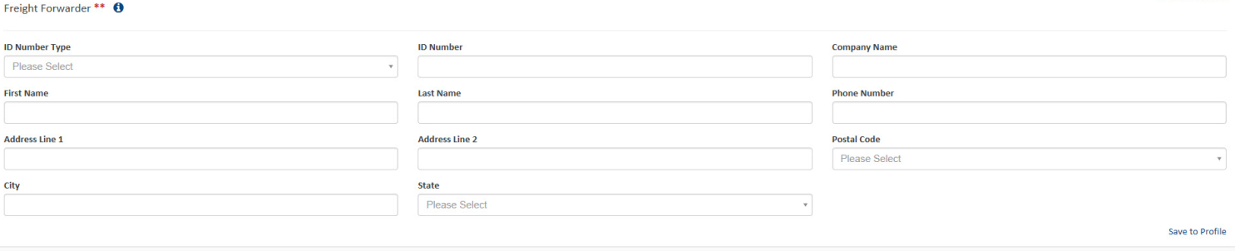
Explanation of Data Fields for this section
Address Line 2
Optional
Address Line 1 – Enter the address for the freight forwarder’s location
Required
Phone Number – The contact person’s telephone number
Required
Required: names must have at least two letter; special characters are not allowed
First and Last Name - Provide the contact person’s first and last name
Required: company name
Company Name - Provide the company’s name.
Required
ID Number - Enter either Employer Identification Number (EIN) DUNS or Foreign Entity ID.
Required
ID Number Type – Select either Employer Identification Number (EIN), DUNS or Foreign Entity ID.
Freight Forwarder (conditional)
If you are the freight forwarder, you will need to enter your information into the Freight Forwarder section, and the exporter’s information into the USPPI section.
Postal Code - Enter the postal code for the freight forwarder’s location

Required
City - Enter the city for the freight forwarder’s location

Required

State - Enter the state for the freight forwarder’s location. It must correspond to the postal code entered.

Required

Step | Action
1 | Select Step 3: Commodities
2 | 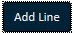  Select Add Line to open up a new commodity line.
Complete all of the commodity details as required.

Note: You may add multiple commodity lines by selecting Add Line.
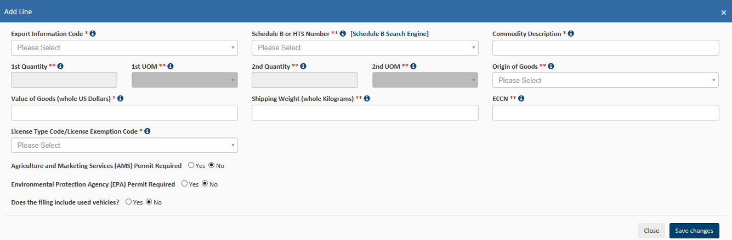
Step 3: Commodities
Required: type of export
Export Information Code - Select the code that identifies the type or condition of the export transaction being made.
Explanation of Data Fields for this section
Conditional: Not required if Export Code is HH (personal and household effects and tools of the trade) is selected.
Schedule B or HTS Number – Report commodity classification codes. Some HTS Numbers are not valid for Export (see “Invalid HTS” ). Provide 10 digits without periods. If you do not have a Schedule B number, use the ’Schedule B Search Engine’ link to locate it.

Conditional: Not required if Export Code is HH.
Conditional: Not required if Export Code is HH (personal and household effects and tools of the trade) is selected.
1st and 2nd Quantity - Report the total quantity of the commodity being exported for each commodity code classification. Report in the unit of measure as required by the Schedule B or HTS Number.
Required: commercial description
Commodity Description - Report an appropriate description for the commodity.
Conditional: not required if Export Code is HH. If the origins vary for the same classification number, report foreign goods separately from domestic goods.
Origin of Goods - Select “domestic” if commodity is grown, produced or manufactured in the U.S. Select “foreign” for goods grown, produced or manufactured in foreign countries, but have not been changed in form or condition in the U.S.
1st and 2nd UOM- The Unit of Measure (UOM) is determined by the Schedule B or HTS number entered. When a valid Schedule B or Harmonized Tariff number is entered, the unit of measure required will automatically populate.

Required: selling price in whole numbers, no symbols. Only report $US dollars
Value of Goods - Report the value of the goods at the U.S. port of export. The value shall be the selling price of the goods including inland or domestic freight, insurance, and other charges to the U.S. For details, see Foreign Trade Regulations 30.6 (a)(17).

Required: weight in whole numbers, no symbols
Shipping Weight - Must be reported in kilograms. Include the weight of the commodity and weight of normal packaging. For details, see Foreign Trade Regulations 30.6(a)(16).

ECCN - This number is used to identify items on the Commerce Control List (CCL).

A complete listing of license codes and descriptions for the U.S. Department of Commerce, Office of Foreign Assets Control (OFAC), Nuclear Regulatory Commission, U.S. Department of State and other Partnership Agency licenses, can be found under Appendix F of the AES Trade Interface Requirements (AESTIR).

Conditional: Only required for certain commodities

Required: determines if other fields need to be reported
License Type Code/License Exemption Code - Select the appropriate license type for the commodity. You may be required to enter additional information based on the license type selected.

Required: indicate yes or no
Does the filing include used vehicles? - A used vehicle, according to Customs and Border Protection CFR 192.2, is defined as “any self-propelled vehicle the equitable or legal title to which has been transferred by a manufacturer, distributor, or dealer to an ultimate purchaser.” You will be required to complete additional information if you are reporting a used vehicle.

Required: indicate yes or no, complete additional fields as required.
Agriculture and Marketing Services (AMS) Permit Required - Does the filing require an Agriculture and Marketing Services (AMS) permit?

Required: indicate yes or no complete additional fields as required.
Environmental Protection Agency (EPA) Permit Required - Does the filing require an Environmental Protection Agency (EPA) Permit?

Step 4: Transportation
Commodity lines should be separated based on their commodity classification code, origin of goods, commodities valued at over $2500, or requiring an export license per commodity classification code. After saving the first commodity, select “Add Line” to open a new Commodity Line.
Adding more than one commodity

Step | Action
1 | Select Step 4: Transportation
2 | Complete all of the transportation details as required.

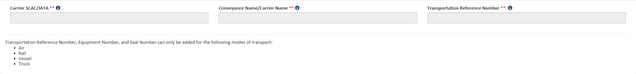
Conveyance Name/Carrier Name – Provide the vessel name for ocean shipments and the carrier name for air, truck, and rail.
You may not report UNKNOWN for the Conveyance Name.
Carrier SCAC/IATA – Carrier Code that identifies the transportation company. Contact your transportation company to obtain their carrier code.

Explanation of Data Fields in this section

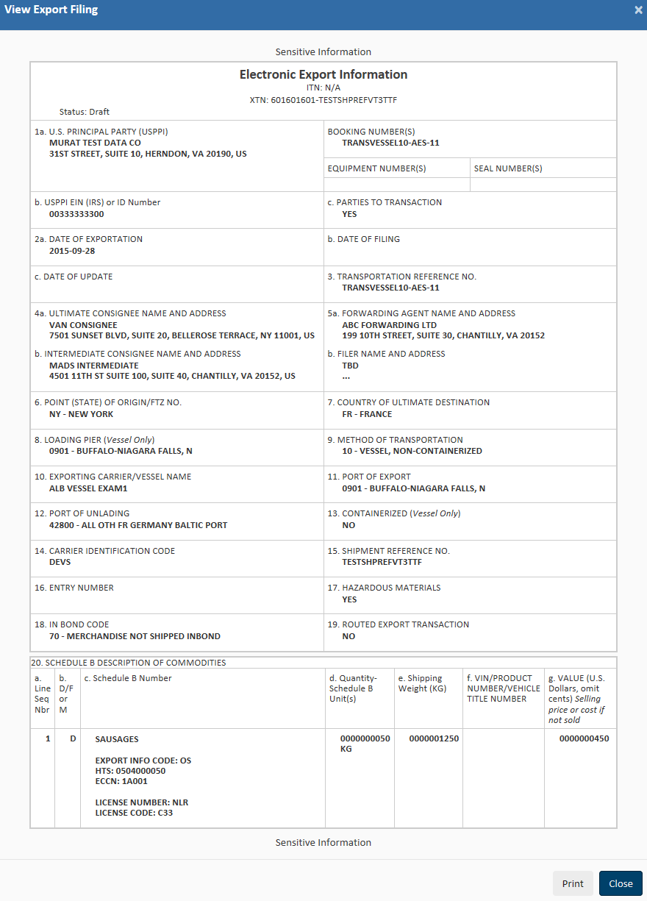
Conditional: only required for vessel shipments. Optional for air shipments.
Transportation Reference Number - This is the reservation number, or booking number, assigned by the ocean carrier to hold space on the vessel for the cargo. Optional for air shipments and it would be the airway bill number
Conditional: only required for Air, Vessel, Rail, and Truck shipments. Not required for USPS shipments.
Conditional: only required for Air, Vessel, Rail, and Truck shipments. Not required for USPS shipments.

Submit Shipment to AES
Step | Action
1 | 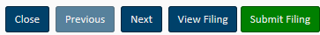  Click Submit Filing.
2 | Observe your response from AES.  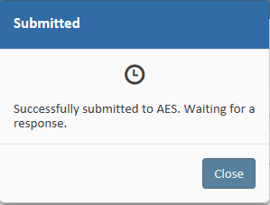

Retrieve and Amend/Edit a Shipment

From the Shipment Manager, you can search for previously filed shipments by entering your search criteria into the Search box.

Step | Action
1 | Navigate to Shipment Manager
2 |   Enter your search criteria into the Search box
3 | Once you have located your shipment, you can retrieve the filing by clicking the Amend or Edit link to the right.

Print a Shipment
Step | Action
1 | Navigate to Shipment Manager
2 | Enter your search criteria into the Search box
3 | Once you have located your shipment, you can print the filing by clicking the Print link to the right.

Delete/Cancel EEI
Step | Action
1 | Navigate to Shipment Manager
2 | Enter your search criteria into the Search box
3 | Once you have located your shipment, you can delete the filing by clicking the Delete or Cancel EEI link to the right.

Template Manager

This feature saves frequent shipment information. The only fields not stored in a template are:

- Shipment Reference Number
- Transportation Reference Number
- Origin State
- Departure Date
- 1st and 2nd Quantity
- Value
- Gross Weight

The Template Manager shows a preview of each template. The Create EEI, Edit or Delete options will allow you to manage your templates directly from this screen.
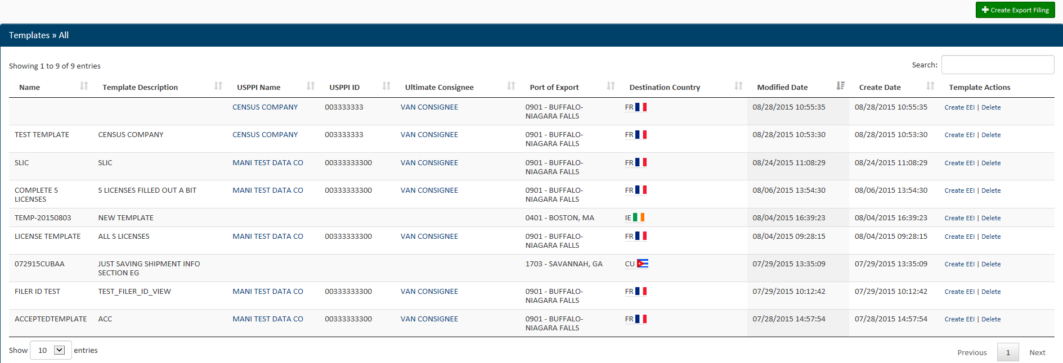
Open the Template Manager
Step | Action
1 | 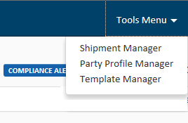  Click Tools Menu at the top right
2 | Select Template Manager

Once selected, the Template Manager will display, and you will have access to all of your templates.
Create EEI from Template
Step | Action
1 | From the Template Manager, identify the template you would like to use for your new EEI
2 | 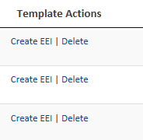  Click on the Create EEI option next to the template you want to use for your EEI.
3 | A new filing session will open up with your template data pre-populated into the form.

Delete template
Step | Action
1 | From the Template Manager, identify the template you would like to delete.
2 | Click Delete
3 | 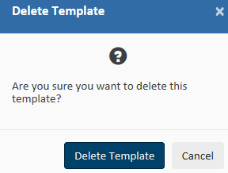  Confirm that you would like to delete this template.

Create New Template

At any point while filing your AES data, you can create a new template.

Step | Action
1 | Open up a new EEI Filing and begin entering the information.
2 | 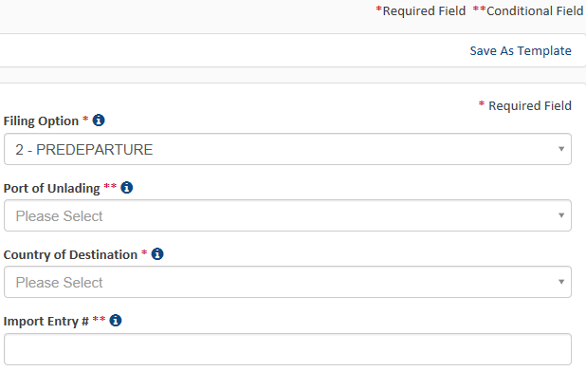  Once you have entered the desired information for your template, click Save as Template at the top right.
3 | 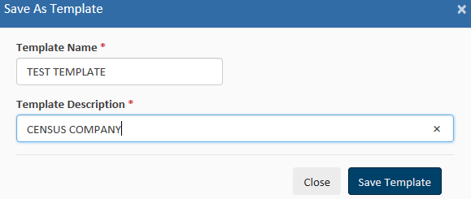  Enter a name and description for the template. When finished, click Save Template.

Step  Load an Existing Template | Action
1 | In the ‘Shipment Manager’ screen, click Create from Template
2 | 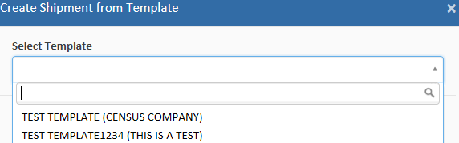  Locate the desired template.
3 | Click the template name to load.
4 | Complete the empty fields and submit the EEI.

Party Profile Manager
This feature saves company information for frequent USPPIs, Freight Forwarders and/or Ultimate Consignees.

Click the Tools menu from the Main Menu and select Party Profile Manager.

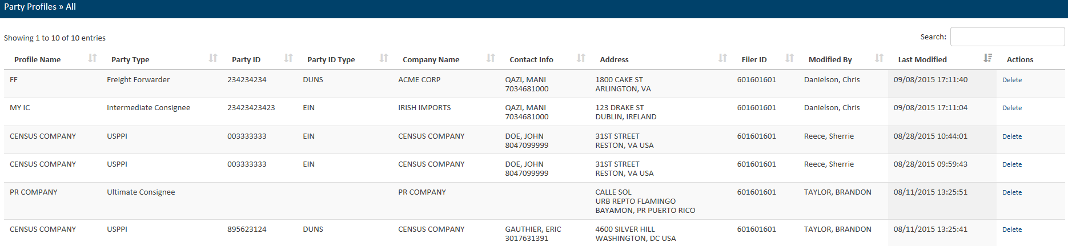

Open the Party Profile Manager
Step | Action
1 | Click Tools Menu at the top right.
2 | Select Party Profile Manager

Once selected, the Party Profile Manager will display, and you will have access to all of your profiles.
Create Party Profile

Step | Action
1 | Create a new EEI Filing
2 | Navigate to Step 2: Parties
3 | Enter the information for the profile you would like to save
4 | Once complete, select Save to Profile.

Loading Profiles
Step | Action
1 | Create a new EEI Filing
2 | Navigate to Step 2: Parties
3 | 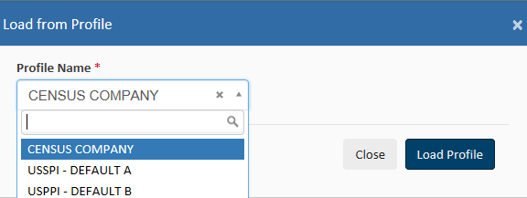  Select Load from Profile.
4 | In the Search box, enter the first few characters of the profile name.
5 | 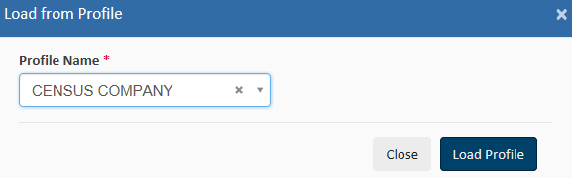  Select your profile and click Load Profile.

Delete profile
Step | Action
1 | From the Party Profile Manager, identify the profile you would like to delete.
2 | 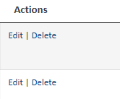  Click Delete.
3 | 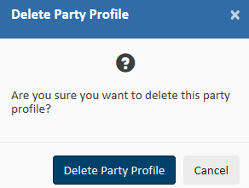  Confirm that you would like to delete this profile by selecting Delete Party Profile.

AES Responses

AES Proof of Filing Citations
Response E-mail
E-mails are sent to the address listed in the Shipment section. If the filing has been accepted, then the Response E-mail will have your ITN included. If the filing has been rejected, the Response E-mail will provide you with a rejection statement.
Once shipments are processed by the Automated Export System (AES), a response message will indicate the status of the shipment. You can access responses in your response e-mail or through the Shipment Manager.
The ITN (Internal Transaction Number) is a confirmation number that proves a shipment has been accepted by AES. This number is unique for every shipment and must be provided to the U.S. Customs and Border Protection (CBP) at the port of export.

Exporters must cite the ITN on the first page of the bill of lading, air waybill, and/or other commercial loading documents.

Postdeparture Citations:
- If an Authorized Agent files on behalf of an approved post-departure participant
  - AESPOST USPPI ID FILER ID Date of Export
  - Example: AESPOST 12345678900 987654321 10/01/2015

- If USPPI files shipments directly to AES
  - AESPOST USPPI ID – Date of Export
  - Example: AESPOST 23456789000 10/01/2015
Predeparture and Advanced Export Citations (AEI) Citations :
- AES ITN
  - Example: AES X20151002111111
Additional Resources
Under the “Related Sites” section on the Homepage, you can find useful links to Government Sites and Partner Agency Websites.

Government Websites
Census Bureau – International Trade Management Division (ITMD)
http://www.census.gov/trade
Provides information on Foreign Trade Statistics, Regulations, reference materials, and extensive details on the AES.

Department of State – Directorate of Defense Trade Controls (DDTC)
http://pmddtc.state.gov/
Provides information for registering with the DDTC and applying for a license to ship items on the U. S. Munitions List (USML). Includes a link to the International Traffic in Arms Regulations (ITAR).

Department of the Treasury – Office of Foreign Assets Control (OFAC)
http://www.ustreas.gov/offices/enforcement/ofac
Provides information regarding specially designated nationals (SDN), blocked persons lists, sanction programs and country summaries.
Customs and Border Protection (CBP)
http://www.cbp.gov/xp/cgov/trade/automated/aes
Provides access to the Customs Export section, including information on:
- AES
- Blocked, denied and debarred persons lists
- Export documents, licenses and requirements

Export.gov – U.S. Commercial Service, International Trade Administration
(ITA)
http://trade.gov/cs/
http://export.gov
Provides access to all export-related assistance and market information offered by the federal government.
Department of Commerce – Bureau of Industry and Security (BIS)
http://www.bis.doc.gov
Provides information on export control basics, export administration policies and regulations, compliance and enforcement, seminars and training, and links to
Export Administration Regulations (EAR), including the Commerce Control List.

ACE Support Help Desk
CONTACT US

Call the ACE Support Help Desk for help with:
- Account Registration help
- Username and Password issues

Toll Free: 1-866-530-4172
E-mail: ACE.Support@cbp.dhs.gov

U.S. Census Bureau

Commodity Classifications
Toll Free: 800-549-0595- Option 2

Hours: M – F: 8 AM - 5:30 PM, EST
E-mail: eid.scheduleb@census.gov

- Schedule B Classification Assistance
- Commodity related reporting issues
- Parameter Change Requests

Automated Export System (AES)
Toll Free: 800-549-0595- Option 1

Hours: M – F: 7:30 AM - 5:30 PM, EST

E-mail: itmd.askaes@census.gov

- AES Filing Problems
- AES Fatal Errors
- AES Monthly Reports
- Filing Post-Departure

Trade Data
Toll Free: 800-549-0595- Option 4

Hours: M – F: 8 AM - 5:30 PM, EST
E-mail:
eid.international.trade.data@census.gov

- Questions about U.S. International Trade Statistics
- Help with USA Trade Online
- Trade Data Products and Subscriptions

Regulations on Filing Export Data
Toll Free: 800-549-0595- Option 3

Hours: M – F: 7:30 AM - 6:30 PM, EST

E-mail: itmd.askregs@census.gov

- Clarifying Regulations
- Responsibilities of the Parties in Export Transactions

Trade Outreach
Toll Free: 800-549-0595- Option 5

Hours: M – F: 7:30 AM - 6:00 PM, EST

E-mail: itmd.outreach@census.gov

- AES Compliance Seminars

Licensing Issues
United States Munitions List (USML) & Commerce Control List (CCL)

U.S. Department of State Licenses
Directorate of Defense Trade Controls:
202-663-2700

Bureau of Industry and Security
Washington, DC: 202-482-4811
Western Regional Office: 949-660-0144
Assistance in Exporting Worldwide -U.S. Commercial Service: 1-800-USA-TRADE

