 | National Park Service  U.S. Department of the Interior  OMB Control Number XXXX-XXXX  Current Expiration Date: XX-XX-XXXX

Old Rag Mountain Visitor Study
Shenandoah National Park

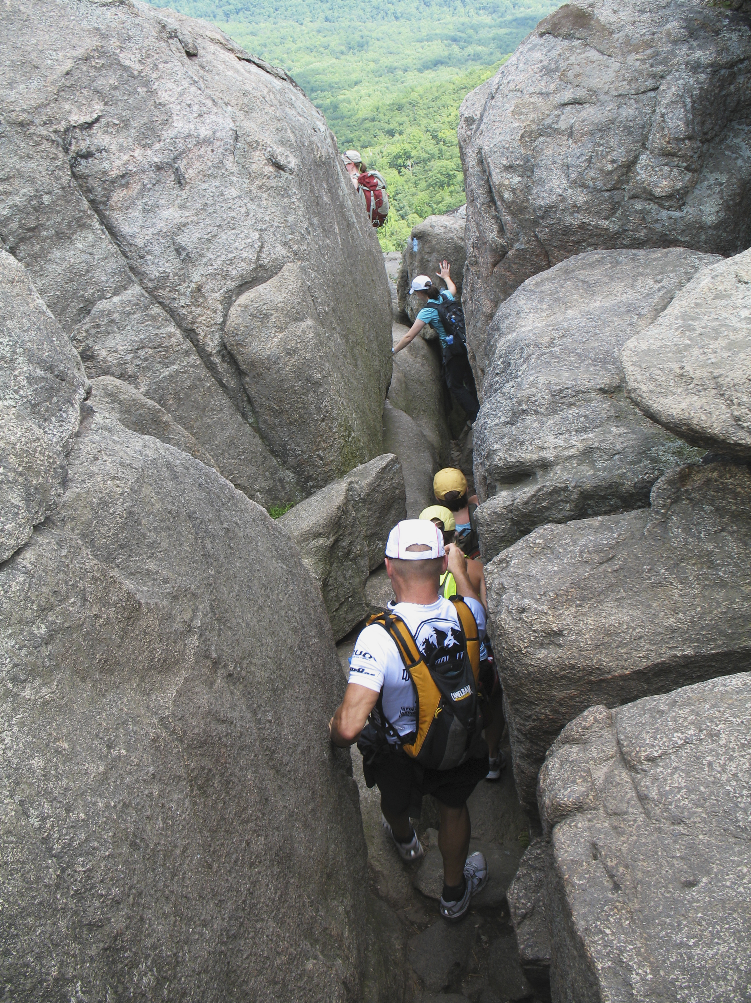

2019

ID: ______________ Date: ______________

Time:___________AM/PM Binder # ____________

Weather: Sunny / Overcast / Rain / Storm

Special Event: No/Yes (Specify) ____________________________________

Paperwork Reduction and Privacy Act Statements: The Paperwork Reduction Act requires us to tell you why we are collecting this information, how we will use it, and whether or not you have to respond. This information will be used by the National Park Service as authorized by 54 USC 100702. We will use this information to evaluate visitors’ perceptions of crowding, safety, and overall experiences on Old Rag. Your responses are voluntary and anonymous. Your name and address will not be collected. At the completion of this collection all personal information will be destroyed and in no way be connected with the results of this survey. A Federal agency may not conduct or sponsor and you are not required to respond to, a collection of information unless it displays a currently valid OMB Control Number.

Burden Estimate: We estimate that it will take an average of 12 minutes to complete this questionnaire. You may send comments concerning the burden estimates or any aspect of this information collection to the Social Science Program Chief, National Park Service, 1201 Oakridge Drive, Fort Collins, CO, 80525-5596; nps_nrss_social_science@nps.gov (email).

Thank you for agreeing to complete this survey! All questions in this survey are related to your hike on Old Rag today. Your responses will help Shenandoah National Park make informed management decisions.

1. Group and Trip Characteristics

- Including yourself, how many people were in your hiking group on Old Rag today?
Number of adults (18 years or older)
Number of children (under 18 years)

- Which of the following best describes your hiking group today? Please mark all that apply.
O Hiked alone
O Family
O Friends
O Organized group (Please specify):_____________________________________

- Which of the following best describes your hike on Old Rag today? Please mark one.
O Day hike
O Part of an overnight backpacking trip (SKIP TO QUESTION 6)

- Where did you start your day hike on Old Rag today? Refer to the map and mark one.
O Nethers
O Berry Hollow
O Other (Please specify):__________________________________________

- In which direction did you complete your day hike on Old Rag today? Refer to the map and mark one.
O Clockwise loop
O Counterclockwise loop
O Out and back, rather than a loop

- How much total time did you spend hiking on Old Rag today? Please list partial hours as ¼, ½, or ¾.
Number of hours

- Did you hike to the top of Old Rag today? Please mark one.
O Yes
O No

- Is your hike today the first time you have hiked on the Old Rag Trail? Please mark one.

O Yes
O No Including this hike today, how many times have you hiked on the Old Rag Trail?

Total number of times hiked Old Rag Trail, including today: ____________

- When did you decide to take this hike on Old Rag? Please mark one.
O Today
O Before today, but in the last week
O More than a week ago, but in the last month
O More than a month ago, but in the last year
O More than a year ago
O Don’t know/can’t recall

- Did you use any of the following types of information to plan and/or prepare for your hike on Old Rag today? Please mark one for each row.
 | Yes | No
Previous visit | O | O
Friends/relatives/word of mouth | O | O
Inquiry to park via phone, mail, or email | O | O
Shenandoah National Park website (nps.gov/SHEN) | O | O
Other website (Specify): _____________________ | O | O
Apps (such as Strava, TraiLink, AllTrails, etc.) | O | O
Local businesses (hotels, motels, restaurants, etc.) | O | O
Maps/brochures | O | O
Newspaper/magazine articles | O | O
Other units of the National Park System (NPS) | O | O
School class/program | O | O
Social media (such as Facebook, Twitter, etc.) | O | O
State welcome center/visitors bureau/chamber of commerce | O | O
Television/radio programs/DVDs | O | O
Travel guides/tour books (such as AAA, etc.) | O | O

- During your hike on Old Rag today, did you feel prepared for the following common safety situations that you may have encountered? Please mark one for each row.

Did you feel prepared for… | Yes | No
Exposure to sun | O | O
Hot, humid weather | O | O
Bad weather/storms | O | O
Cold temperatures at higher elevations | O | O
Steep sections of trail | O | O
Limited access to drinking water | O | O
Proper footwear required for the terrain | O | O
Strength and fitness needed for the hike | O | O

2. Visitor Experience

NOTE TO REVIEWER: For the following question, each respondent will be asked to review a randomly ordered set of six photographs used to depict various levels of crowding on the top of Old Rag. Each of the six photographs will be presented individually, and the respondent will be asked to view each photo and indicate (yes or no) if they would feel crowded with the number of people in the area photographed. At the end of the photo evaluation section, the survey administrator will leave the respondent to complete the remainder of the survey.

- We would like to know how many other hikers you think it is acceptable to see on the top of Old Rag Mountain without it being too crowded. To help judge this, we have a series of photographs that show different numbers of hikers in this area. Please ask the survey administrator to show you these photos to answer the following question.

For each photograph, please tell us if you would feel crowded if you were on the top of Old Rag with the number of people depicted in the photograph. Please mark one for each photograph.

 | I would feel crowded…
 | Yes | No
Photo 1 | O | O
Photo 2 | O | O
Photo 3 | O | O
Photo 4 | O | O
Photo 5 | O | O
Photo 6 | O | O

- Should the number of people allowed to hike Old Rag each day be limited if it is needed for any of the following reasons, even if it limits when you can hike Old Rag? Please mark one for each row.

Should the number of hikers
per day be limited?
Reason for Limit | Yes | No | Don’t Know/ Not Sure
To protect the quality of visitors’ experiences  (i.e., prevent crowding) | O | O | O
To protect visitors’ safety | O | O | O
To reduce environmental impacts | O | O | O
To protect Congressionally-designated Wilderness values | O | O | O

- Did you feel crowded at any of the following locations during your Old Rag hike today? Please mark one for each row.
 | I felt crowded…
 | Yes | No | Did not  visit today
In the parking lot | O | O | O
In the rock scramble near the top of Old Rag | O | O | O
On top of Old Rag | O | O | O

- Did you have to wait in a bottleneck/line of people at any point during your hike on Old Rag today? Please mark one.

O Yes:__________Minutes waited in bottleneck/line
O No

- Did you worry about any of the following risks during your hike on Old Rag today? Please mark one for each row.
 | I was worried about...
 | Yes | No
Slipping and having a bad fall while hiking on the trail | O | O
Getting lost/losing the marked trail | O | O
Someone falling into me while hiking the trail | O | O
Being unable to make it through the rock scramble | O | O
Unsafe/risky behavior of others threatening my safety | O | O
Being unable to complete the whole hike | O | O
Being injured while hiking the trail | O | O
Not finishing the hike before dark | O | O
Not having access to restrooms on the trail | O | O

- Did you encounter any of the following on your Old Rag hike today? Please mark one for each row.

 | No | Yes, Some | Yes, A Lot
Graffiti | O | O | O
Litter | O | O | O
Visible human or dog waste | O | O | O
Human or dog waste odor | O | O | O
Dangerous behavior | O | O | O
Falling rocks | O | O | O
Individuals you believe were unprepared for the hike | O | O | O
Individuals walking off-trail/creating their own trail | O | O | O
Individuals cutting switchbacks | O | O | O
Dogs on the trail or summit | O | O | O
Drone usage | O | O | O
Loud noise or music created by other visitors | O | O | O

- To what extent would you support or oppose each of the following potential management practices for hiking on Old Rag? Please mark one for each row.

 | Strongly Oppose | Slightly Oppose | Neither Support nor Oppose | Slightly Support | Strongly Support
Require an orientation (e.g., a short video) that reinforces safety, trail etiquette, and Leave No Trace principles | O | O | O | O | O
Provide more rangers along the trail to reinforce safety, trail etiquette, and Leave No Trace principles | O | O | O | O | O
Limit the number of people allowed to hike Old Rag each day by means of a first come, first served permit system | O | O | O | O | O
Limit the number of people allowed to hike Old Rag each day by means of a reserve in advance permit system | O | O | O | O | O
Set hourly limits on the number of people allowed to hike Old Rag, to ensure the number of people on the trail at one time does not exceed a certain number | O | O | O | O | O

- Did you encounter a uniformed Park Ranger on your Old Rag hike today? Please mark all that apply.
O Yes
O No

3. Background Information

- What is your age? _________

- What is your gender? Please mark one.
O Male
O Female
O Do not identify as male or female
O I prefer not to answer

- Where do you live?

U.S. ZIP Code _____

Country (if not U.S.) __________________

- Are you Hispanic or Latino? Please mark one.
O Yes
O No
O I prefer not to answer

- What is your race? Please mark all that apply.
O American Indian or Alaska Native
O Asian
O Black or African American
O Native Hawaiian or other Pacific Islander
O White
O I prefer not to answer

- What is the highest level of formal education you have completed? Please mark one.
O Less than high school
O Some high school
O High school graduate or GED
O Some college, business, or trade school
O College, business, or trade school graduate
O Some graduate school
O Master’s, doctoral, or professional degree
O I prefer not to answer

- Is there anything else you would like to tell us about your Old Rag hike today?

Thank you for your help! Please return the survey to the administrator.

