Shenandoah National Park
Visitor Survey
2017
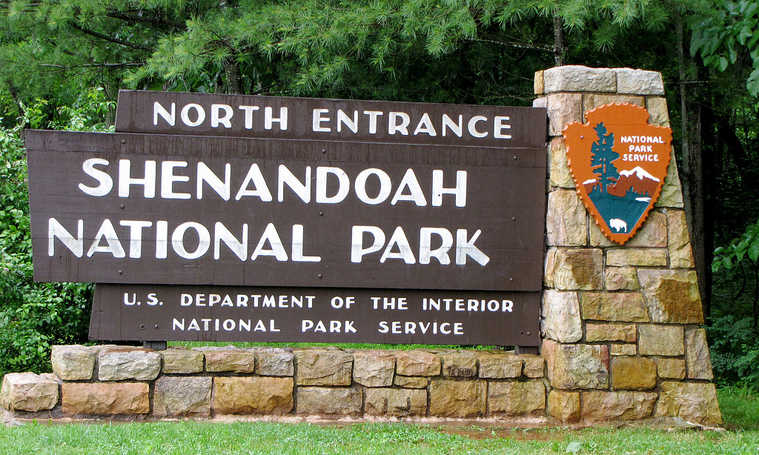

To be completed by field staff:
ID ________ Travel party ID__________ Date __________ Location ___________

Field staff____________

PAPERWORK REDUCTION and PRIVACY ACT STATEMENT: The Paperwork Reduction Act requires us to tell you why we are collecting this information, how we will use it, and whether or not you have to respond. We are authorized by the National Park Service Protection Interpretation and research in System (54 USC §100702) to collect this information. The routine uses of this information will be for the benefit of NPS Managers and Planning staff Shenandoah National in future initiatives related to the use of technology based services (e.g. Mobil apps and WiFi) within the Park. The data collected will be summarized to evaluate visitor uses and expectations of technology. Your responses to this collection are completely voluntary and will remain anonymous. You can end the process at any time and will not be penalized in any way for choosing to do so. All paper versions of the information collected will be destroyed at the end of the collection period and no personal identifiable records will be maintained or stored for any purposes. Data collected will only be reported in aggregates and no individually identifiable responses will be reported. A Federal agency may not conduct or sponsor, and you are not required to respond to, a collection of information unless it displays a currently valid OMB Control Number (1024-0224). We estimate that it will take about 10 minutes to complete this interview. You may send comments concerning any aspect of this information collection to: Roy Wood, Chief of Interpretation – roy_wood@nps.gov (email0); or Phadrea Ponds, NPS Information Collection Coordinator, Fort Collins, CO 80525, pponds@nps.gov (email).

SECTION 1

1. Is this your first visit to Shenandoah NP? □YES □NO

If ‘no’

How many times have you visited before today?

How many years have you been visiting?

2. Have you ever visited other National Park Service sites? □YES □NO

3. How many people in your group today?

4. Do you own a mobile device? Yes/no
If ‘yes’ how many?

5. How many mobile devices did you bring on your trip today?

SECTION 2

6. Please tell us how much you agree or disagree with the following statements about mobile devices.
 | Strongly  Disagree | Disagree | Neutral | Agree | Strongly  Agree
Mobile devices enhance my personal life | -2 | -1 | 0 | 1 | 2
Mobile devices help me connect with friends and family | -2 | -1 | 0 | 1 | 2
Mobile devices enhance my work life | -2 | -1 | 0 | 1 | 2
Mobile devices enable me to stay connected to work wherever I am | -2 | -1 | 0 | 1 | 2
Staying connected to work allows me more time away from the office | -2 | -1 | 0 | 1 | 2
Mobile devices enhance my outdoor experiences | -2 | -1 | 0 | 1 | 2
I use mobile devices to search for information about my outdoor experiences | -2 | -1 | 0 | 1 | 2
Mobile devices detract from my outdoor experiences | -2 | -1 | 0 | 1 | 2
I like being constantly connected | -2 | -1 | 0 | 1 | 2
Being constantly connected decreases my enjoyment of outdoor experiences | -2 | -1 | 0 | 1 | 2
Mobile devices distract me from immersing myself in an outdoor experience | -2 | -1 | 0 | 1 | 2

7. Please tell us how mobile devices influenced your experiences at Shenandoah National Park (NP).
 | Strongly  Disagree | Disagree | Neutral | Agree | Strongly  Agree
Mobile devices improved my experiences at Shenandoah NP | -2 | -1 | 0 | 1 | 2
Using Mobile devices will help me share my experiences at Shenandoah NP with my family and friends | -2 | -1 | 0 | 1 | 2
I was able to spend more time at Shenandoah today because I was able to be connected to work during my visit | -2 | -1 | 0 | 1 | 2
Mobile devices detract from my experiences at Shenandoah NP | -2 | -1 | 0 | 1 | 2
I was distracted because I felt connected to work | -2 | -1 | 0 | 1 | 2
Mobile devices distracted me from immersing myself in my experiences at Shenandoah | -2 | -1 | 0 | 1 | 2
Mobile devices prevented me from feeling disconnected | -2 | -1 | 0 | 1 | 2
Mobile devices prevented me from connecting to nature | -2 | -1 | 0 | 1 | 2
It is annoying seeing people using their mobile devices at Shenandoah NP | -2 | -1 | 0 | 1 | 2

8. Please tell us about your preferences for WiFi access at Shenandoah NP.
How important to you is it that there is: | Extremely Unimportant | Unimportant | Neutral | Important | Extremely Important
WiFi in all buildings | -2 | -1 | 0 | 1 | 2
WiFi in all campgrounds | -2 | -1 | 0 | 1 | 2
WiFi park-wide | -2 | -1 | 0 | 1 | 2
Cell service park-wide | -2 | -1 | 0 | 1 | 2
Cell service park-wide in all national parks | -2 | -1 | 0 | 1 | 2

9. Please rank the following reasons for using mobile devices in outdoor experiences in order of importance to you. Please rank the following statements from 1 = most important to 6 = least important.
- ____ To stay connected to friends/family
- _____To use as a camera
- _____Sharing important moments during my visit
- _____To feel safe
- _____To get information about places I am visiting
- _____To find local businesses/restaurants I might want to visit

10. Please tell us how much you agree or disagree with the following statements about nature and outdoor experiences.
 | Strongly  Disagree | Disagree | Neutral | Agree | Strongly  Agree
I enjoy being outdoors, even in unpleasant weather. | -2 | -1 | 0 | 1 | 2
My ideal vacation spot would be a remote, wilderness area. | -2 | -1 | 0 | 1 | 2
I always think about how my actions affect the environment. | -2 | -1 | 0 | 1 | 2
I am very aware of environmental issues. | -2 | -1 | 0 | 1 | 2
I take notice of wildlife wherever I am. | -2 | -1 | 0 | 1 | 2
I don’t often go out in nature. | -2 | -1 | 0 | 1 | 2
I am not separate from nature, but a part of nature. | -2 | -1 | 0 | 1 | 2
The thought of being deep in the woods, away from civilization, is frightening. | -2 | -1 | 0 | 1 | 2
My feelings about nature do not affect how I live my life. | -2 | -1 | 0 | 1 | 2
My relationship to nature is an important part of who I am. | -2 | -1 | 0 | 1 | 2

11. Did you know that several National Park sites have mobile apps that can be used on phones and tablets?

□YES □ NO (go to Q#12)

(a) If ‘yes’, have you downloaded any NPS apps to your mobile device(s)?

□YES (phone) □YES (tablet) □NO (go to Q#12)

If ‘yes’, which app(s) did you download?

(b) Did you use the mobile app before going to the park?

□YES □NO (go to Q#12)

If ‘Yes’, How often □ 1 time a day □ 1 time a week □ 1time a month □ only once

(c) Did you use the mobile app while at the park?

□YES □NO (go to Q#12)

If ‘Yes’, How often □ more than 1 time an hour □ 1 time an hour □ 1 time per 2 hours □ only once

(d) Do you plan to use the mobile app after your visit to the park?

□YES □NO

12. How useful would a Shenandoah National Park mobile app be for you?

Extremely useful Useful Neither useful nor un-useful Un-useful extremely un-useful

13. Did you know Shenandoah National Park has social media sites?
□YES □NO (go to Q 14)

(a) If ‘Yes’
Did you use any of the Shenandoah National Park social media sites before coming to the park today?
□YES □NO (go to Q 14)

(b) If ‘Yes’ Which of the Shenandoah National Park social media sites did you use?
□ Facebook □ Twitter □ Instagram □ Snapchat □ Other__________

14. Which of the following social media sites do you use the most often (select only one)?
□ I do not use social media □ Facebook □ Twitter □ Instagram □ Snapchat □ Other________
For the social media site you selected above as using the most, how often do you use it?
More than: □ 1time a day □ 1 time a week □ 1 time a month □□ only once

15. Did you use any social media sites while at the park today?
□YES □NO (go to Q 16)

(a) If ‘Yes’ which social media sites did you use while at the park today
□ Facebook □ Twitter □ Instagram □ Snapchat □ Other________

(b) How often
□ more than1 time per hour □ 1 time per hour □ 1time per 2 hours □ only once

16 Did you use other social media/websites to find information about Shenandoah?
□YES □NO (go to Q 17)

(a) If ‘Yes’ Did you use any before coming to the park today?
□YES □NO

(b) If ‘Yes’ which did you use?
□ Facebook □ Twitter □ Instagram □ Snapchat □ Other________

(c) How often did you use it before coming to the park today?
□ 1 time a day □ 1 time a week □ 1 time a month □□ only once

17. Please circle only one

I prefer to use: mobile apps websites I do not use either

18. Will you continue to visit Shenandoah related websites when you return home? □YES □NO

Why or why not:

19. How important to you is the ability to get real time information about Shenandoah NP?
Extremely Unimportant
Unimportant
Neither Unimportant nor Important
Important
Extremely Important

20. How likely are you to show Shenandoah related websites to friends/family/coworkers as a way of sharing your experience?
Extremely Unlikely
Unlikely
Neither Unlikely nor Likely
Likely
Extremely Likely

21. Please indicate how often you use the following when at home
 | Never Use | Less than 1 hour per day | 1-2 hours per day | 3-4 hours per day | More than 5/hours a day
Facebook | 0 | 1 | 2 | 3 | 4
Twitter | 1 | 2 | 3 | 4 | 5
Snapchat | 1 | 2 | 3 | 4 | 5
Instagram | 1 | 2 | 3 | 4 | 5
Other:______ | 1 | 2 | 3 | 4 | 5
Personal blogs/websites | 1 | 2 | 3 | 4 | 5

22. My phone camera is the only camera I have □YES □NO

23. My phone camera is the only camera I used during my visit today □YES □NO

SECTION 3: ABOUT YOU
24. What is your zip code? ____________

25. What year were you born? ________________

26. What is your gender? (select one) Male Female Do not wish to answer

27. What is the highest level of school you have completed? (select one)

Less than high school | Some college | Graduate or professional degree
Some high school | Two-year college graduate | Do not wish to answer
High school graduate | Four-year college graduate
28. What is your ethnicity? (select all that apply)
Hispanic or Latino
Not Hispanic or Latino

29. What is your race? (select all that apply)

American Indian or Alaska Native | Hawaiian or Pacific Islander
Asian | White
Black or African American | Do not wish to answer

30. Which category best describes your total household income in U.S. dollars during 2016 before taxes? (select one)

Less than $24,999 | $50,000 to $74,999 | $150,000 to $199,999
$25,000 to $34,999 | $75,000 to $99,999 | $200,000 or more
$35,000 to $49,999 | $100,000 to $149,999 | Do not wish to answer

Thank you for your help with this survey! Please return it to the person who gave it to you.
If you have any questions or concerns, please contact:
Dr. Ryan Sharp – ryansharp@ksu.edu
Dr. Jeffrey Skibins –jskibins@ksu.edu

