Rocky Mountain National Park Backcountry Visitor Post-Experience Survey 2017

“Thank you for agreeing to complete the survey questions. Your participation is voluntary and your responses are anonymous. The survey is self-paced, and administered on an iPad. Select your responses by touching the appropriate ‘buttons’ on the screen. Your responses are automatically saved within the application.”

PAPERWORK REDUCTION ACT STATEMENT: The National Park Service is authorized by the NPS Research Mandate (54 USC 100702) to collect this information. This information will be used by park managers to understand existing visitor use patterns, visitor motivations, and visitor perspectives about backcountry recreation in Rocky Mountain National Park. Response to this request is voluntary. No action may be taken against you for refusing to supply the information requested. The permanent data will be anonymous. An agency may not conduct or sponsor, and a person is not required to respond to, a collection of information unless it displays a currently valid OMB control number.

BURDEN ESTIMATE Public reporting burden for this form is estimated to average 10 minutes per response. Please direct comments regarding the burden estimate or any other aspect of this form to: Chris Monz, Department of Environment and Society, Utah State University; chris.monz@usu.edu; or Phadrea Ponds, NPS Information Collection Coordinator, Fort Collins, CO; pponds@nps.gov.

Topic Area 1: GROUP5

1) How many people are in your group including you? ___________

Topic Area 1: RES2

2) Are you a permanent resident or citizen of the United States?
☐ Yes - What is your zip code? ______________
☐ No - What is your country of origin? _______________________

Topic Area 4: VISHIS7

3) Have you visited Rocky Mountain National Park before today?
 Yes
 No

If YES, approximately how many times have you visited Rocky Mountain National Park? _________

4) Have you visited this trail within Rocky Mountain National Park before today?
 Yes
 No

If YES, approximately how many times have you visited this trail? __________

Topic Area 5: RecACT15

5) Below is a list of common activities available at Rocky Mountain National Park. Please indicate:
- Which one of these activities was your primary planned activity for today
- Which of these activities did you participate in today

Activity | (A)  Primary Activity (Select one) | (B)  Participated in  (Select all that apply)
Fishing (conventional tackle) |  | 
Fly fishing |  | 
Backcountry camping |  | 
Nature/wildlife observation |  | 
Hiking |  | 
Climbing |  | 
Scenic driving |  | 
Horse-back riding |  | 
Photography |  | 
Other (specify):______________ |  | 

Topic Area 2: INFOSOURCE9

6) How did you or your group obtain information about your primary activity in Rocky Mountain National Park (ROMO)? If you used a source listed, select the box indicating how helpful the information was that you received. If you did not use a source, select “Did not use.”

Source | Not helpful at all | Slightly helpful | Moderately helpful | Very helpful | Extremely helpful | Did not use
ROMO website |  |  |  |  |  | 
ROMO Visitor center |  |  |  |  |  | 
ROMO maps, pamphlets |  |  |  |  |  | 
Talking with ROMO personnel |  |  |  |  |  | 
Colorado Parks and Wildlife website |  |  |  |  |  | 
Colorado Parks and Wildlife information center |  |  |  |  |  | 
Conservation organization website/meetings (specify):_______ |  |  |  |  |  | 
Newspaper/magazine articles |  |  |  |  |  | 
Radio/TV broadcasts |  |  |  |  |  | 
Travel guide book |  |  |  |  |  | 
Word-of-mouth |  |  |  |  |  | 
Previous visits |  |  |  |  |  | 
Commercial outfitter |  |  |  |  |  | 
Package tour/guiding companies |  |  |  |  |  | 
Specialized recreation shops |  |  |  |  |  | 
Transporter service |  |  |  |  |  | 
Social media (specify):____________ |  |  |  |  |  | 
Online forum/blog |  |  |  |  |  | 
Other (specify):_________________ |  |  |  |  |  | 

Topic Area 2: INFOSOURCE13

7) Did you find the type of information about Rocky Mountain National Park that you needed?
 Yes
 No (Please specify information you needed) _________________________________________

Topic Area 5: HUNTFISH8

8) If you could not visit your current location for your primary activity, which other area(s) in Rocky Mountain National Park do you think can offer just as desirable an experience as this location? Indicate how desirable each location would be, and mark which is your current location. A map is provided for reference.

Location | Very Undesirable | Undesirable | Neutral | Desirable | Very Desirable | Current Location
Bear Lake Trailhead |  |  |  |  |  | 
Fern Lake Trailhead |  |  |  |  |  | 
Glacier Gorge Trailhead |  |  |  |  |  | 
Other (specify): |  |  |  |  |  | 

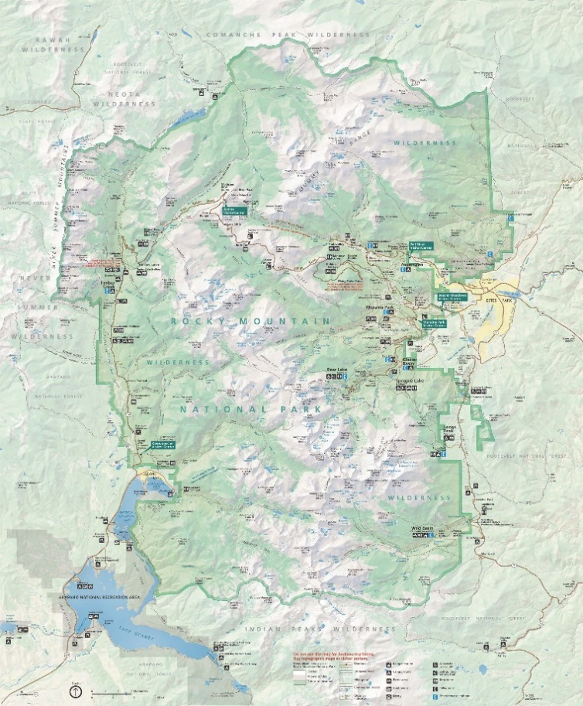
Reference map

Topic Area 5: PART23

9) Are there specific circumstances that would cause you to:

Participate in your primary activity elsewhere in Rocky Mountain National Park: _____________

Participate in your primary activity outside Rocky Mountain National Park: _________________

Participate in a different activity: ____________________

10) Imagine that during your next trip to this location you discovered that it was slightly more crowded with other visitors than you normally find acceptable. What would you do? (Select one)

 I would make an exception and still participate in my primary activity in this area.
 I would still participate in my primary activity, but elsewhere in Rocky Mountain National Park.
 I would still participate in my primary activity, but outside Rocky Mountain National Park.
 I would temporarily participate in a different activity in Rocky Mountain National Park.
 I would temporarily participate in a different activity, but outside Rocky Mountain National Park.

Topic Area 6: CROWD3

11) How did the number of people you saw at this location compare with what you expected? (Select one)

 A lot less than what you expected
 A little less than what you expected
 About what you expected
 A little more than what you expected
 A lot more than what you expected
 You did not have any expectations

Topic Area 1: AGE1

12) What is your age? _________

Topic Area 1: EDUC1

13) What is the highest level of formal education you have completed? (Select one)

 Less than high school
 Some high school
 High school graduate
 Vocational/trade school certificate
 Some college
 Two-year college degree
 Four-year college degree [or Bachelor’s degree]
 Master’s Degree [or Graduate degree]
 Ph.D., M.D., J.D., or equivalent

Topic Area 1: GEND1

14) What is your sex?
 Male
 Female

Topic Area 1: RACE/ETH2

15) Which of these categories best indicates your race? (Select all that apply)
 American Indian or Alaska Native
 Asian
 Black or African American
 Native Hawaiian or other Pacific Islander
 White

Topic Area 1: RACE/ETH1

16) Are you Hispanic or Latino/a?
 Yes
 No

Topic Area 10: ECON12

17) Which category best represents your annual household income? (Select one)
 | Less than $25,000 |  | $75,000 to $99,999
 | $25,000 to $34,999 |  | $100,000 to $149,999
 | $35,000 to $49,999 |  | $150,000 to $199,999
 | $50,000 to $74,999 |  | $200,000 or more

Topic Area 5: RecEXP 12

18) Below is a list of possible experiences you may want to have while participating in your primary activity in Rocky Mountain National Park.
For each item, please indicate how important the experience is to you.

Experience | Not at all | Slightly Important | Moderately Important | Very Important | Extremely Important
To foster a connection with others in your group |  |  |  |  | 
To experience a sense of connection with nature |  |  |  |  | 
To view mountains |  |  |  |  | 
To experience new and different things |  |  |  |  | 
To experience solitude |  |  |  |  | 
To share this place with family/friends |  |  |  |  | 
To view alpine and sub-alpine lakes and streams |  |  |  |  | 
To experience excitement |  |  |  |  | 
To be alone |  |  |  |  | 
For family recreation |  |  |  |  | 
To be outdoors |  |  |  |  | 
To be a beautiful place |  |  |  |  | 
To have an adventure |  |  |  |  | 
To be away from crowds of people |  |  |  |  | 

19) For each of the following experiences, draw a circle on the map provided around location where you would go to have that experience. If you would have to leave Rocky Mountain National Park to have that experience, leave the map blank.

Where would you go to:

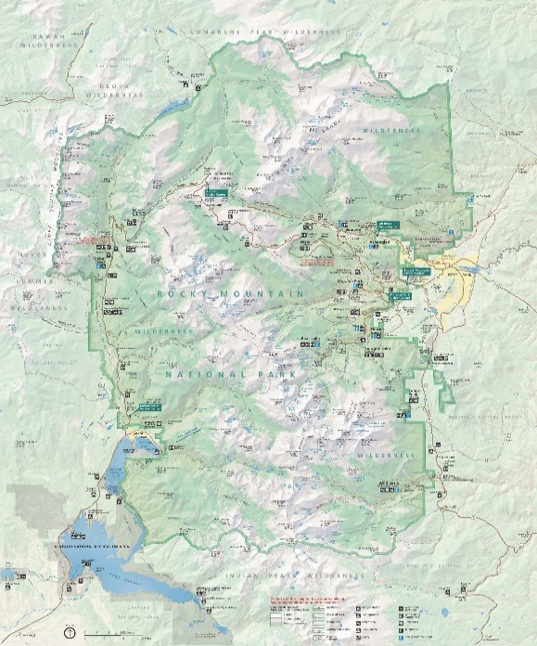  A) Connect with nature | 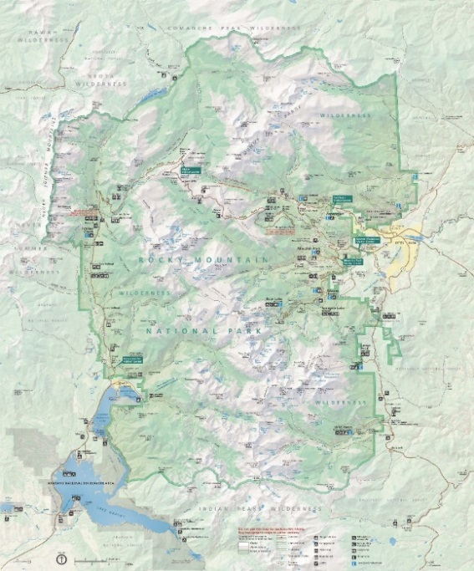  B) Experience solitude
C) Have an adventure  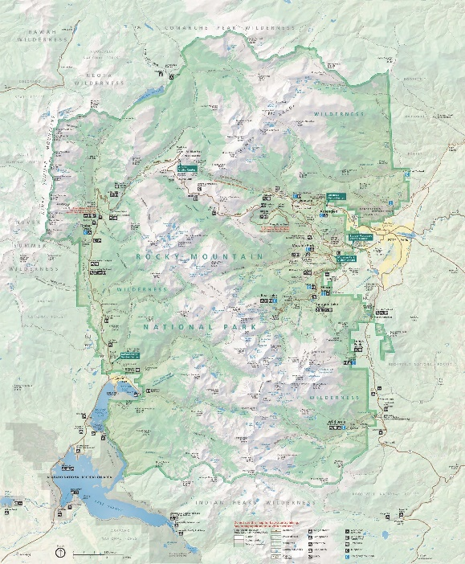 | D.) View scenic beauty
E) Enhance personal relationships

