NOTE: For the purposes of this review and submission the justifications for each question or section of questions is highlighted in a shaded text box above each question. The questionnaire will be administered primarily through a tablet and these text boxes will not be printed on the final version of the surveys. The Topic Areas noted are consistent with the currently approved pool questions for the NPS Programmatic Review Process (1024-0224). The questions that are variations are denoted as such.
Separate form on tablet completed by interviewer would add date, time, location, interviewer initial and important notes for context setting.


OMB # T B D
Expiration date:12/31/2018

[Site Location Here] Visitor Survey 2017
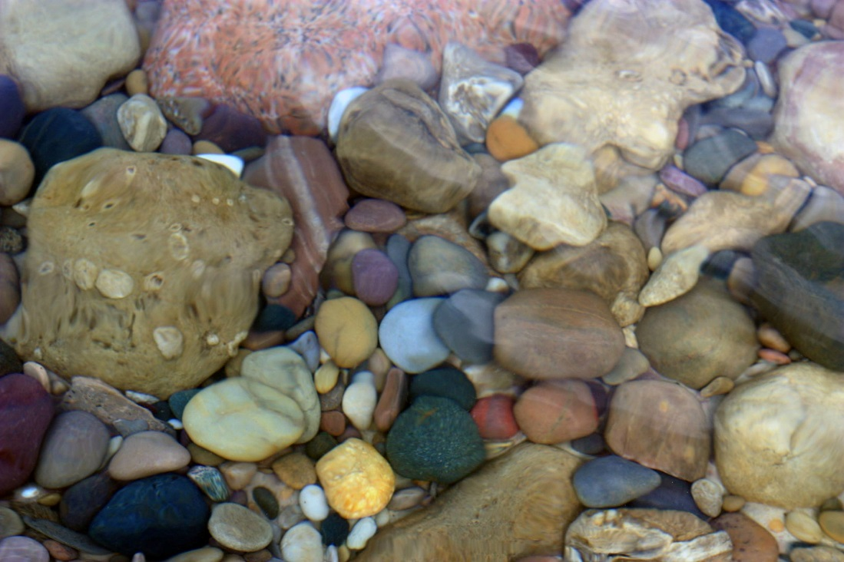

Thank you for agreeing to help [Site Location Here] at Pictured Rocks National Lakeshore!

Your input is important to park management and its decisions. Response to this request is voluntary. While you are not required to respond, your cooperation is needed to make the survey results comprehensive, accurate, and timely. This survey is sponsored by the National Park Service and the information will be used to understand visitor use and conditions at [Site Location Here] at Pictured Rocks National Lakeshore.

PAPERWORK REDUCTION ACT STATEMENT: The National Park Service is authorized by the NPS Research Mandate (54 USC 100702) to collect this information. This information will be used by park managers to understand visitor preferences for conditions at Pictured Rocks Miners Beach location. Responses to this request are voluntary and anonymous. Your name will never be associated with your answers, and all contact information will be destroyed when the data collection is concluded. No action may be taken against you for refusing to supply the information requested. An federal agency may not conduct or sponsor, and a person is not required to respond to, a collection of information unless it displays a currently valid OMB control number and expiration date.
BURDEN ESTIMATE STATEMENT: Public reporting burden for this form is estimated to average 15 minutes per response. Direct comments regarding the burden estimate or any other aspect of this form to: Bruce Leutscher, Pictured Rocks National Lakeshore Pictured Rocks National Lakeshore, P.O. Box 40 Munising, MI 49862; bruce_leutscher@nps.gov (email).

SECTION 1 Past and current visit to Pictured Rocks National Lakeshore
Topic Area 4: VISIHIS3

1. Over the past twelve months, how many visits have you made to Pictured Rocks National Lakeshore?
______ Number of visits (Including today)
Topic Area 4: VISIHIS2

2. In which year did you make your first visit to Pictured Rocks National Lakeshore?
______ Year O Don’t know/Not sure O This is my first visit (go to question 5)
Topic Area 4: VISIHIS1

3. Are you a first time visitor to [Site Location Here]?
O Yes O No
If YES, about how many times have you visited [Site Location Here], including this visit?
______ Number of visits O Don’t know/Not sure
4. In which year did you make your first visit to [Site Location Here]?
______ Year O Don’t know/Not sure
Topic Area 1: GROUP1

5. Please select the choice below that best describes your traveling party. (Please select only one choice)
O Individual O Family only O Friends only O Family plus friend’s O Tour group
O Other (Please specify) ____________________________
Topic Area 1: GROUP5

6. How many people are in your group, including you?
____Number of people
How many vehicles are in your group, including you?
____Number of vehicles

Topic Area 4: DEST9

7. On this visit, how long did you stay at Pictured Rocks National Lakeshore? Please list partial hours as 1/4, 1/2, or 3/4.
________Number of hours, if less than 24 hours
OR
_______Number of days, if 24 hours or more
Topic Area 4: DEST9

8. On this visit, how long did you stay at [Site Location Here]? Please list partial hours as 1/4, 1/2, or 3/4.
________Number of hours, if less than 24 hours
OR
_________Number of days, if 24 hours or more
Topic Area 2: BACCOM10 (Variation)
________Number of hours, if less than 24 hours
OR
_______Number of days, if 24 hours or more10 modified to include categories to reduce respondent burden

9. Why did you and your personal group choose to visit [Site Location Here]? Please mark (•) all that apply.
O Convenient with traffic flow

O Easy to access beach

O Followed directions on GPS, Google Maps, MapQuest, etc.
O Saw signs on highway

O Suggested by friends/relatives
O Suggested by visitor center
O Have visited before and enjoyed it
O Other beaches too crowded
(Which beaches? ___[Alternate Site Location] __12 Mile ___Other ___Don’t remember)
Topic Area 4: DEST6

10. On this trip, if you had not chosen to visit [Site Location Here], what other recreation site would you have visited instead? Please list or, if unsure, mark that circle
_______________________________________________ O Don’t know/Not sure
11. How far is this alternative site from your home?
________ miles O Don’t know/Not sure
Topic Area 5: RecEXP1

12. On this visit to [Site Location Here], in which activities did you participate? Please mark (•) all that apply.
O View Surf/Sand O Play/Swim in the Water
O Nature Photography O Kayak on my own/with own Group
O Kayak on a Commercial Trip O Walk the Beach
O Relax O Picnic
O Stand up Paddleboard O Other (________________________)
Topic Area 5: RecACT23
)

13. Have you kayaked at Pictured Rocks on this visit or past visit(s)? Please mark (•) one.
O Yes, participated in kayaking in this or past visits
O No, have not participated in kayaking at Pictured Rocks
14. Have you ever kayaked in other places?
O Yes, I have kayaked O No, I have never kayaked
Topic Area 8: PREF5 (Variation) MODIFIED, added physical activity REP items

15. Below is a list of possible experiences you may want (prefer) to have while visiting [Site Location Here]. For each item please indicate how important the experience is to you on your visit to this beach.
 | Not at all Important | Slightly Important | Moderately Important | Very Important | Extremely Important
To experience solitude | O | O | O | O | O
To view scenic beauty | O | O | O | O | O
To be with family or friends | O | O | O | O | O
To be physically active | O | O | O | O | O

SECTION 2 Perception of crowding at Pictured Rocks National Lakeshore

The questions in the section are from (in the following order):
TOPIC AREA 6: VERP 1 & 2 and TOPIC AREA 5: HUNTFISH 11

Recreation Managers at [Site Location Here] are interested in understanding visitor perception of crowding. We would like you to view a series of photographs of people on the beach as well as some kayaks. We would like for you to view the photos and rate how acceptable you would find the number of people and/or kayaks in each photo. For the purposes of this question and the ones to follow -3 is a “very unacceptable” number of visitors that would like to see at [Site Location Here], and “+3 is a “very acceptable” number of visitors that would like to see at [Site Location Here]. (Circle one number for each photograph.

EXAMPLE
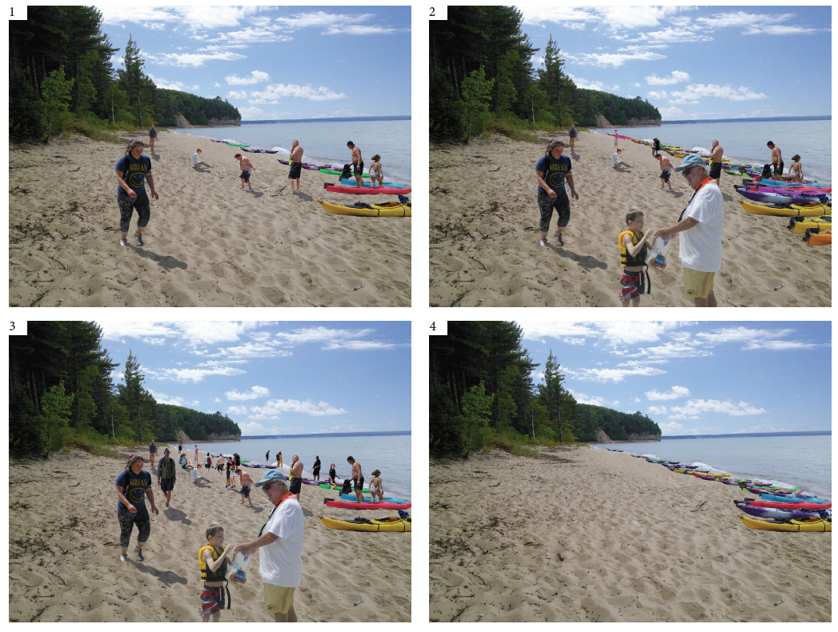
2
1
4
3
EXAMPLE
16. Please rate each photograph by indicating how acceptable you find each one based on the conditions shown.
 | Very Unacceptable | Unacceptable | Slightly Unacceptable | Neutral | Slightly Acceptable | Acceptable | Very Acceptable
Photo 1 | -3 | -2 | -1 | 0 | +1 | +2 | +3
Photo 2 | -3 | -2 | -1 | 0 | +1 | +2 | +3
Photo 3 | -3 | -2 | -1 | 0 | +1 | +2 | +3
Photo 4 | -3 | -2 | -1 | 0 | +1 | +2 | +3

Which photograph shows the level of use that you would prefer to experience in the [Site Location Here] area?
Photo number: ____

17. Which photograph shows the highest level of use that Pictured Rocks National Lakeshore should allow in the [Site Location Here] area? If none of the photographs show the highest level of use to allow, you may indicate that by checking the circle below.
Photo number: ____
O None of the photographs show the highest level of use to allow at [Site Location Here]

18. Which photograph shows conditions when you would leave the area and not return?
Photo number: ____
O None of the photographs show conditions when I would leave
EXAMPLE
- 19. Please rate each photograph by indicating how acceptable you find each one based on the conditions shown.

 | Very Unacceptable | Unacceptable | Slightly Unacceptable | Neutral | Slightly Acceptable | Acceptable | Very Acceptable
Photo 1 | -3 | -2 | -1 | 0 | +1 | +2 | +3
Photo 2 | -3 | -2 | -1 | 0 | +1 | +2 | +3
Photo 3 | -3 | -2 | -1 | 0 | +1 | +2 | +3
Photo 4 | -3 | -2 | -1 | 0 | +1 | +2 | +3

Which photograph shows the level of use that you would prefer to experience in the [Site Location Here] area?
Photo number: ____

20.Which photograph shows the highest level of use that Pictured Rocks National Lakeshore should allow in the [Site Location Here] area? If none of the photographs show the highest level of use to allow, you may indicate that by checking the circle below.
Photo number: ____
O None of the photographs show the highest level of use to allow at [Site Location Here]

23.Which photograph shows conditions when you would leave the area and not return?
Photo number: ____
O None of the photographs show conditions when I would leave
EXAMPLE
23. Please rate each photograph by indicating how acceptable you find each one based on the conditions shown.
 | Very Unacceptable | Unacceptable | Slightly Unacceptable | Neither acceptable or unacceptable | Slightly Acceptable | Acceptable | Very Acceptable
Photo 1 | -3 | -2 | -1 | 0 | +1 | +2 | +3
Photo 2 | -3 | -2 | -1 | 0 | +1 | +2 | +3
Photo 3 | -3 | -2 | -1 | 0 | +1 | +2 | +3
Photo 4 | -3 | -2 | -1 | 0 | +1 | +2 | +3

Which photograph shows the level of use that you would prefer to experience in the [Site Location Here] area?
Photo number: ____
24. Which photograph shows the highest level of use that Pictured Rocks National Lakeshore should allow in the [Site Location Here] area? If none of the photographs show the highest level of use to allow, you may indicate that by checking the circle below.
Photo number: ____
O None of the photographs show an unacceptable level of use high at [Site Location Here]
25.Which photograph shows conditions when you would leave the area and not return?
Photo number: ____
O None of the photographs show conditions when I would leave
EXAMPLE
26. Please rate each photograph by indicating how acceptable you find each one based on the conditions shown.
 | Very Unacceptable | Unacceptable | Slightly Unacceptable | Neither acceptable or unacceptable | Slightly Acceptable | Acceptable | Very Acceptable
Photo 1 | -3 | -2 | -1 | 0 | +1 | +2 | +3
Photo 2 | -3 | -2 | -1 | 0 | +1 | +2 | +3
Photo 3 | -3 | -2 | -1 | 0 | +1 | +2 | +3
Photo 4 | -3 | -2 | -1 | 0 | +1 | +2 | +3

Which photograph shows the level of use that you would prefer to experience in the [Site Location Here] area?
Photo number: ____

27.Which photograph shows the highest level of use that Pictured Rocks National Lakeshore should allow in the [Site Location Here] area? If none of the photographs show the highest level of use to allow, you may indicate that by checking the circle below.
Photo number: ____
O None of the photographs show an acceptable level of use high at [Site Location Here]

29.Which photograph shows conditions when you would leave the area and not return?
Photo number: ____
O None of the photographs show conditions when I would leave
30. During the planning process for your visit to [Site Location Here], how did the possibility of crowding affect your trip plans? (Please select one response)
O | It did not affect my plans
O  O | I planned to visit on a day and time I thought would be less crowded  I planned to visit during a time I thought would be less crowded
O | I planned to visit [Site Location Here] on a day of the week I thought would be less crowded
O | I planned to visit during the off-season when I thought would be less crowded
Topic Area 6: CROWD23

31. How crowded did you feel while at the following locations at [Site Location Here] Area? (fill in one circle for each location) If you did not visit an area, simply mark that column.

 | Not Crowded | Slightly crowded | A little crowded | Somewhat crowded | Moderately crowded | Very crowded | Extremely crowded | Did not visit
[Site Location Here] parking lot | O | O | O | O | O | O | O | O
[Site Location Here] trail head | O | O | O | O | O | O | O | O
[Site Location Here] trail | O | O | O | O | O | O | O | O
East Beach area | O | O | O | O | O | O | O | O
West Beach area | O | O | O | O | O | O | O | O

SECTION 3 Perception of management at Pictured Rocks National Lakeshore

Topic Area 9: OPMGMT13

32. Please indicate the extent to which you would support or oppose each of the following potential management actions at [Site Location Here]. The list of items are not necessarily actions that are going to occur in the area but we are interested in your opinions about these potential actions. (Please mark (•) one for each item.)
 | Strongly Support | Support | Neither Support nor Oppose | Oppose | Strongly Oppose | Don't Know/ Not Sure
Reduce number of cars | O | O | O | O | O | O
Reduce number of people on beach | O | O | O | O | O | O
Reduce number of boats on water | O | O | O | O | O | O
Reduce number of boats on beach | O | O | O | O | O | O
Increase parking capacity | O | O | O | O | O | O
Add bathrooms | O | O | O | O | O | O
Add changing facilities | O | O | O | O | O | O
Add fresh water supply | O | O | O | O | O | O
Provide information to users about safety | O | O | O | O | O | O
Provide information to users about preferred behaviors | O | O | O | O | O | O
Provide information to users about crowded times | O | O | O | O | O | O
Increase enforcement of rules | O | O | O | O | O | O
Provide greater bus support | O | O | O | O | O | O
Provide greater bike support | O | O | O | O | O | O

33. This is a two-part question. First we are interested in your perceptions of problems at [Site Location Here]. Second, we are interested in if they affected your experience and how you responded to them.
Topic Area 9: OPMGMT14

First, how much of a problem do you think the following issues are at [Site Location Here]? Please mark (•) one for each
 | Not a problem | Slight problem | Moderate problem | Very much a problem | Extreme problem
1. Number of visitors on the beach | O | O | O | O | O
2.Inappropriate visitor behaviors | O | O | O | O | O
3.Dogs off leash | O | O | O | O | O
4.Finding parking | O | O | O | O | O
5.Alcohol consumption on the beach | O | O | O | O | O
6.Lines for bathroom use | O | O | O | O | O
7.Number of boats on beach | O | O | O | O | O
8.Encounters with boat operators | O | O | O | O | O
9.Vegetation impacts | O | O | O | O | O
10.Erosion | O | O | O | O | O
11.Wildlife Disturbance | O | O | O | O | O
NEW QUESTION

34.Did any of these problems affect your ability to have desired experiences?
O Yes (which MOST interfered with your visit? Insert the number (1-11) from the list above __)
O No (go to next question #35)

35. To what extent do you agree or disagree with the following statement, The problem I experienced affected my ability to have desired experiencs? (if respond anything but strongly agree or agree, go to question # page #)
Topic Area 6: CROWD9 Modified

Strongly Agree | Agree | Neither agree nor disagree | Disagree | Strongly disagree
O | O | O | O | O

Topic Area 6: CROWD1

36. In response to the problem, please indicate if and how frequently you did each of the following.
 | Did not use | Used somewhat | Used quite a bit | Used a great deal
Followed established rules for visitor etiquette | O | O | O | O
Talked to other members of my group about the incident | O | O | O | O
Wished the situation would go away or be over with | O | O | O | O
Thought about why the incident occurred | O | O | O | O
Didn’t let it get to me; refused to think about it too much | O | O | O | O
Tried to forget the whole thing | O | O | O | O
Went on as if nothing had happened | O | O | O | O
Refused to get too serious about it | O | O | O | O
Stood my ground and fought for what I wanted | O | O | O | O
I tried to keep my feelings to myself | O | O | O | O
Expressed anger to the person who caused the incident | O | O | O | O
I made a plan of action and followed it | O | O | O | O
Made light of the situation | O | O | O | O
Keep others from knowing how bad things were | O | O | O | O
Talked to park personnel about the incident | O | O | O | O
Came up with a couple of different solutions | O | O | O | O
Planned to avoid [Site Location Here] on my next visit | O | O | O | O
Moved within [Site Location Here] to avoid the issue | O | O | O | O
Left the beach and went to a different part of the Lakeshore | O | O | O | O
Left the area altogether | O | O | O | O
Changed the time I will visit in the future | O | O | O | O

SECTION 4 Demographic questions
Topic Area 1: GR12

37. Are you traveling with a pet today?
O No O Yes, Specify number of pet(s) ___ Dog(s) ___ Cat (s) ___ Other___________
Topic Area 1: AGE1 (variation)

38. In what year where you born?
_______ Year
Topic Area 1: RACE/ETH2

39. Are you Hispanic or Latino?
O Yes O No
Topic Area 1: RACE/ETH4

40. Which of these categories best indicates your race? Please mark (•) one or more.
O American Indian or Alaska Native
O Asian
O Black or African American
O Native Hawaiian or other Pacific Islander
O White
Topic Area 1: RES3

41. Are you a permanent resident or citizen of the United States?
O Yes (What is your Zip Code and state of residence? Zip code __________ State____________)
O No (What country do you live in? __________________________)
Topic Area 1: LANG5

42. Would you or any member of your personal group prefer to receive information about Pictured Rocks National Lakeshore, programs, services, etc. in languages other than English?
O Yes - which language(s)? _________________________
O No
Thank you for taking the time to complete this questionnaire! Enjoy your day!

