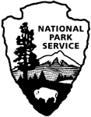 | National Park Service  U.S. Department of the Interior  OMB Control Number: 1024-0224  Expiration Date: 5/31/2019

Fort Matanzas
National Monument
Visitor Study

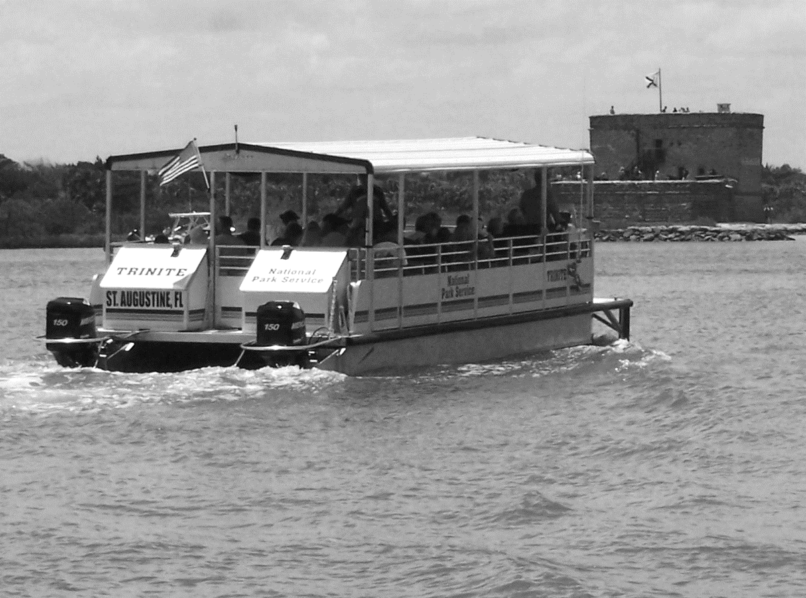

2017

ID: Date:

Time: : AM PM Location: ________________________

Weather: Sunny Partly Cloudy Overcast/Rain Storm

Special Event? No Yes (Specify) ________________________________________

Paperwork Reduction and Privacy Act Statements: The National Park Service is authorized by the NPS Research Mandate (54 USC 100702) to collect this information. This information will be used by park managers to evaluate visitor experiences related to the services and facilities managed Fort Matanzas National Monument. Responses to this request are voluntary and anonymous. Your name will never be associated with your answers, and all contact information will be destroyed when the data collection is concluded. No action may be taken against you for refusing to supply the information requested. An agency may not conduct or sponsor, and a person is not required to respond to, a collection of information unless it displays a currently valid OMB control number and expiration date.

Burden Estimate: We estimate that it will take an average of 10 minutes to complete this questionnaire. You may send comments concerning the burden estimates or any aspect of this information collection to the Social Science Program Chief, National Park Service, 1201 Oakridge Drive, Fort Collins, CO, 80525-5596; nps_nrss_social_science@nps.gov (email).

OMB Approval XXXX-XXXX
Current Expiration Date: X-XX-XXXX

DIRECTIONS
Please have the adult in your group (at least 18 years old) having the next birthday complete this questionnaire.
A visit is defined as the day in which you were contacted to complete this questionnaire.
For questions that use circles (O), please mark your answer by filling in the circle with black or blue ink.

1. Group Characteristics

Topic Area 1 – GROUP5
- Including yourself, how many people are in your personal group during your visit to Fort Matanzas National Monument (NM) today?
Number of adults (18 years or older)
Number of children (under 18 years)

Topic Area 1 – GROUP4
- Which of the following best describes your personal group? Please mark (●) one.
O Organized group
O Church group
O Youth camp
O School group
O Scouts (i.e., Boy Scouts, Girl Scouts, Cub Scouts, etc.)
O Other (Please specify): _____________________________________
O Alone
O Family
O Friends
O Family and friends
O Other (Please specify): ____________________________

Topic Area 4 – VISHIS3
- Including this visit, approximately how many times have you visited Fort Matanzas NM?

In the last 12 months: ____________ times, including this visit

In your lifetime: ____________ times, including this visit

Topic Area 4 – VISHIS11
- How much total time did you spend in the park today? Please mark (●) one.
O Less than 1 hour
O About 1 hour
O Between 1 and 2 hours
O About 2 hours
O More than 2 hours

2. Trip Characteristics

Topic Area 2 – ITIN2
- When did you decide to visit the park? Please mark (●) one.
O Today
O In the last week
O More than a week ago, but in the last month
O More than a month ago, but in the last year
O More than a year ago
O Don’t know/can’t recall

Topic Area 2 – INFOSOURCE9
- Prior to your visit today, how did you obtain information about the park? Please mark (●) all that apply.
O Previous visit
O Friends/relatives/word of mouth
O Inquiry to park via phone, mail, or email
O Fort Matanzas NM website (nps.gov/FOMA)
O TripAdvisor (tripadvisor.com)
O Other website (Please specify):
O Local businesses (hotels, motels, restaurants, etc.)
O Maps/brochures
O Newspaper/magazine articles
O Other units of the National Park System (NPS)
O School class/program
O Social media (such as Facebook, Twitter, etc.)
O State welcome center/visitors bureau/chamber of commerce
O Television/radio programs/DVDs
O Travel guides/tour books (such as AAA, etc.)
O Other (Please specify):

OR

O Did not obtain information prior to this visit

Topic Area 2 – INFOSOURCE13
- Did you have the information about the park you needed today? Please mark (●) one.
O Yes
O No (Please specify information you needed but didn’t have today.)

Topic Area 2 – TPURPOSE2
- How important to you was each of the following reasons for visiting the park today? Please mark (●) one for each row.

 | Not at All Important | Slightly Important | Moderately Important | Very Important | Extremely Important
To visit a National Park Service site | O | O | O | O | O
To learn more about historic weapons | O | O | O | O | O
To view wildlife or natural scenery | O | O | O | O | O
To learn more about people who occupied the fort and St. Augustine | O | O | O | O | O
To relax | O | O | O | O | O
To be outdoors | O | O | O | O | O
To learn more about the fort as a structure | O | O | O | O | O
To spend time with friends/family | O | O | O | O | O
To experience solitude | O | O | O | O | O
To learn more about nature | O | O | O | O | O
Other (Please specify):  ________ | O | O | O | O | O

Topic Area 2 – TPURPOSE1
- Of the reasons listed in Question 9, which was the most important reason for you to visit the park today?

3. Park Visit

Topic Area 4 – DEST22
- Which of the following places in Fort Matanzas NM did you visit today? Refer to the survey administrator’s map of the park, if needed to help you answer this question. Please mark (●) all that apply.
O Visitor Center
O Fort Matanzas
O Nature Trail
O Inlet beach
O Ocean beach
O Bookstore
O Bathrooms
O Other (Please specify):__________________________________

Topic Area 5 – RecACT7, RecACT14 and Topic Area 6 – RecACT19
- a. Did you and your personal group attend any formal ranger/volunteer-led programs at the park today?
O Yes
What formal program(s) did you and your personal group attend? Please mark (●) all that apply.
O Cannon or musket firing demonstration
O Ferry trip
O Ranger-led activity, such as a tour or talk
O Cultural demonstration or performance
O Special event (Please specify): ______________________________________
O Other (Please specify): ______________________________________

O No
Why not? Please mark (●) all that apply.
O Not interested in formal ranger/volunteer-led programs
O No formal programs were available when we were there
O Crowds prevented attendance
O Not enough time
O Other reasons (Please specify): ________________________________

Topic Area 5 – RecACT19
- In which of the following programs and services did you personally participate within the park today? Please mark (●) all that apply.
O Having a conversation with a ranger/volunteer
O Watching park film
O Self-guided nature trail walk
O Reading the park brochure or newspaper
O Participating with a child in your group in the Junior Ranger program
O Other (Please specify):

OR

O Did not participate within any programs or services

Topic Area 6 – EVALSERV27
- To what extent do you agree or disagree with each of the following statements about learning opportunities at Fort Matanzas NM? Please mark (●) one for each row.

 | Strongly Disagree | Disagree | Neither Agree  nor Disagree | Agree | Strongly Agree | Not Applicable
Brochures at the park were engaging. | O | O | O | O | O | O
I learned something that was personally meaningful from having a conversation with a ranger/volunteer. | O | O | O | O | O | O
Brochures at the park did not meet my expectations for information included. | O | O | O | O | O | O
Brochures at the park were not memorable. | O | O | O | O | O | O
I am not interested in having a conversation with a ranger/volunteer while visiting the park. | O | O | O | O | O | O
I learned something that was personally meaningful from brochures at the park. | O | O | O | O | O | O
My conversation with a ranger/volunteer was memorable. | O | O | O | O | O | O
Brochures at the park helped me value Fort Matanzas NM. | O | O | O | O | O | O

Topic Area 7 – EVALSERV5/EVALSERV6
- How important to you was it during your visit to the park today to learn about the following subjects, and how would you rate the quality of the brochures/programs/exhibits at the park about each? For each item, please mark (●) one for importance and one for quality.
 | IMPORTANCE |  |  |  |  | QUALITY
 | Not at all Important | Slightly Important | Moderately Important | Very Important | Extremely Important | No Exhibits/Programs  At All | Poor | Average | Good | Very Good | Not Applicable
Native American history and culture | O | O | O | O | O | O | O | O | O | O | O
Architecture and construction | O | O | O | O | O | O | O | O | O | O | O
Spanish colonial history and culture | O | O | O | O | O | O | O | O | O | O | O
Historic preservation | O | O | O | O | O | O | O | O | O | O | O
Historic weaponry | O | O | O | O | O | O | O | O | O | O | O
Hispanic or Latino American history and culture | O | O | O | O | O | O | O | O | O | O | O
Archaeology | O | O | O | O | O | O | O | O | O | O | O
Coastal Florida nature | O | O | O | O | O | O | O | O | O | O | O
Beach rules and regulations | O | O | O | O | O | O | O | O | O | O | O
Beach/surf conditions | O | O | O | O | O | O | O | O | O | O | O
American history and culture | O | O | O | O | O | O | O | O | O | O | O
Other (Please specify):  _________________ | O | O | O | O | O | O | O | O | O | O | O

Topic Area 4 – FVIS6
- If you were to visit the park again in the future, are there specific subjects you would like to learn about? Please mark (●) one.
O Yes (Please specify subjects you would like to learn about.)

O No
Topic Area 4 – FVIS7
- Fort Matanzas NM uses several ways to present information about the above subjects. In what ways would you be interested in learning about the above subjects if you were to visit again? Please mark (●) all that apply.
O Ranger-led talk
O Informal conversations with a ranger/volunteer
O Film/video
O Demonstrations
O Information boards
O Reenactments
O Smartphone app
O Audio tour
O Other (Please specify):__________________________________

Topic Area 7 – EVALSERV15
- a. Is there any learning or educational aspect of your visit that could have been enhanced by the informational/interpretive
programs, brochures, and/or exhibits at the park? Please mark (●) one.
O Yes
O No Go to Question 19

b. What would you recommend to improve current informational/interpretive programs, brochures, and/or exhibits provided at the park? Please be specific.

Topic Area 7 – RecExp15
- What did you enjoy most about your visit to the park today?

Topic Area 7 – RecEXP16
- What did you enjoy least about your visit to the park today?

4. Visitor Experience

Topic Area 4 – DEST3 and DEST4
- a. Were you and your personal group able to take a ferry trip to Fort Matanzas today? Please mark (●) one.
O Yes
Was the departure time of your ferry trip your first choice?
O Yes
O No
O No
What reasons prevented you from doing so? Please mark (●) all that apply.
O Not enough time
O Bad weather
O Trip was cancelled
O No tickets were available for ferry trip to the fort
O Other reason (Please specify):________________________

Topic Area 4 – RecEXP6
- How important was taking a ferry trip to Fort Matanzas to you and your personal group today? Please mark (●) one.

Not at All Important | Slightly Important | Moderately Important | Very Important | Extremely Important
O | O | O | O | O

Topic Area 6 – EVALSERV27
- To what extent do you agree or disagree with each of the following statements about your experience at the park today? Please mark (●) one for each row.

 | Strongly Disagree | Disagree | Neither Agree  nor Disagree | Agree | Strongly Agree | Not Applicable
I didn’t have to wait long for a ferry trip to Fort Matanzas today. | O | O | O | O | O | O
There were too many people on my ferry trip to Fort Matanzas today. | O | O | O | O | O | O

Topic Area 6 – CROWD30
- Please indicate how your experience of each of the following items during this visit compared with your expectations. Please mark (●) one for each item.
 | A lot more than expected | More than expected | About as expected | Less than expected | A lot less than expected | I had no expectation
Amount of information available to guide my visit | O | O | O | O | O | O
Number of opportunities (e.g. programs, exhibits, films) to learn | O | O | O | O | O | O
Number of rangers/volunteers available to answer my questions | O | O | O | O | O | O
Topic Area 5 – RecEXP17
- How much of a problem were each of the following potential issues for you at the park today? Please mark (●) one for each row.

 | Big Problem | Small Problem | Not a Problem | Not Applicable
Difficulty finding a parking space at the Visitor Center | O | O | O | O
Too many people inside the Visitor Center | O | O | O | O
Too many people inside the bookstore | O | O | O | O
Wait time for a ferry trip to Fort Matanzas | O | O | O | O
Too many people at Fort Matanzas | O | O | O | O
Not enough park staff present | O | O | O | O
Not enough restrooms | O | O | O | O
Crowding from organized groups | O | O | O | O
Not enough parking at beaches | O | O | O | O
Noise from organized groups | O | O | O | O
Other (Please specify): | O | O | O | O

6. Background Information

Topic Area 1 – AGE1
- What is your age? _________

Topic Area 1 – GEND1
- What is your gender? Please mark (●) one.
O Male
O Female

Topic Area 1 – RES2
- Where do you live?
US ZIP ____________
Country (if not US) _______________________

Topic Area 1 – RACE/ETH1
- Are you Hispanic or Latino? Please mark (●) one.
O Yes
O No
O I prefer not to answer.

Topic Area 1 – RACE/ETH2
- What is your race? Please mark (●) all that apply.
O American Indian or Alaska Native
O Asian
O Black or African American
O Native Hawaiian or other Pacific Islander
O White
O I prefer not to answer.

Topic Area 1 – EDUC1
- What is the highest level of formal education you have completed? Please mark (●) one.
O Less than high school
O Some high school
O High school graduate or GED
O Some college, business, or trade school
O College, business, or trade school graduate
O Some graduate school
O Master’s, doctoral, or professional degree
O I prefer not to answer.

Topic Area 1 – LANG1
- When visiting an area such as Fort Matanzas NM, what language do you personally prefer to use? Please mark (●) one for speaking and one for reading.

 | Speaking | Reading
English | O | O
Spanish | O | O
Other (Please specify): | O | O

Topic Area 9 – OPMGMT10
- Is there anything else you would like to tell us about your visit to the park?

Thank you for your help!
Please return the survey to the administrator.

