CAHPS Clinician and Group Data Submission Registration Form

Registration Step 1: Provide Contact Information
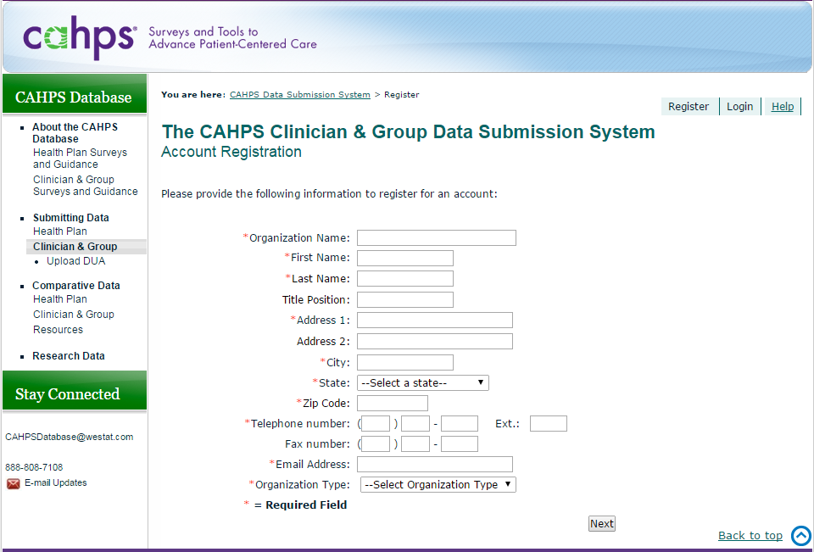
Public reporting burden for this collection of information is estimated to average 5 minutes per response, the estimated time required to complete registration. An agency may not conduct or sponsor, and a person is not required to respond to, a collection of information unless it displays a currently valid OMB control number. Send comments regarding this burden estimate or any other aspect of this collection of information, including suggestions for reducing this burden, to: AHRQ Reports Clearance Officer Attention: PRA, Paperwork Reduction Project (0935-XXXX) AHRQ, 5600 Fishers Lane, # 07W41A, Rockville, MD 20857.

Form Approved
OMB No. 0935-XXXX
Exp. Date XX/XX/20XX

Registration Step 2: Create Username and Password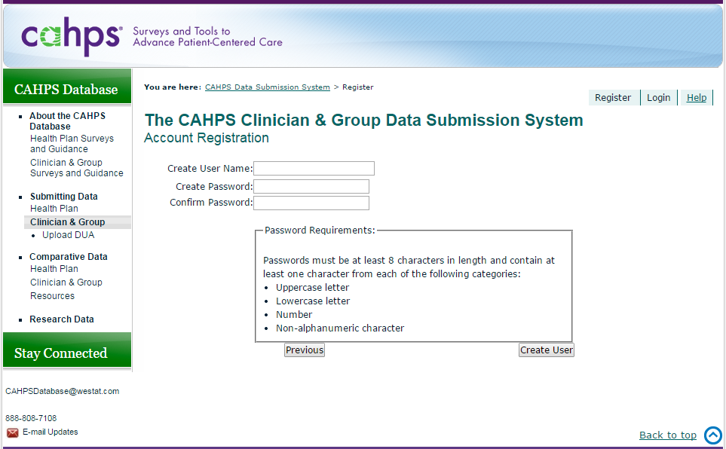
Form Approved
OMB No. 0935-XXXX
Exp. Date XX/XX/20XX

