Form Approved
OMB No. 0923-0047
Exp. Date: 12/31/2018

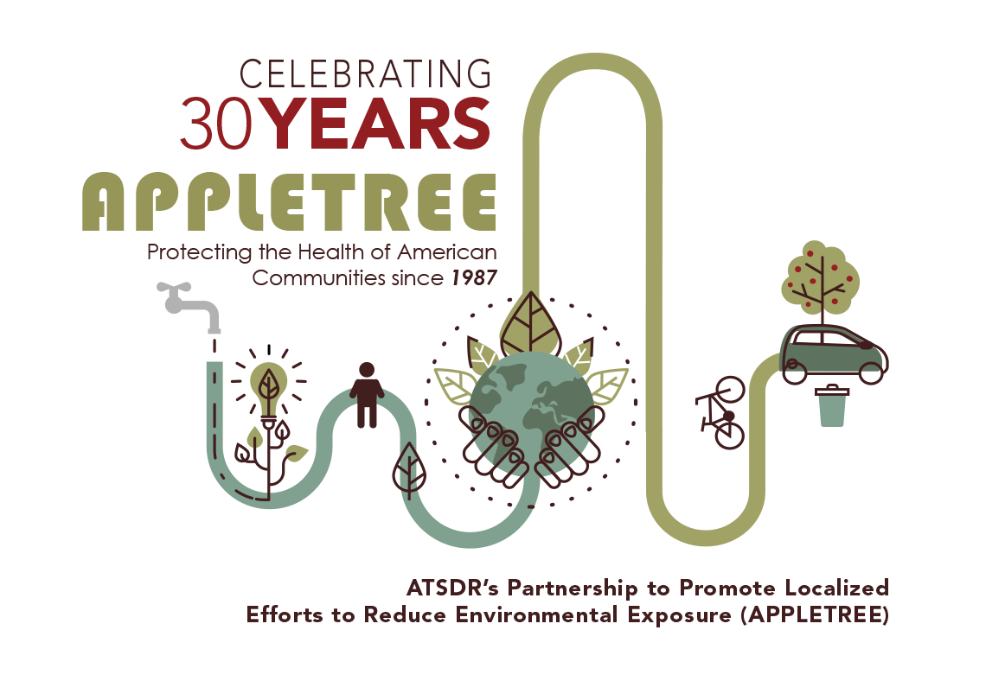

CDC estimates the average public reporting burden for this collection of information as approximately 10 minutes per response, including the time for reviewing instructions, searching existing data sources, gathering and maintaining the data needed, and completing and reviewing the collection of information. An agency may not conduct or sponsor, and a person is not required to respond to collection of information unless it displays a currently valid OMB control number. Send comments regarding this burden statement or any other aspect of this collection of information, including suggestions for reducing this burden to CDC/ ATSDR Reports Clearance Officer, 1600 Clifton Road, MS D-74, Atlanta, GA 30333, ATTN: PRA (0923-0047).

Are you a Federal or State employee?

Federal State Neither

Overall, how would you rate the APPLETREE Meeting?

Excellent Very good Good
Fair Poor

How well were logistics (transportation/hotel) for the Meeting organized?

Extremely organized Very organized Somewhat organized Not so organized
Not at all organized

Was Meeting length too long, too short, or about right?

Much too long Somewhat too long About right Somewhat too short Much too short

Do you agree or disagree with the following statements?





















Communication by ATSDR prior to the Meeting was adequate.

Strongly Agree Agree

Not Applicable, or
Neutral Disagree Strongly Disagree

The Meeting agenda was well thought-out and organized.

Strongly Agree Agree


Not Applicable, or
Neutral Disagree Strongly Disagree





The agenda included TOO MANY topics. Would prefer more time spent on fewer topics.










The "Safe-Siting" presentations were helpful and of value to my program.
Adequate time was allotted to "Safe-Siting" topics.
The Track Sessions allowed me to
participate in     





discussions relevant to my job/role.
The Health Assessment Track topics were relevant and of interest.
The Health Education





Track topics were      relevant and of interest
The Program Management Track topics were relevant and of interest.
The Program Evaluation presentation was helpful and of value to my program.

Adequate time was allotted for Program Evaluation discussion.





As a result of the Program Evaluation presentation, I have a
better understanding of     





how to prepare an evaluation strategy for my program.
The Management Q&A was helpful and informative.

I feel like I had adequate access to my TPO, Management, and other ATSDR staff.

Strongly Agree Agree



Not Applicable, or
Neutral Disagree Strongly Disagree






I would have preferred fewer didactic presentations. I felt talked AT too much.

What do you consider to be the most valuable aspect of the APPLETREE Meeting?

Gaining topical awareness on science/policy issues Networking with other states
Networking and face time with ATSDR management and staff Providing direct input and feedback to ATSDR
This meeting is of little value to me

Other (please specify)

Please rate the following




Good Satisfactory Needs Improvement
Meeting location
Hotel location   

Logistics (ground transportation)






Small Group Time   
Networking Time
State showcase time

Cafeteria/Food

Is there anything else you’d like to share about Meeting?

