ToxFAQs Before and After Testing Email Invitation

Sample Email Invitation – sent by Qualtrics

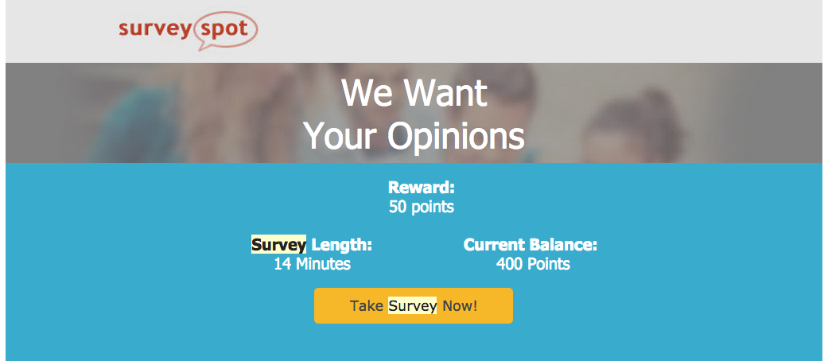

20

