U.S. tap water is one of the safest and healthiest drinking water supplies in the world. To keep it as safe and healthy as possible, the Centers for Disease Control and Prevention (CDC) is conducting a study to find links between people’s health and their water use habits. Pinellas County is participating in this study.
Attachment E7

Key Points

- Pinellas County Utilities water division (the group that supplies drinking water to the residents in your county) has volunteered to participate in the CDC Water and Health Study.

- The study goal is to determine links between water use and health in communities across the United States.

- Water utility personnel will collect water samples from the outdoor water spigots of some residents’ homes. They might run the water through a filter for about 30 minutes to sample about 30 gallons of water (which is equal to the amount of water used in a 15 minute shower with a water-saving showerhead).

- Study personnel will NOT ENTER your home.

- Being selected for the study does not mean that there is anything unusual about or wrong with your water service.

- Water sample results will not be linked to specific households. The water samples collected are large enough to be representative of the drinking water serving your community.

- Water samples collected as a part of this study will only be used for research purposes, and will not be used to determine water quality compliance. Results will be combined with those from other utilities across the country.

- Pinellas County Utilities water division would notify residents in the unlikely event that something is wrong with the water. You can access your utility’s publically available annual consumer confidence report (CCR) for information on the drinking water quality in your area (available at: www.pinellascounty.org/utilities).

- If you have concerns about the water sample collection, call the Utilities Customer Service line at (727) 464-4000.
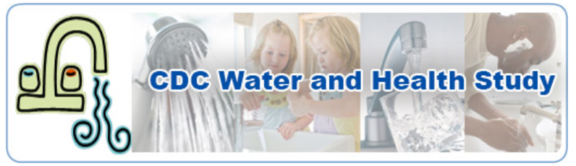

For more information, visit www.cdc.gov/healthywater/study or contact the CDC study team at waterhealthstudy@cdc.gov.

