Welcome to the PSE Change Network Survey!

The PSE Change Network Survey is being conducted by Battelle at the request of the Centers for Disease Control and Prevention (CDC), Division of Cancer Prevention and Control (DCPC). The survey is part of a larger comprehensive evaluation of a pilot program (also known as the 1017 program) in which CDC awarded additional funds to 13 Comprehensive Cancer Control programs to increase their focus on Policy, System, and Environmental (PSE) change strategies.
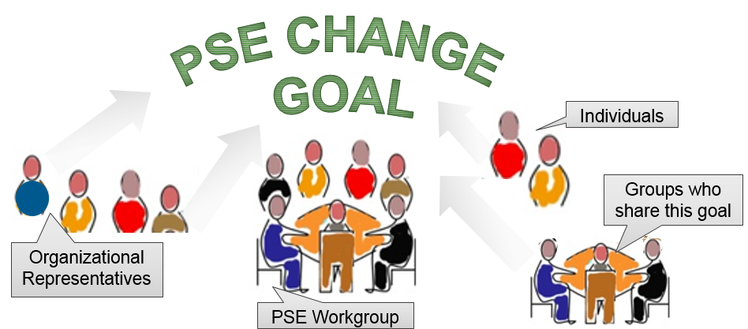
You have been asked to participate in this survey because of your involvement in PSE change initiatives led by the 1017 program in your state or tribe. For the purpose of this survey, a PSE Change Network is defined as a group of engaged community partners, organizations, and/or one or more formal groups who work together to prevent and control cancer by implementing PSE change strategies.
This survey will take about 20 minutes to complete. Please answer the survey questions to the best of your ability based on your personal knowledge and experience with PSE change networks. You do not need to complete the survey in one sitting; your answers are not final until you hit the “Submit” button.
Your completed survey will be assigned a unique identification number so that data from respondents in the same state or tribe can be compiled. Other data security procedures will be implemented to ensure that your answers are maintained in a secure manner and your responses are never linked to you personally. You may choose not to participate in this survey, or to terminate your involvement at any time, without any penalty to you or your program. Completion of the survey constitutes your consent to participate.

If you have any questions about this evaluation please contact Battelle’s study director Marilyn Sitaker at 206-528-3365, or CDC’s technical lead Angela Moore at 770-488-3094. If you have any questions about your rights as a research participant, please contact Chair, Battelle Institutional Review Board, at 1-877-810-9530, extension 500.
NEXT

Public reporting burden of this collection of information is estimated to average 20 minutes per response, including the time for reviewing instructions, searching existing data sources, gathering and maintaining the data needed, and completing and reviewing the collection of information. An agency may not conduct or sponsor, and a person is not required to respond to a collection of information unless it displays a currently valid OMB control number. Send comments regarding this burden estimate or any other aspect of this collection of information, including suggestions for reducing this burden to CDC/ATSDR Reports Clearance Officer; 1600 Clifton Road NE, MS D-74, Atlanta, Georgia 30333; ATTN: PRA (0920-1016)
- Please select your name and organization/program/department from the list:
[A list of the program director and policy analyst in each site, plus up to 18 other organizations that are members of the PSE change network will be provided below for the respondent to select their name]

2. What is your job title?_____________________________
3. How long have you been in this position (in months)?_______________________
4. Please indicate what you or your organization contributes, or can potentially contribute, to PSE change efforts in your state or tribe (Select as many as apply)
- Funding
- In-Kind resources (e.g., Meeting Space)
- Paid staff
- Volunteers and/or volunteer staff
- Data resources including data sets, collection & analysis
- Information/ feedback
- Specific health expertise
- Expertise in PSE change strategies
- Expertise other than health or PSE change
- Connections with community allies
- Connection with community decision makers
- Fiscal management (e.g. acting as fiscal agent)
- Facilitation/leadership
- Communication/ use of media to convey public health benefits of PSE change.
- IT/web resources (e.g. server space, web site development, social media)
5. What is the most important contribution to PSE Change efforts made by you or your organization?? (Select one)
- Funding
- In-Kind resources (e.g., meeting space)
- Paid staff
- Volunteers and/or volunteer staff
- Data resources including data sets, collection & analysis
- Information/ feedback
- Specific health expertise
- Expertise in PSE change strategies
- Expertise other than health or PSE change
- Connections with community allies
- Connection with community decision makers
- Fiscal management (e.g. acting as fiscal agent)
- Facilitation/leadership
- Communication/ use of media to convey public health benefits of PSE change.
- IT/web resources (e.g. server space, web site development, social media)
6. What are the expected outcomes of PSE change efforts in your state or tribe? (Select as many as apply)
- Improved communication/use of media
- Public awareness
- Community support
- Decision maker’s understanding of the issue
- Public policy changes
- Health care system changes
- Improved health outcomes
- Community environmental changes
- Reduction of health disparities

7. Which single outcome of PSE change efforts is most important? (Select one)
- Improved communication/use of media
- Public awareness
- Community support
- Decision maker’s understanding of the issue
- Public policy changes
- Health care system changes
- Improved health outcomes
- Community environmental changes
- Reduction of health disparities

8. How successful have PSE change efforts been in your state or tribe? Success could include conducting a PSE assessment, formulating PSE change proposals, developing strong partner networks, educating decision makers, as well as achieving PSE changes or health impacts. (Select one)
- Not Successful
- Somewhat Successful
- Successful
- Very Successful
- Completely Successful
9. What aspects of partner collaboration contribute to this success? (Select as many as apply)
- Bringing together diverse stakeholders
- Meeting regularly
- Exchanging information/knowledge
- Sharing resources
- Shared learning/technical assistance
- Informal relationships created
- Collective decision-making
- Having a sense of shared mission, goals

10. In your opinion, do you have the right mix of groups, organizations, and/or schools to implement PSE change initiatives in your state or tribe? (Select one).
- No
- Yes
- Don’t know
For the next series of statements, please indicate your level of agreement or disagreement:
11. There is a common sense of mission among those working to achieve PSE changes. (Select one)
- Strongly Disagree
- Disagree
- Agree
- Strongly Agree
- Don’t Know
12. There is general agreement among those who are working on the initiatives as to which PSE changes should be prioritized (Select one)
- Strongly Disagree
- Disagree
- Agree
- Strongly Agree
- Don’t Know
13. There is general agreement on which strategies should be used to pursue PSE change. (Select one)
- Strongly Disagree
- Disagree
- Agree
- Strongly Agree
- Don’t Know
14. I can talk openly and honestly at meetings where PSE change initiatives are discussed. (Select one)
- Strongly Disagree
- Disagree
- Agree
- Strongly Agree
- Don’t Know

15. I feel that I have a voice in decision-making when PSE change initiatives are discussed. (Select one)
- Strongly Disagree
- Disagree
- Agree
- Strongly Agree
- Don’t Know

16. Which statement best describes the governance structure of your PSE Change network? (Select one)
- There is a lead organization that manages the network and takes care of administrative tasks
- All participants contribute to the management and leadership of the network—no formal administrative entity
- The network has a distinct administrative entity established to manage the network, with a hired manager
- Other________________________________________
- I’m not sure

17. What are the main strategies used to resolve conflicts that occur when PSE change initiatives are discussed? (Select two only)
- Open debate about opposing viewpoints
- Postponing or avoiding discussions of controversial issues
- Having a third party mediate between those with opposing viewpoints
- Having the opposing parties negotiate directly with each other
- One party to the conflict gives in
- Don’t know

18. From your perspective, or that of your organization, how much do the benefits of working on PSE change initiatives outweigh the costs at this point? (Select one)
- The costs outweigh the benefits
- The benefits are roughly equal to the costs
- The benefits outweigh the costs
- Don’t know

19. From the list below, select the individuals with which you have an established relationship (either formal or informal). You will be asked a set of questions about your relationship with each person you select, in the context of working together on PSE change initiatives.
[List of all individuals that are members of the PSE change network]

 | Question | Partner 1 | Partner 2 | …Partner 19
Network Interaction | - Did participating in PSE change initiatives give you the chance to begin a working relationship with this partner? | - Yes  - No | - Yes  - No | - Yes  - No
Network Interaction | - How frequently does your organization work with this partner on issues related to PSE change initiatives? | - Never-  - Once a year or less  - About once a quarter  - About once a month  - Every week  - Every day | - Never-  - Once a year or less  - About once a quarter  - About once a month  - Every week  - Every day | - Never-  - Once a year or less  - About once a quarter  - About once a month  - Every week  - Every day
Network Interaction | - In general, what type of activities do you undertake with this partner? | - None  - Coordinated Activities  - Cooperative Activities  - Collaborative Activities | - None  - Coordinated Activities  - Cooperative Activities  - Collaborative Activities | - None  - Coordinated Activities  - Cooperative Activities  - Collaborative Activities
Strategic Value | - How valuable is the power and influence of this partner to achieving PSE change? | - Not at all  - A small amount  - A fair amount  - A great deal | - Not at all  - A small amount  - A fair amount  - A great deal | - Not at all  - A small amount  - A fair amount  - A great deal
Strategic Value | - How valuable is this partner’s level of involvement to achieving PSE change? | - Not at all  - A small amount  - A fair amount  - A great deal | - Not at all  - A small amount  - A fair amount  - A great deal | - Not at all  - A small amount  - A fair amount  - A great deal
Strategic Value | - How valuable is the resource contribution made by this partner to achieving PSE change? | - Not at all  - A small amount  - A fair amount  - A great deal | - Not at all  - A small amount  - A fair amount  - A great deal | - Not at all  - A small amount  - A fair amount  - A great deal
Trust | - How reliable is this partner in terms of following through on commitments? | - Not at all  - A small amount  - A fair amount  - A great deal | - Not at all  - A small amount  - A fair amount  - A great deal | - Not at all  - A small amount  - A fair amount  - A great deal
Trust | - To what extent does this partner share a common sense of mission with others working on PSE change initiatives? | - Not at all  - A small amount  - A fair amount  - A great deal | - Not at all  - A small amount  - A fair amount  - A great deal | - Not at all  - A small amount  - A fair amount  - A great deal
Trust | - How open to discussion is this partner? | - Not at all  - A small amount  - A fair amount  - A great deal | - Not at all  - A small amount  - A fair amount  - A great deal | - Not at all  - A small amount  - A fair amount  - A great deal

ACKNOWLEGEMENTS:
Questions 1 – 9, and 19, are from the PARTNER TOOL created by Dr. Danielle Varda. For more information about the online Partner Tool, including background, technical manual, instructions for online data collection and analysis, as well as online demos, please visit: http://www.partnertool.net/
Questions 10 – 18, are from the Coalition Self-Assessment Survey, Allies Against Asthma, created by Dr. Erin Kennedy and Dr. Shoshanna Sofaer. http://www.asthma.umich.edu/media/eval_autogen/CSAS.pdf

Coordinated Activities: Exchanging information and altering program activities for mutual benefit and to achieve a common purpose. Cooperative Activities: Exchanging information, altering activities and sharing resources for mutual benefit and to achieve a common purpose. Increased organizational commitment; may involve written agreements. Shared resources can involve human, financial and technical contributions. Collaborative Activities: Exchanging information, altering activities, sharing resources and enhancing each other’s capacity for mutual benefit and to achieve a common goal. Organizations and individuals are willing to learn from each other to become better at what they do. Organizations share risks, responsibilities and rewards.
Power/Influence: The partner holds a prominent position in the state or tribe by being powerful, having influence, being a successful change agent, and showing leadership.
Level of Involvement: The partner is strongly committed and active in the partnership and gets things done.
Contributing Resources: The partner contributes funding, information, or other resources to the PSE change effort.
Open to Discussion: This partner is willing to engage in frank, open and civil discussion, especially when disagreement exists. They are willing to consider a variety of viewpoints and talk together (rather than at each other). You are able to communicate with this partner in an open, trusting manner.

