OMB Control Number: 0990-0281
ODPHP Generic Information Collection Request: Prevention Communication and Formative Research

Audience Research to Inform Physical Activity Guidelines Strategic Communication

Attachment G:
ODPHP Physical Activity Guidelines, 2nd Edition
Graphics and Taglines (English)
Stimulus Material

June 21, 2017

Submitted to:
Sherrette Funn
Office of the Chief Information Officer
U.S. Department of Health and Human Services

Submitted by:
Frances Bevington
Strategic Communication and Public Affairs Advisor
Office of Disease Prevention and Health Promotion
U.S. Department of Health and Human Services

1. Go Your Way
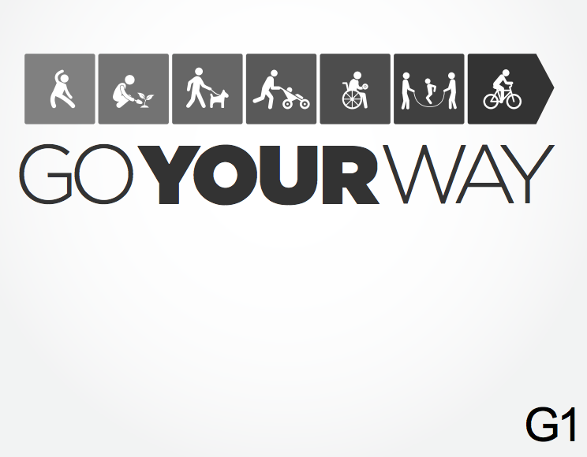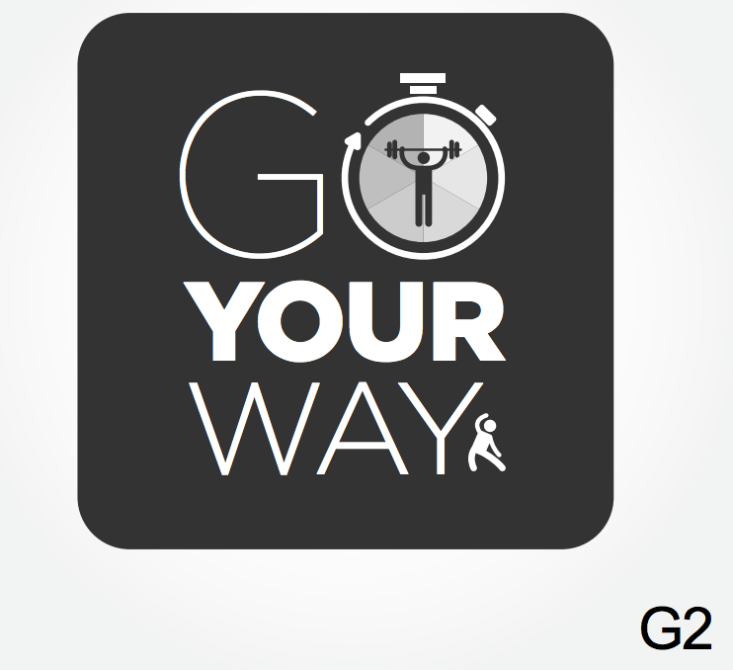

- Get moving your way. Just about any activity counts. (G1)
- Find your way to better health. (G2)

2. Your Move/My Move
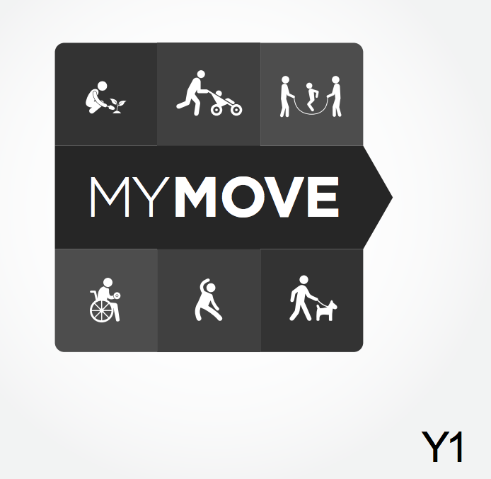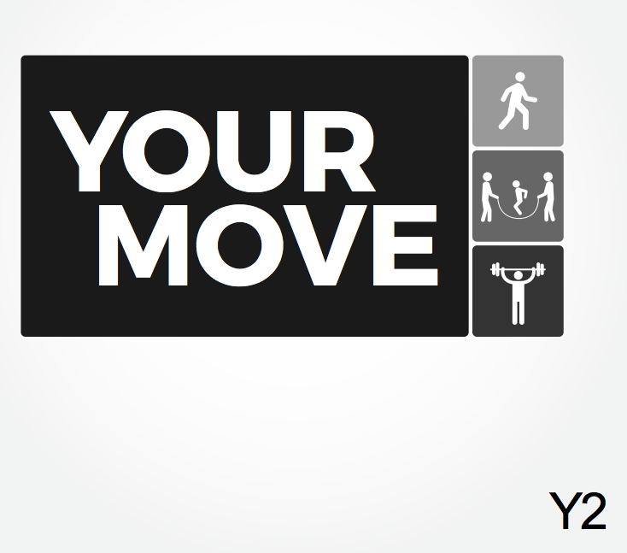

- Walk. Run. Dance. Play. Make your move. (Y1)
- Walk. Run. Dance. Play. What’s your move? (Y2)

3. Move My Way
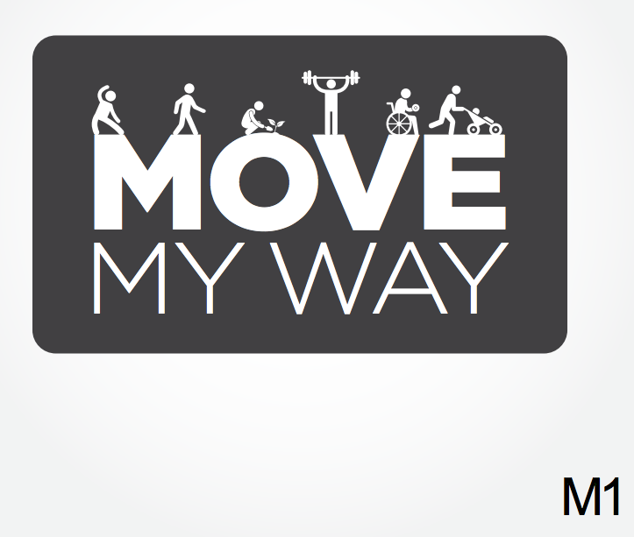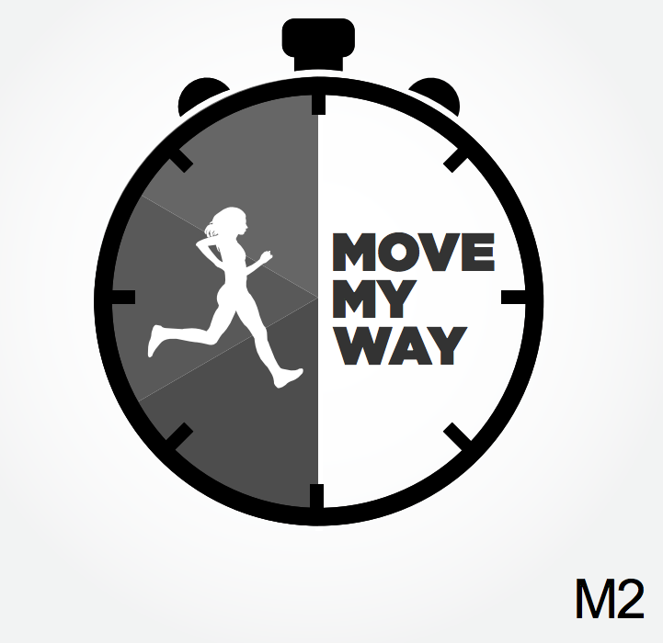

- What’s the best way to meet the Physical Activity Guidelines? Your way. (M1)
- Meet the Physical Activity Guidelines your way. (M2)

4. Go for 150/My 150
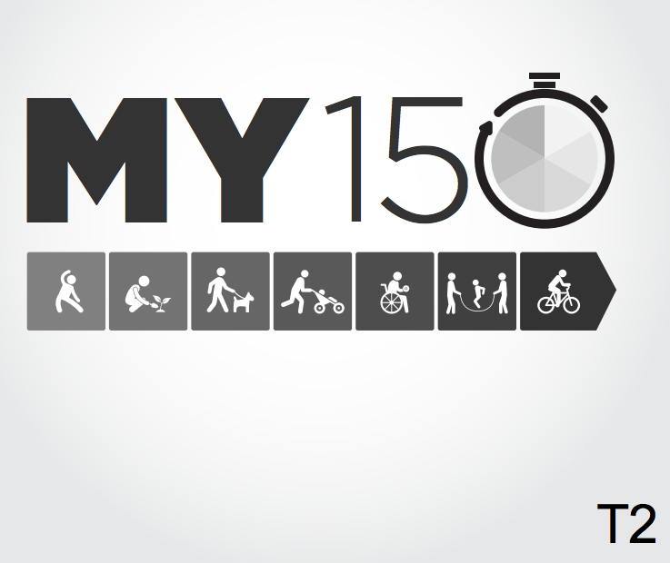

- Set a goal. Build up to 150 minutes of activity each week. (T1)
- Go for 150 minutes of activity every week. What’s your 150? (T2)

