Enter your survey responses online using the Census Bureau’s website.

STEP 1: Go to the survey’s website https://respond.census.gov/gus
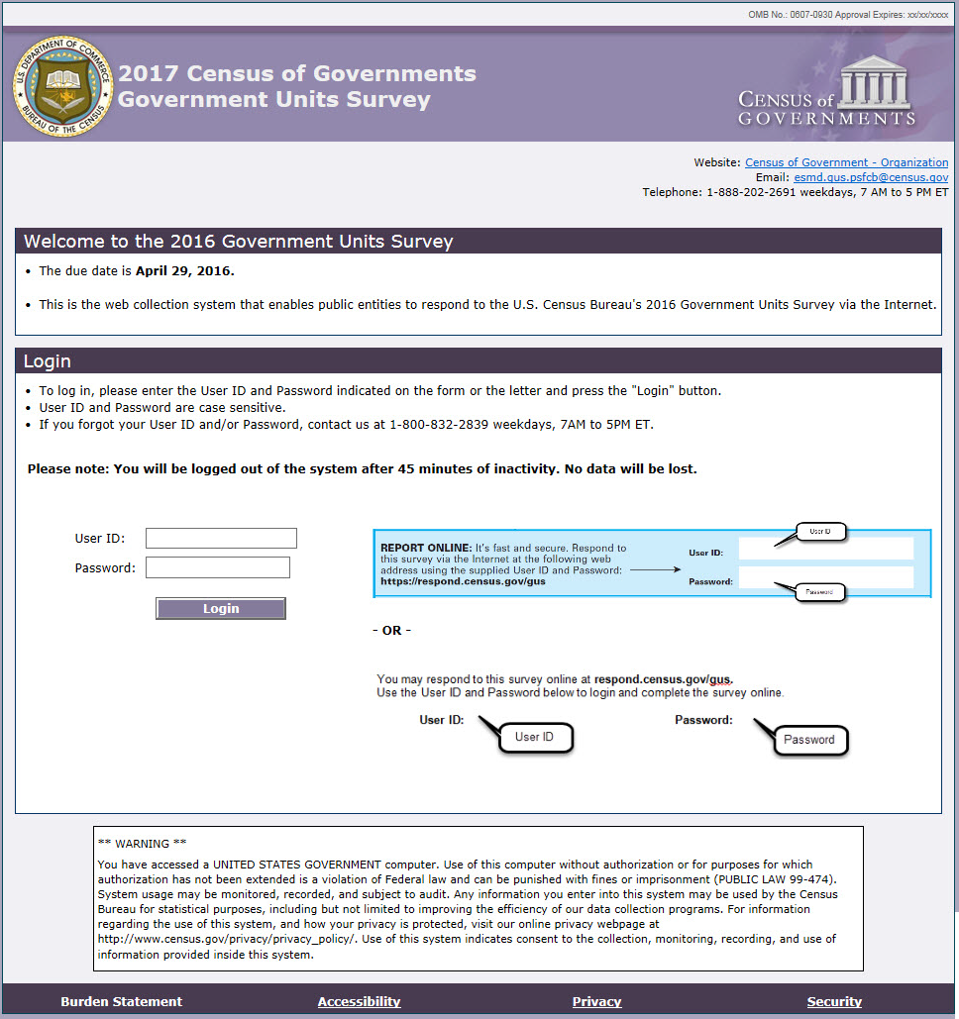

STEP 2: Enter your User ID and Password found in the letter you received in the mail.

Our web collection system is both
fast and secure.

It allows you to:
- Upload files
- View auto-summed totals
- Assess possible data issues instantly
- Navigate with a user-friendly interface
- Access detailed information about the survey
- Print a blank form
- Review and print a completed copy of the form
2017 Census Of Governments
Government Units Survey
- Electronic Reporting -
Respond Online!

