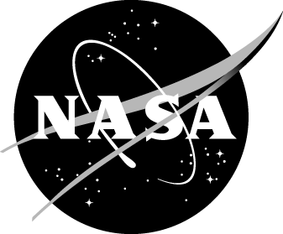
Study Overview for Parents of Students Participating in NASA STEM Challenges

NASA will be studying its STEM Challenges offered through your child’s afterschool program to learn more about how the activity is implemented and to understand the outcomes for students who participate. NASA is asking parents and their students to participate in the study. To help make the study successful, NASA is asking over XXX students to participate.

There are XXX parts of the study that involve collecting information from your student.

- [insert study components affecting students]

What it Means to Participate in this Study
Your child’s participation in the evaluation is voluntary. When your child completes an assessment, s/he does not have to answer any question they do not want to. Also, if you do not want your child be part of the evaluation, you can call [insert number] (toll-free) or e-mail [insert email] to request that your child not be included in the evaluation; simply state that you do not what your child to participate in the study and provide your child’s name and the name of the school/center at which she/he participates in an afterschool program. Your child can take part in the program even if he/she does not take part in the evaluation.

Protecting Your Information
Protecting your information is very important to us.

- NASA’s Office of Education, the companies doing the study, and the afterschool program providers will follow strict rules to protect the information you and your child provide.
- The study reports will not include your or your child’s names.
- Paper copies of your child’s responses and electronic copies of the data will be stored securely.
- We will not share information that identifies your child to anyone outside the study team and the afterschool program providers, except as required by law. A final dataset with survey responses will be prepared for NASA at the end of the study, but only after names and other identifiers are removed from the data.

As with all data collection, there is a very small chance that someone will see your child’s answers without permission. The NASA Office of Education and the study team have many procedures in place to protect the privacy of the data collected, so we do not think this will happen. However, if it does, all NASA Office of Education procedures will be followed to correct the situation.

Questions about the Evaluation
For questions about the evaluation, please email [insert email] or call [insert name], Study Director, at [insert phone number] (toll-free) or Patricia Moore Shaffer, NASA’s Office of Education Evaluation Manager, at 202-358-5230 (toll call). For questions about your child’s rights as a participant in this evaluation, please call [insert as appropriate contact information for IRB administrator].

