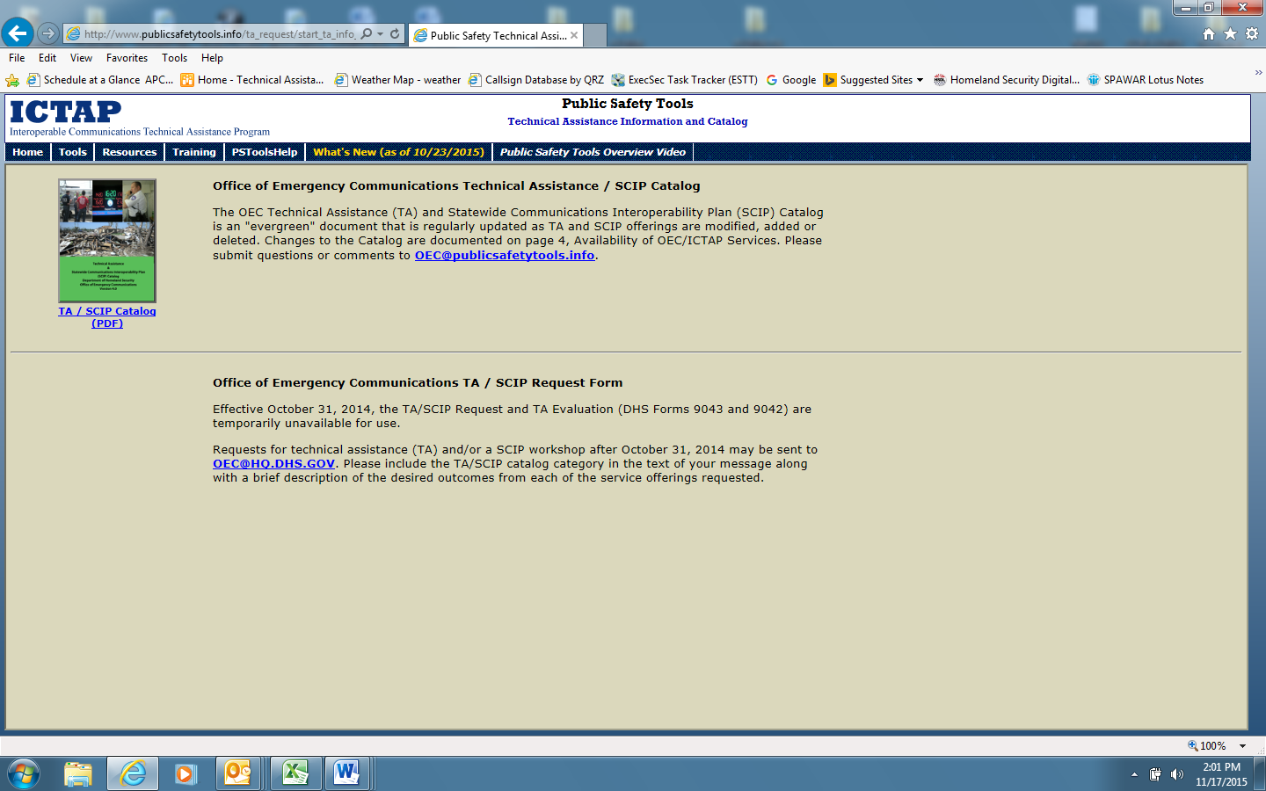
On this screen the user may access the Electronic (fillable) and PDF versions of the Technical Assistance (TA) Request (DHS Form 9043) and TA Evaluation (DHS Form 9042) by clicking on the link below the TA/SCIP Catalog, for either form. Examples of both forms are shown on the next 8 pages. (Note* the Forms expired on 10/31/2014 and subsequently were removed from the site and not available for a screen shot.)

