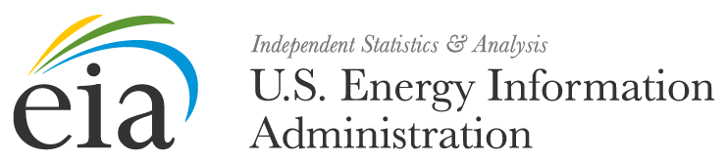

[Date]

FROM: [EIA Contact]

TO: [EIA-111 Respondent]

SUBJECT: CAMPAIGN REMINDER FOR THE QUARTERLY
ELECTRICITY IMPORTS AND EXPORTS SURVEY (EIA-111)

Reference: OMB No. 1905-0208 (Expiration Date: 09/30/2015)

This is a reminder that the Q2 2015 reporting period is due in less than a week, on July 31, 2015. These data are collected pursuant to the Federal Energy Administration (FEA) Act of 1974, Public Law 93-275, and response to this survey is mandatory under the FEA Act.

The data collected from the EIA-111 are used to obtain an accurate measure of the flow of electricity into and out of the United States by collecting data on U.S. electricity imports and exports. The data will appear in several EIA publications, such as the Annual Energy Outlook, the Electric Power Annual, and the Annual Energy Review. The data will also be used in other EIA products, such as the State Energy Data System and for EIA forecast models.

We want to help make this process as easy for you as possible. Thank you for your time and effort in diligently completing this form. We appreciate your timely report of Q2 2015 data by July 31, 2015.

Please log into the U.S. Energy Information Administration Data xChange Community Portal to access the campaign and submit your data. The campaign can be accessed from the U.S. Energy Information Administration Data xChange Community Portal Home or Campaign tab. For instructions on how to submit your data, select the Knowledge tab and type in 111 and you will find Information Session materials that include YouTube Videos, Power Point presentations and Frequently Asked Questions.

If you have not completed your submission for this reporting period, we advise you to please do so prior to the due date as your response is mandatory and required by law. Failure to respond may result in fines and other penalties. Your company’s mandatory participation will continue into the future unless otherwise notified. EIA estimates that the average reporting burden for this survey is 1.5 hours. The information reported on Form EIA-111 will be considered public information and may be publicly released in identifiable form.

EIA has a legal mandate to carry out a central, comprehensive, and unified energy data and information program. All persons owning or operating facilities or business premises who are engaged in any phase of energy supply shall make available to the Administrator such information and periodic reports. By law the EIA Administrator has the authority to conduct mandatory information collections and obtain the information by issuing subpoenas, conducting physical inspections or by other means identified in 15 U.S.C. 779.

If you are a new user and require assistance or if you are no longer the person submitting the Form EIA-111, then please contact us immediately.
Questions or concerns should be directed to the U.S. Energy Information Administration Customer Care Center directly via e-mail at EIA4USA@eia.gov, or call 1-855-EIA-4USA (1-855-342-4872) Monday through Friday, 8:00 AM - 6:00 PM ET.


Visit the EIA Data xChange Community Portal


  Forward this email
  This email was sent to matthew.grosso@eia.gov by matthew.grosso@eia.gov |
  Update Profile/Email Address | Rapid removal with SafeUnsubscribe™ | Privacy Policy.
  
  U.S. Energy Information Administration | 1000 Independence Ave, SW | Washington | DC | 20585

