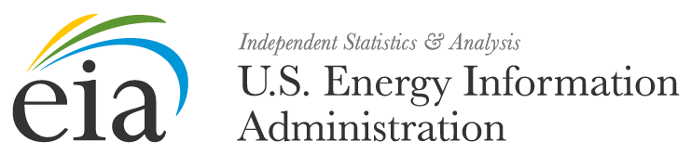

[Date]

About EIA

The U.S. Energy Information Administration (EIA) is the statistical and analytical agency within the U.S. Department of Energy. EIA collects, analyzes, and disseminates independent and impartial energy information to promote sound policy making, efficient markets, and public understanding of energy and its interaction with the economy and the environment. EIA is the Nation's premier source of energy information and, by law, its data, analyses, and forecasts are independent of approval by any other officer or employee of the United States Government.

What is the EIA-111 Electricity
Import/Export Survey?

The Energy Information Administration uses the EIA-111 Electricity Import/Export Survey form to obtain an accurate measure of the flow of electricity into and out of the United States by collecting data on U.S. electricity imports and exports. U.S. entities that purchase, sell or exchange electricity will report monthly flows of electric energy received or delivered across the border and the costs associated with these transactions. U.S. Balancing Authorities that are directly inter-connected with Foreign Balancing Authorities will report actual and implemented interchange.

Why are we contacting you?

Based on information gathered by EIA, you have been identified as the initial point of contact for providing information needed to complete the EIA-111 survey. If you are the appropriate contact, please confirm by emailing us at EIA4USA@eia.gov. If you are not the appropriate contact, please forward the appropriate person's contact information to EIA4USA@eia.gov and we will contact them directly.
What is EIA's Data xChange Community Portal?

The EIA Data xChange Community Portal is a simple, easy to use, on-line resource that provides essential data management services supporting energy data collections, proprietary energy data transfer, customized energy reporting and much more.

What's Next?

Please watch your email over the next few days for additional information regarding web-based EIA-111 survey information sessions, Data xChange Portal training & access instructions, and data submission timelines.

We are very excited to provide you with a new and innovative way of submitting and receiving data from the U.S. Energy Information Administration. Please keep a copy of your survey responses for your records.

Response to this survey is mandatory and required pursuant to 15 U.S.C., Sections 764(b), 772(b) and 790a of the Federal Energy Administration Act of 1974. Failure to respond may result in fines and other penalties. Your company’s mandatory participation will continue into the future unless otherwise notified. EIA estimates that the average reporting burden for this survey is 1.5 hours. The information reported on Form EIA-111 will be considered public information and may be publicly released in identifiable form.

If you have any questions, please don't hesitate in contacting us at EIA4USA@eia.gov or call 1-855-EIA-4USA (1-855-342-4872) Monday through Friday, 8:00 AM-6:00 PM ET.

Thank you for your anticipated support of EIA's data collection activities. We look forward to your participation.

EIA Survey Support Team
U.S. Energy Information Administration
EIA4USA@eia.gov
1-855-EIA-4USA


Visit the EIA Data xChange Portal


  Forward this email
  This email was sent to William.Booth@eia.gov by eia4usa@eia.gov |
  Update Profile/Email Address | Rapid removal with SafeUnsubscribe™ | Privacy Policy.
  
  US Energy Information Administration | 1000 Independence Ave, SW | Washington | DC | 20585

