Attachment 2a: Targeted advertisement

Participants Wanted for Research Study

The National Center for Health Statistics
is looking for teens in grades 9-12 (aged 15-18) who have used alcohol or marijuana. The survey research interview will be no longer than 60 minutes and participants will receive $40.

FOR MORE INFORMATION,
Call [fill name] at: 301-458-[fill XXXX]

Centers for Disease Control and Prevention
National Center for Health Statistics
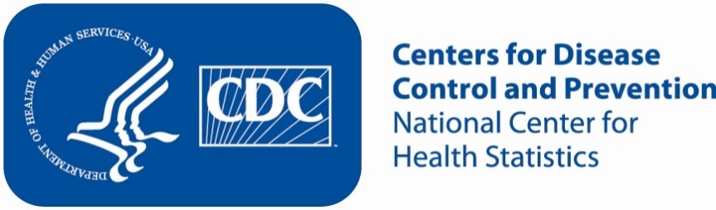
Attachment 2b: Non-Specific Advertisement/flyer

Participants Wanted for Research Study

The National Center for Health Statistics
is looking for teens in grades 9-12 (aged 15-18) to answer a variety of health questions that may be asked on a national survey. The survey research interview will be no longer than 60 minutes. Participants will receive $40.

FOR MORE INFORMATION,
Call [fill name] at: 301-458-[fill XXXX]

Centers for Disease Control and Prevention
National Center for Health Statistics

