Attachment 2a: Semi-targeted advertisement [note that one or more statements within the bracketed section below will be selected at a time, depending on recruiting needs].

Participants Wanted for Research Study

The National Center for Health Statistics
is looking for adults aged 18 and over to answer a variety of health questions that may be asked on a national survey. We would like to talk to [parents/guardians of children aged 2-17, adults who have smoked cigarettes within the last 12 months, adults who have seen a health care provider within the last 12 months.] The survey research interview will be no longer than 60 minutes and participants will receive $40.

FOR MORE INFORMATION,
Call [Fill Name] at: 301-xxx-xxxx

Centers for Disease Control and Prevention
National Center for Health Statistics
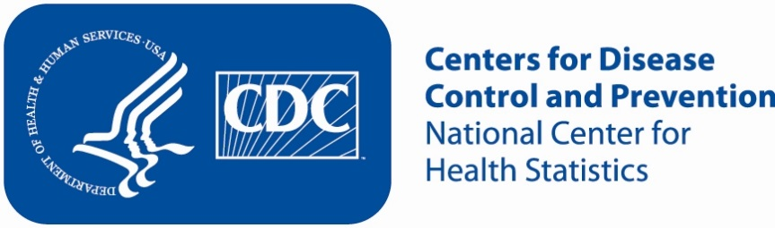
Attachment 2b: Non Specific Advertisement/flyer

Participants Wanted for Research Study

The National Center for Health Statistics
is looking for adults aged 18 and over to answer a variety of health questions that may be asked on a national survey. The survey research interview will be no longer than 60 minutes. Participants will receive $40.

FOR MORE INFORMATION,
Call [Fill Name] at: 301-xxx-xxx

Centers for Disease Control and Prevention
National Center for Health Statistics

